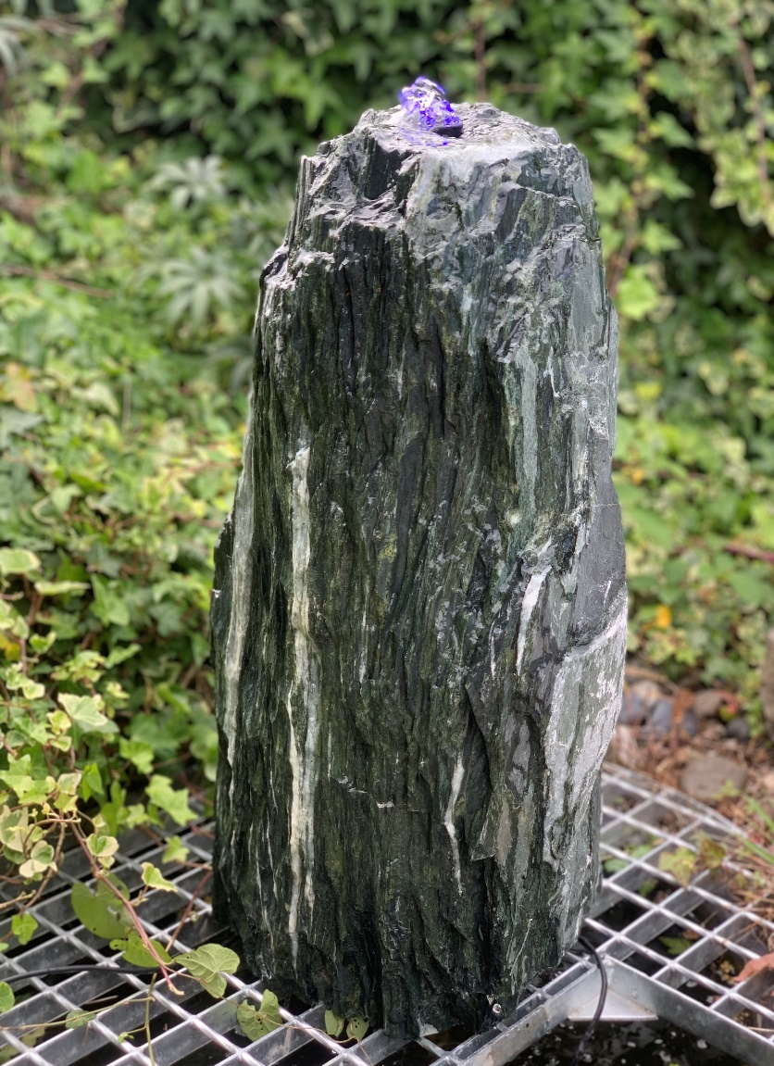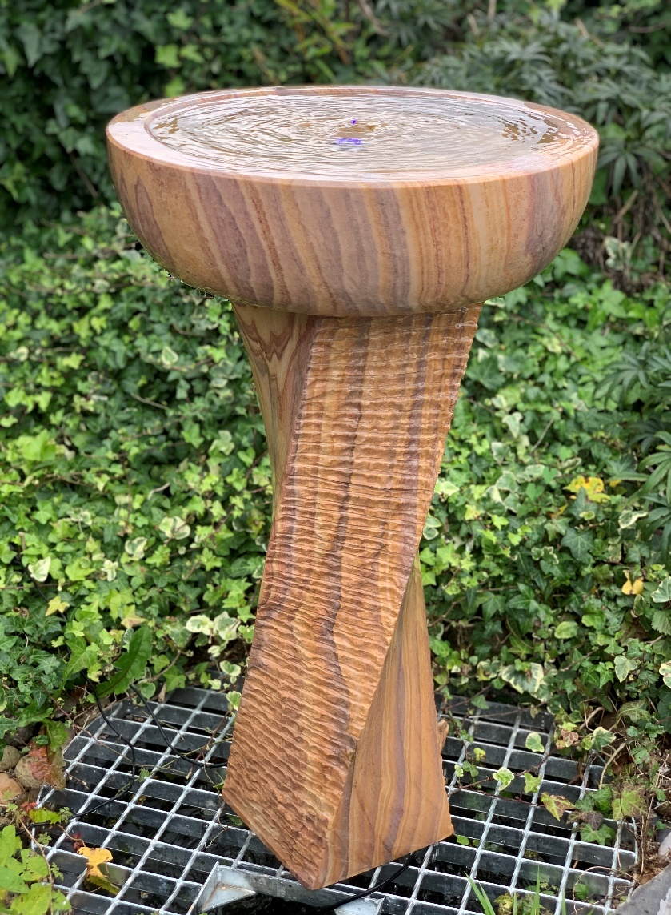
2117 GREEN ANGEL MONONITH 70~80CM H/ 2117-55CM 2338 RAINBOW S.STONE ANGEL FALLS FEATURE
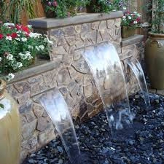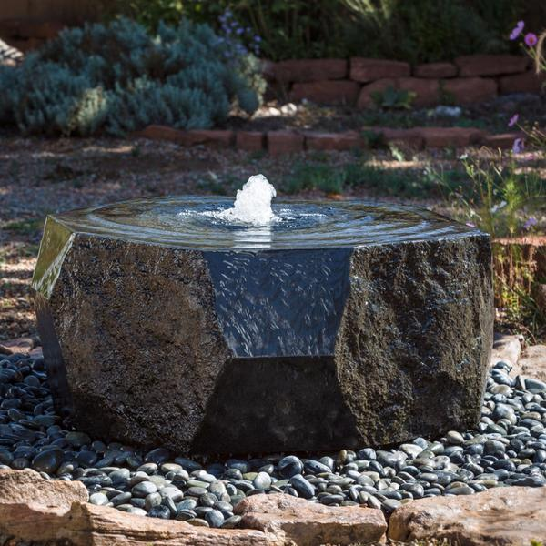
6313~ 6322 EC BLADES 30CM ~90CM, 3.5CM LIP OR 15CM LIP 2233 BASALT CRYSTAL 40~ 45CM X 15CM H
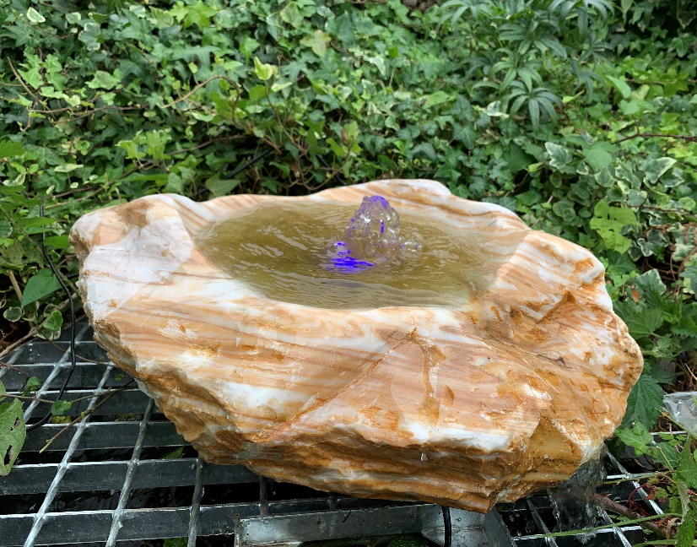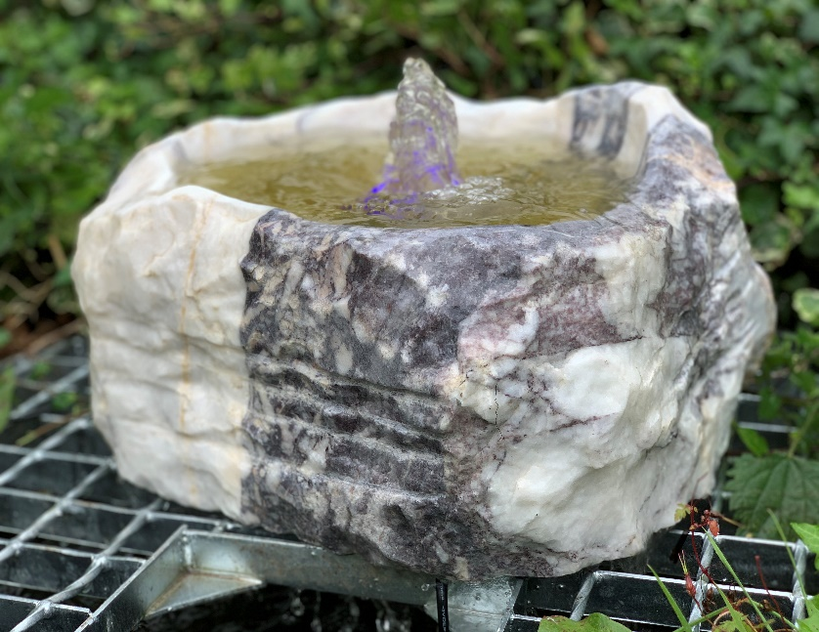
2220 ONYX-MARBLE BOULDER FOUNTAINS, VARIOUS COLOURS, SIZE APPROX 30~45CM W
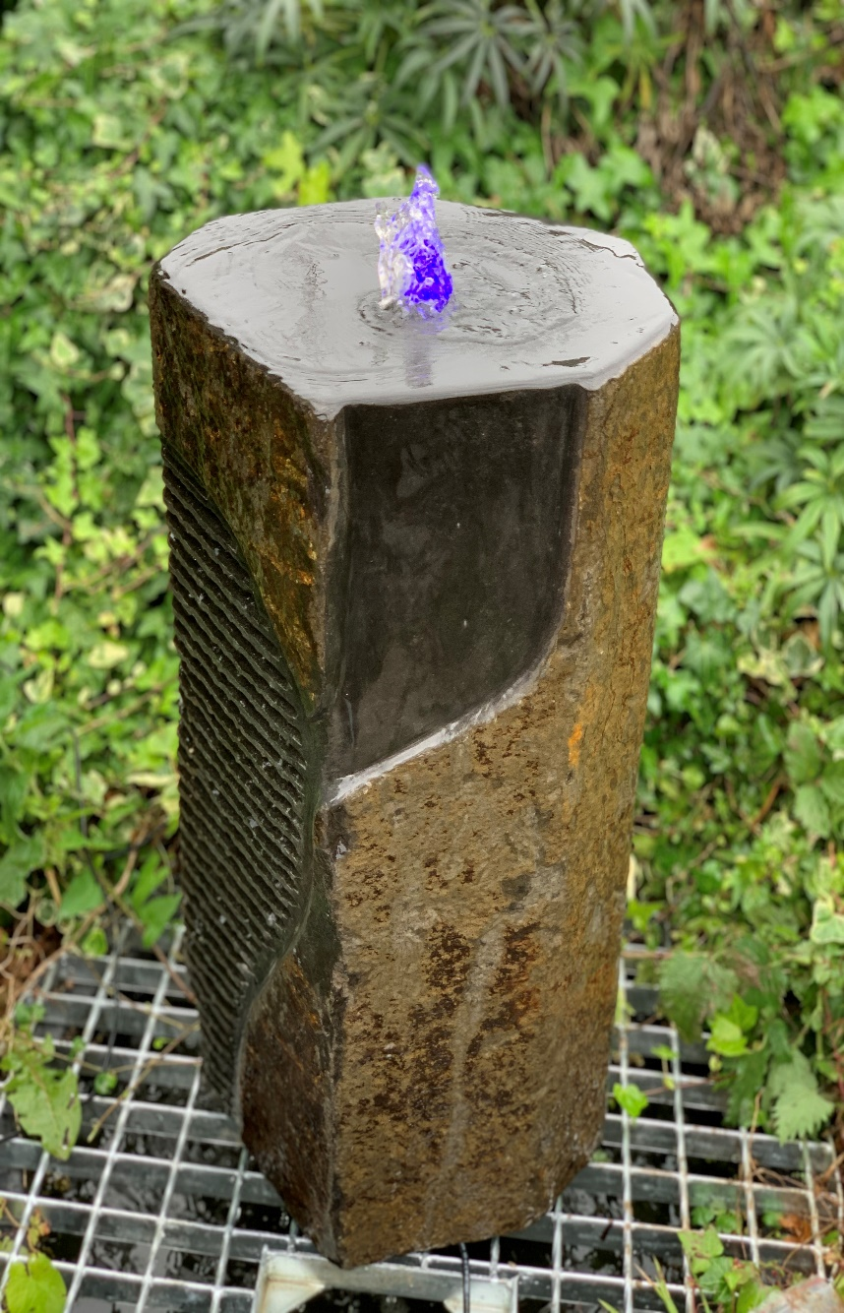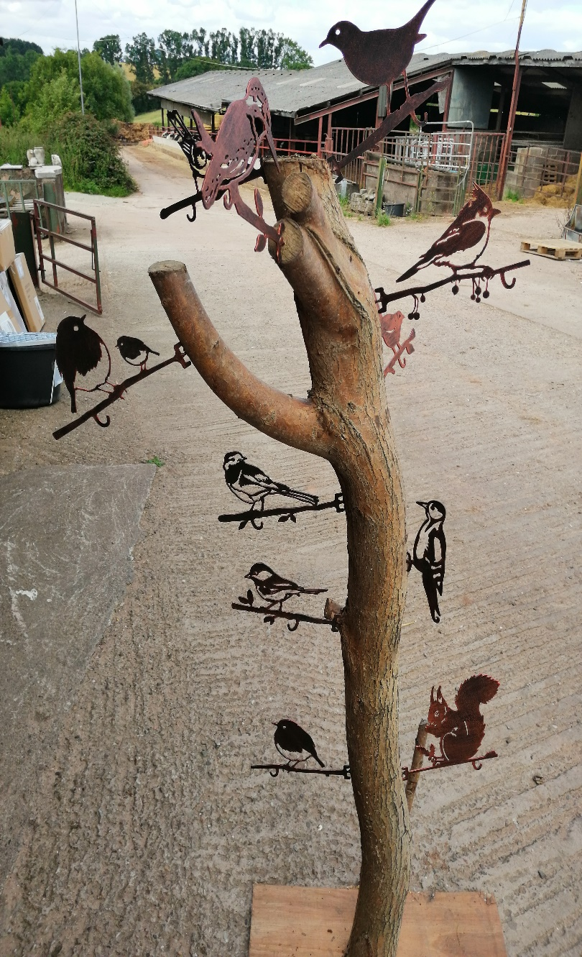
2229 CHUNKY BASALT COLUMN 30X60CM H 1060 BIRD FEEDER HANGERS, 2MM STEEL, COPPER FINISH
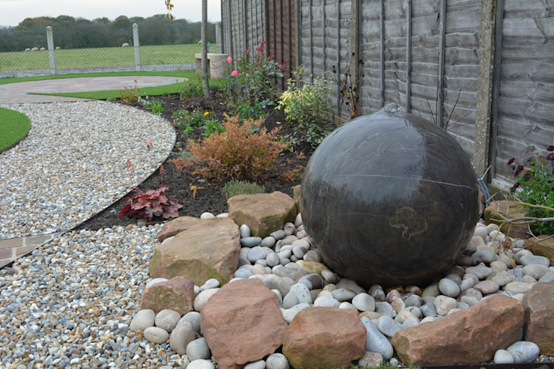
4014BL DIA40CM BLACK LIMESTONE SPHERE DRILLED POLISHED / 4014BBL-35CM
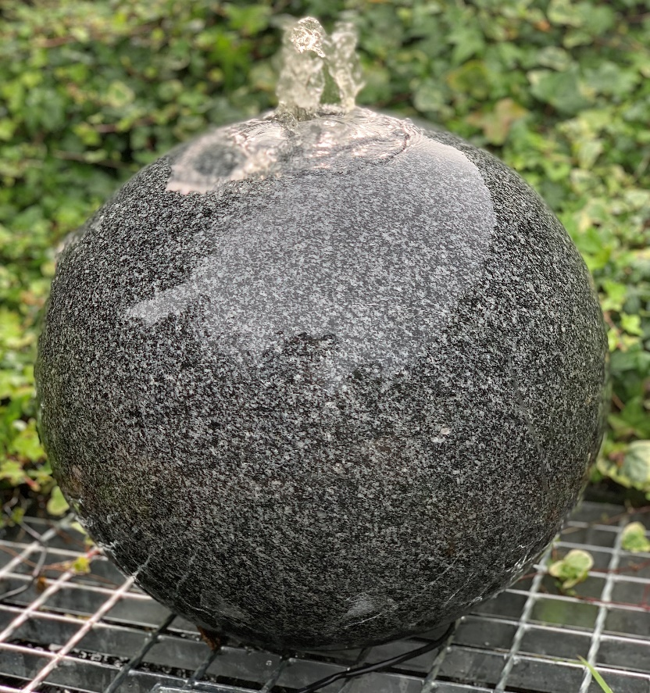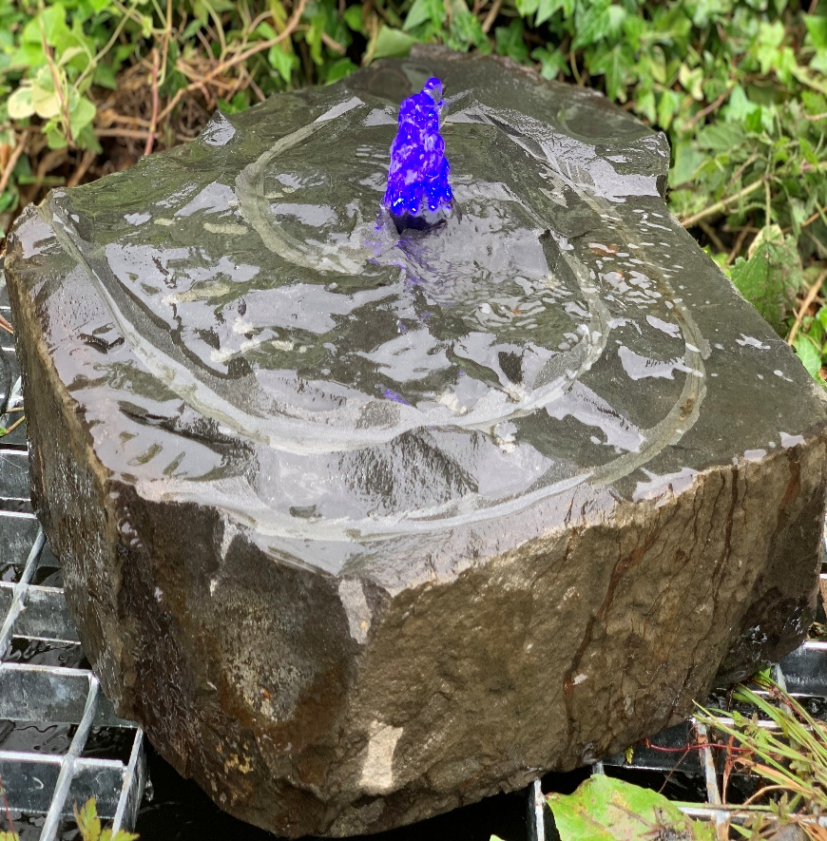
4014DG DARK GREY GRANITE SPHERE DIA40CM 2230
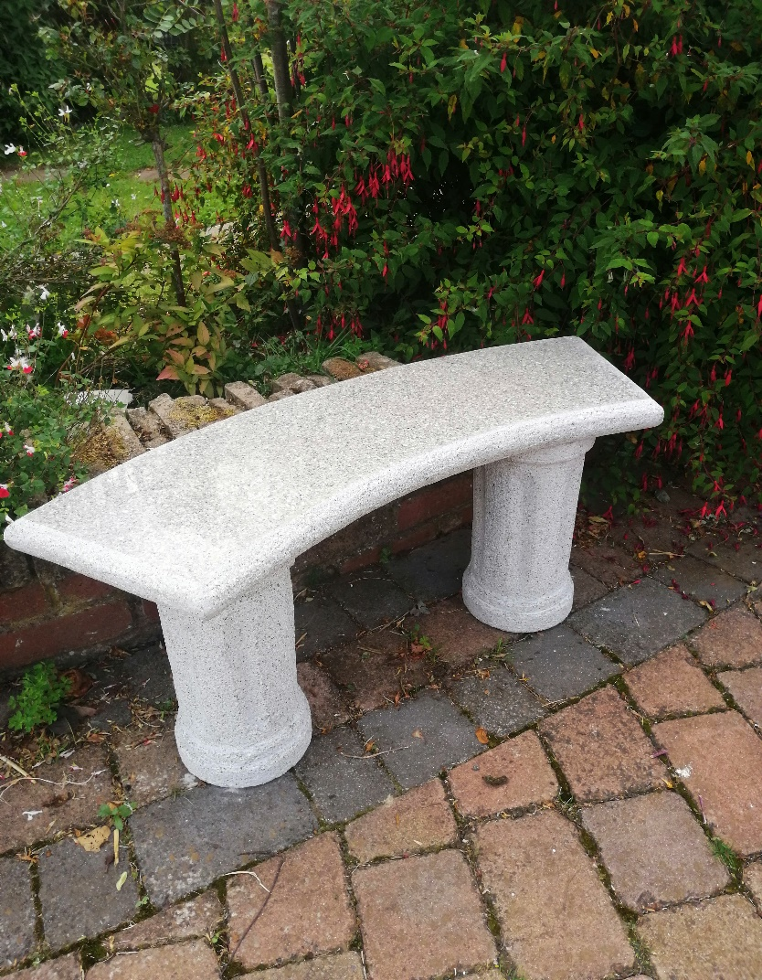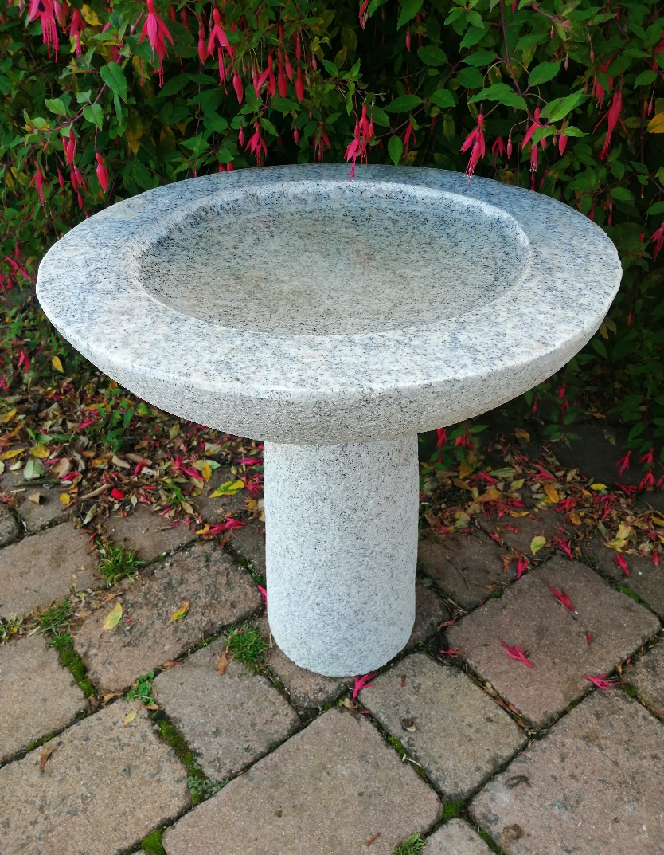
5003G FLORENCE BENCH 100CM, GREY GRANITE / 5003P 8007M-M DIA45 X 50CM H, GREY OR PINKY GRANITE
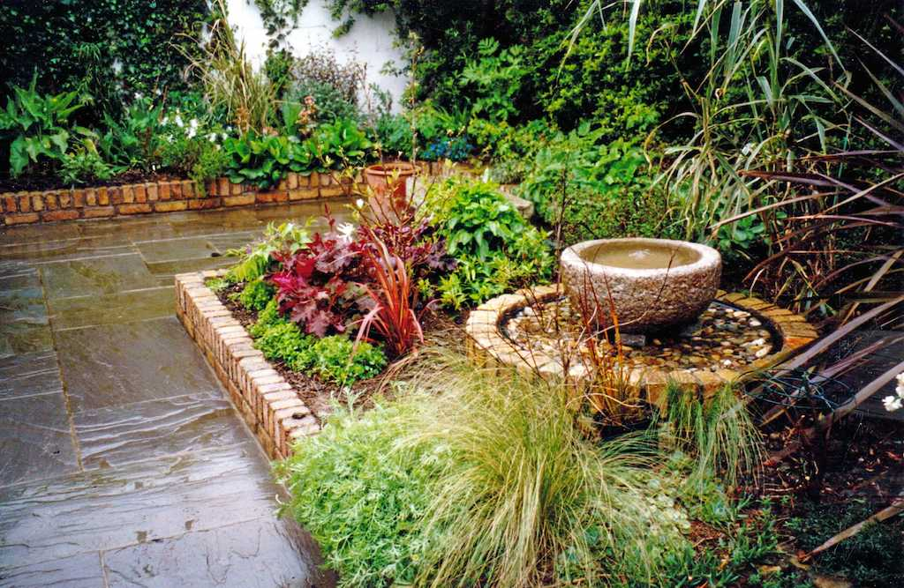
2364 GRANITE BABBLING URN, GREY or PINKY, DIA50CM X 25CM H, HAMMERED FINISH

