**EC reserviors & grids, water feature kit and accessories**

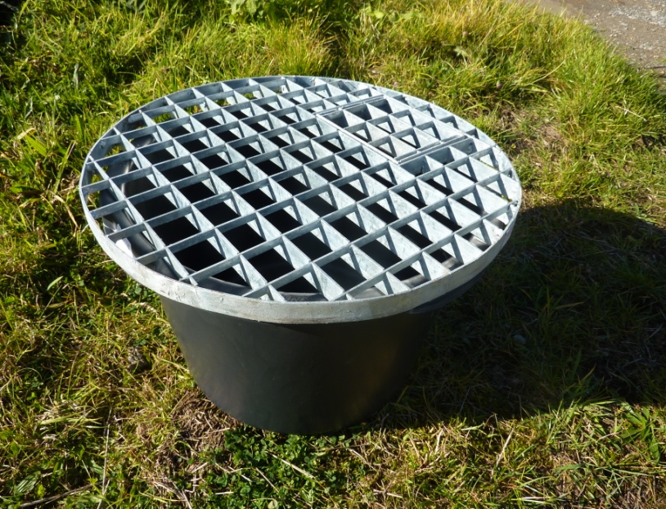 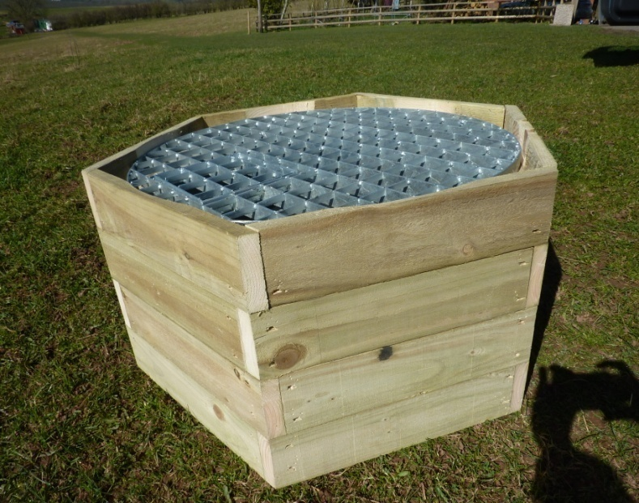

6008 SERIES OF RESERVIOR & GRIDS ( 5 DIFFERENT SIZES) 6002 EC HAXI SHAPE PATION BOX ( 3 DIFFERENT SIZES)

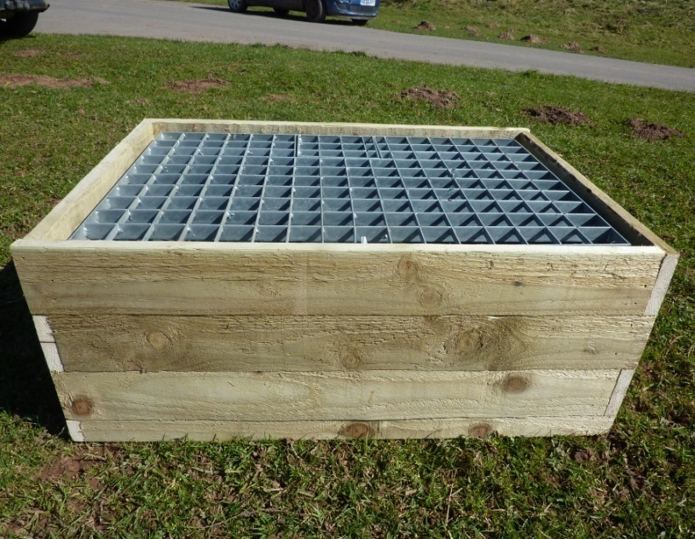 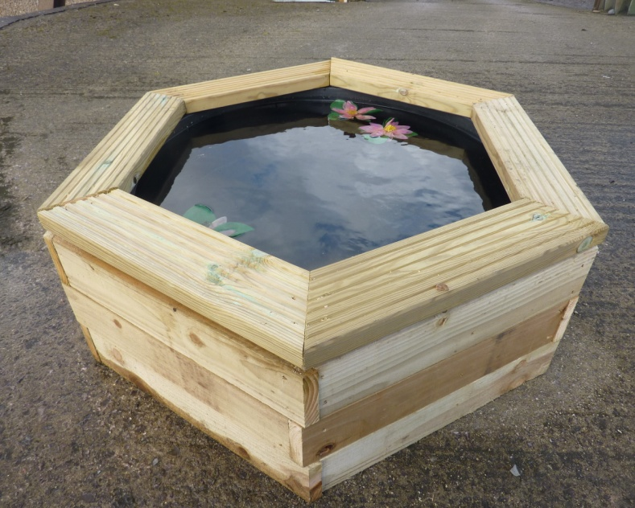

6008-TR GRID SIZE 81X51CM/ 6002 RECTANGLE BOX 6002 PATIO POND WITH BUCKET ( LARGE & MEDIUM)

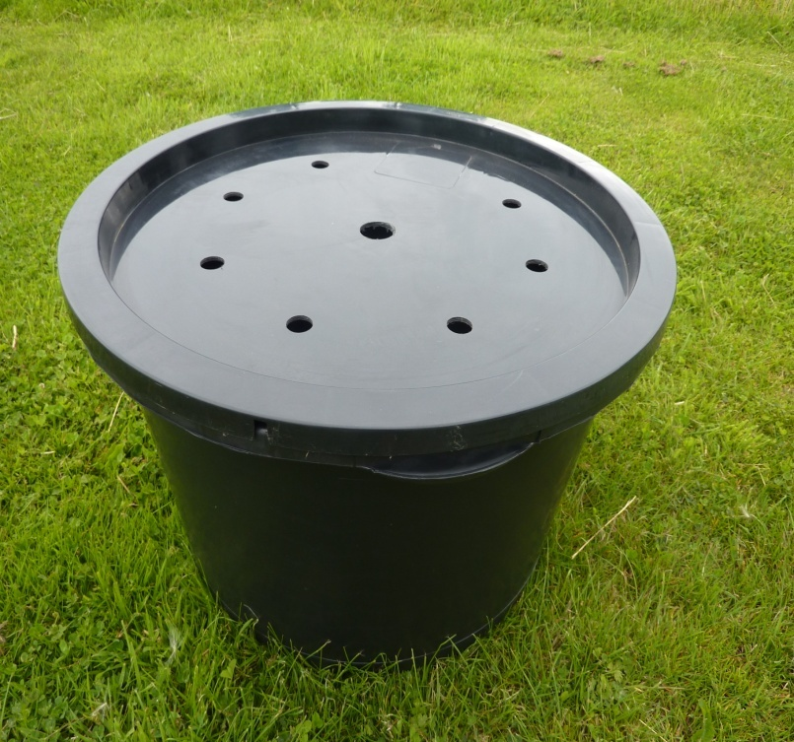 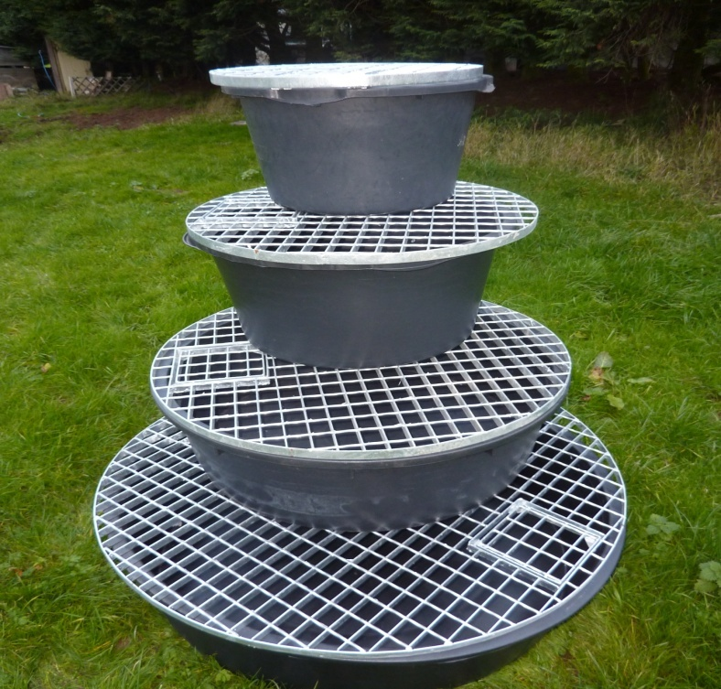

6003 RESERVIOR &TOUGHENED PLASTIC LID DIA67CM X34CM H 6008 RESERVIOR AND GRIDS

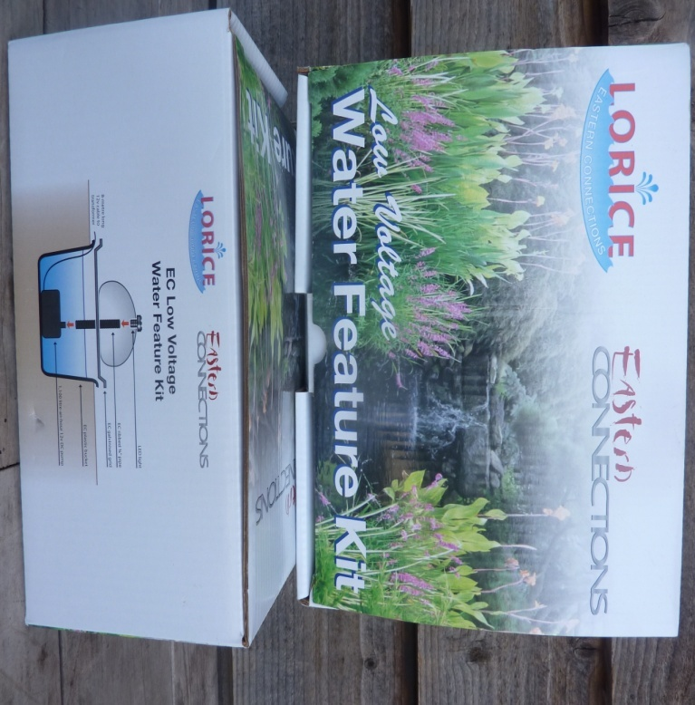 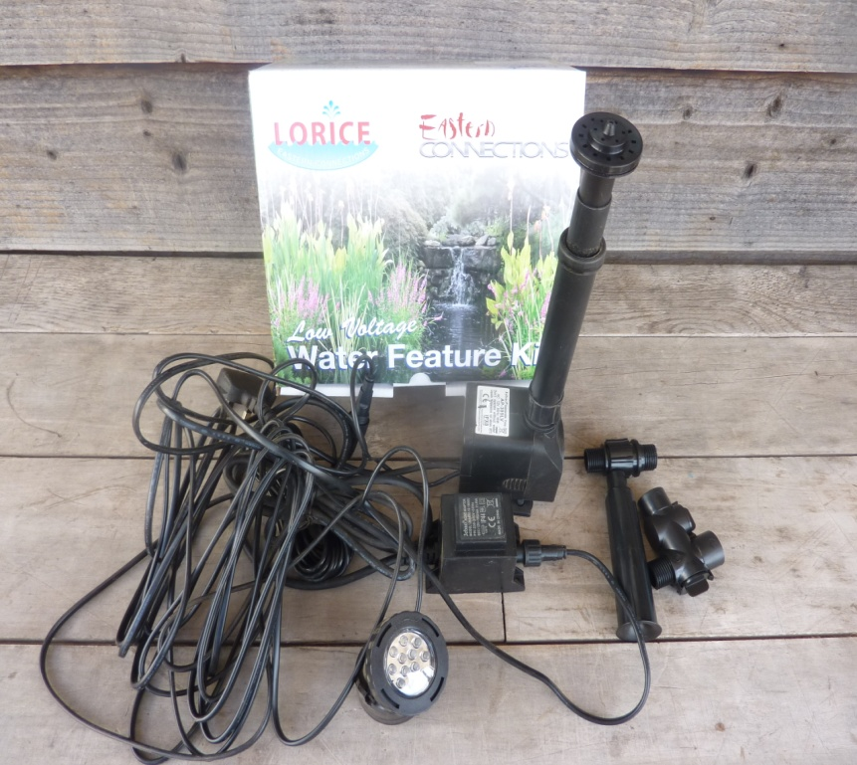

6008ECO LOW VOLTAGE WATER FEATURE KIT 1000L/H 6008 FOUNTAIN KIT, LOW VOLTAGE, 1000l/h,W/ NOZZLE SET

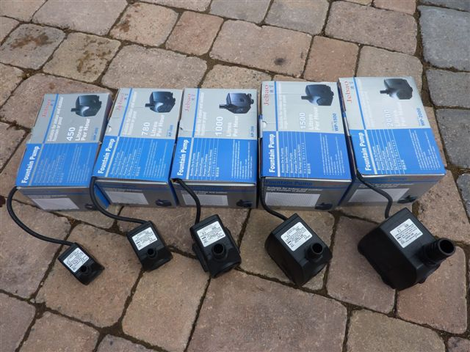 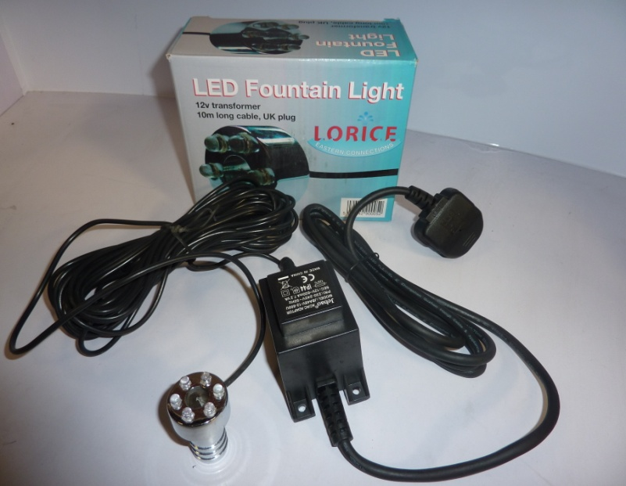

6011 SERIES OF WATER FEATURE PUMPS ( 450L~3000L/H) 6014 & 6105 FEATURE LED LIGHT, COPPER CASE

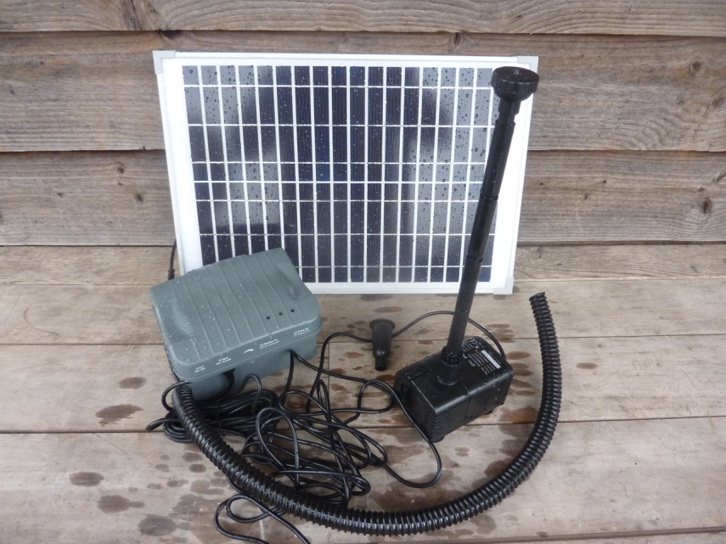 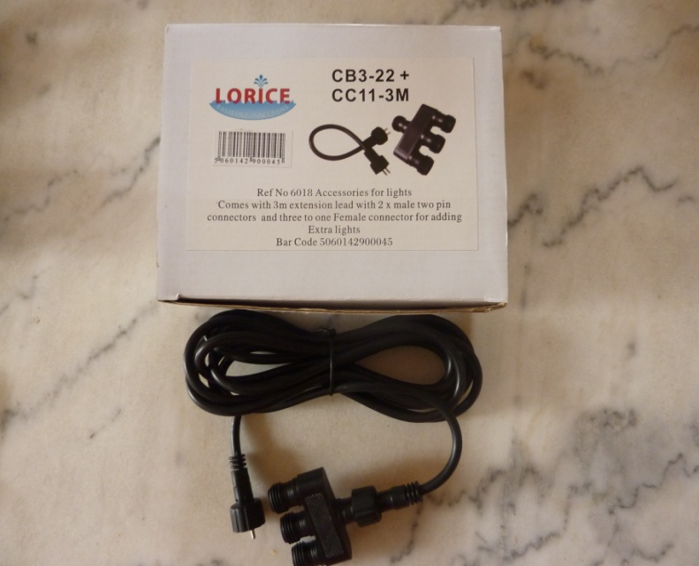

6112 EC SOLAR PUMP ,W/BATTERY, 980~1560L/H 6018 EC 1 TO 3 COCNNECTOR+ 3M L CONNECTING CABLE

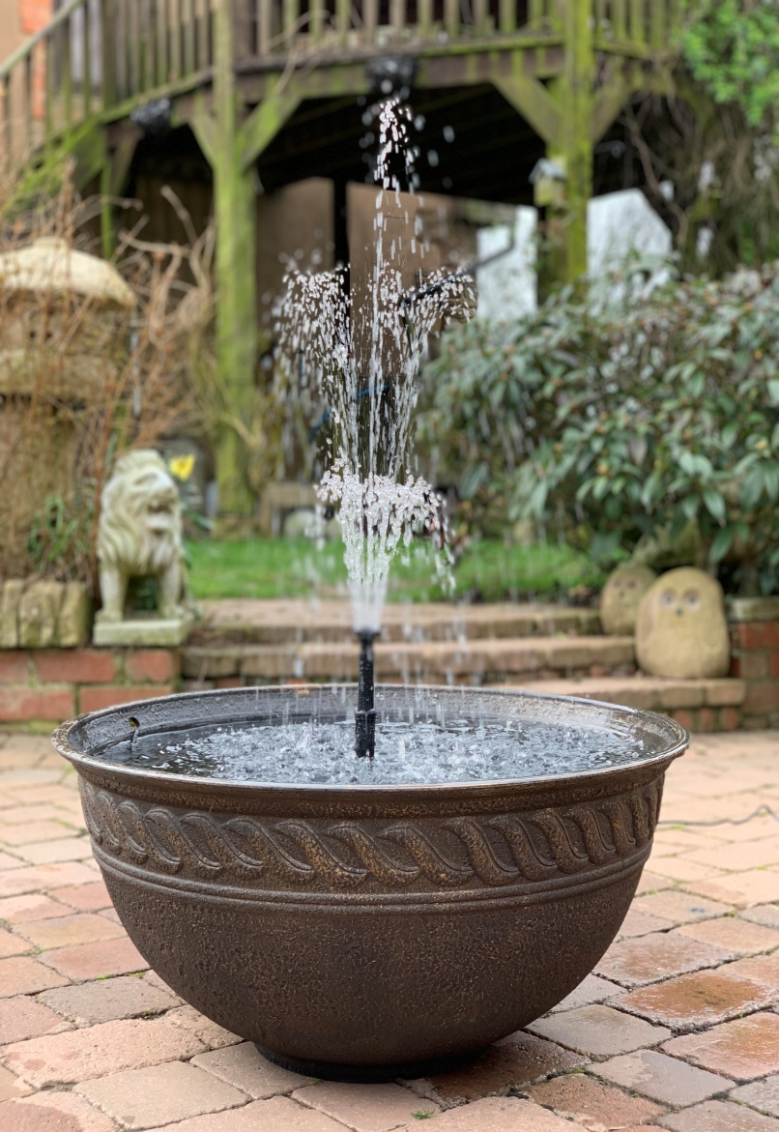 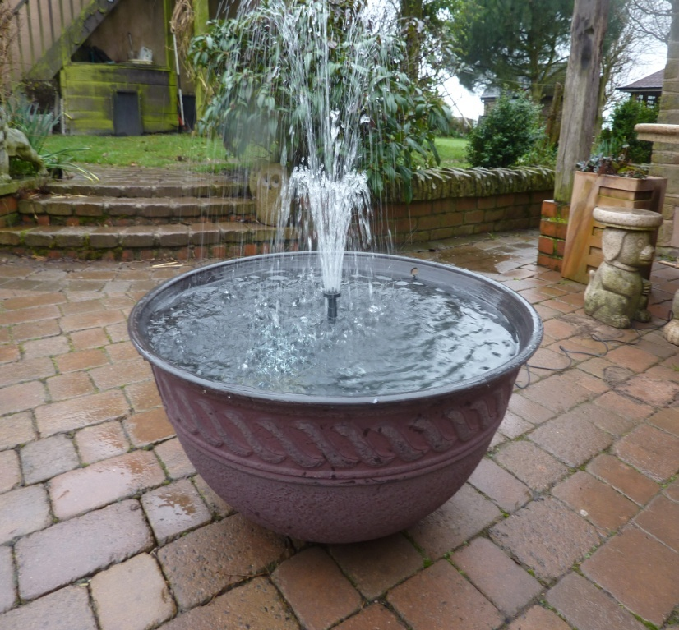

6305 LOTUS BOWL FOUNTAIN, PLASTONE, DIA 80CM X37CM H, BRONZE FINISH OR DARK RED FINISH, WITH FOUNTAIN KIT

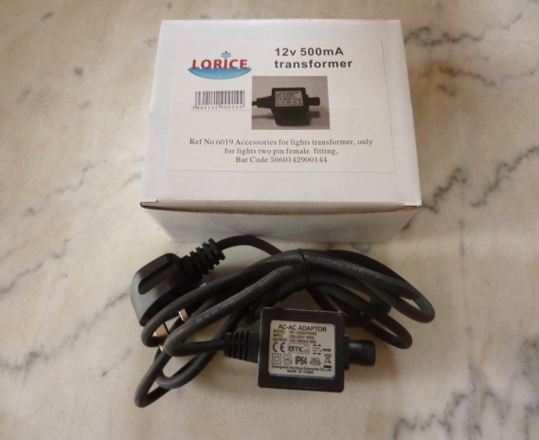 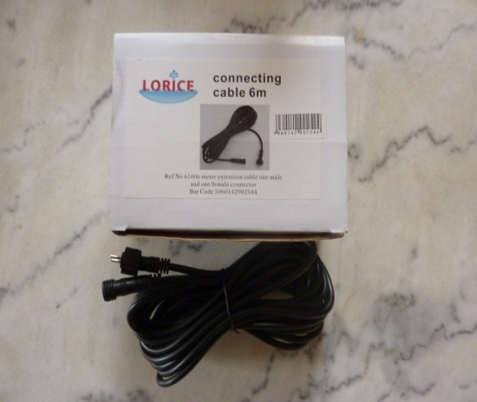

6019 EC IN LINE TRANSFORMER FOR LED LIGHT 6110 6M EXTENSION CABLE

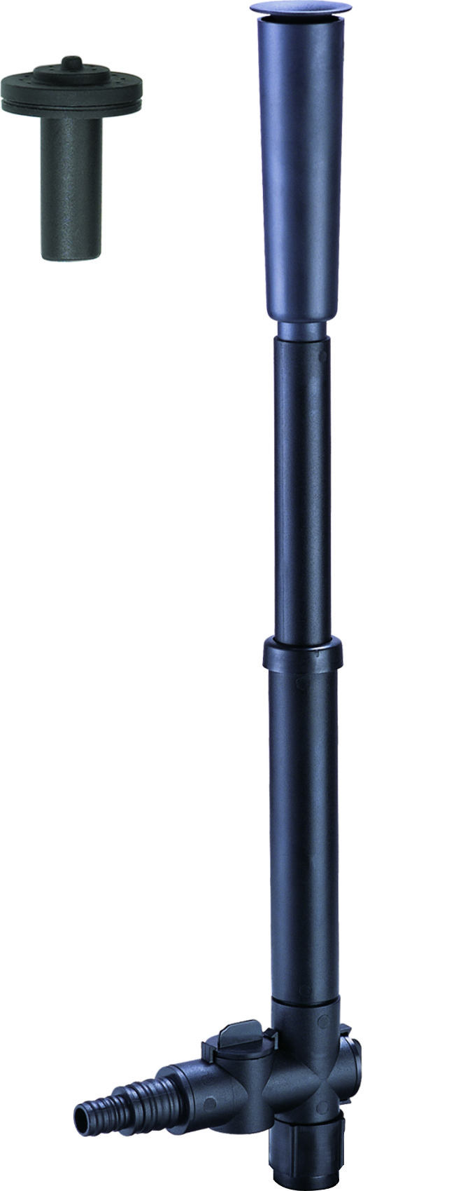 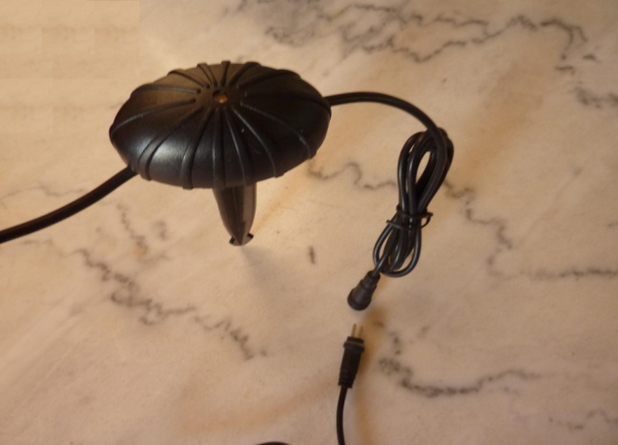 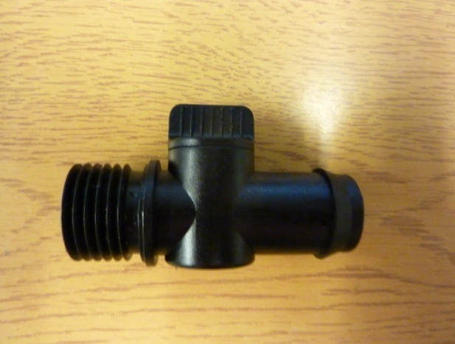

6113 FT-03 NOZZLE SET 6115 DUST TO DAWN SENSOR 6117 3/4" TO 3/4" FLOW AJUSTER

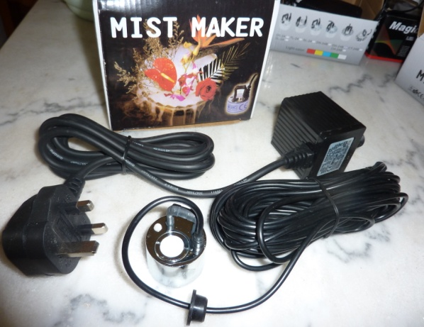 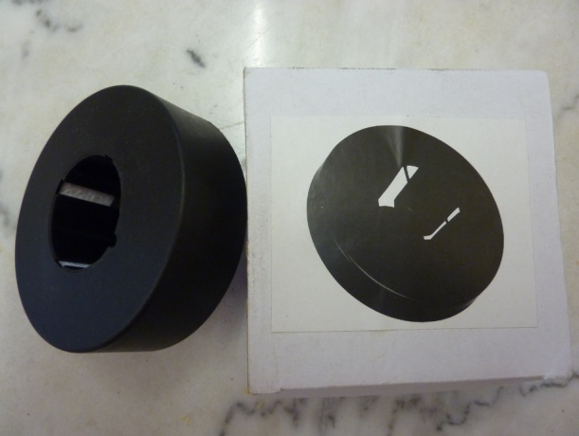 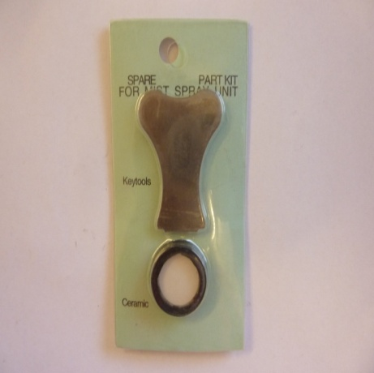

6301 outdoor mini mist maker 6310 mini mist maker float 6312 spare single disc replacement

6201 REPLACEMENT PUMP for 6008ECO 6119 replacement led (copper case) 6119P REPLACEMENT LED Light

Light head dia30mm, 6 leds , -2M CABLE- Light head dia30mm, 6 leds

6016 30VA TRANSFORMER FOR LV PUMP 1100L/H 6015 21.6VATRANSFORMER FOR LV PUMP 800~1000L/H **6109SP head**

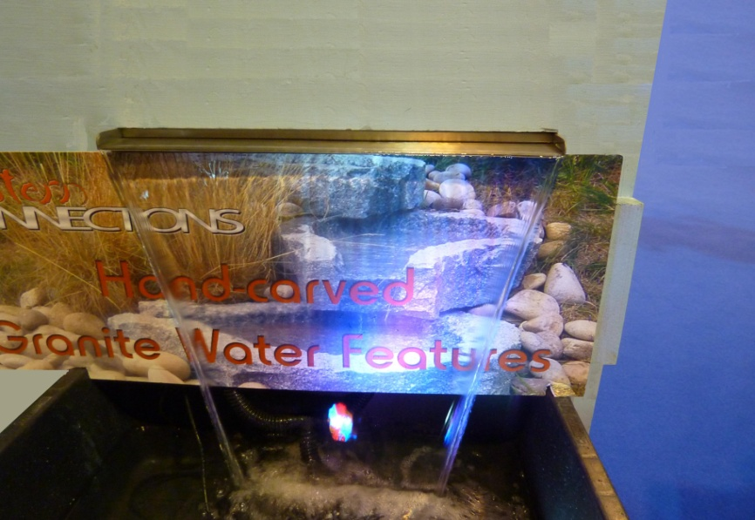 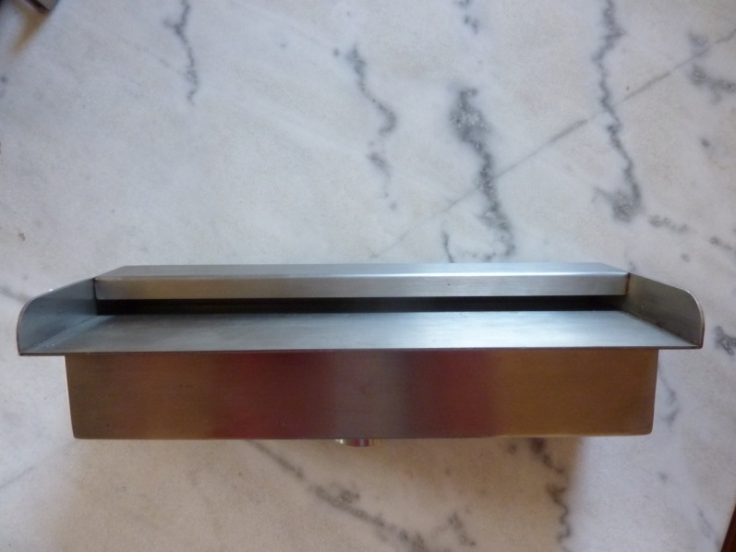

6313~6315, 6320 EC STAINLESS STEEL WATER BLADE, 30CML /45CM L/60CML/90CM L**, DUAL ENTRY**

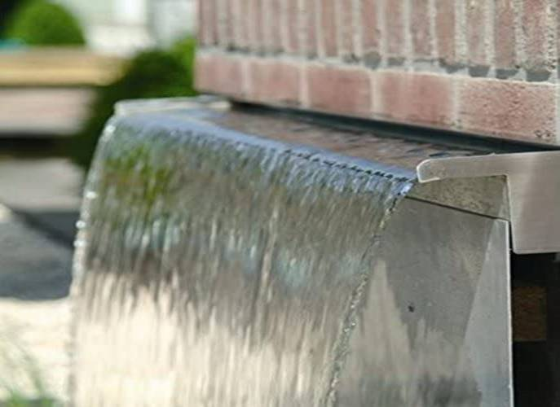

6316~6319 EC stainless steel water **blade 15CM long lip**, **dual entry**, 30cm~90cm 6320 EC **mount on the wall** 45cm blade

**6108 natural granite rock light 36leds auto colour changing 6008eco-s 12V 800L/H pump with led light**

