GARDEN SCREEN PANNELS, LASER CUT STEEL , POWDER COATED
*All free standing garden screens are individually packed in its own carton box, with picture and barcode, our product code and sizes, ready for check out point.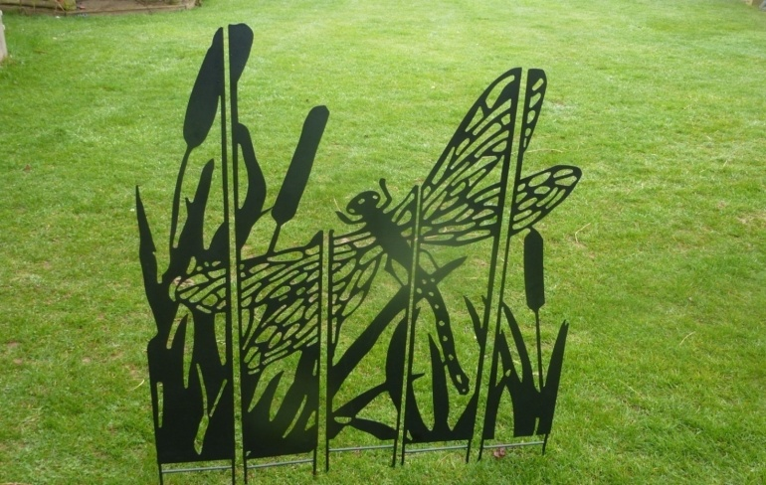 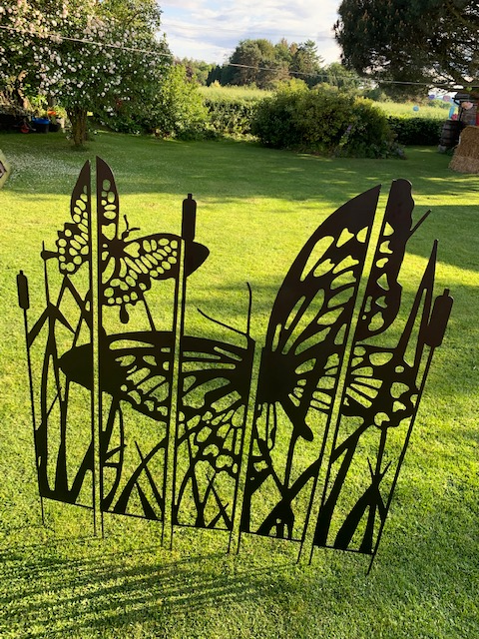
1031 Dragon flying screen, 125x135cm H, plus 20cm spike, in black or copper brown FINISH, £65.00/pc
1032 Butterfly garden screen, 125cm x135cm H, plus 20cm spike, in black or copper brown, £69.00/pc
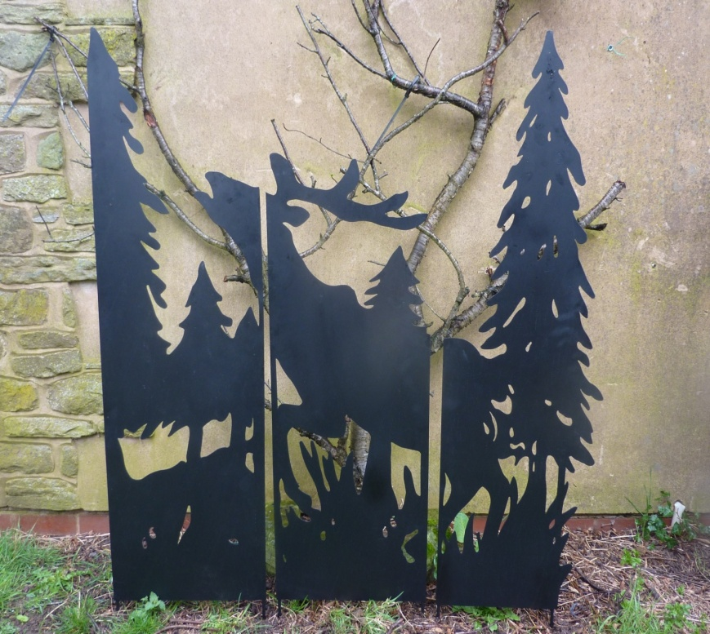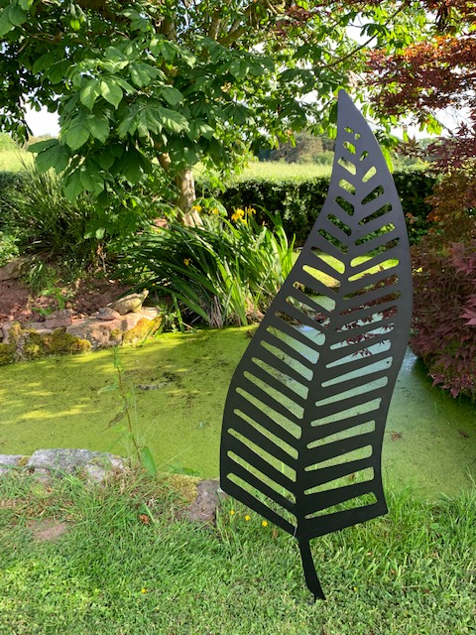
1030 stag in woods, 120cm W x120cm H, 3 PANNELS, plus 20 cm spike in black finish only. £49.00/pc
1056 single leave stake, 40x120cmH, black, 1mm thick steel. black finish only. £17.00/pc, 4pcs/ctn
*All free standing garden screens are made from laser cut appx. 0.8mm~1mm steel panels with 5mm strengthening rod, finished with black or copper brown powder coating. *Exclusively designed and supplied by Eastern Connections, copy right reserved.
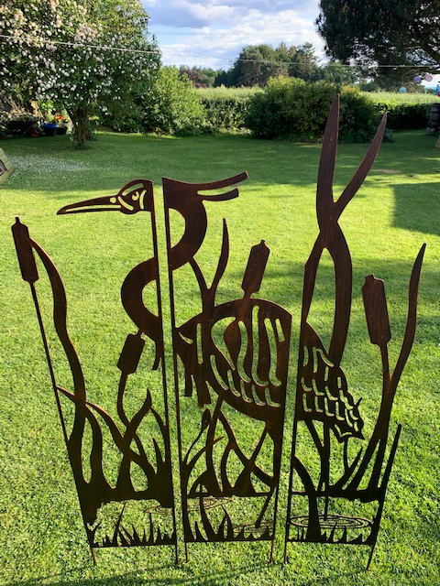
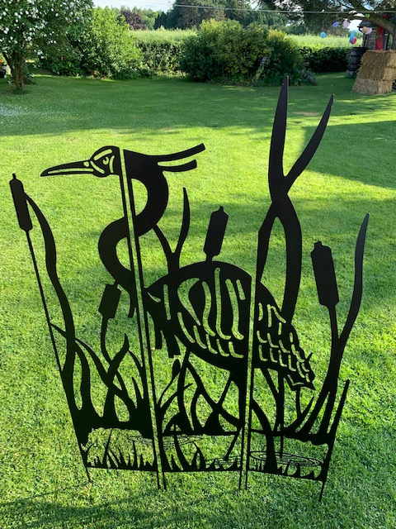
1034 Heron, 100CM W X135CM H PLUS 20CM SPIKE, 3 PANNELS, Black or Brown, £49.00/PC
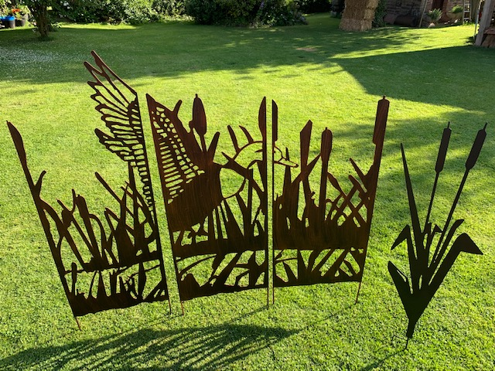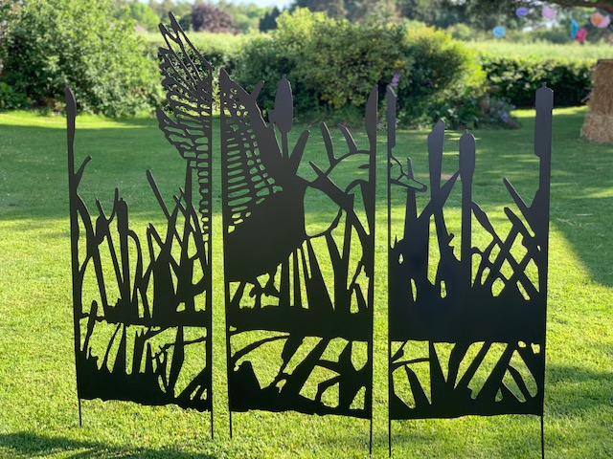
1033 Flying mallard screen , 150cm x 135cm H,+ 20cm spike, in black or copper brown finish. £69.00/PC
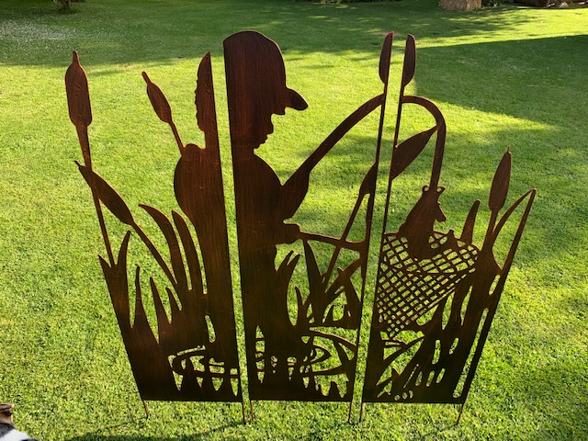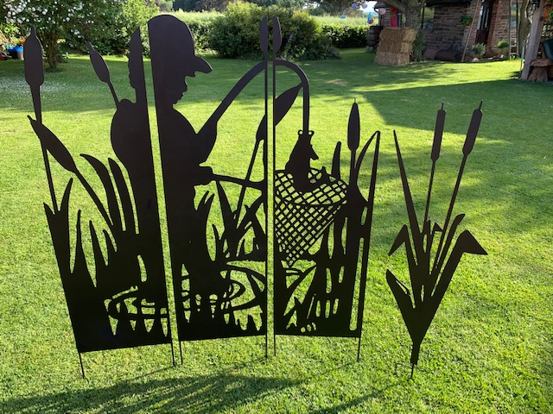
1035 Garden fishing boy screen,135x135cm H, + spike 20cm, in black or copper brown finish,£65.00/pc
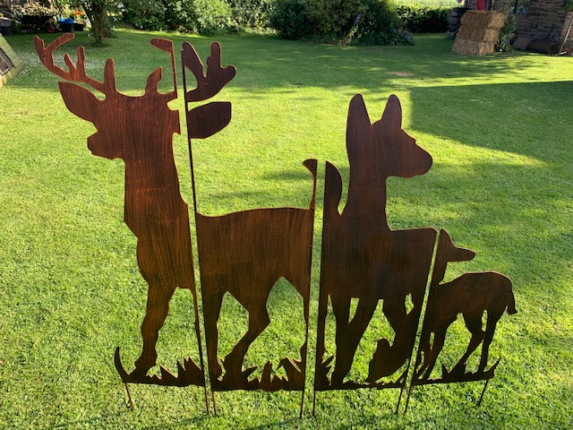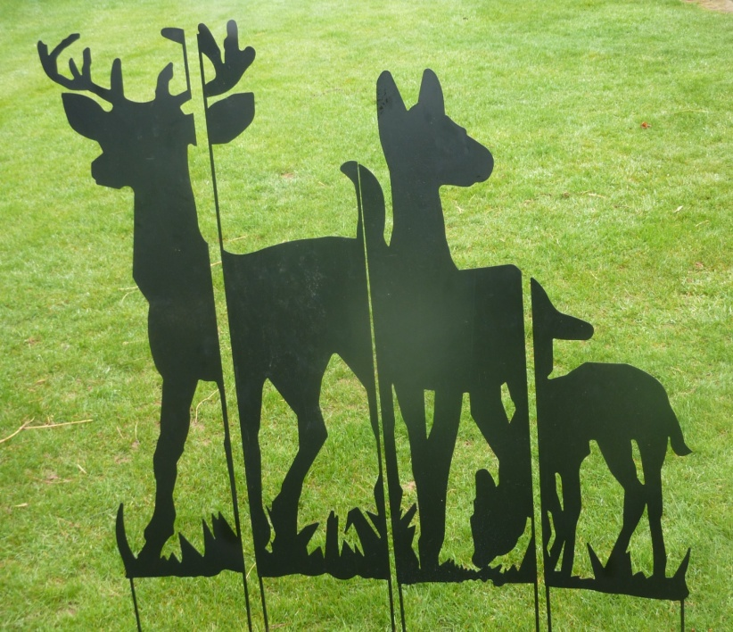
1036 Deer family,135cm x135cm H,+20cm spike, black or copper brown, £65.00/pc
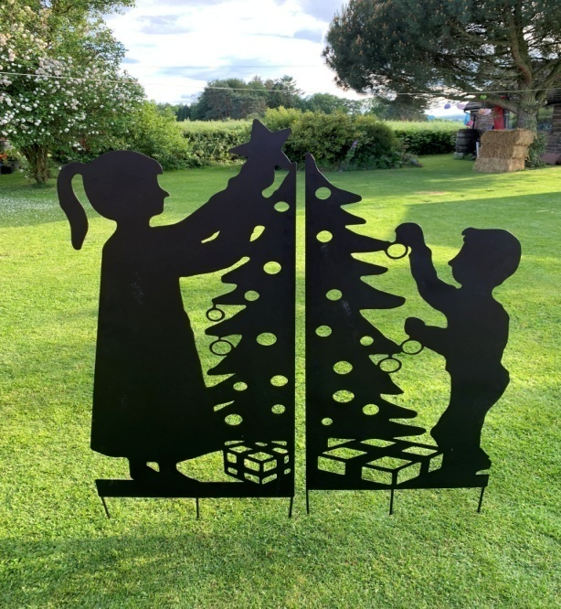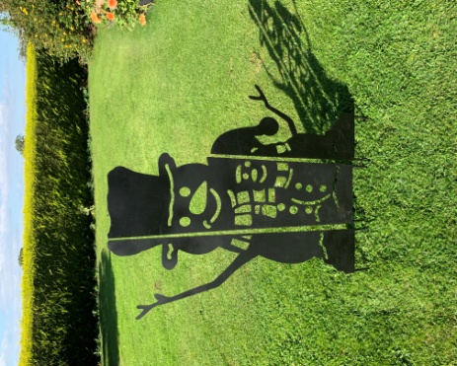
1038 boy & Girl Christmas tree panel, 120x135cm H,+ spike £49.00/pc 1037 SNOW MAN SCREEN 90CMx135CM H,+ SPIKE, BLACK,£39.00/pc
1038S boy & Girl Christmas tree panel ,80x90cmH,+spike, £29.00/pc 1037S SNOW MAN SCREEN 66CMx 90CM H,+SPIKE, BLACK, £24.00/pc
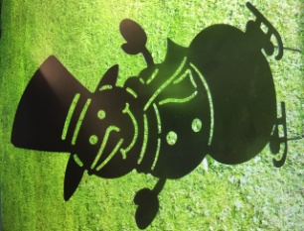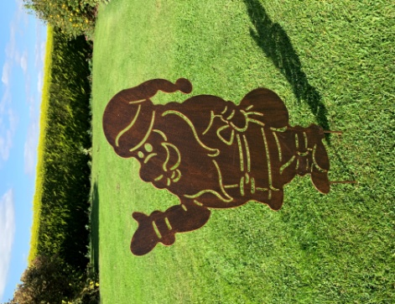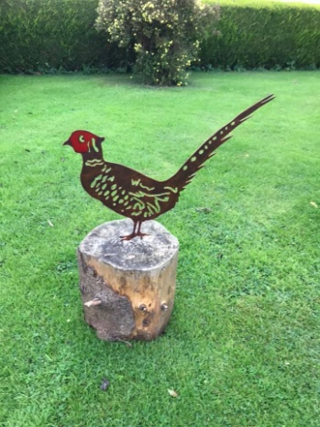
1039 snowman 33.5x63cmH, black 1040 father Christmas 36x68cmH, brown 1052 Pheasant 54X1X38.5CM H
£8.50/pc , 4pcs/ctn £11.00/pc , 4pcs/ctn £9.50/pc,m 4pcs/ctn
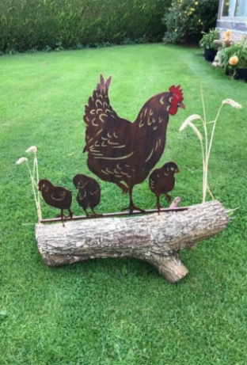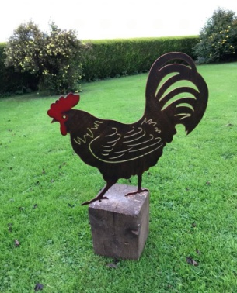
1042 Hen&chick 58x64cm H, cooper brown , £15.00/pc 1041 Cockerel 49.5x62cm H, cooper brown, £9.50/pc
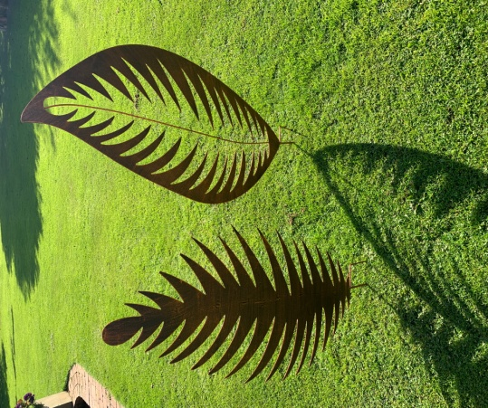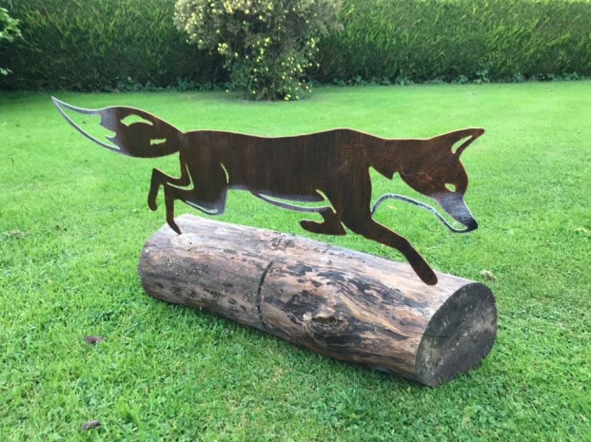
1055 set of leaves,118cm H/137cm H £45.00/set brown 1043 running fox,95x41cmH,+spike,brown, £15.00/pc,4pcs/ctn
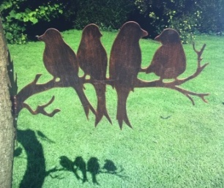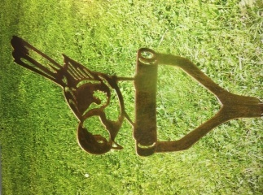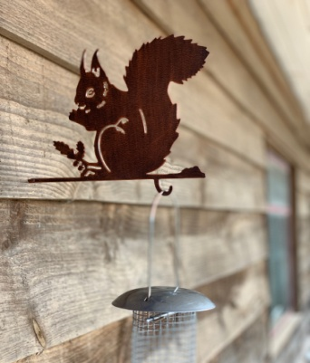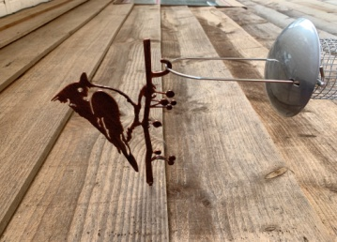
1053 bird group stake,50x10x33cmH 1054 bird on spade 35cmH 1057 red squirrel 15cm H 1060-crested Tit
£7.95/pc, 6pcs/ctn £2.45/pc, 8pcs/ctn £3.85/pc, 8pcs/ctn £2.85/pc, 8pcs/ctn
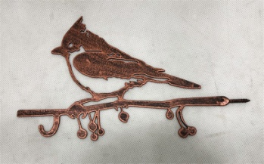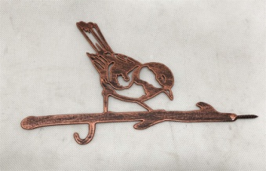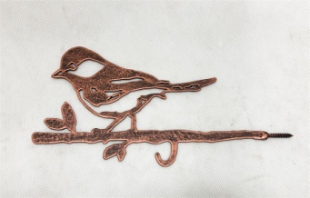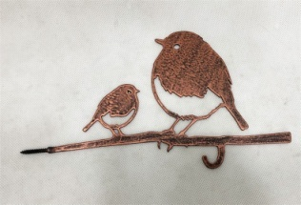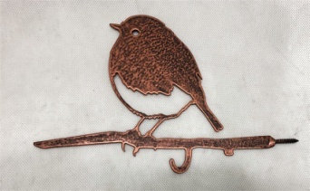
1060- Creasted tit / blue tit/ great tit/ robbin &baby/ single robin / black bird/ wren/ woodpecker/wag tail
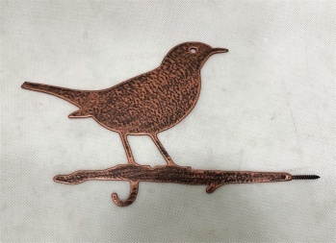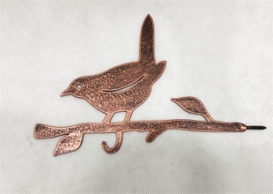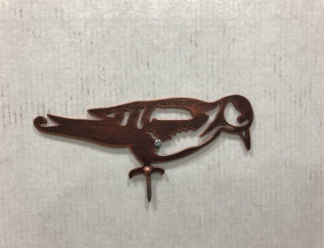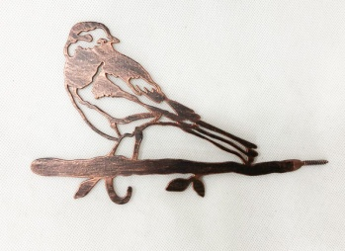2mm thick steel
*Our birds have a hook designed for your bird feeder or a garden tree lamp, maybe a wind chime! 8pcs/ctn
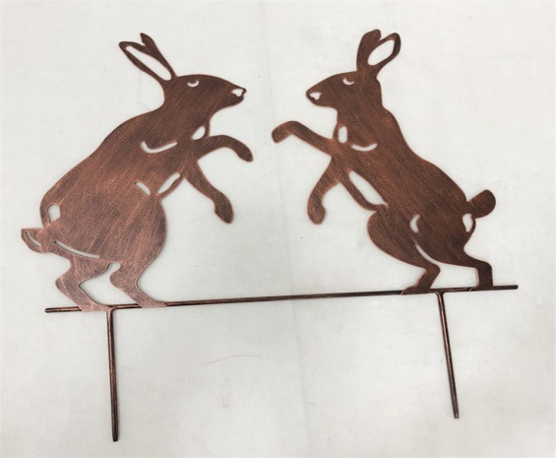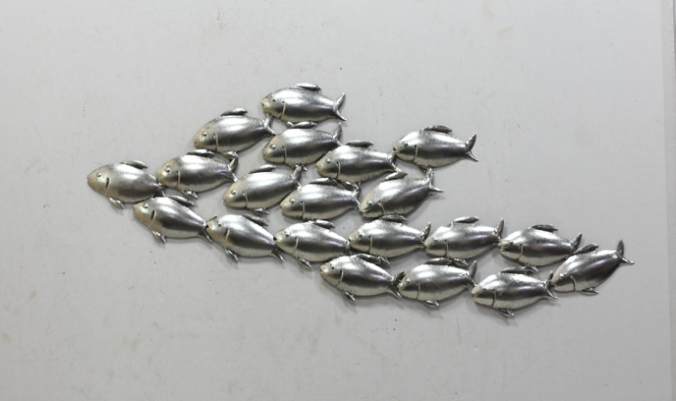
1058 HARES 40CM H +SPIKE, 1mm steel, brown,n 1074 FISH WALL ART 25FISHES 90cm L x31cm H, chrome finish
£8.50/pc,4pcs/ctn £14.95/pc ,4pcs/ctn
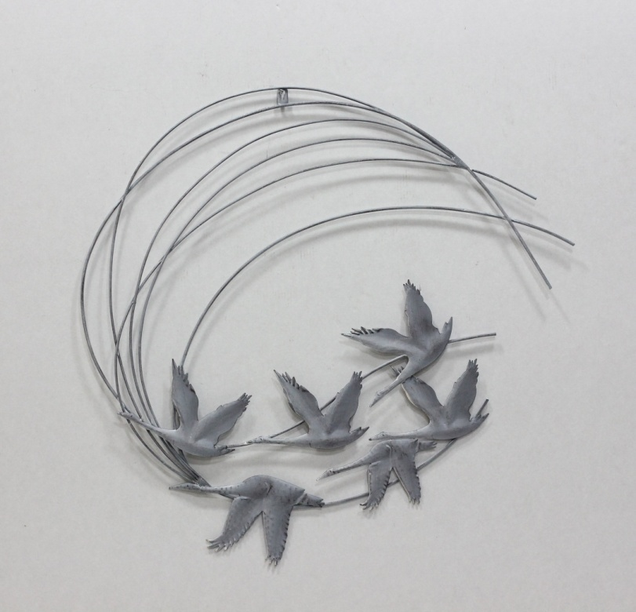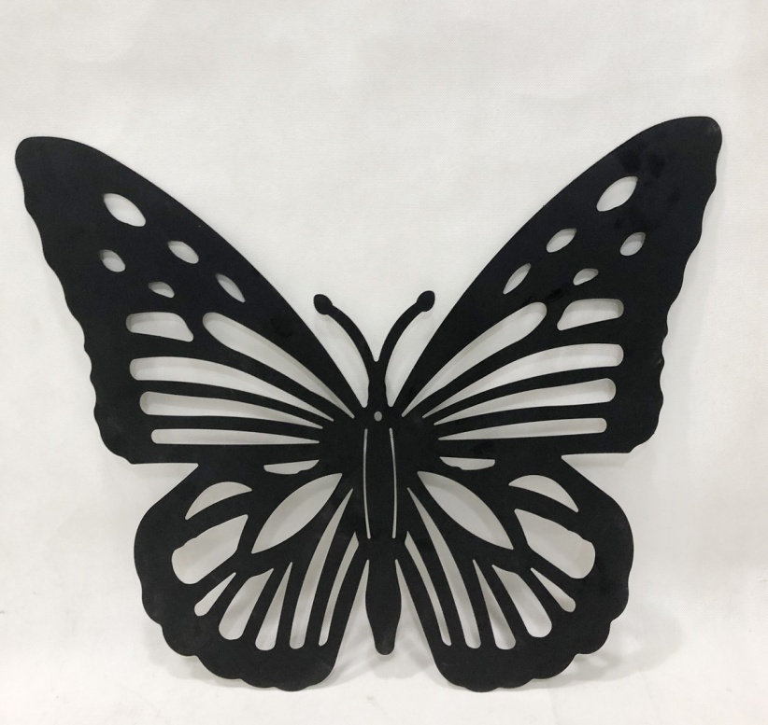
1073 FLYING GEESE 70CM , £15.59/pc, 4pcs/ctn 1076 BUTTERFLY WALL ART 60X50CM H,£9.95/pc, 4pcs/ctn
Grey powder coated finish Black powder coated finish
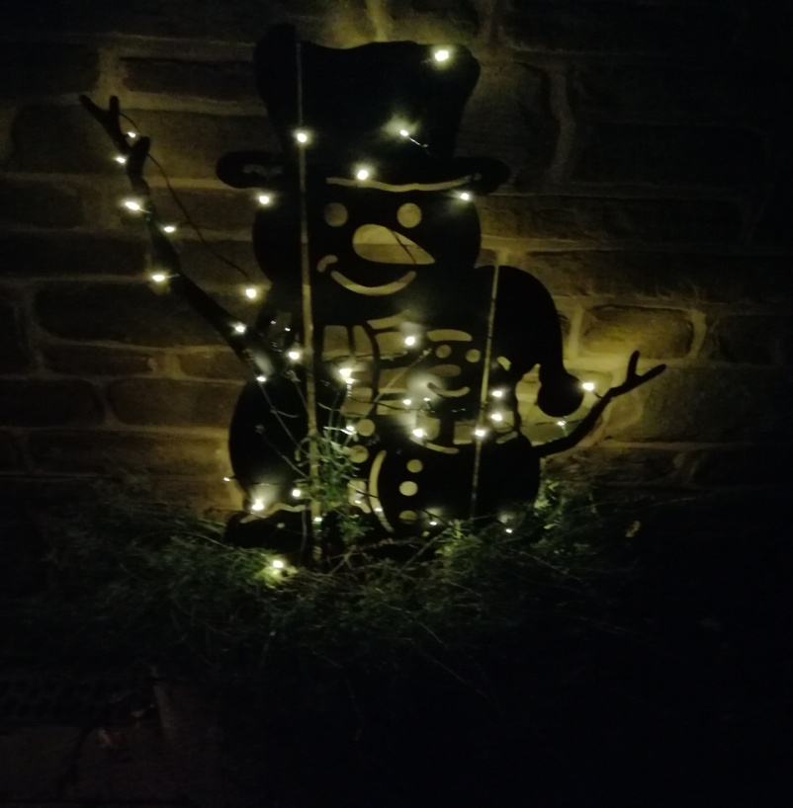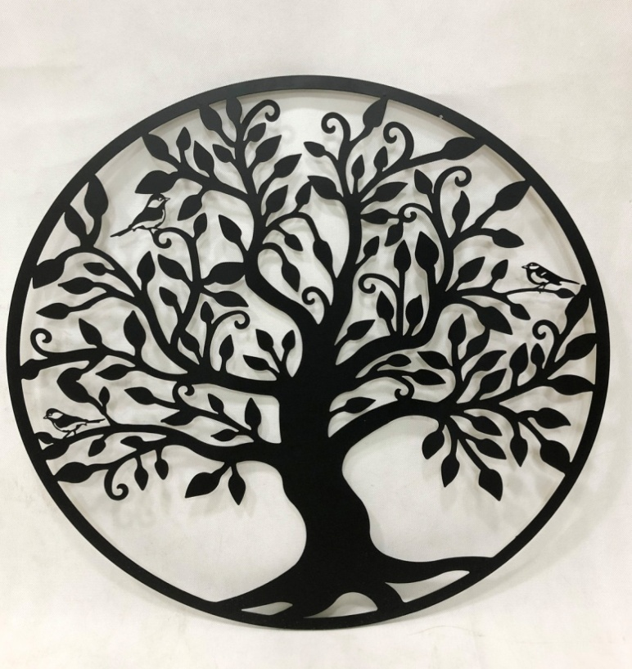
1037/ 1037S SNOWMAN LITE UP AT EVENING 1070- TREE WITH BIRD WALL ART DIA60CM, 4pcs/ctn
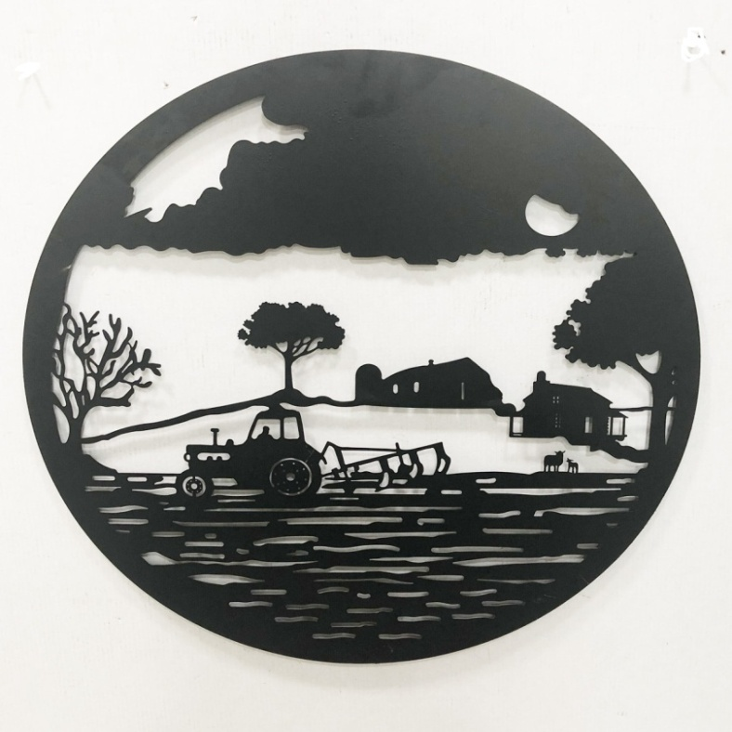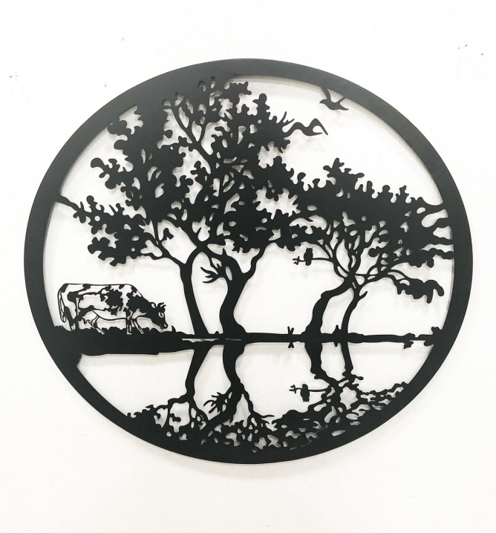
1070-TRACTOR FIELD WALL ART DIA60CM £14.95/pc for all 60cm round wall art 1070-COW IN FIELD WALL ART DIA60CM
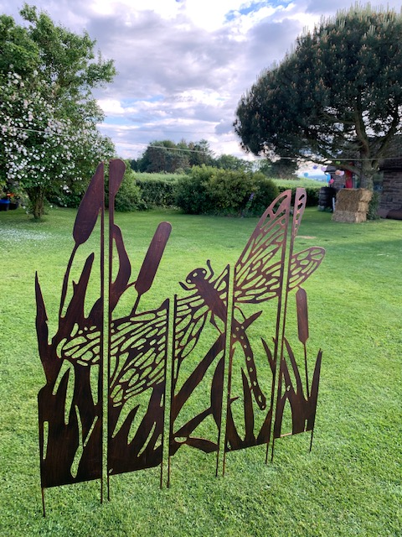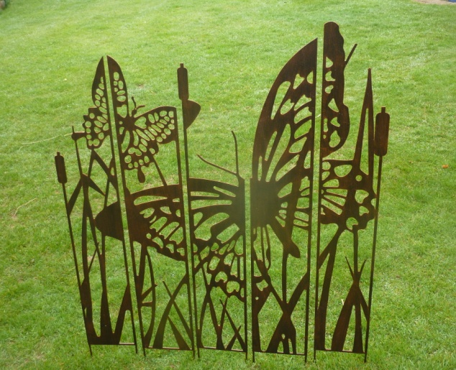
1031-COPPER BROWN COLOUR 1032-COPPER BROWN COLOUR
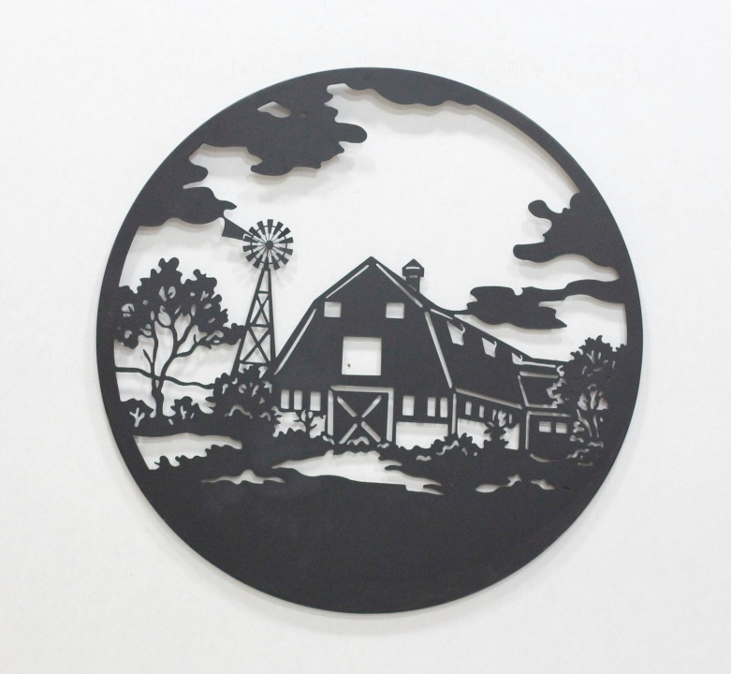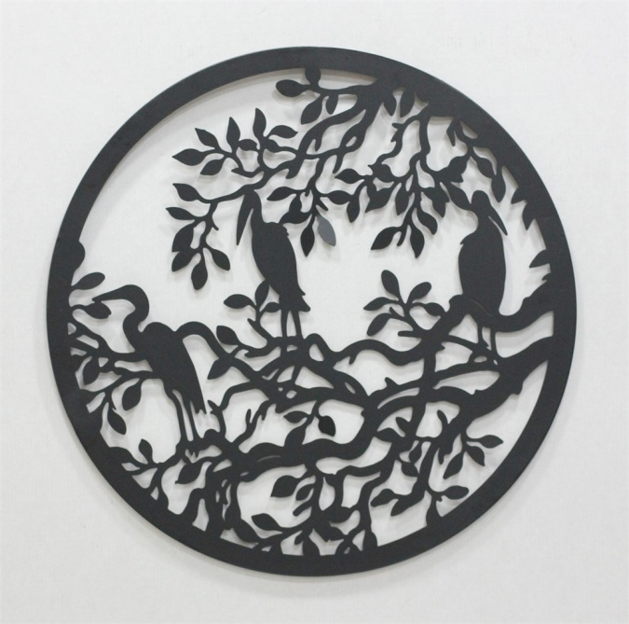
1070- DUCHBARN WALL ART DIA60CM £14.95/pc for all 60cm round wall art 1070- HERON WALL ART DIA60CM
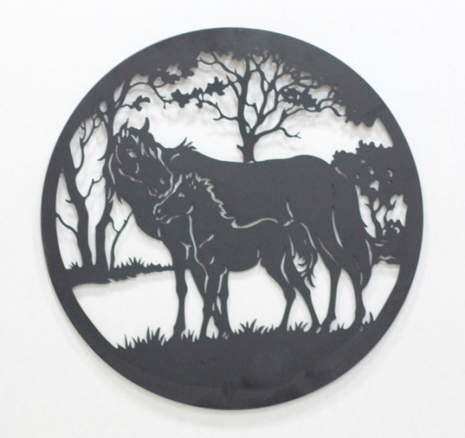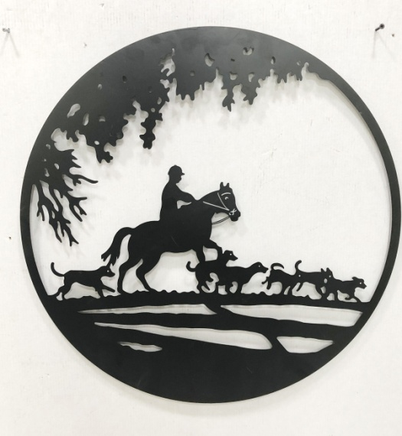
1070- horse wall art dia60cm 4pcs/ctn 1070-hunting scene dia60cm
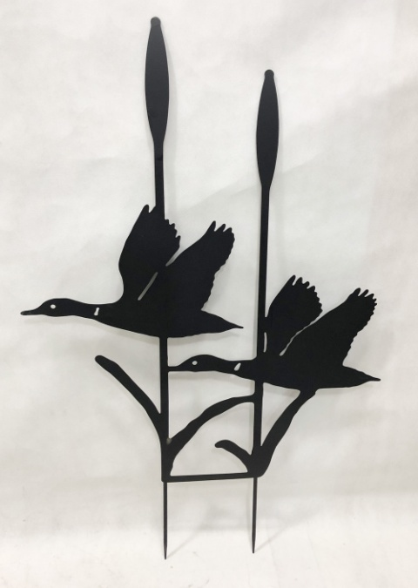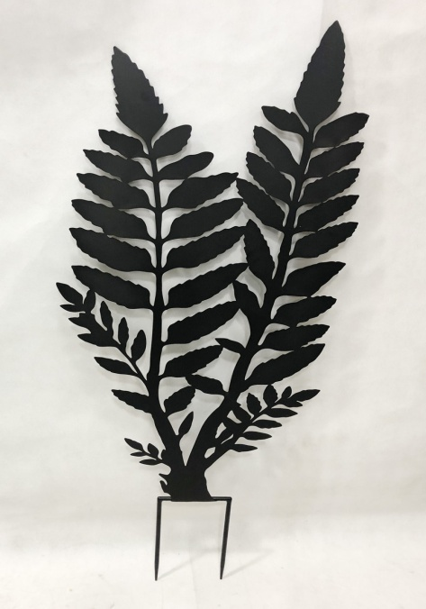
1075 FLYING DUCK GARDEN STAKE £17.95/pc 1072 FERN GARDEN STAKE £17.25/pc
also supply the trade with following products since 2002
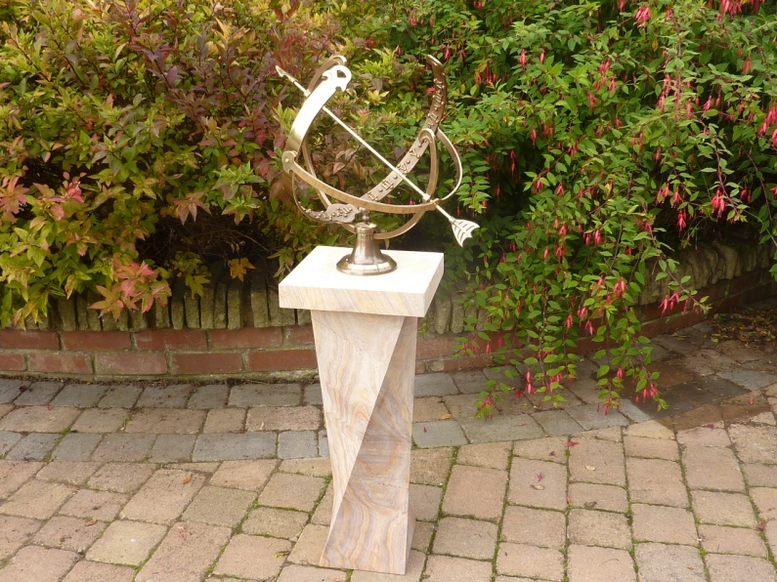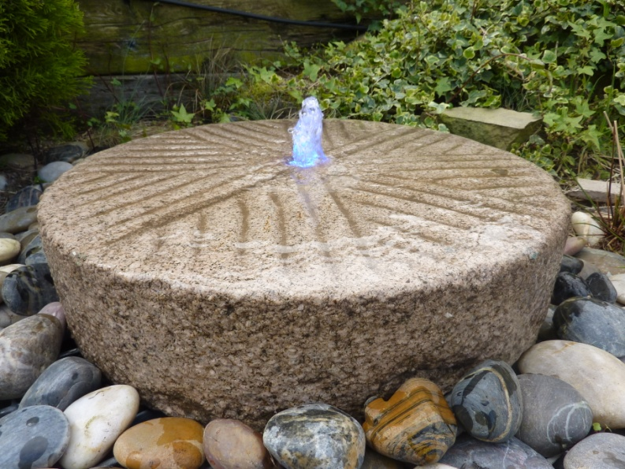
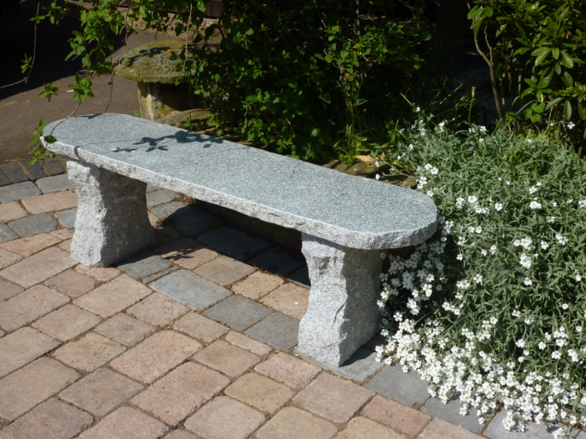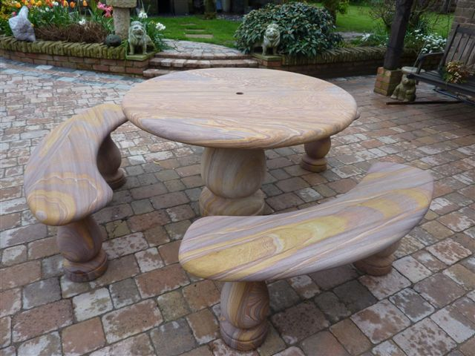
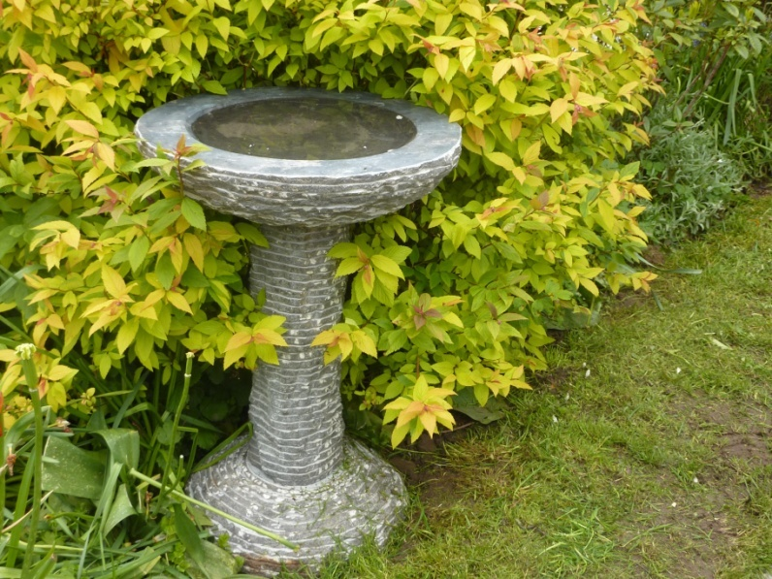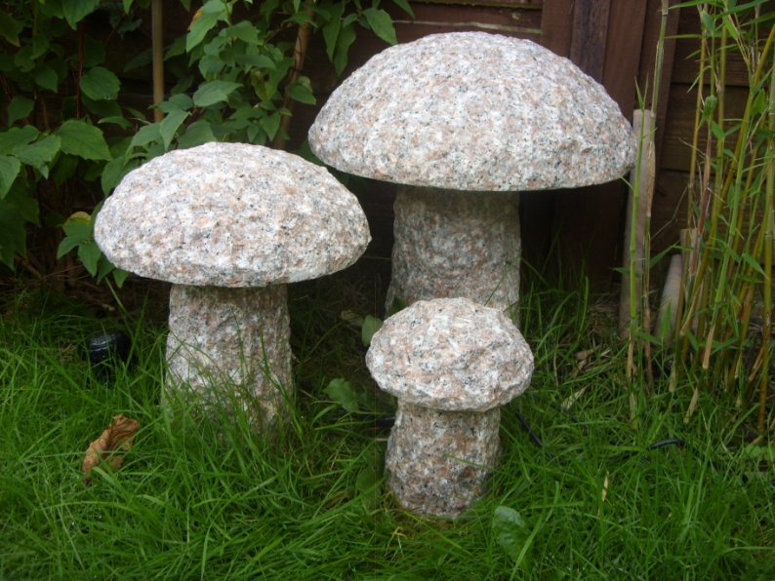
All range of natural stone garden bird baths, lanterns, benches, table sets, ornaments & lots of water features supplied from stock in Worcestershire.
Hand carved solid natural stone including granite, sandstone, limestone, basalt, onyx, marble, and slate.
Please contact us at 01886 880215 email: Ice@eastern-connections.com; Gavin@eastern-connections.com

