ESTERN CONNECTIONS WATER FEATURES
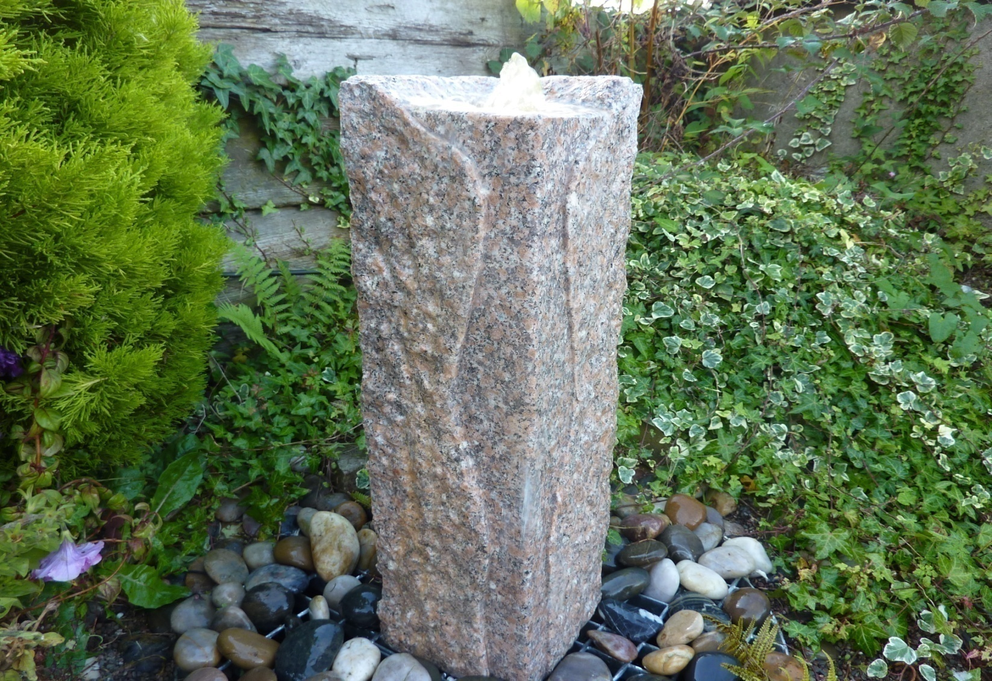 2011M JURO FOUNTAIN, RUSTIC PINKY GRANITE SIZE 25X25X90CM H
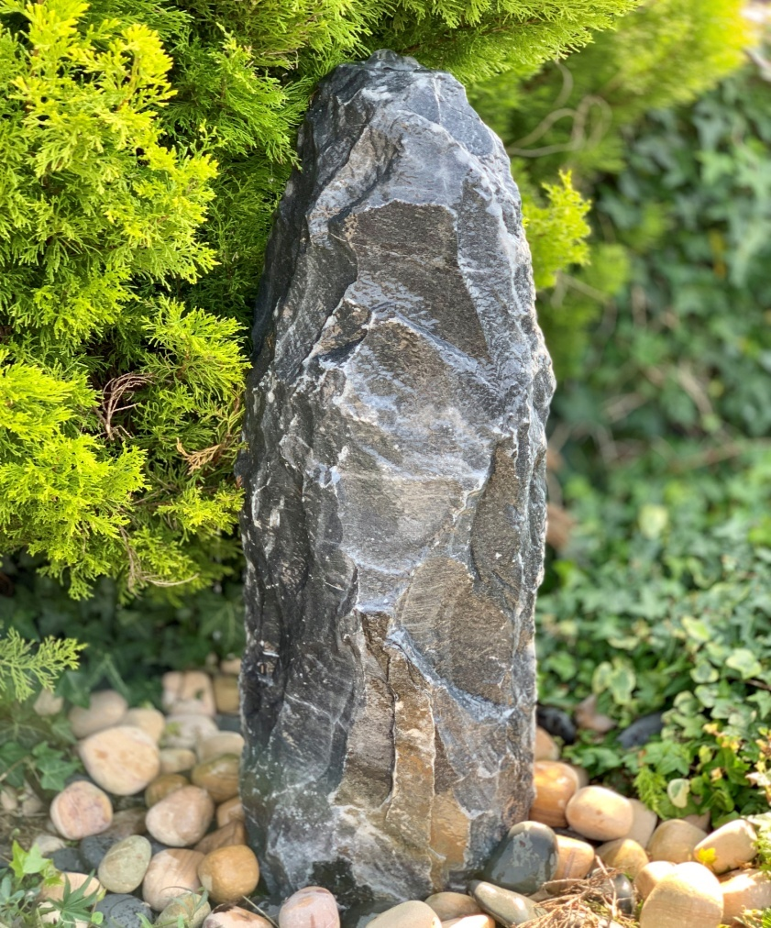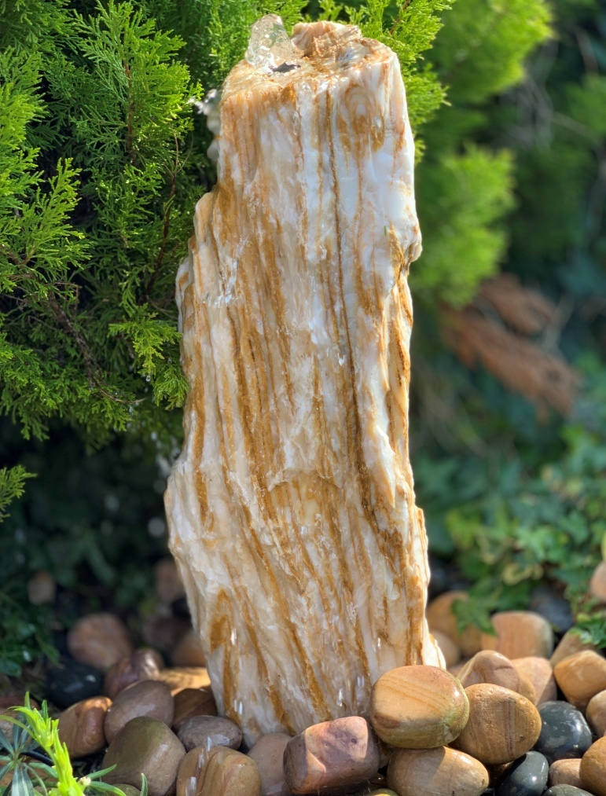
2112 BLACK ANGEL MONOLITH, 80~90CM H, 25~30CM BASE 2116 RIVERIA MONONITH 70CM H, 25~30CM BASE
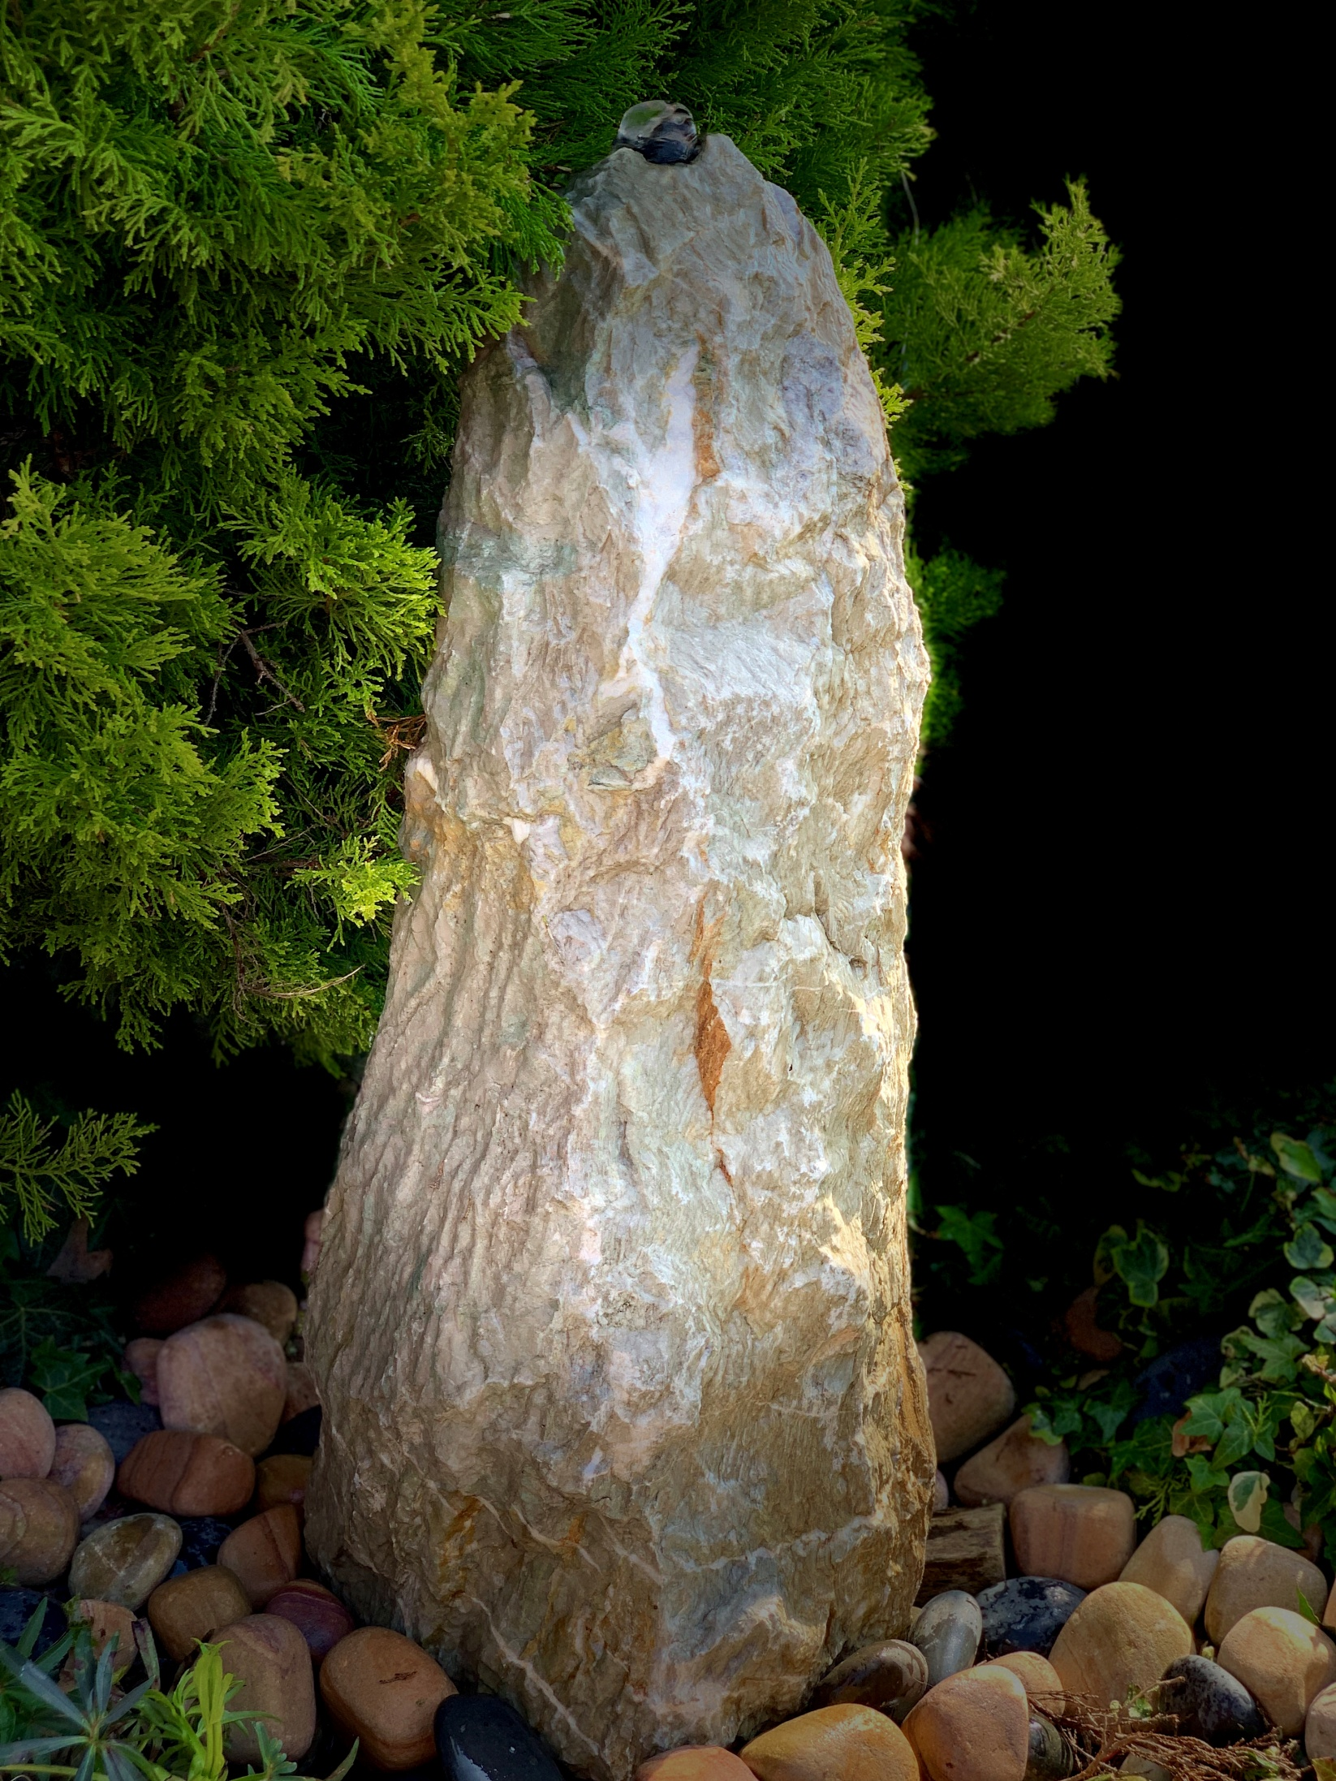
2113 GREEN PARADISE MONONITH 70CM H, 25~30CM BASE

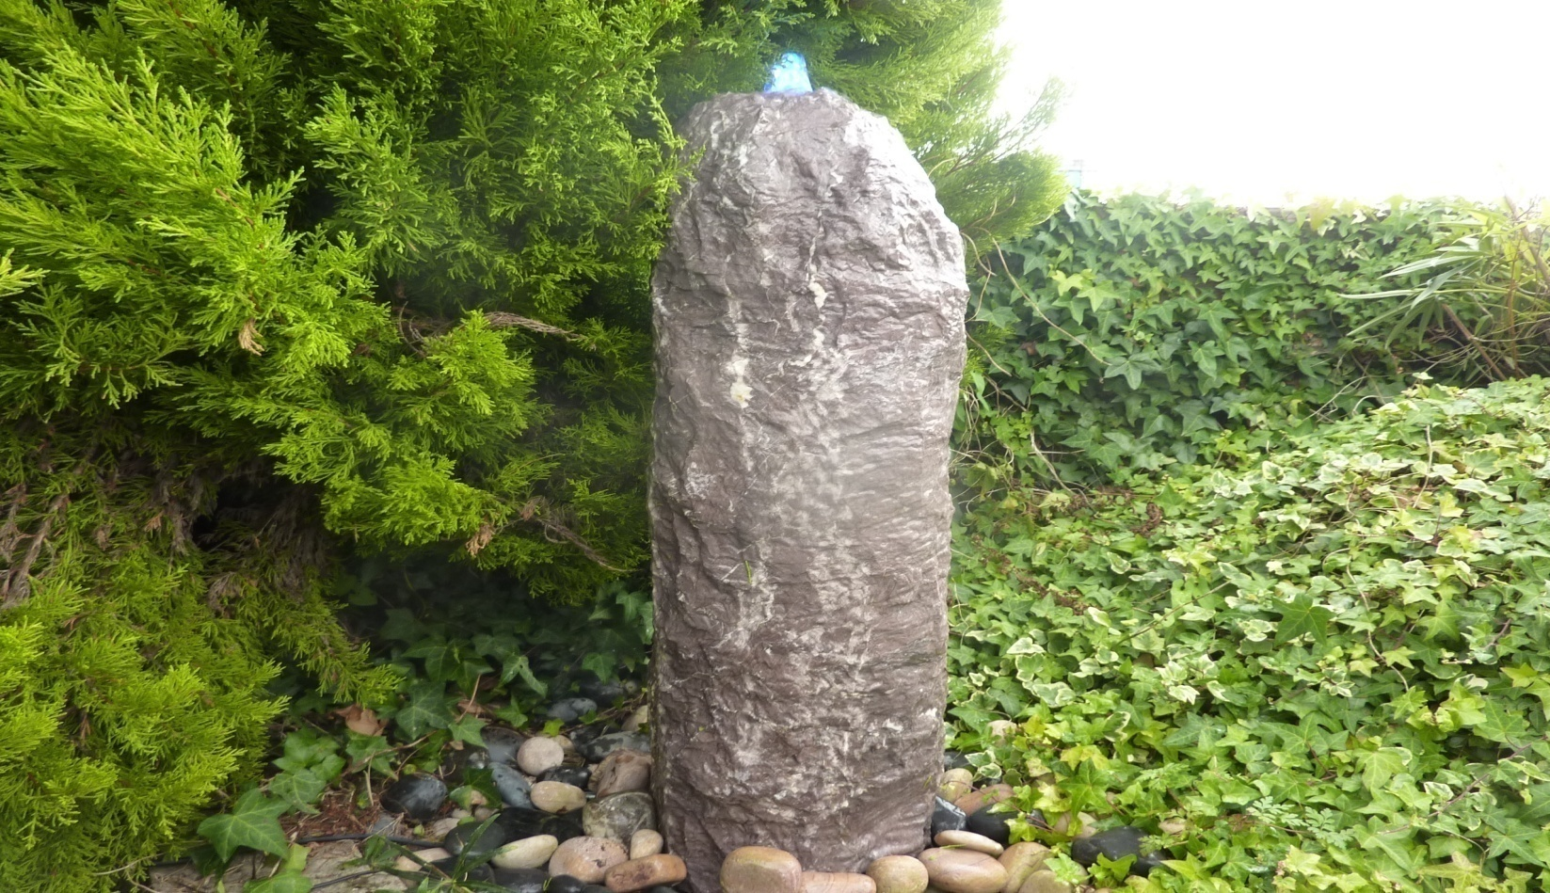
2113 PURPLE PARADISE (PLUM) MONONITH ASSORTED SIZES AND COLOURS
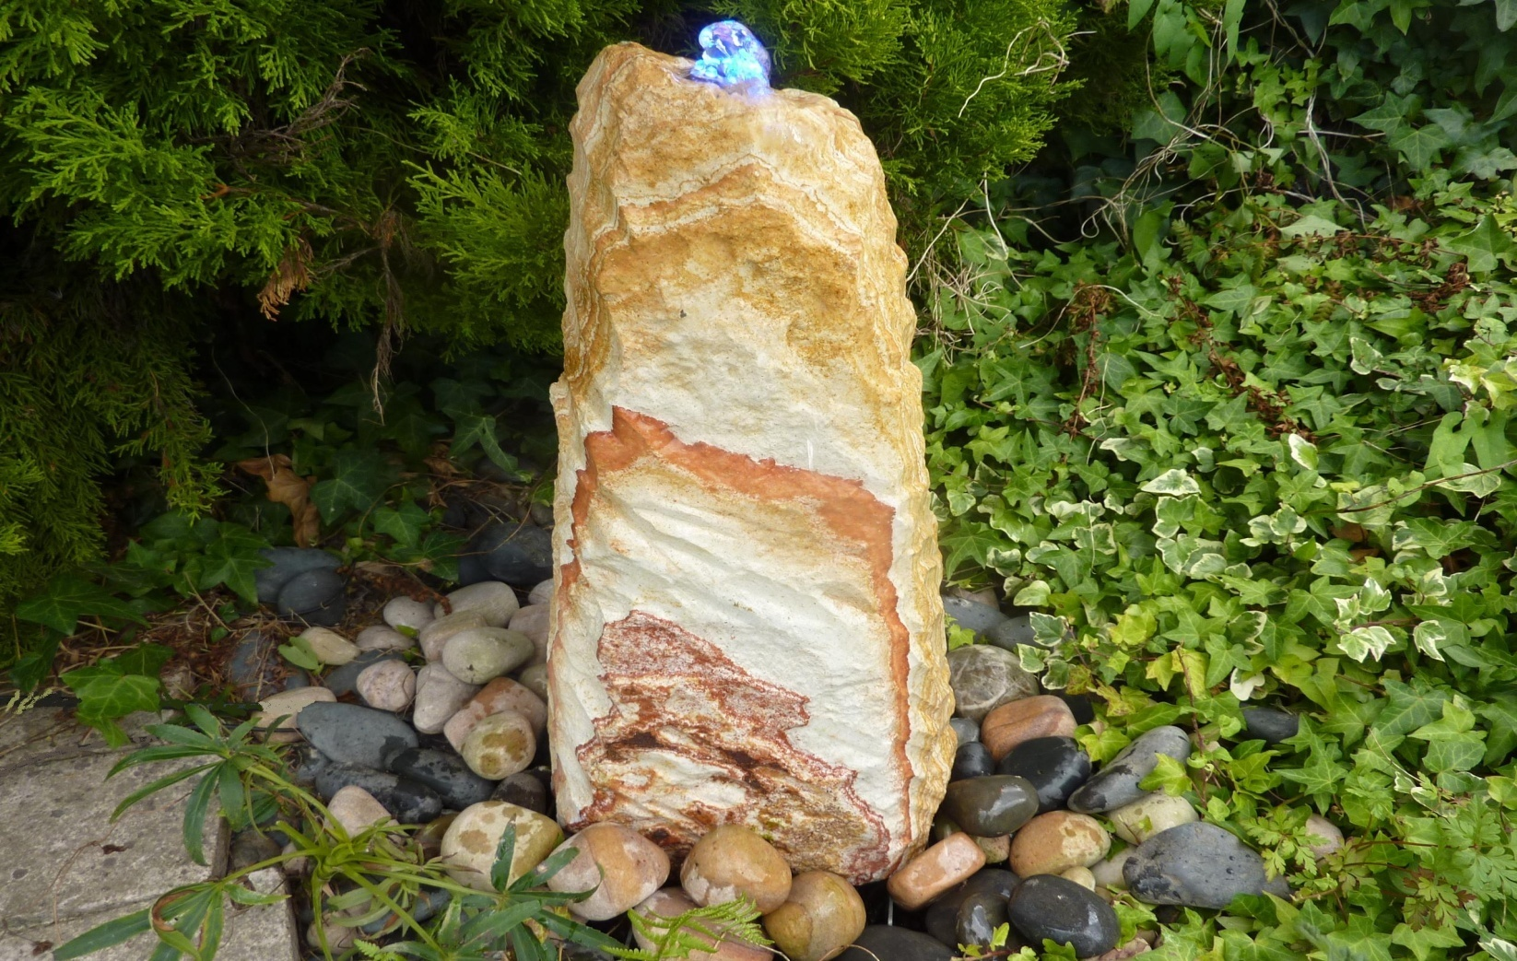
2118 RAINBOW MONONITH ASSORTED SIZES AND COLOURS
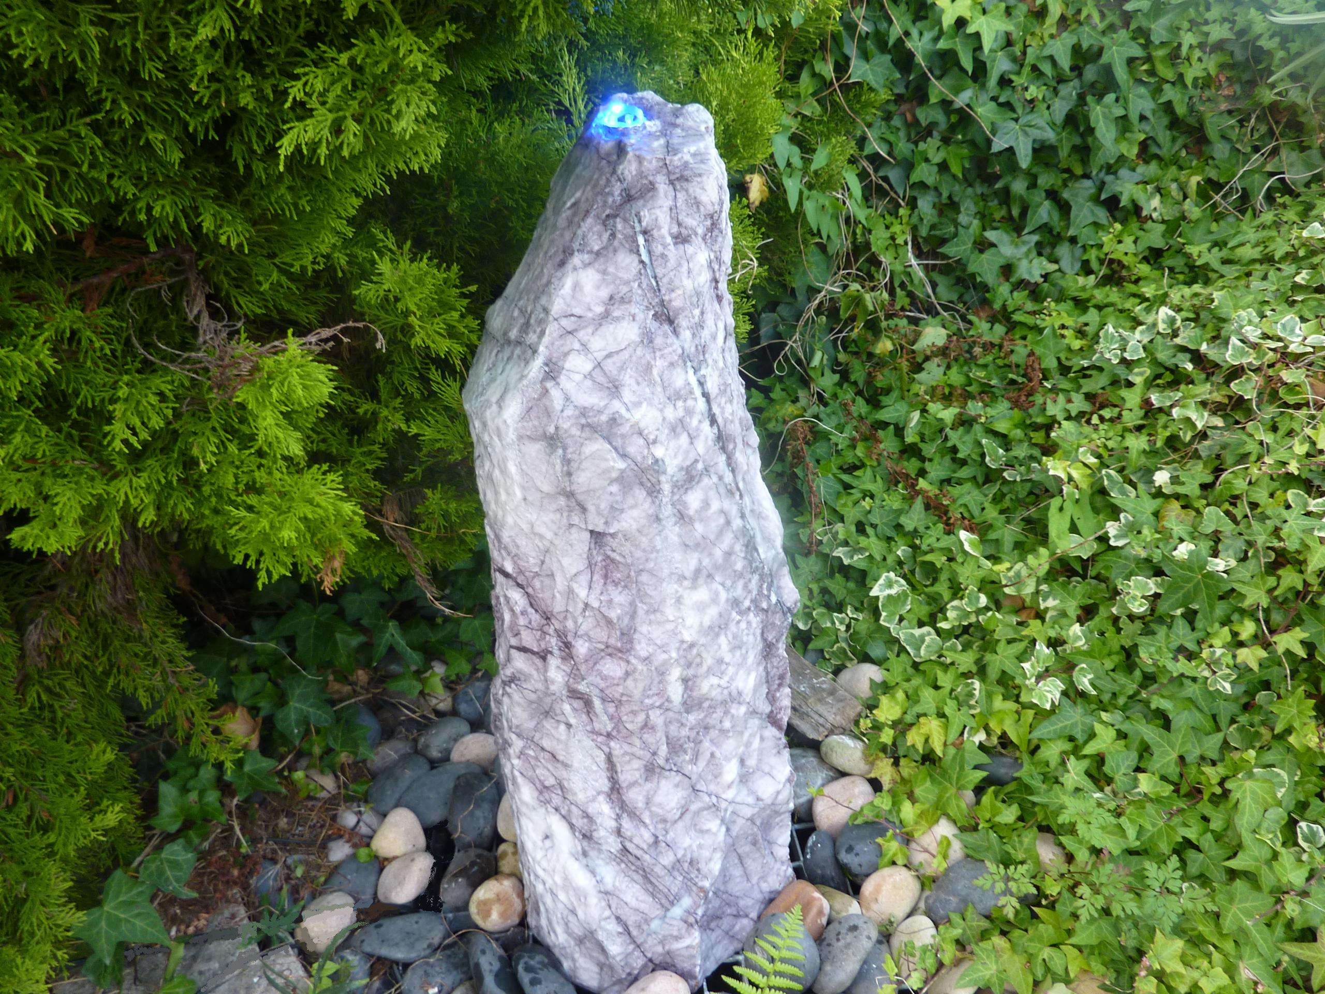
2119 PURPLE MONONITH, ASSORTED SIZES AND COLOURS, 50~70CM H
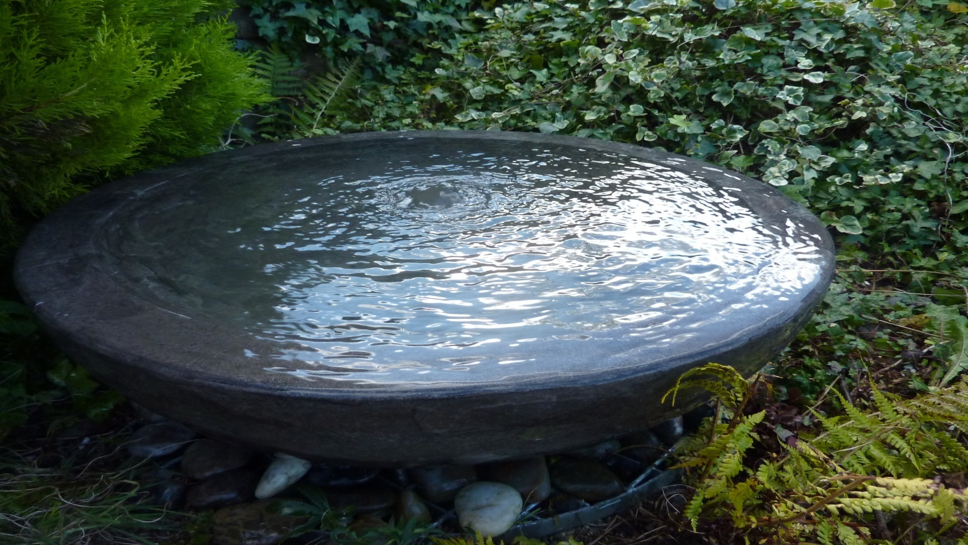
2203 LARGE BLACK LIMESTONE BABBLING BOWL DIA72 X20CM H

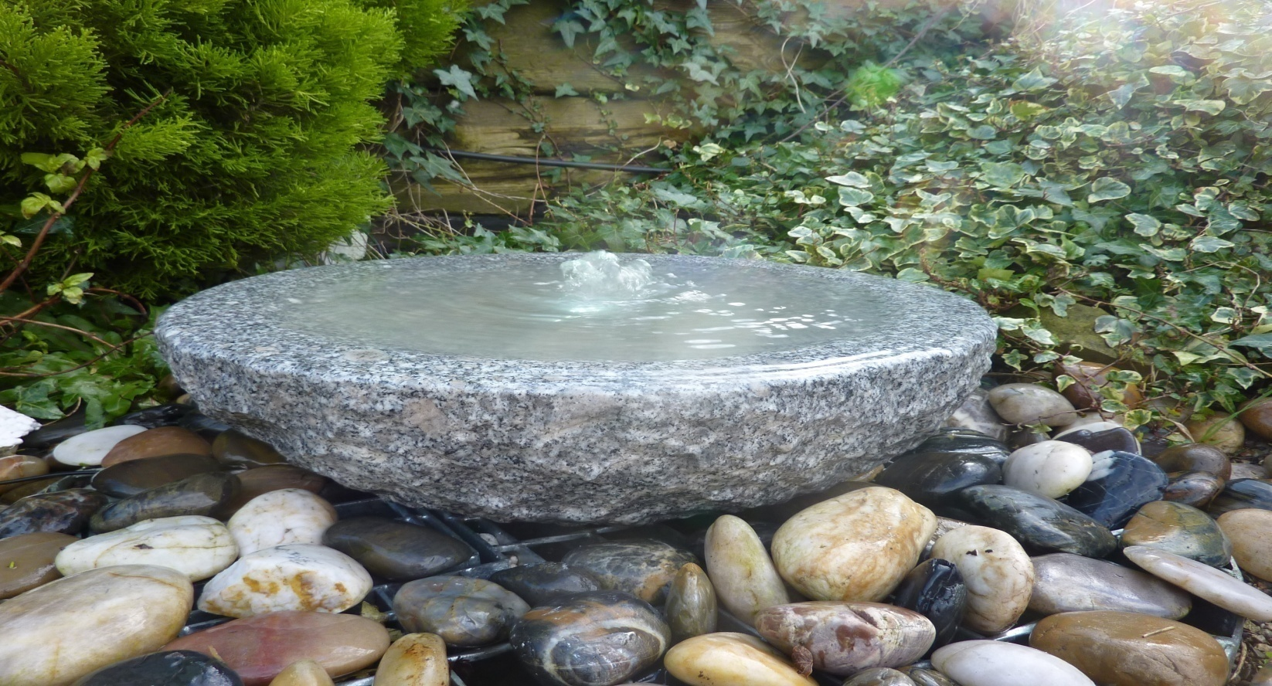
2205 BABBLING BOWL GREY GRANITE DIA 50CM X 15CM HIGH; 2205SG SIZE: DIA45CM X12CM H
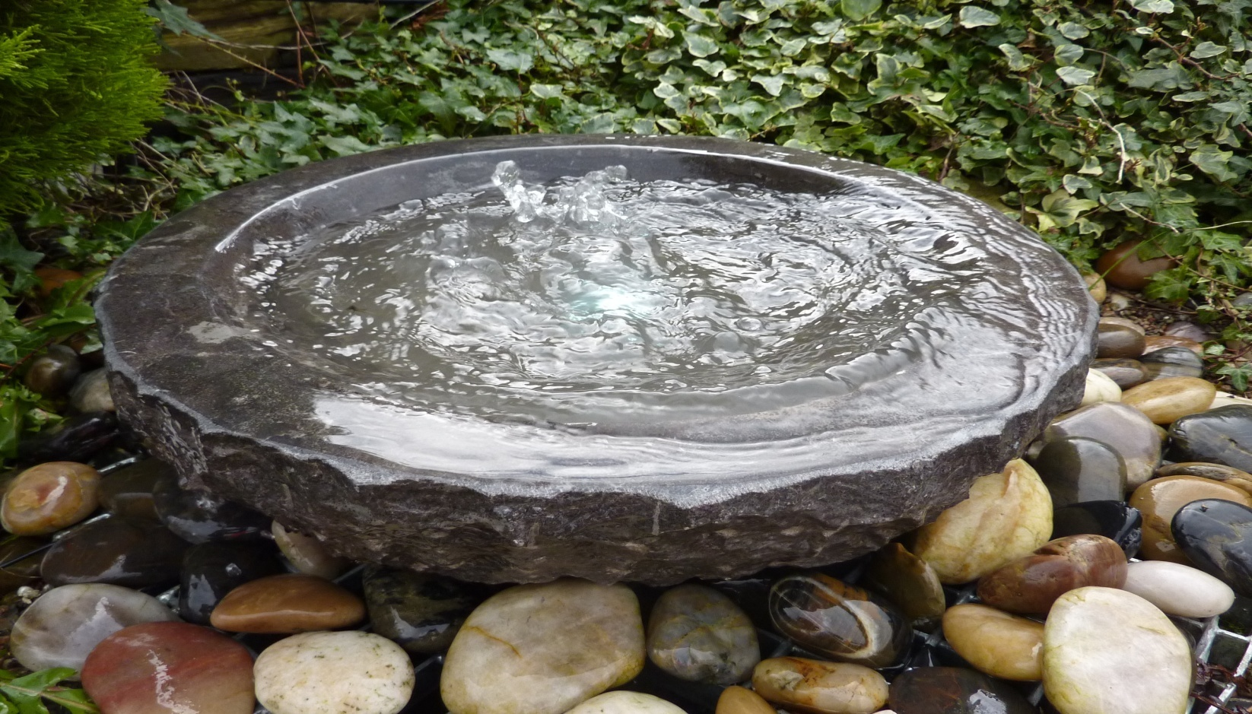
2205BL BABBLING BOWL BLACK LIMESTONE DIAM 50CM X 15CM HIGH; 2205SBL SIZE: DIA45CM X 12CM H
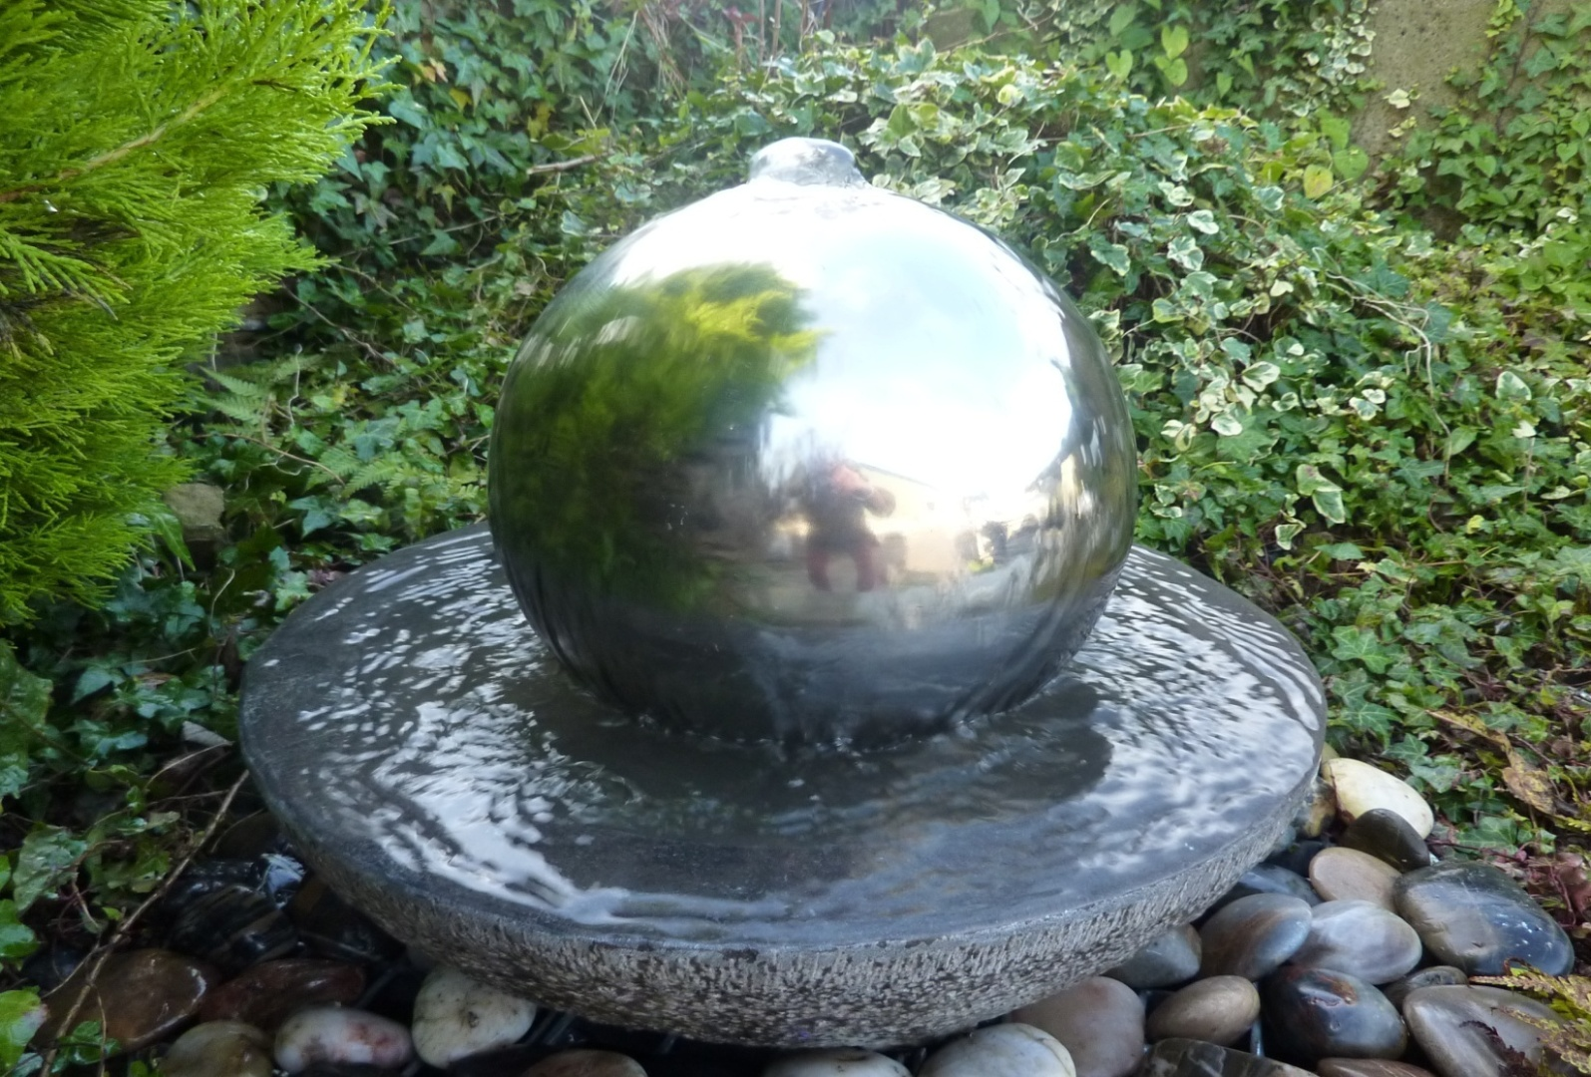
2205BL-SS30 BABBLING BOWL BLACK LIMESTONE DIA 50CM X 15CM H PLUS dia30cm STAINLESS STEEL SPHERE
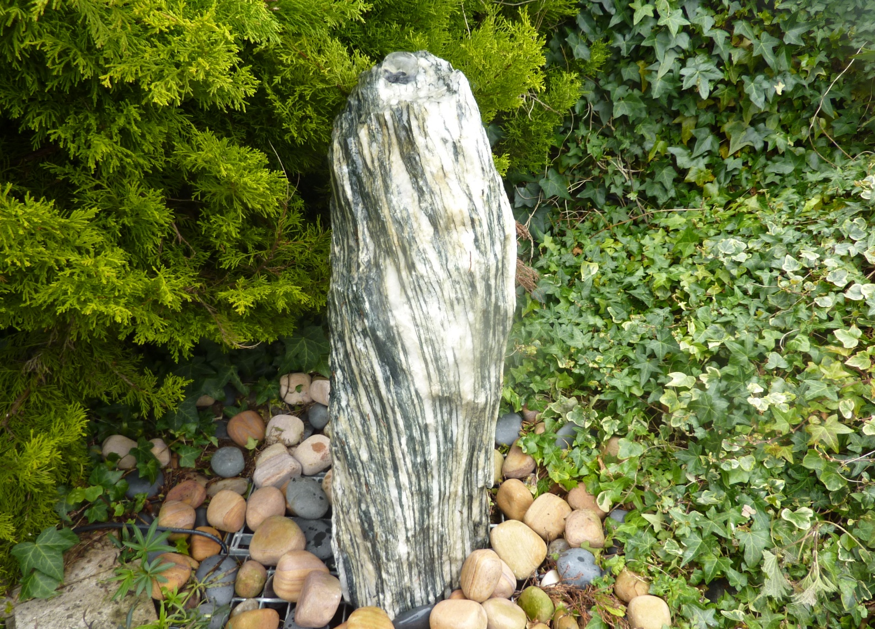
2117 GREEN ANGEL MONONITH 70CM H, 25~30CM BASE

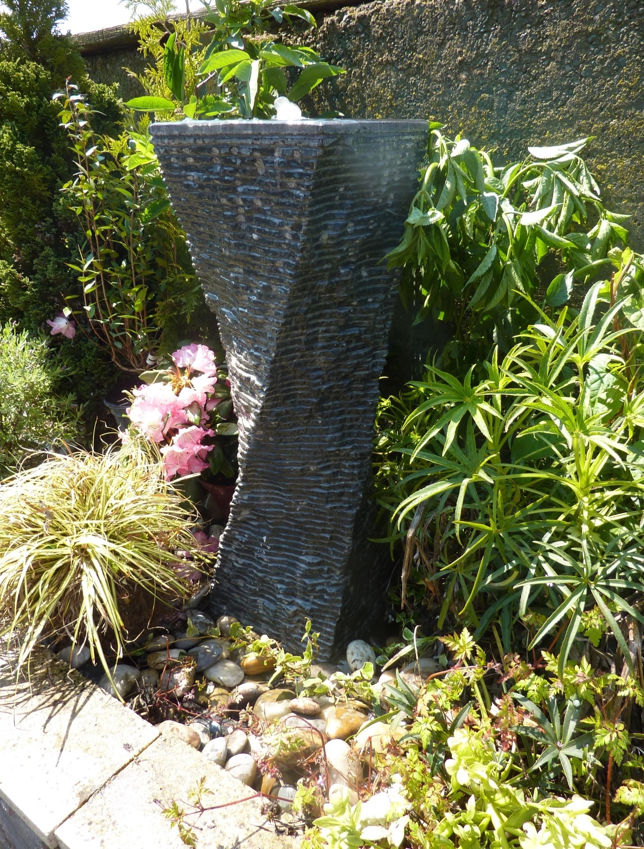
2204 TWISTED FOUNTAIN, 25X25X80CM H, BLACK LIMESTONE
2204SG SIZE: 20X20X60CM H, GREY GRANITE; 2204SL 20X20X60CM H, BLACK LIMESTONE
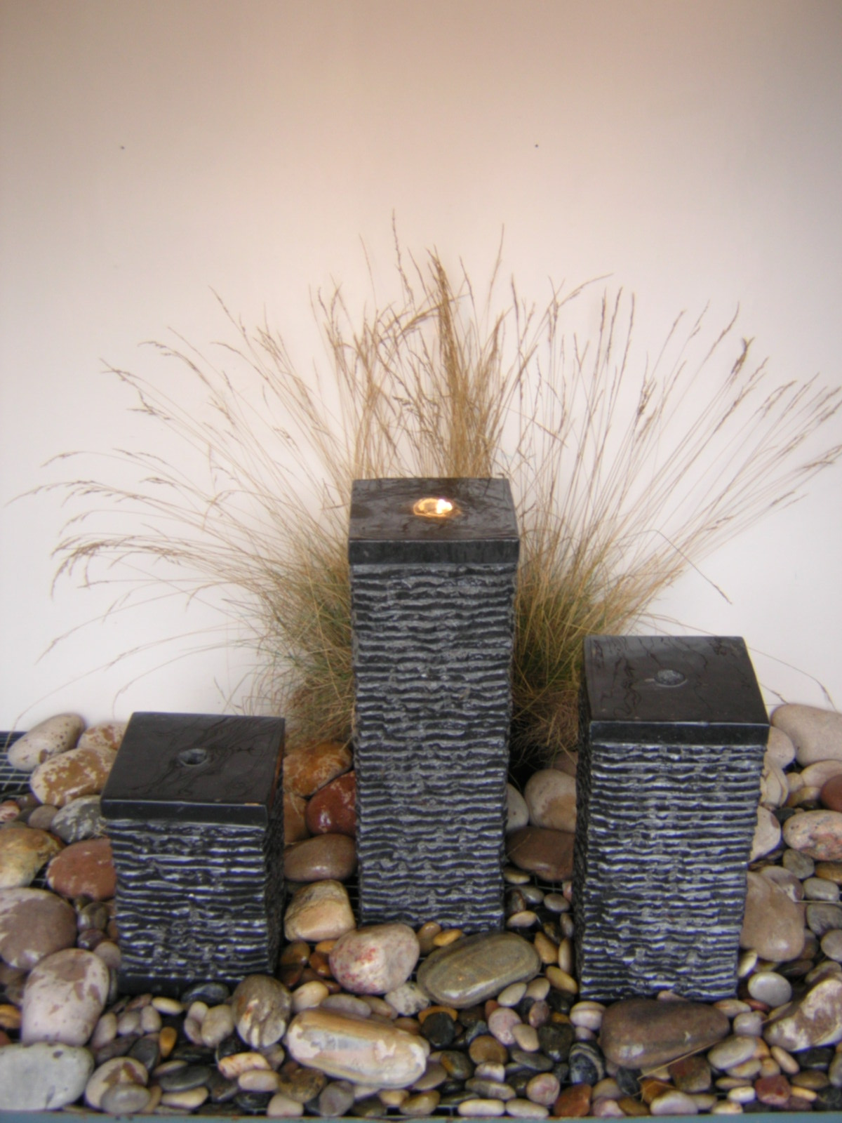
2128 SET OF 3 BLACK LIMESTONE COLUMNS, 16X16X20/35/50CM H
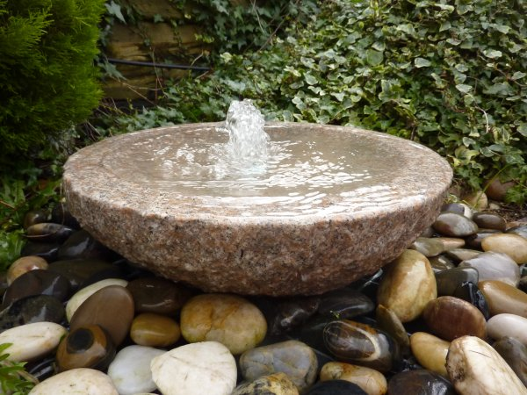
2205P BABBLING BOWL PINKY GRANITE 50CM DIA 15CM HIGH
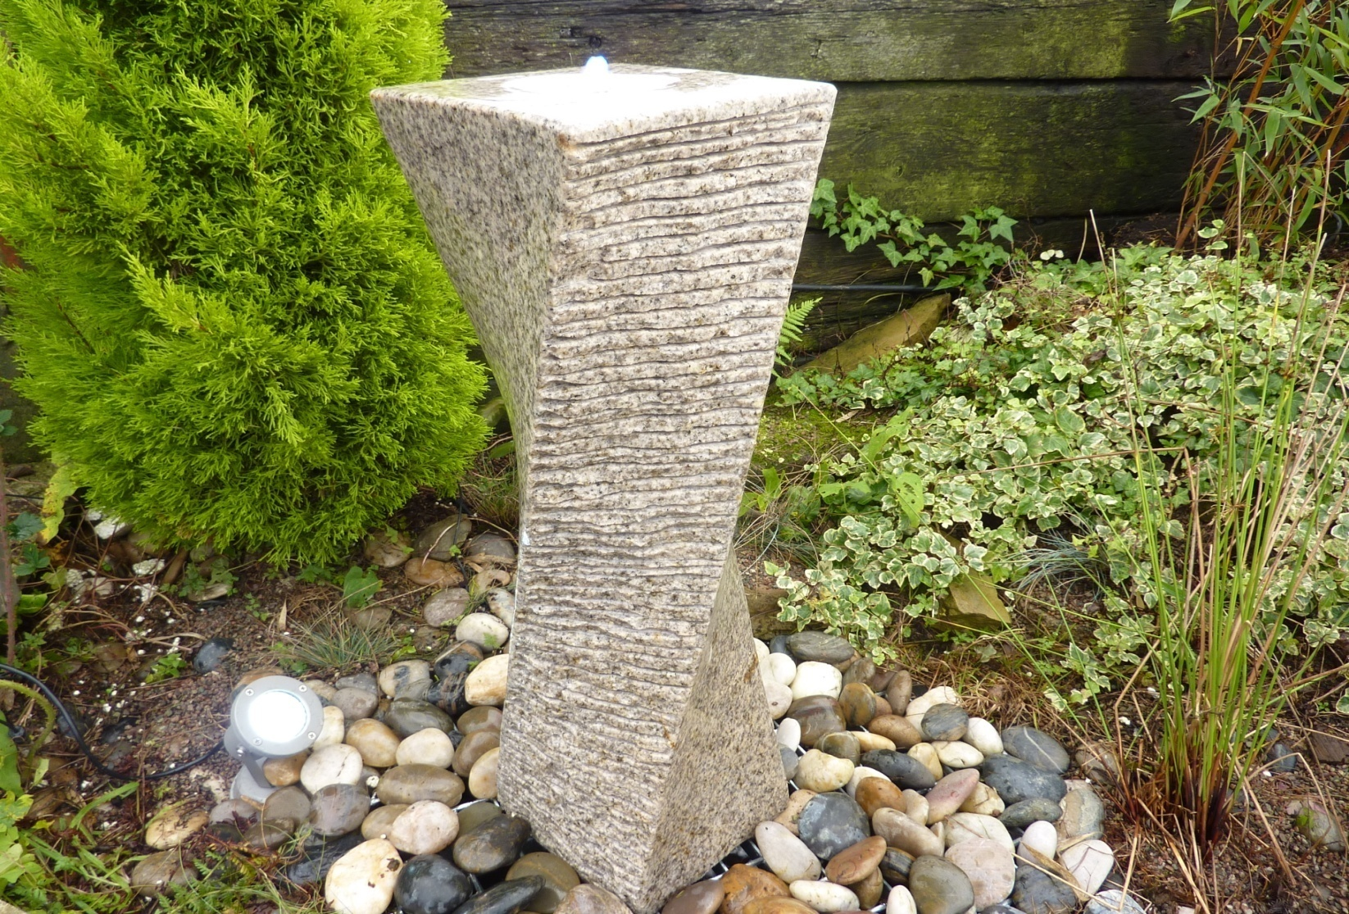
2208B DRILLED TWIST, BEIGE GRANITE,22X22X75CM H
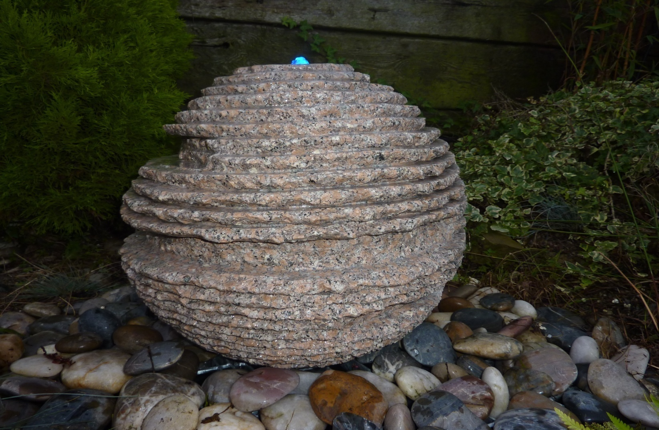
2216P PINKY GRANITE RUSTIC SPHERE DIA40CM; 2216P-50 DIA50CM
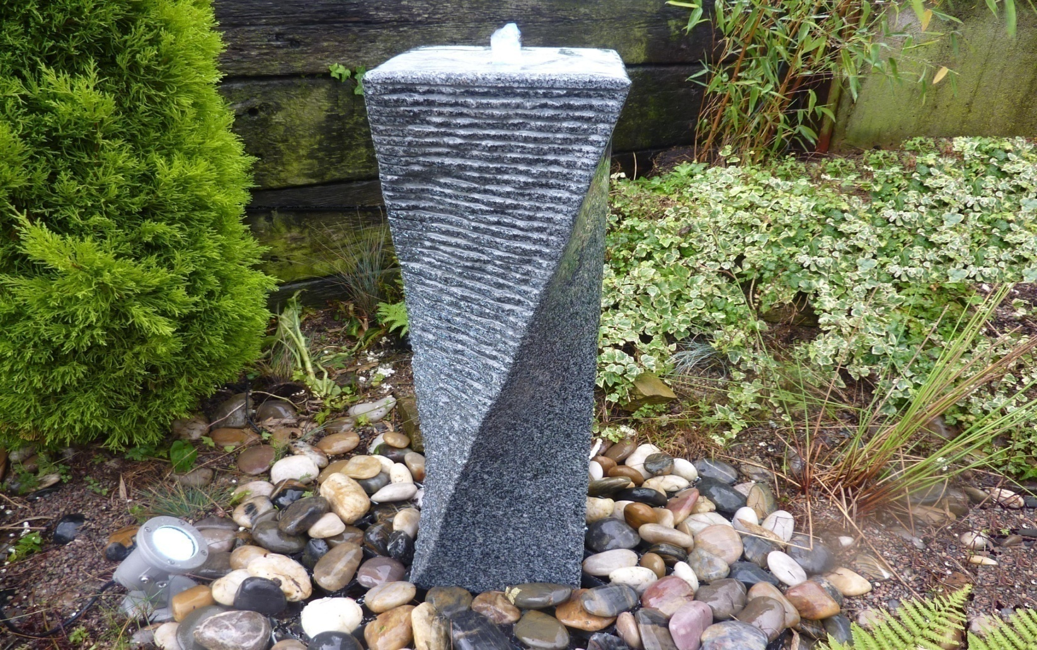
2208D DRILLED TWIST, DK GREY GRANITE,22X22X75CM H
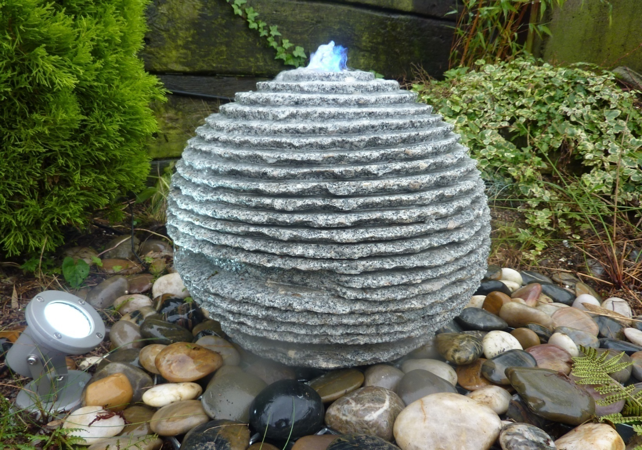
2216G GREY GRANITE RUSTIC SPHERE DIA40CM; 2216G-50 DIA50CM
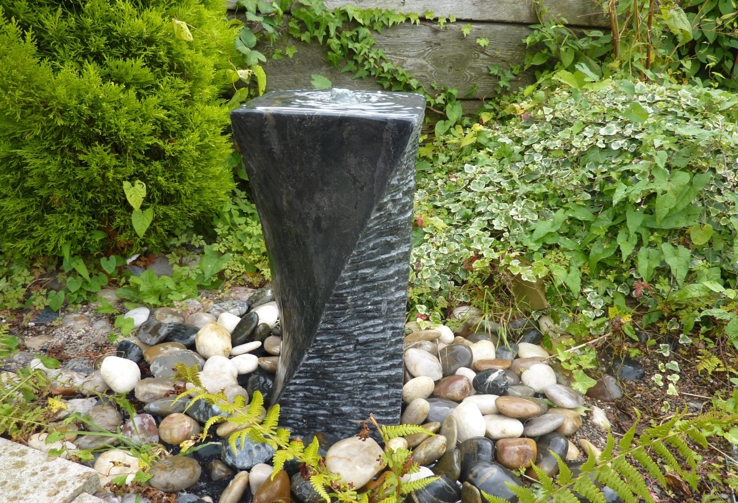
2208BL DRILLED TWIST, BLACK LIMESTONE,22X22X75CM H
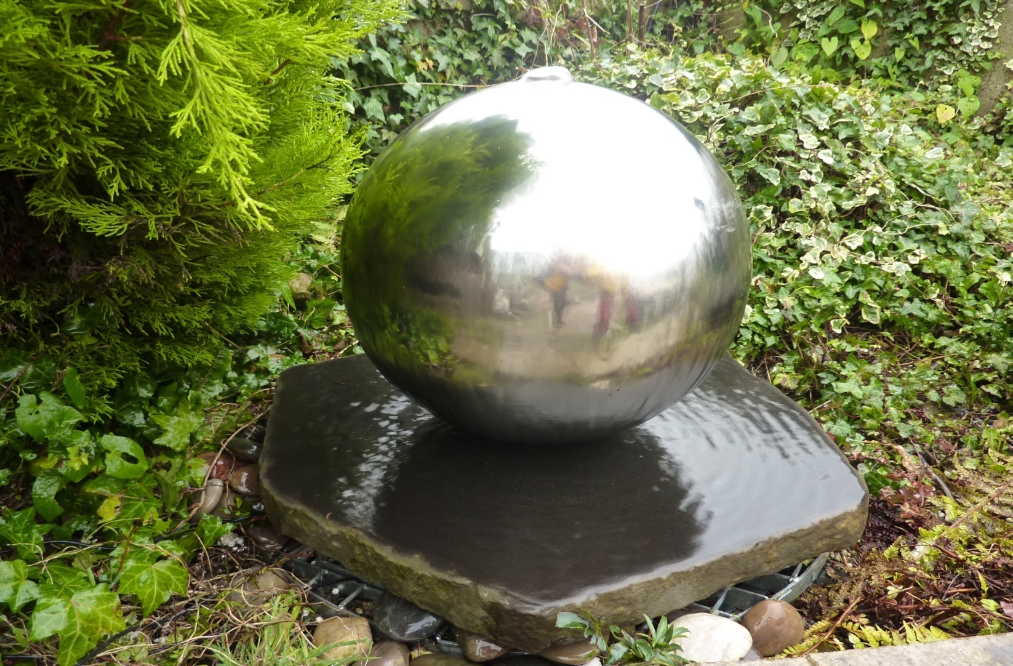
2218-SS30 BASALT SLAB 40~45CM X3CM H W/ DIA30CM STAINLESS STEEL SPHERE
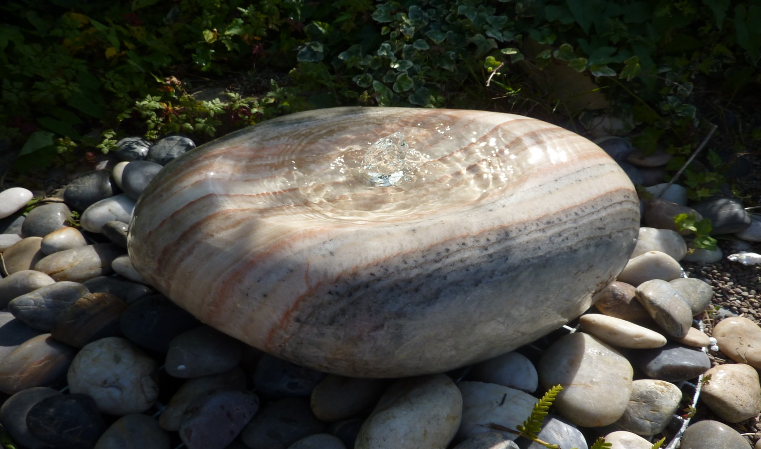
2221-ONYX POLISHED MARBLE FOUNTAIN 35~45cm x 20~30cm H
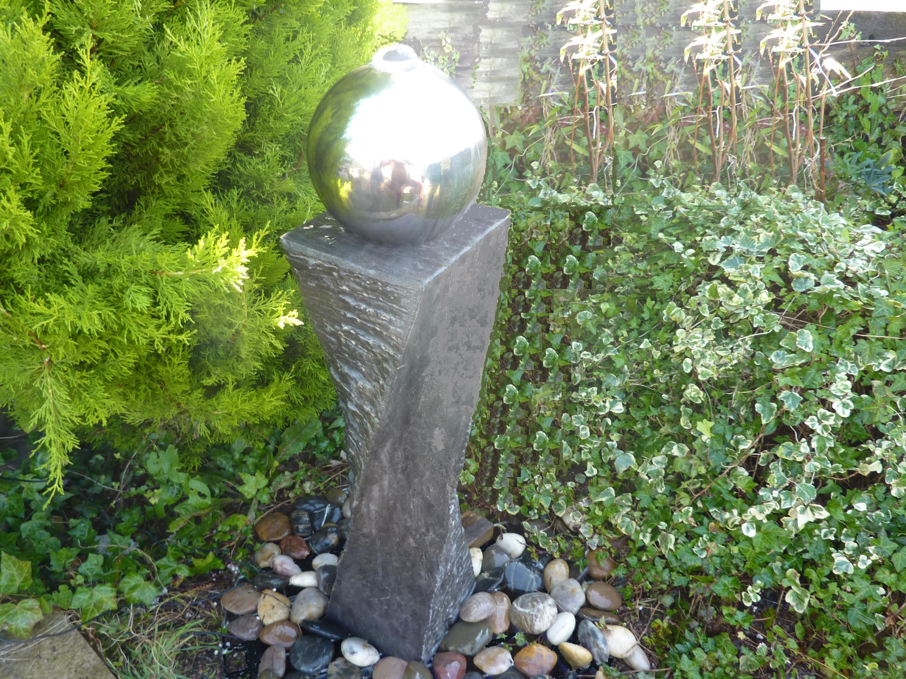
2208BL-SS20 EC BLACK LIMESTONE TWIST W/DIA20CM SS SPHERE total 22X22X95CM H
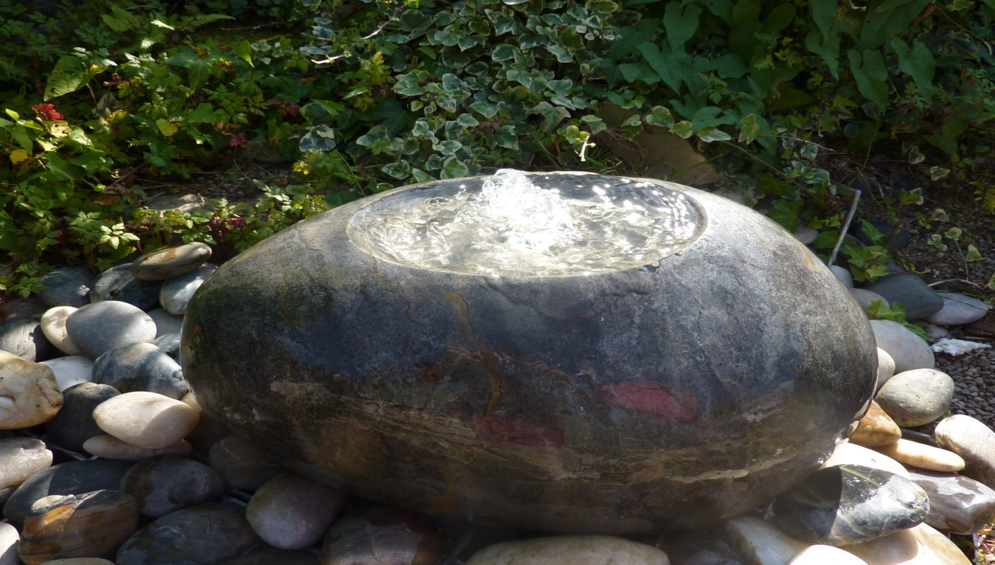
2221-BLACK POLISHED MARBLE FOUNTAIN 35~45cm x 20~30cm H
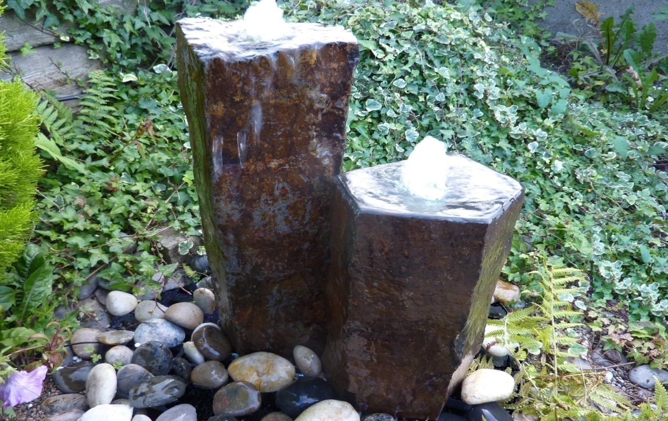
2222 SET OF 2 BASALT FOUNTAIN, 20~30 X 40/50CM H
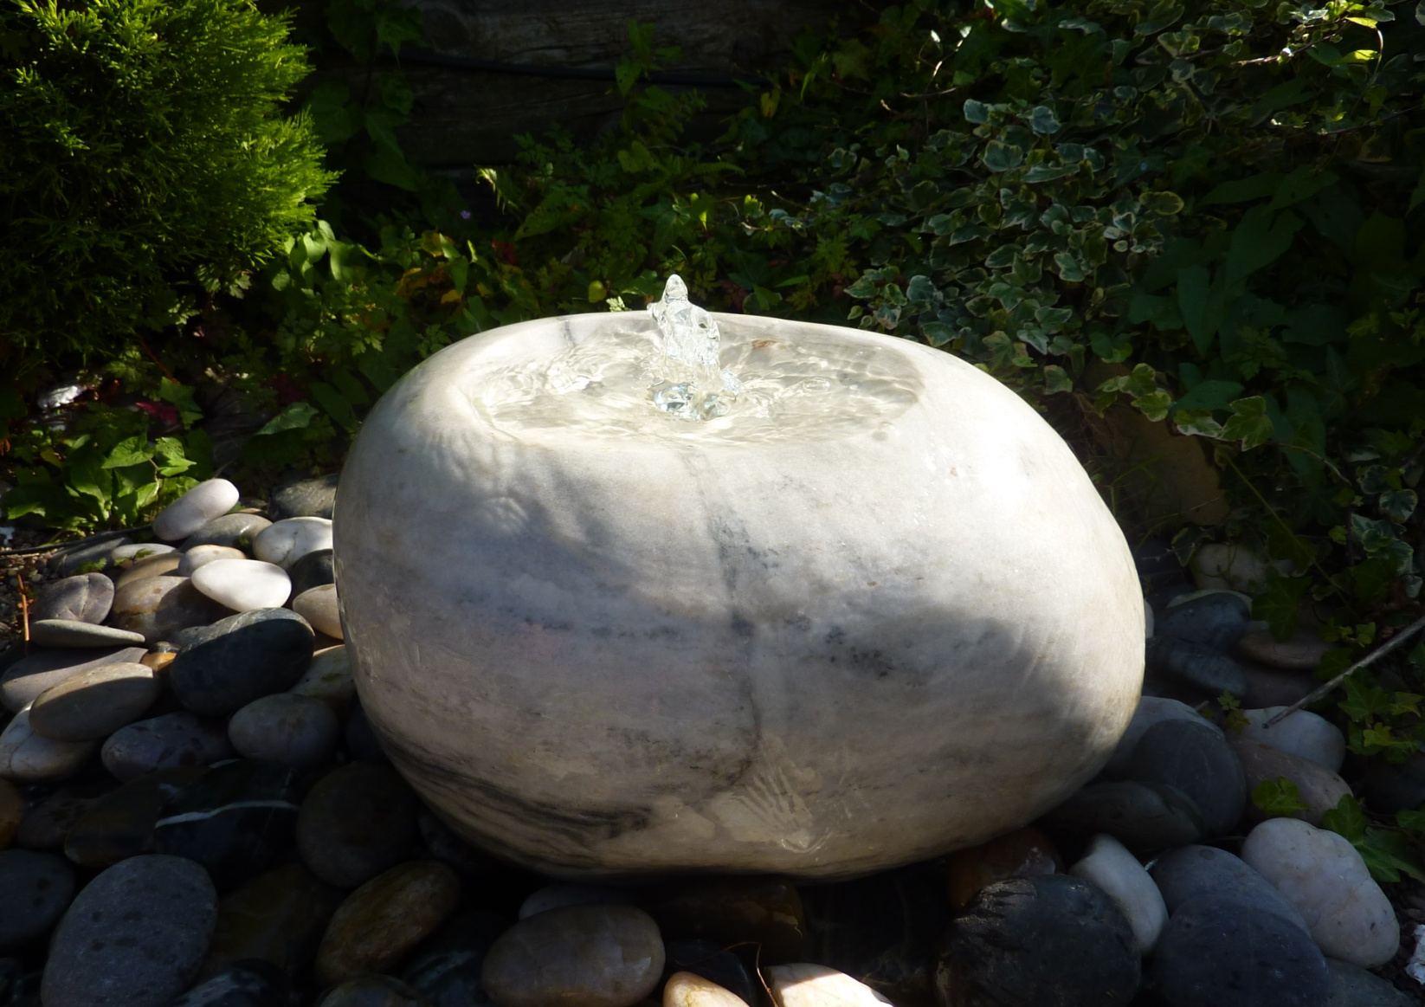
2221-WHITE/BLACK POLISHED MARBLE FOUNTAIN 35~45cm x 20~30cm H
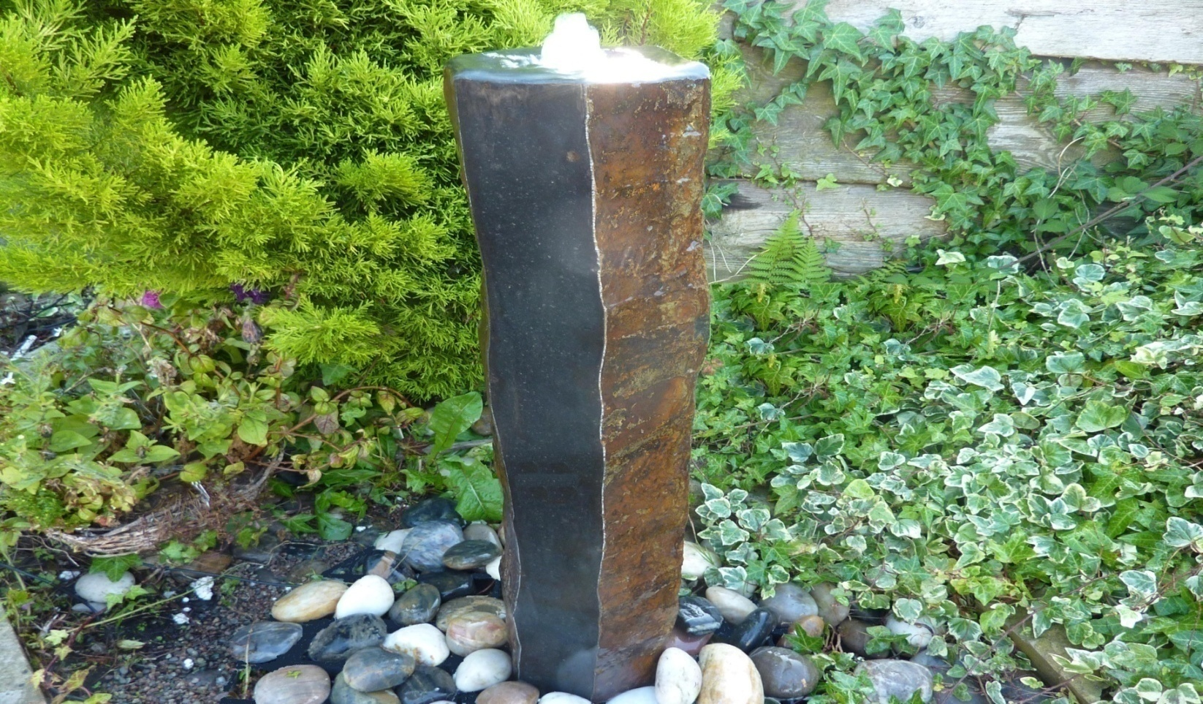
2224 BASALT FOUNTAIN 20~30CM W X 70CM H, polished two sides; 2224S 50cm H; 2224L 25~30CM W X90CM H
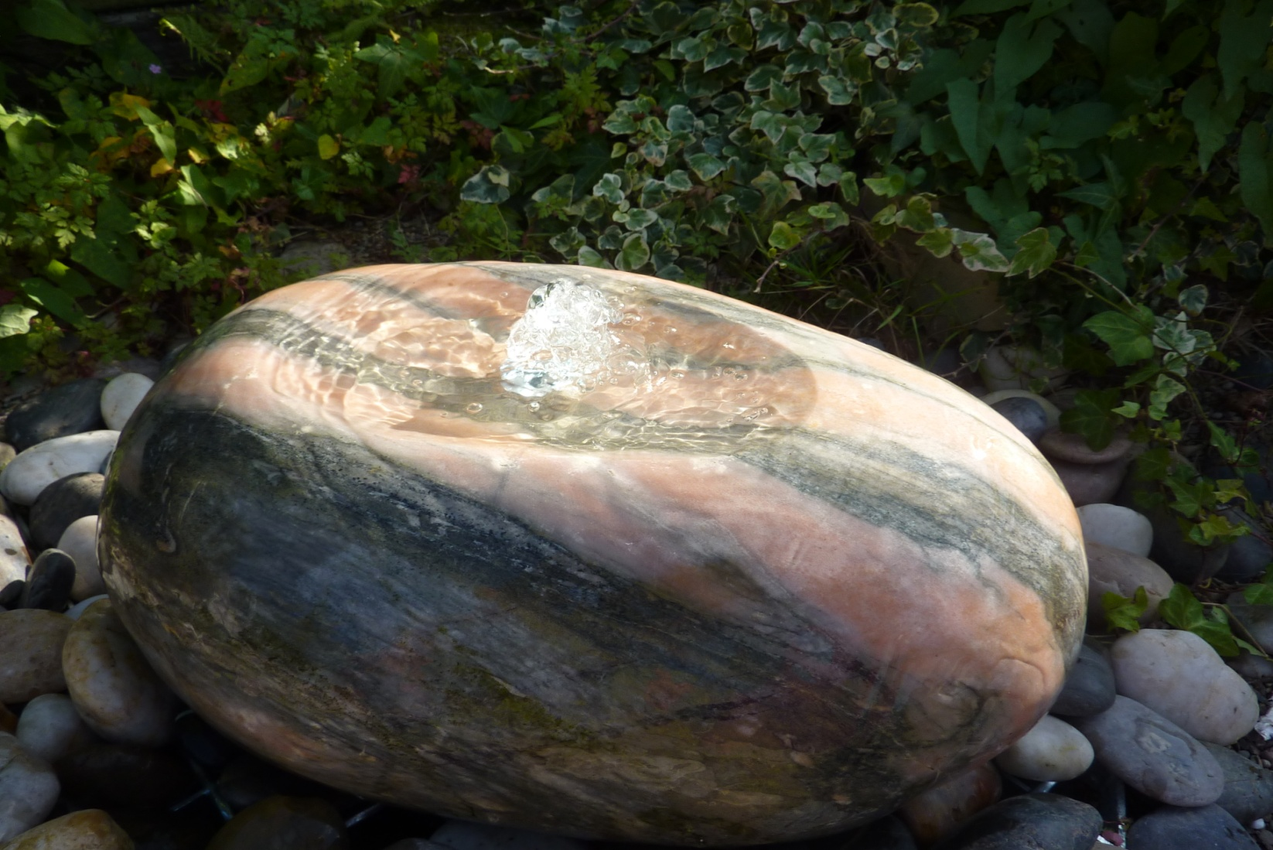
2221-SUNSET POLISHED MARBLE FOUNTAIN 35~45cm x 20~30cm H
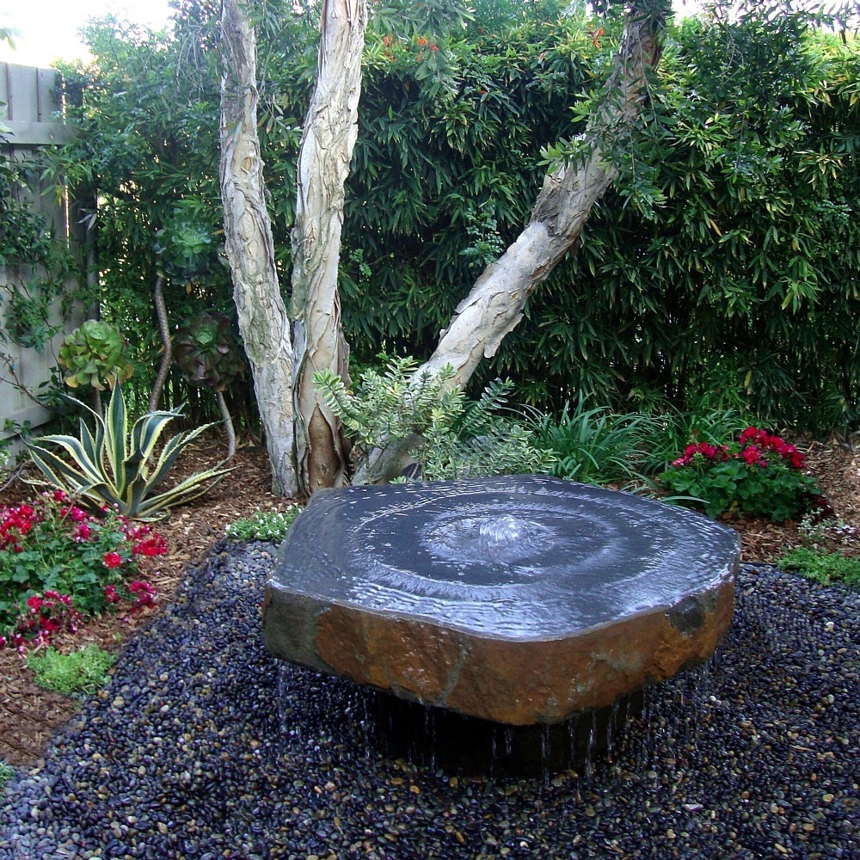
2223L BABBLING BASALT FOUNTAIN, 65~70CM X 10CM H, polished dished top; 2223XL 85~90CM X 10CM H
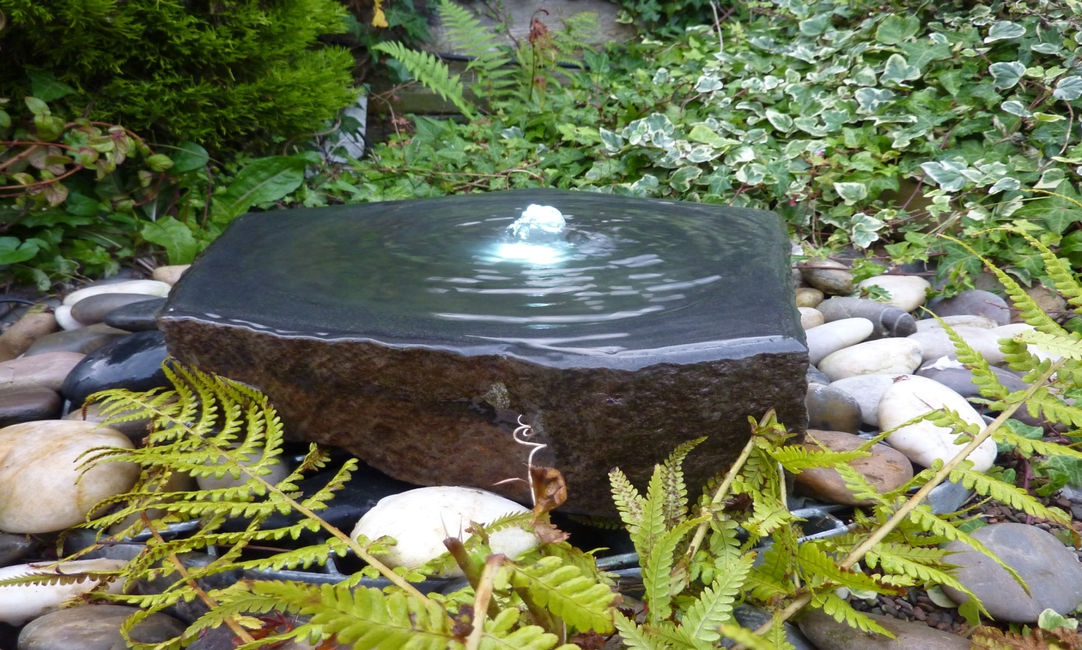
2223 BABBLING BASALT FOUNTAIN, 40~50CM X 8CM H, polished dished top
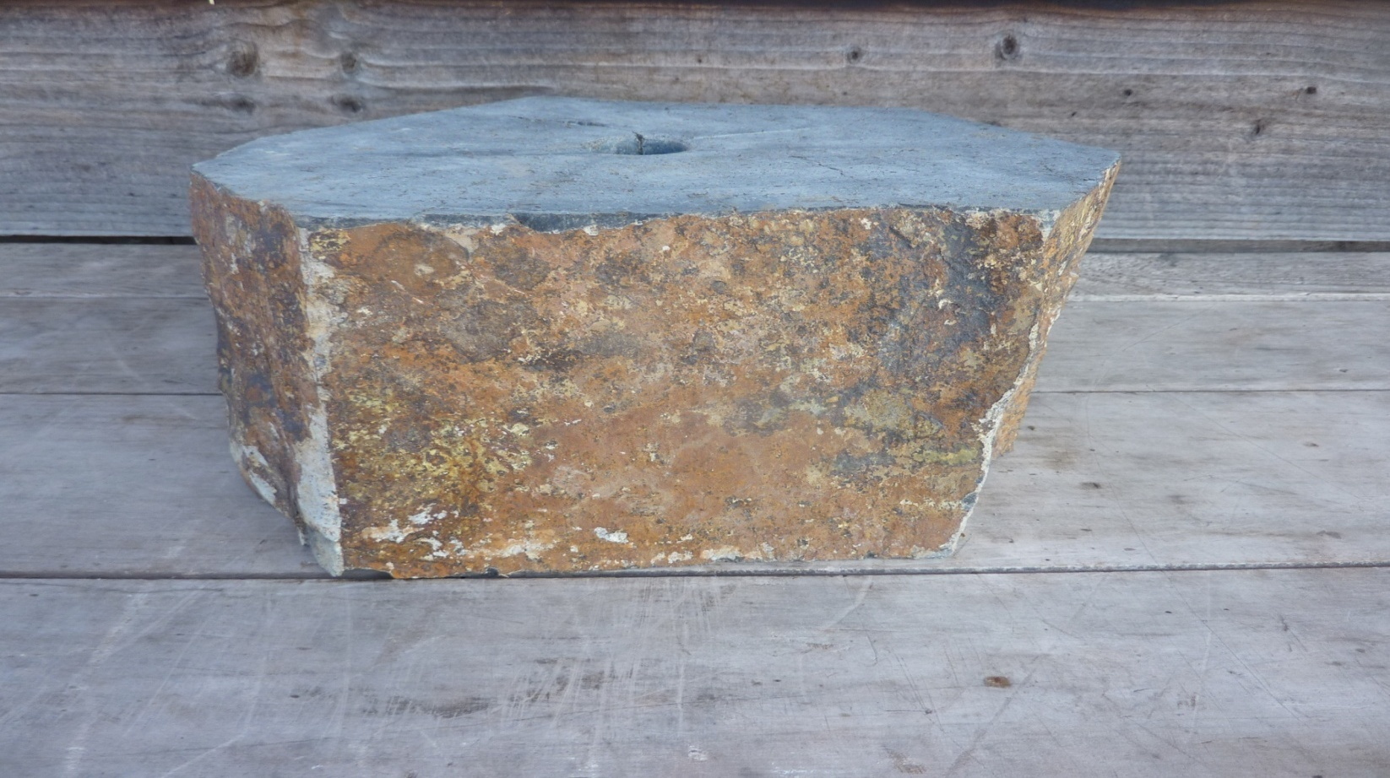2226 DIA20~30CM X18CM H BASALT PLINTH DRILLED W. FEATURE SUPPORT FOR BASALT FOUNTAINS AND MILL STONE FOUNTAINS
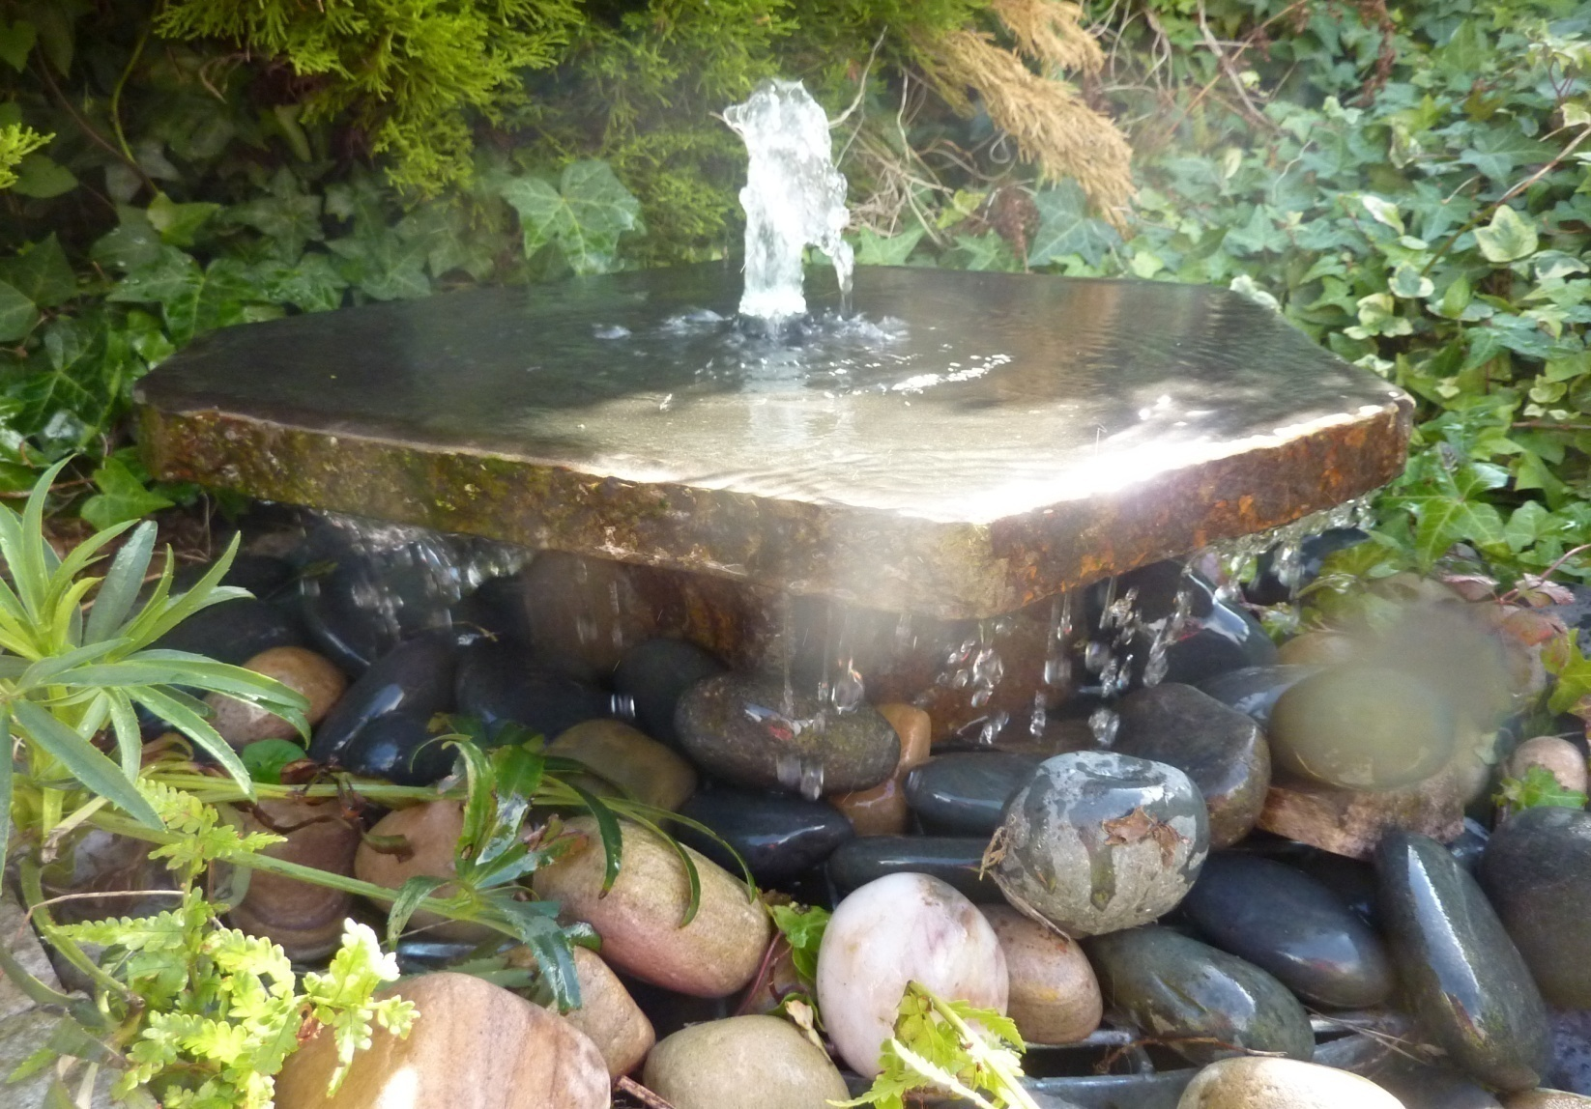
2231 BASALT SLAB FOUNTAIN WITH PLINTH, 40~45 CM W X 21CM H
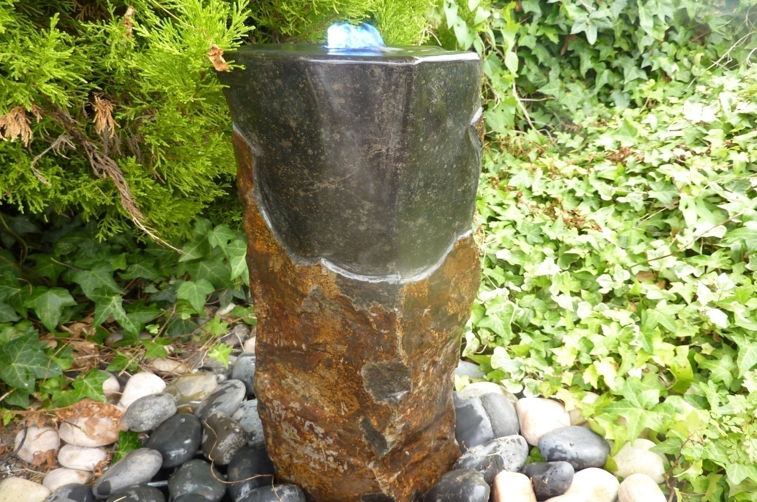
2227-50 BASALT FOUNTAIN, 20~25CM W X 50CM H, POLISHED TOP CORNER; ALSO AVAILABLE 2227-70CM H
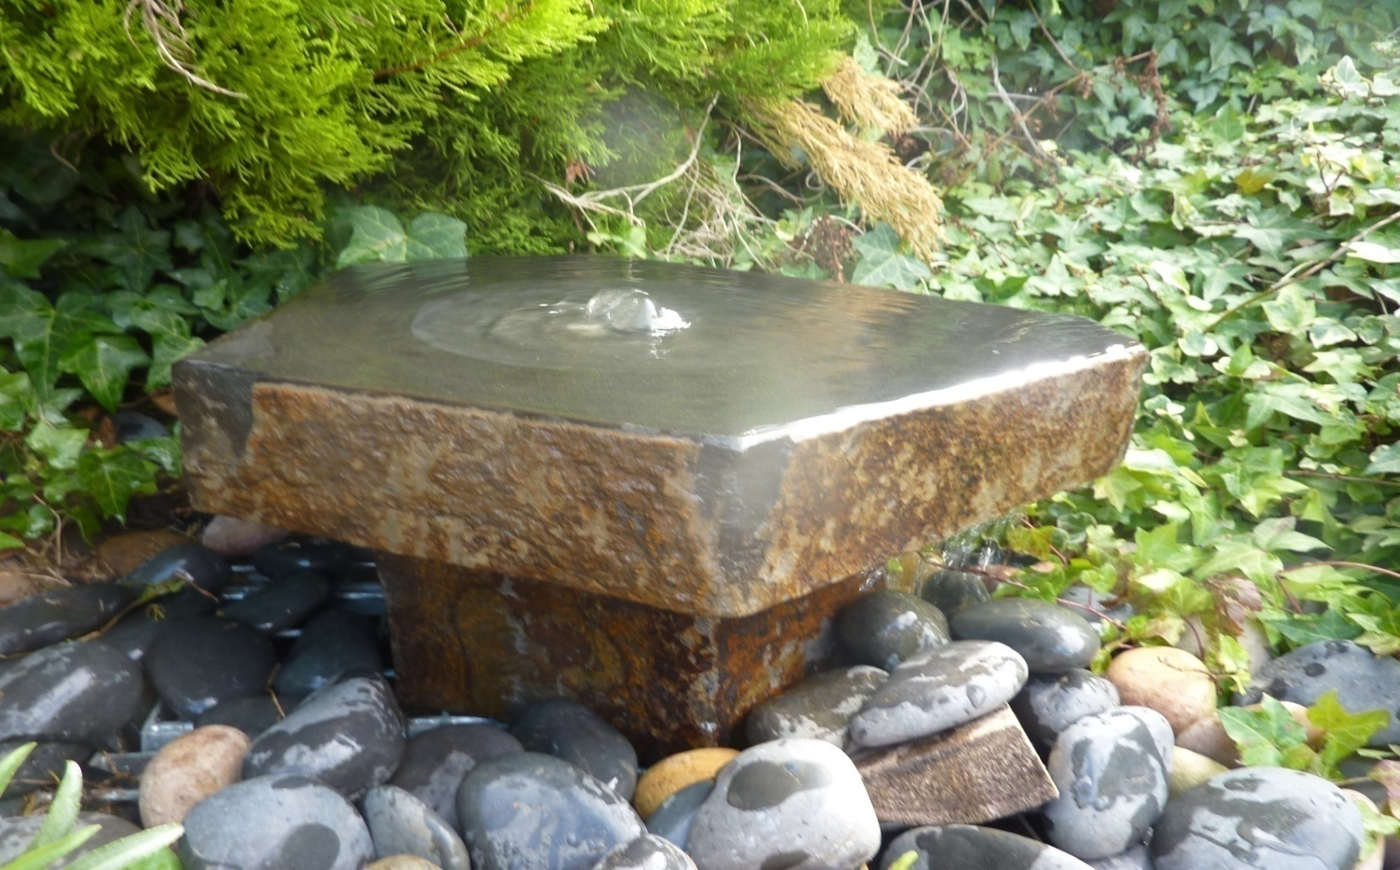
2232 BABBLING BASALT FOUNTAIN WITH PLINTH, 45~50CM X26CM H (COMBINATION OF 2223 + 2226) 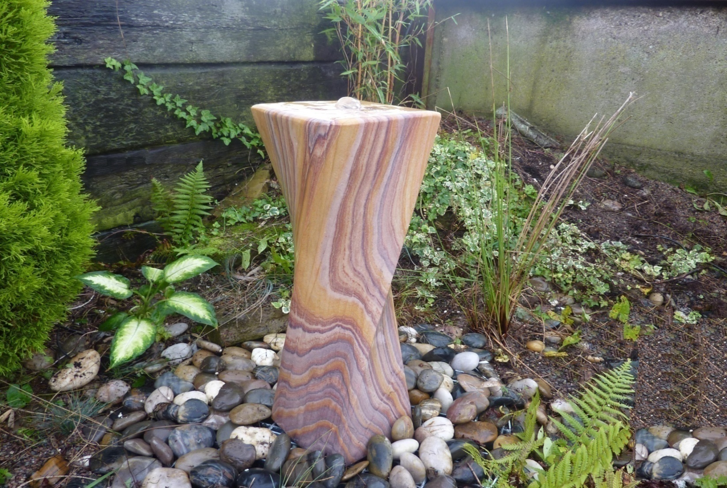
2327 RAINBOW TWIST HONED ALL SIDES, 20X20X65CM H
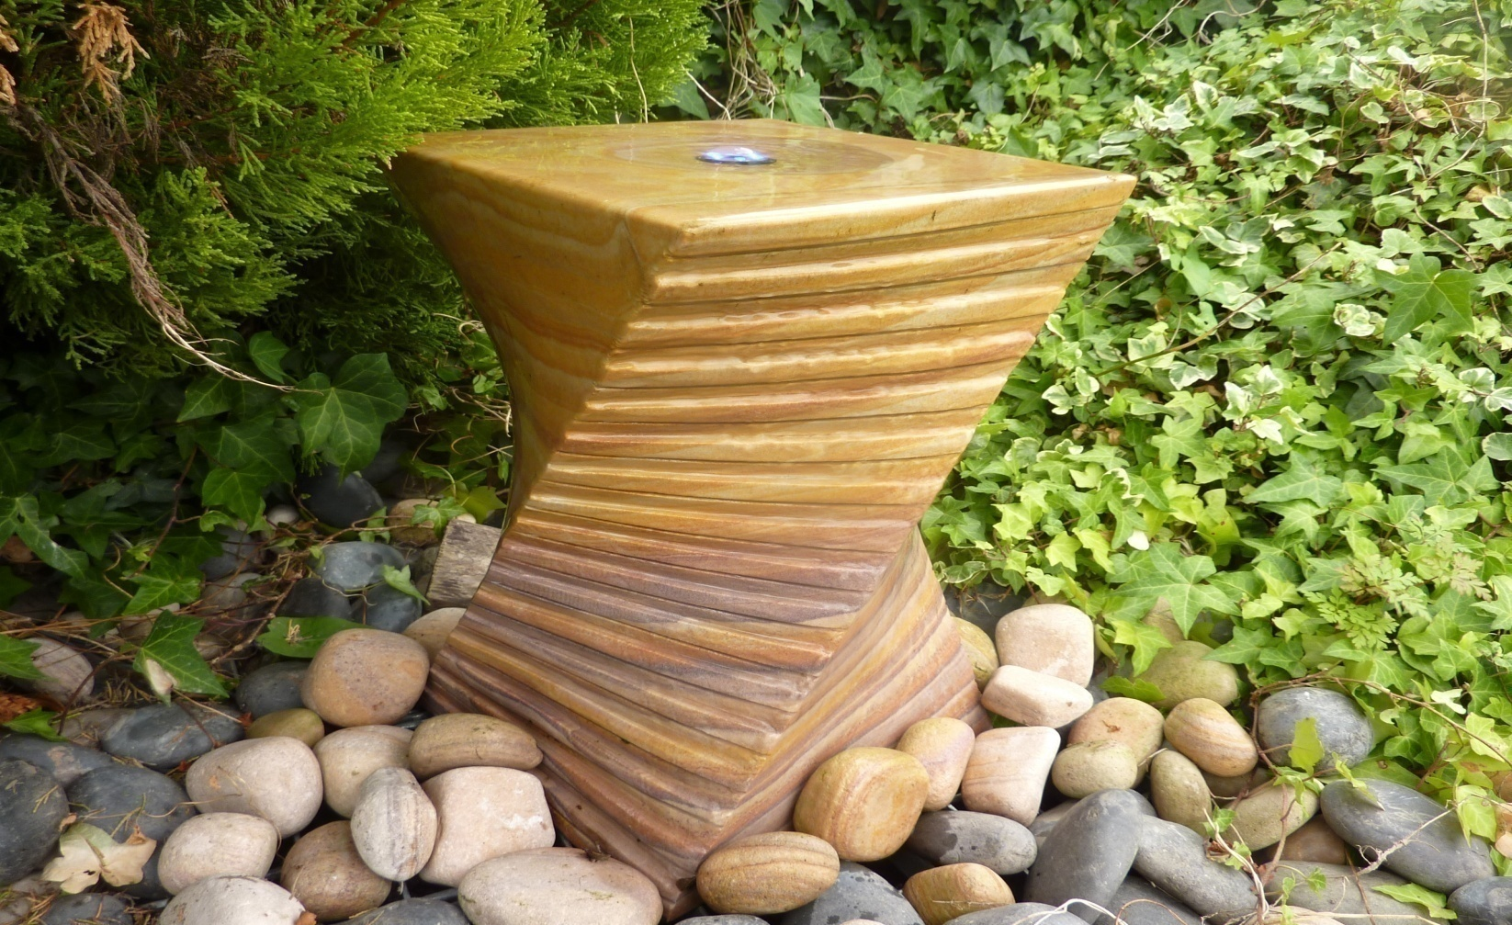
2326 RAINBOW TWIST FOUNTAIN, WITH 2 CASCADING SIDES, 25X25X40CM H

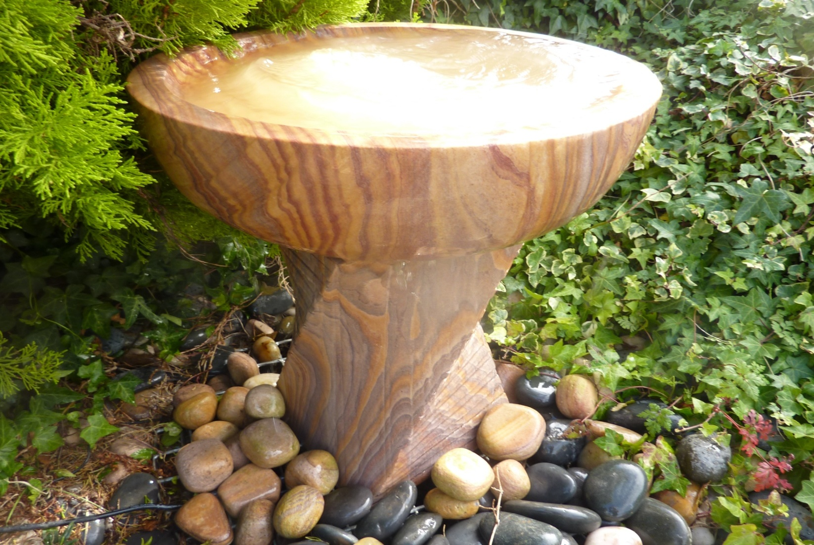
2330 CASCADING CHUBBY TWIST WITH BABBLING BOWL, DIA45 X52CM H
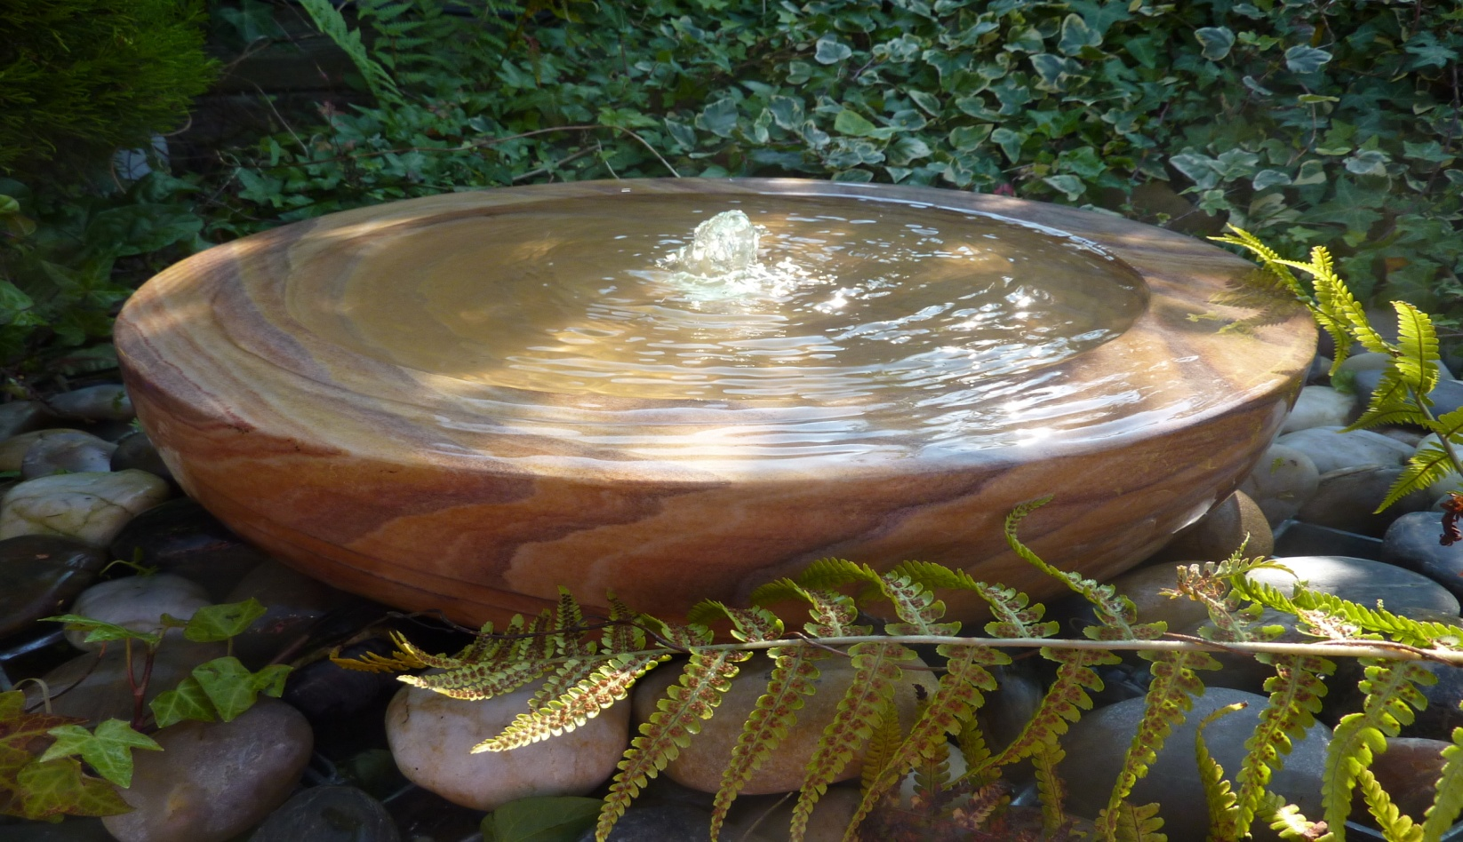
2334 RAINBOW SANDSTONE BABBLING BOWL, DIA45CM X 12CM H; ALSO AVAILABLE 2334L DIA60CM X12CM H
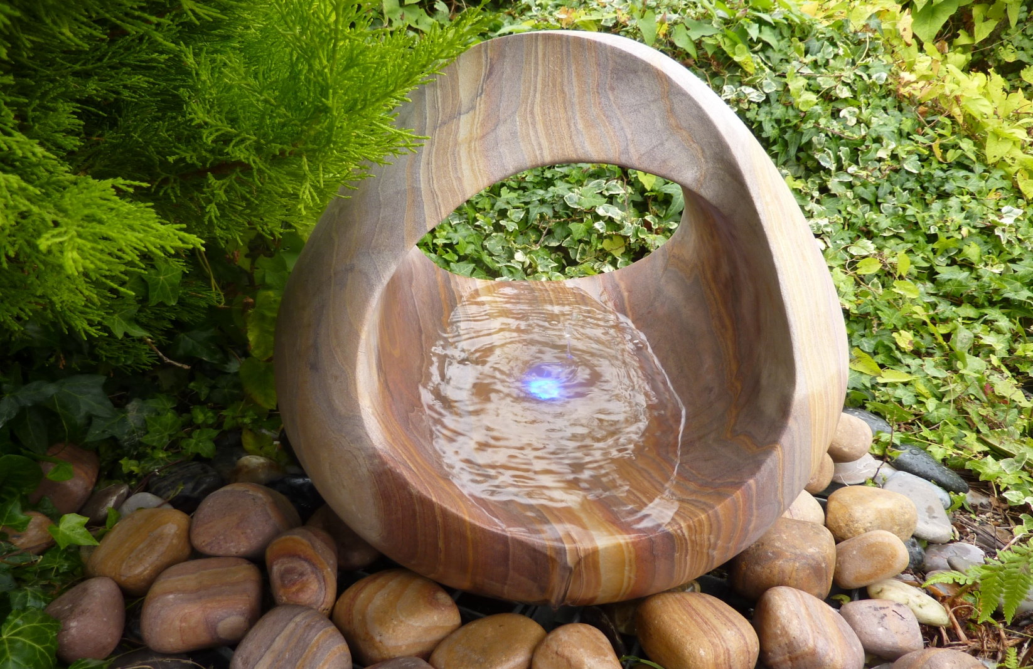
2346 RAINBOW SANDSTONE BABBLING BASKET DIA45 X48CM H
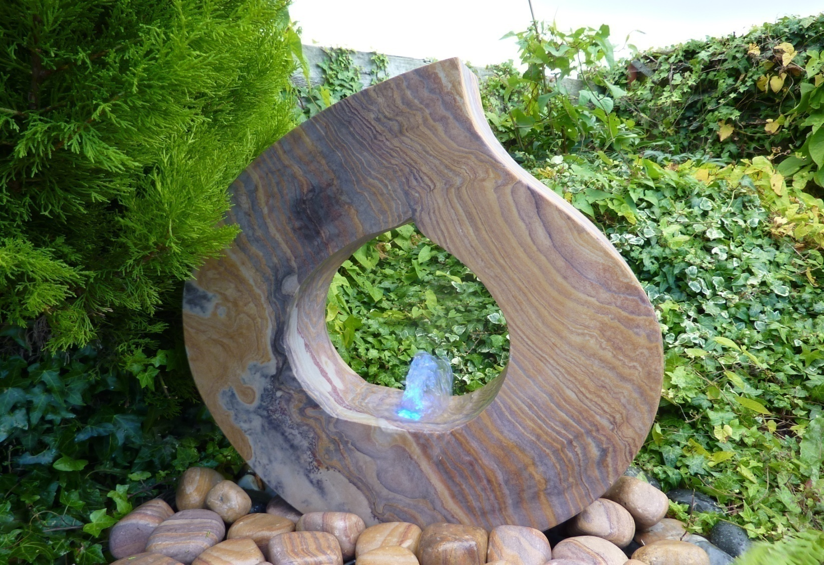
2348 RAINBOW SANDSTONE BABBLING FLAME, 60X13X60CM H
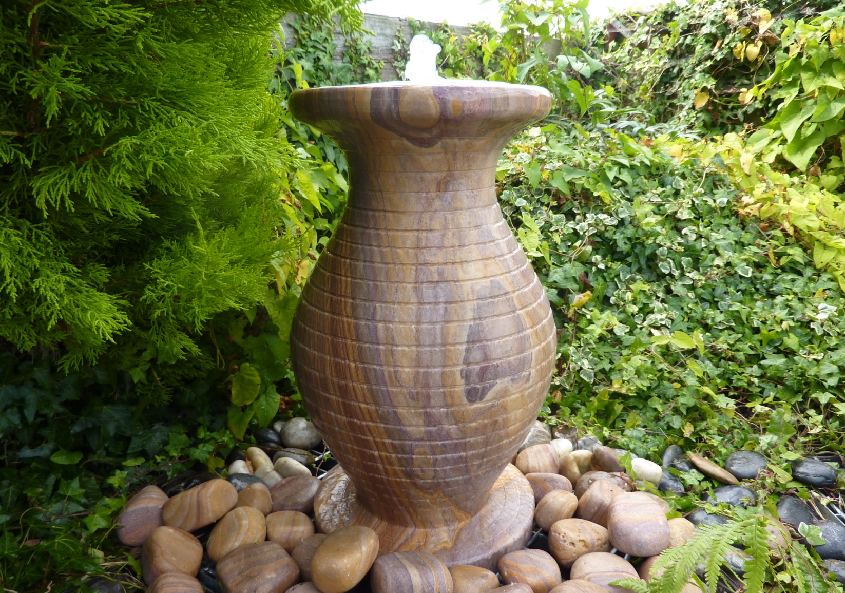
2347 RAINBOW SANDSTONE CASCADING VASE DIA33 X60CM H
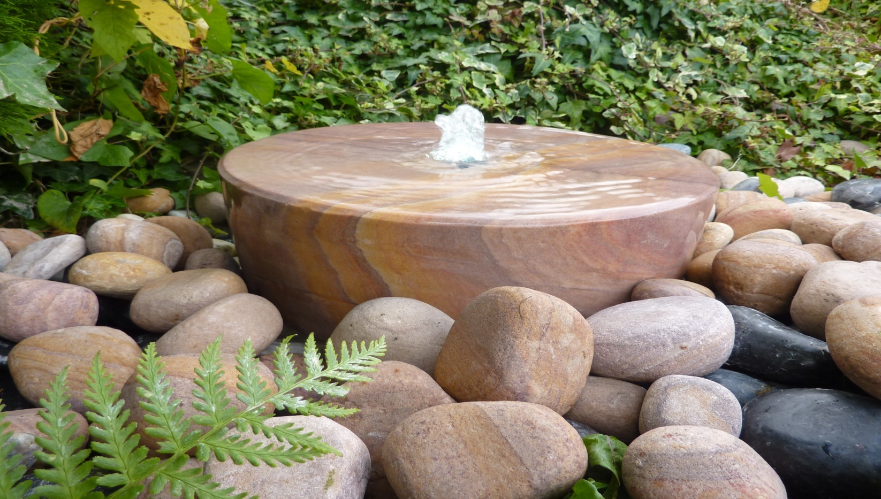
2349L RAINBOW SANDSTONE MILL WHEEL, DIA50 X12CM H; ALSO AVAILABLE 2349 DIA38 X12CM H

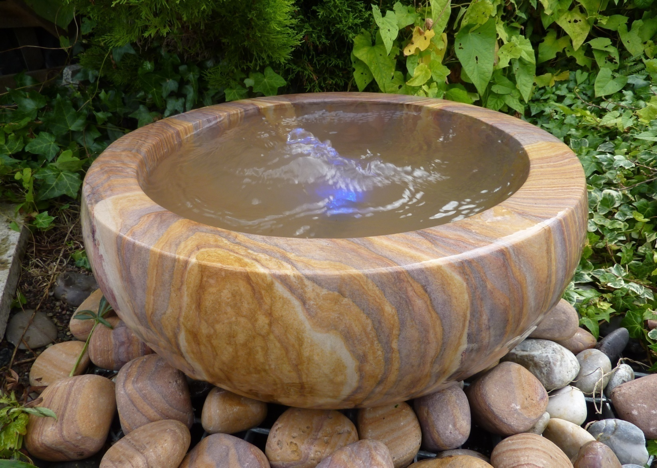
2345 RAINBOW BABBLING URN DIA50CM X25CM H
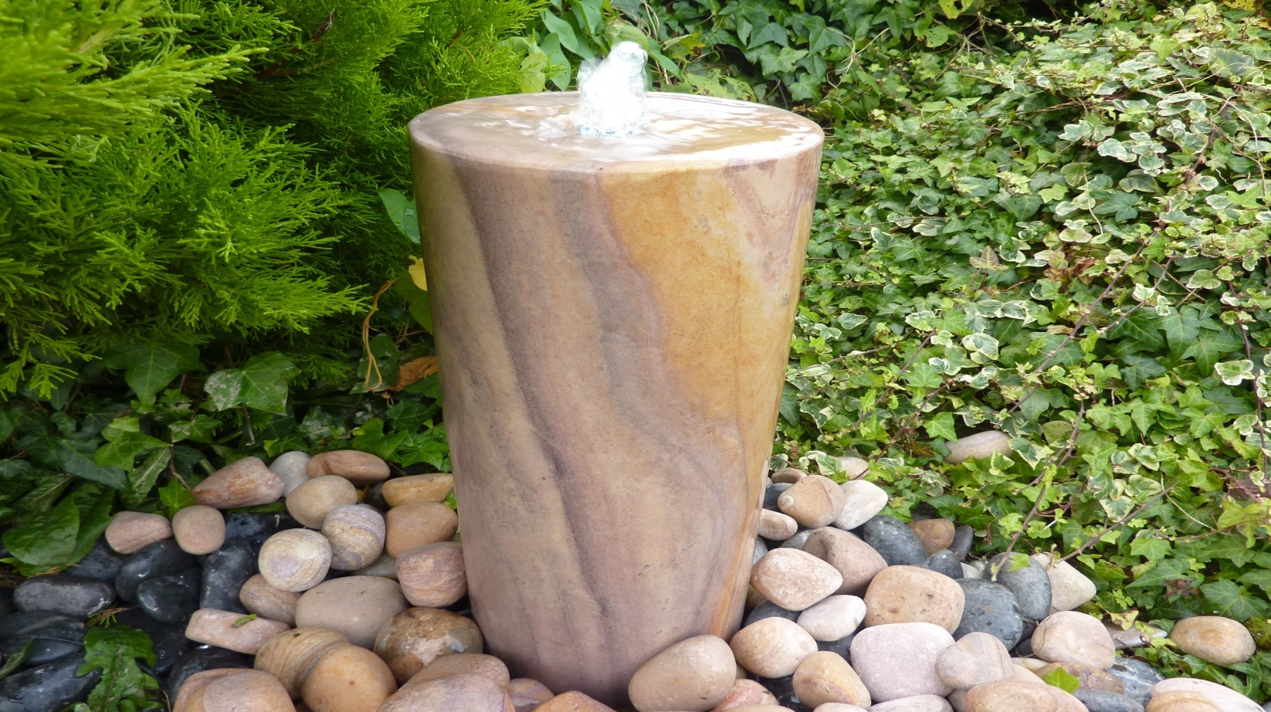
2350S RAINBOW SANDSTONE COLUMN, DIA20 X50CM H; ALSO AVAILABLE 2350 DIA20 X70CM H
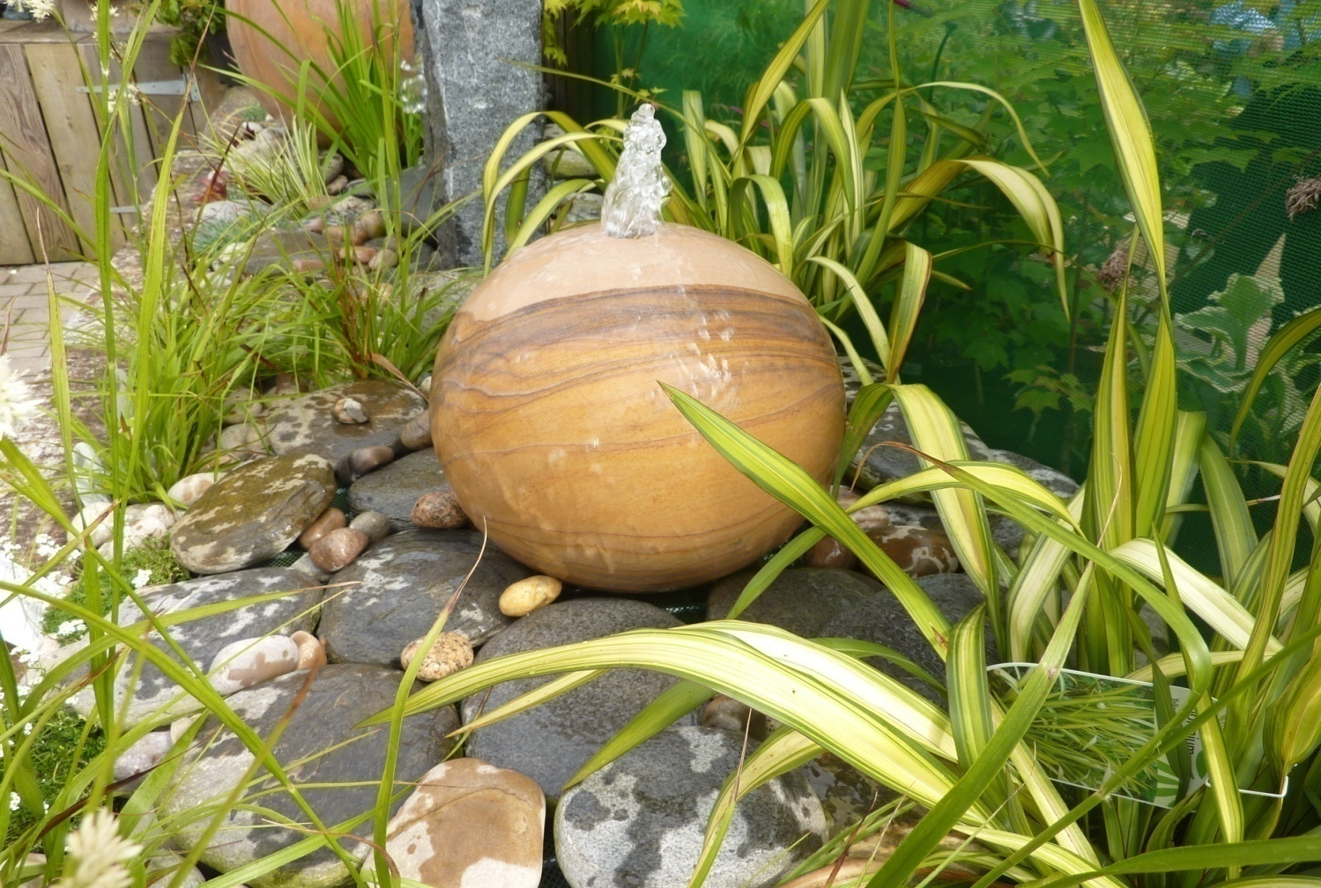
4020 -30CM /40CM /50CM /60CM RAINBOW SANDSTONE SPHERES DRILLED
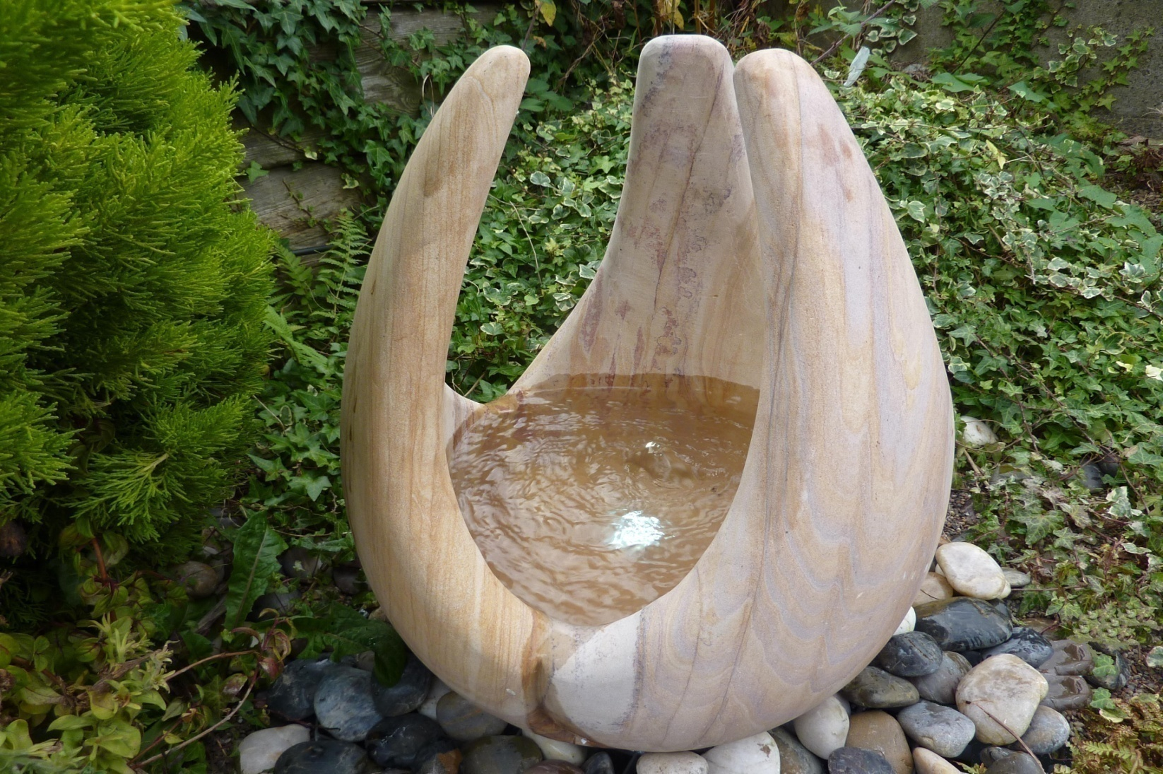
4023 BABBLING LILY, RAINBOW SANDSTONE DIA 36CM X 40CM H; 4023M DIA 42CM X 50CM H; 4023L DIA50X60CM H
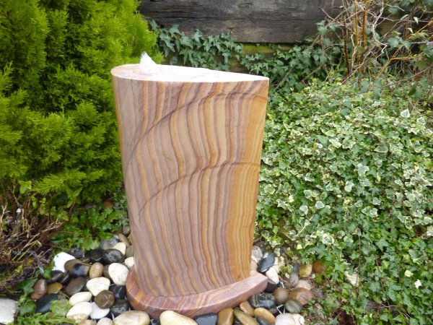
2324 ANGEL'S WING RAINBOW S. STONE WATER FEATURE, 45 X25 X71CM H
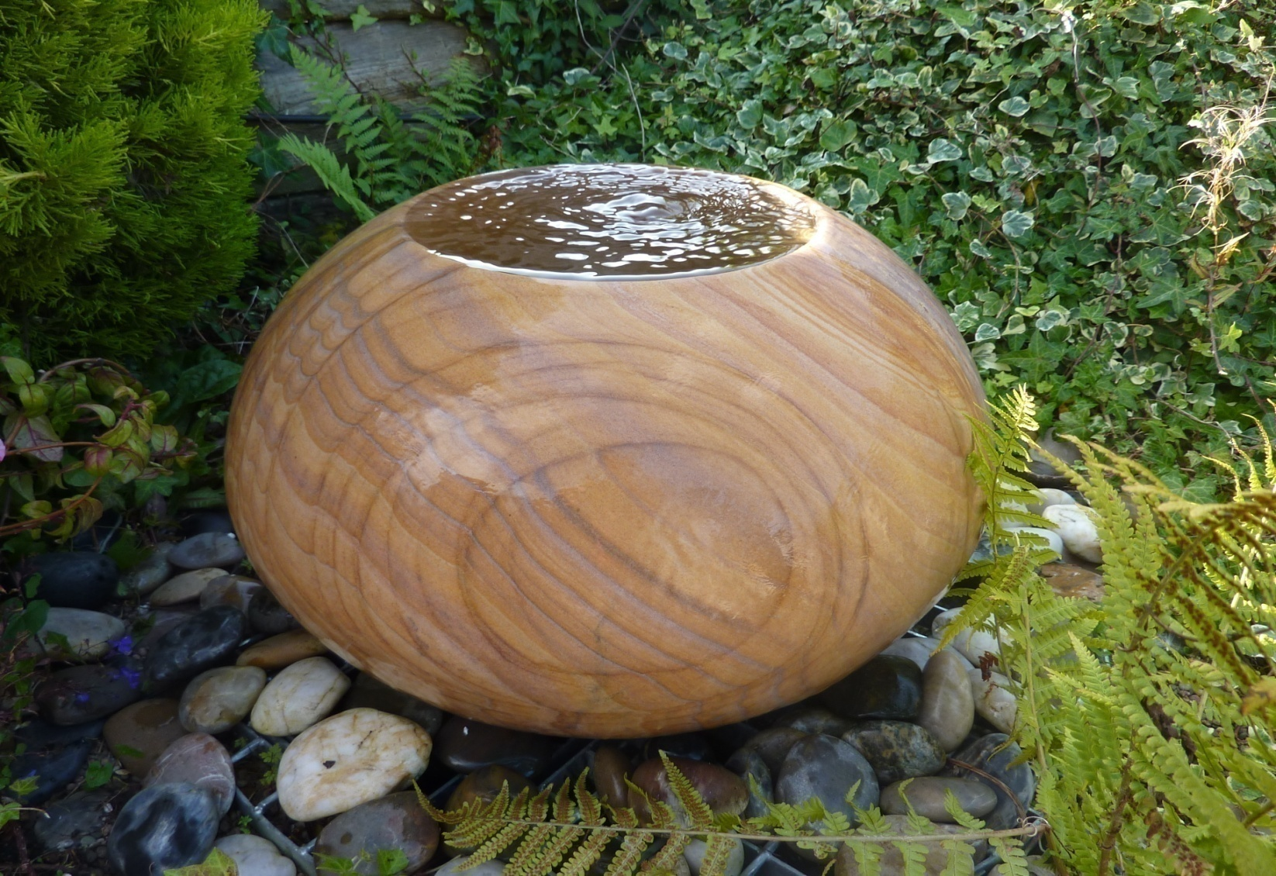
2332M RAINBOW SANDSTONE ARIUS, DIA40X29CM H; ALSO AVAILABLE 2332 DIA50CM X 36CM H
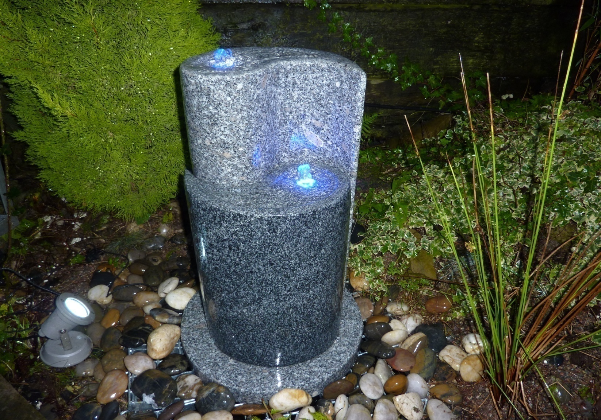
2328 YINYOUNG FOUNTAIN, TWO TONE GRANITE,DIA40 X65CM H
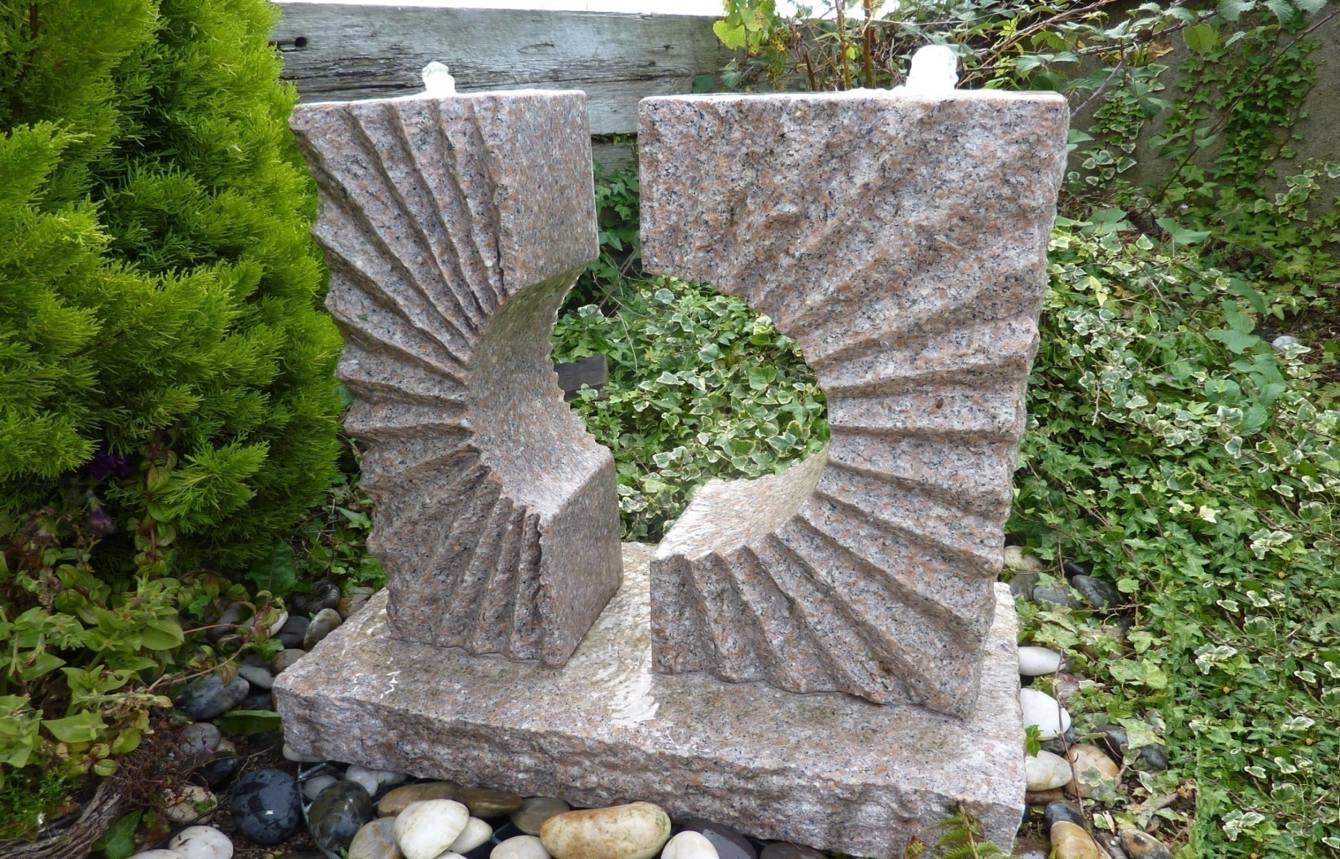
2329P ECLIPSE SUN FOUNTAIN, TWO TONE GRANITE,30X60x70CM H
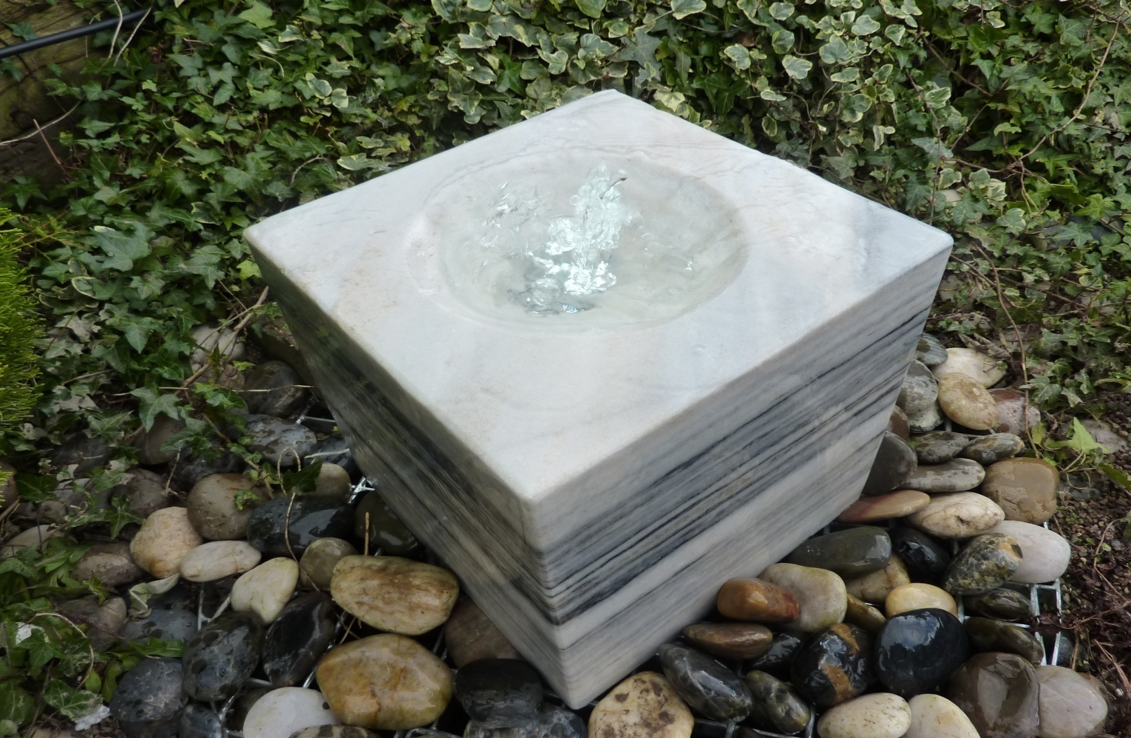
2337S POLISHED BLACK/WHITE MARBLE CUBE 30X30X30CM H
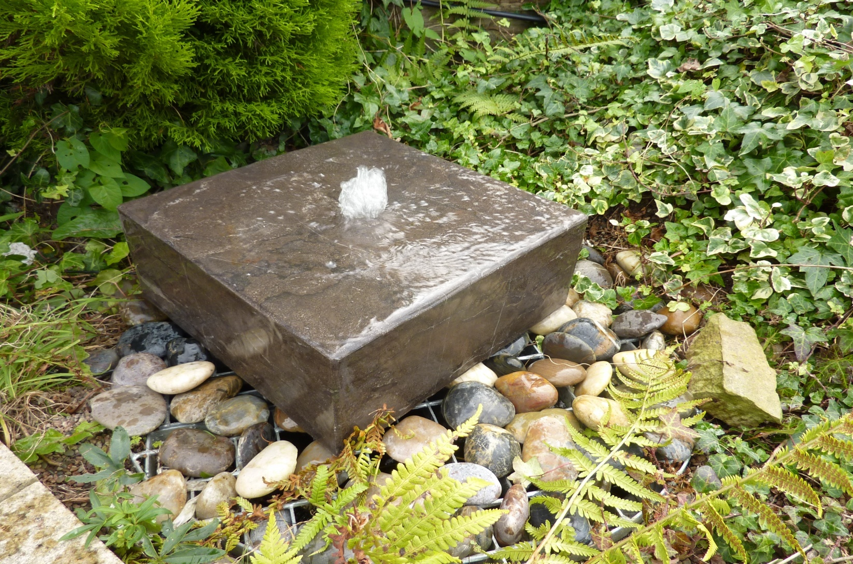
2342 BLACK LIMESTONE HALF CUBE, 38X38X15CM H, POLISHED
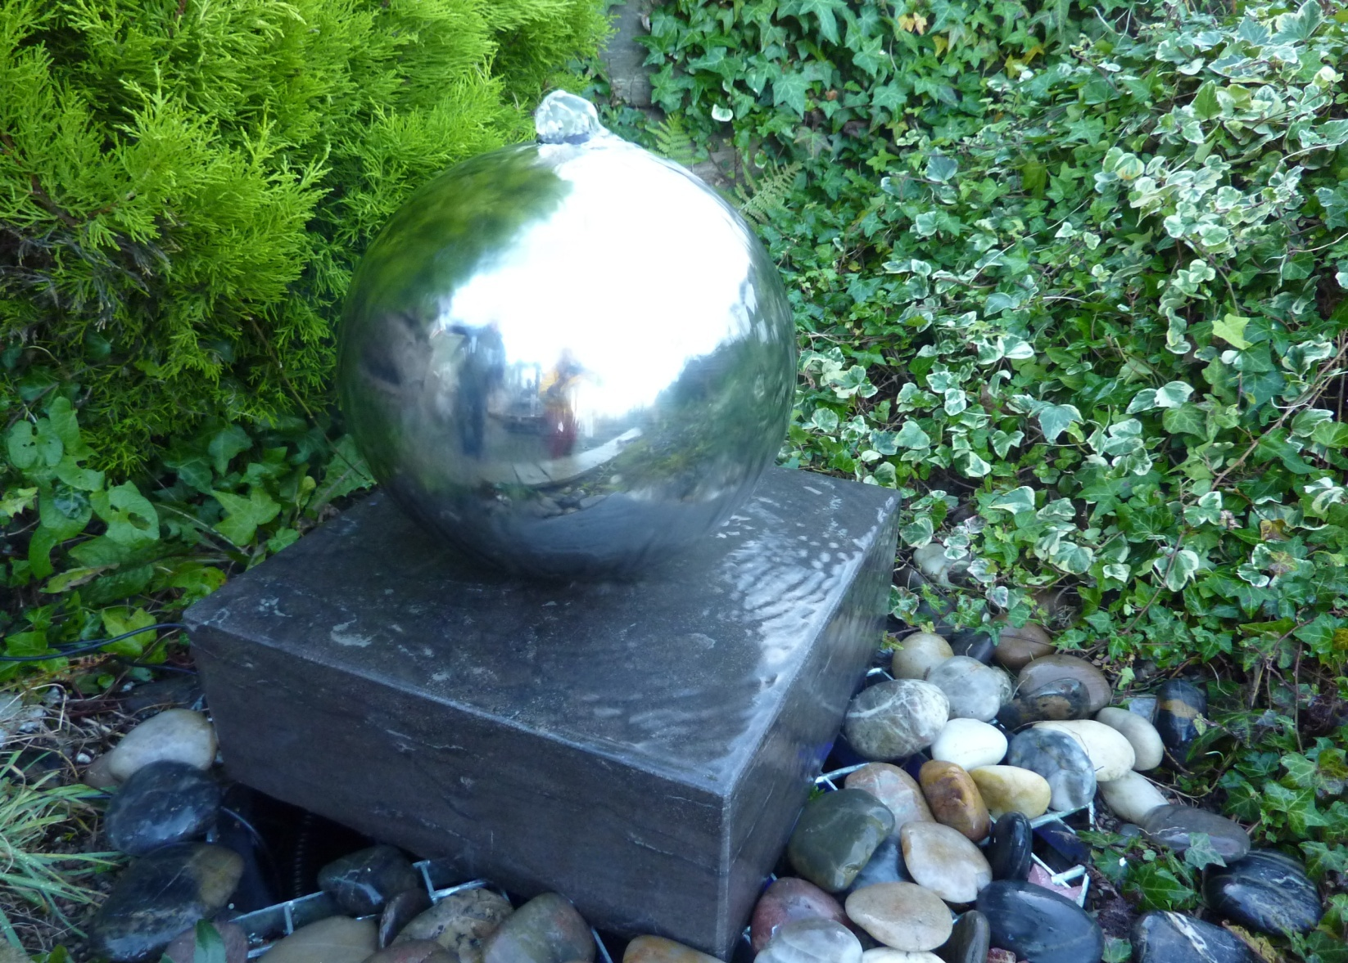
2342-SS30 EC POLISHED BLACK CUBE, 38X38X15CM H PLUS DIA20CM SS SPHERE
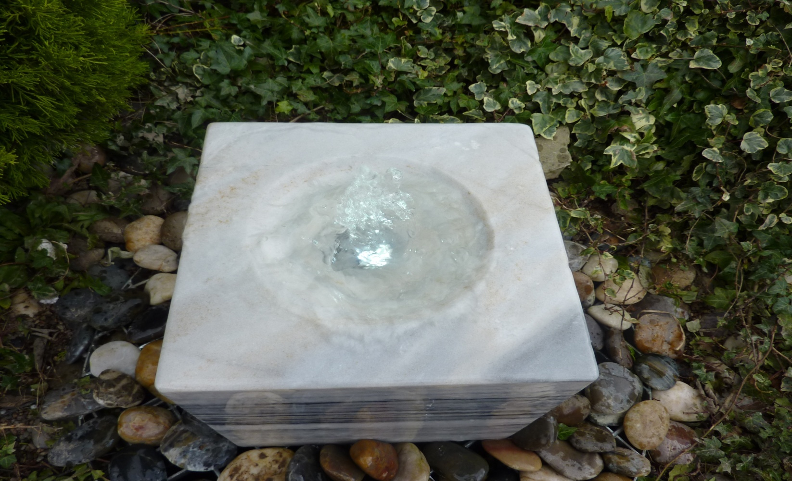
2342BW BLACK /WHITE MARBLE CUBE, 38X38X15CM H, POLISHED
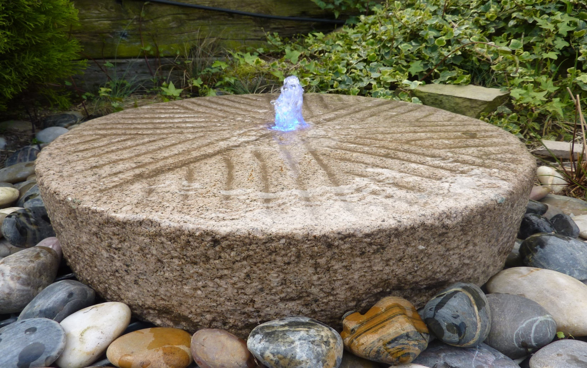
4010 OLD MILL STONE FOUNTAIN, D50~55CM, 8~12CM H; 4010L D60~65CM, 8~12CM H
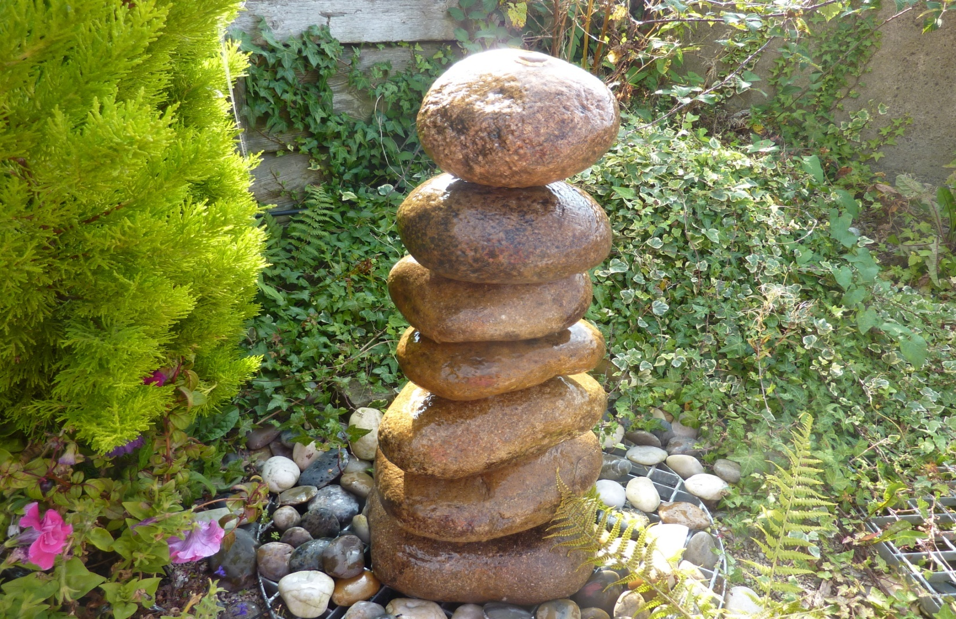
2339 CASCADING PEBBLE FOUNTAIN, 80CM H, NATURAL STACKED PEBBLES
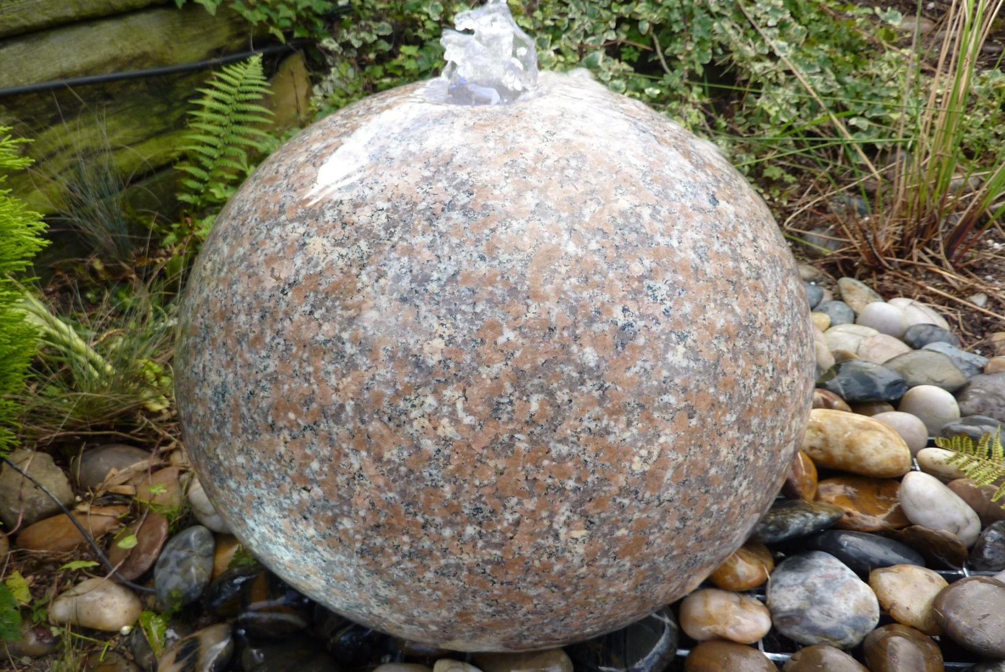
4014P POLISHED DRILLED PINKY GRANITE SPHERE, DIA40CM; 4013P DIA60cm
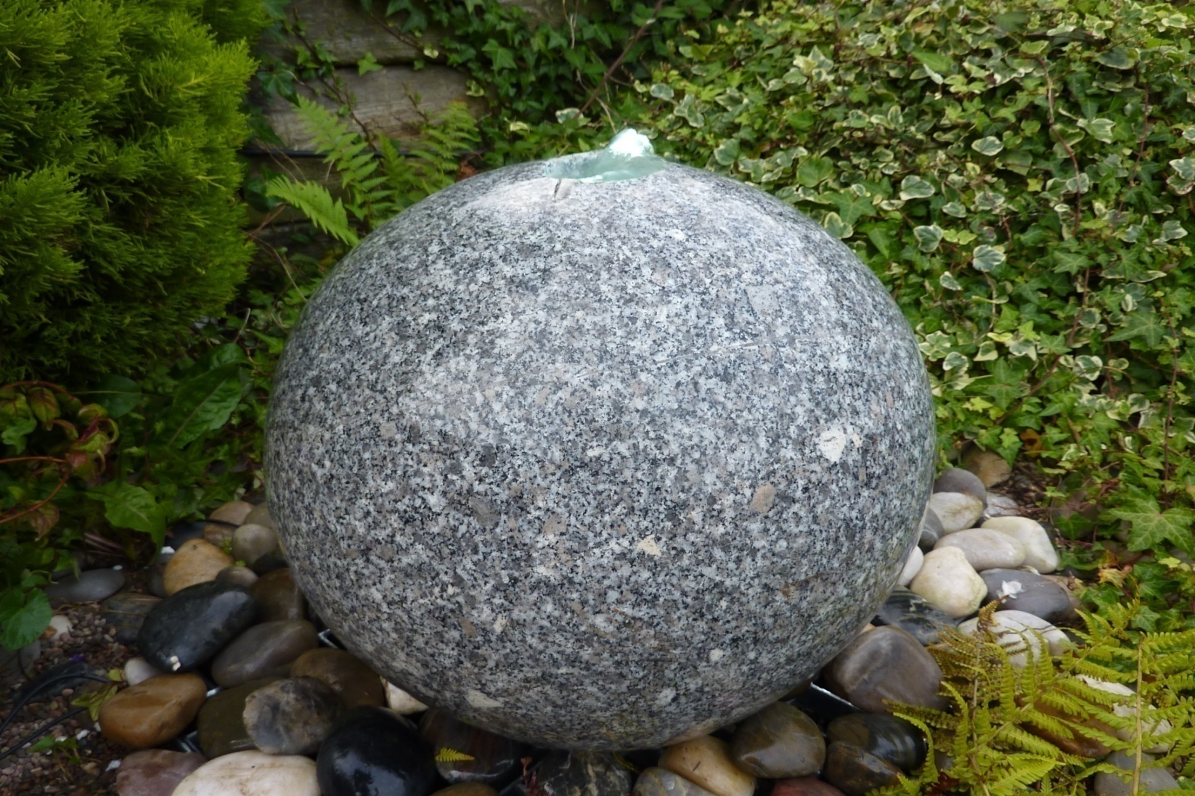
4014G-40CM POLISHED DRILLED GREY GRANITE SPHERE, DIA 40CM; 4014G-35CM; 4013G DIA60CM
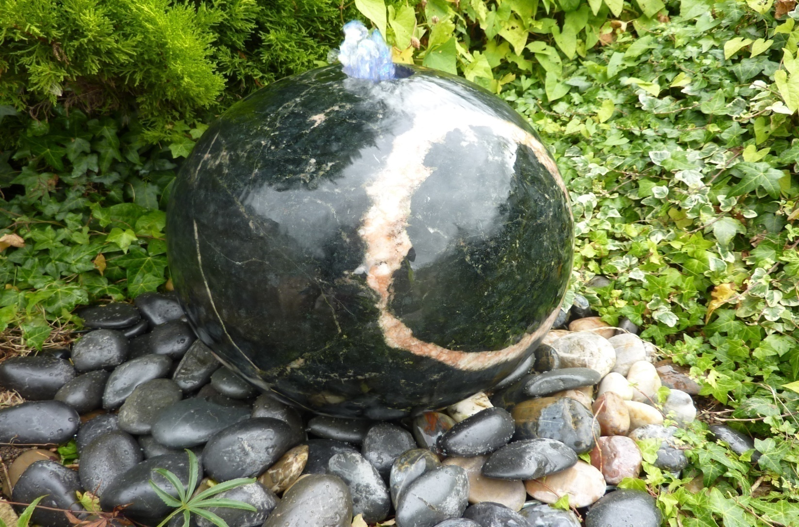
4014YF POLISHED DRILLED YIMENG FLOWER GRANITE SPHERE, DIA40CM
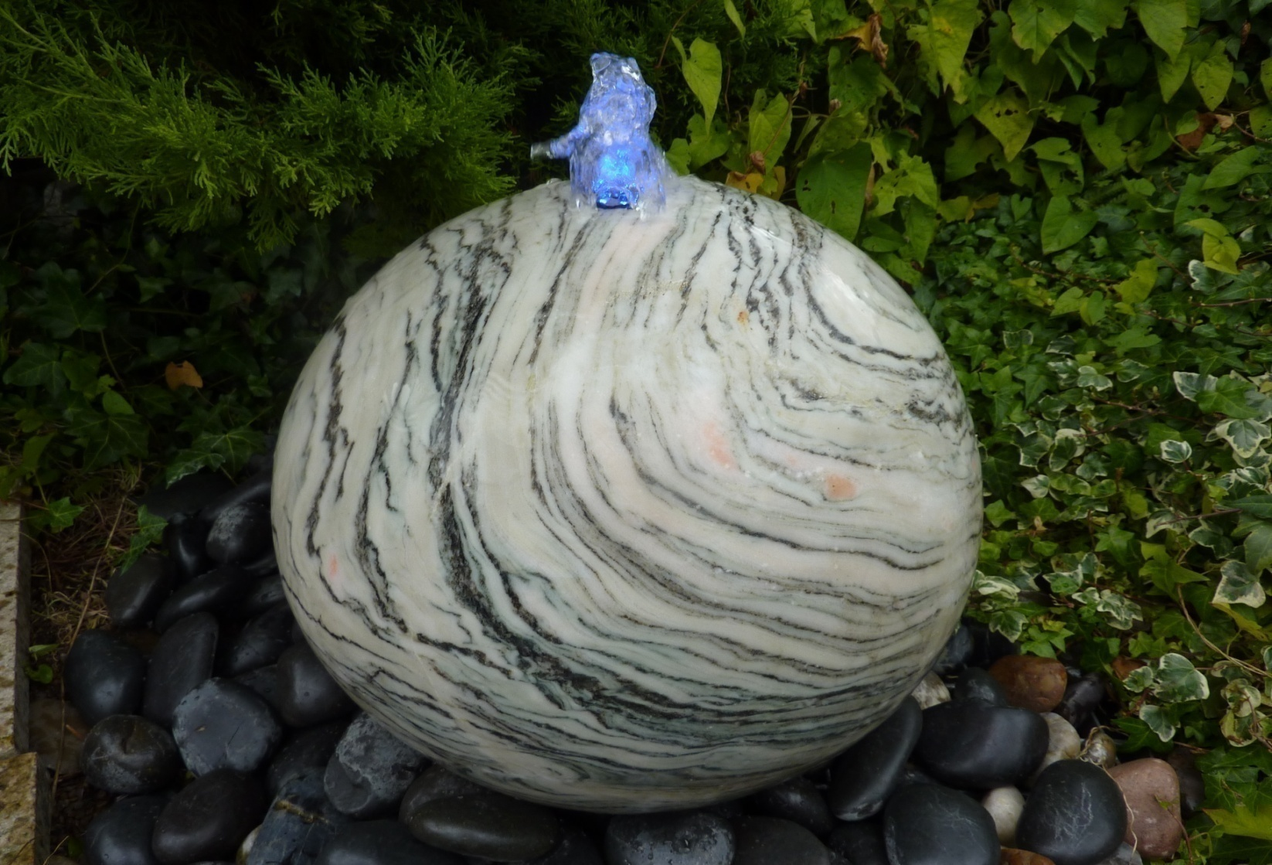
4014WAVEMARBLE POLISHED DRILLED WAVE MARBLE SPHERE, DIA40CM
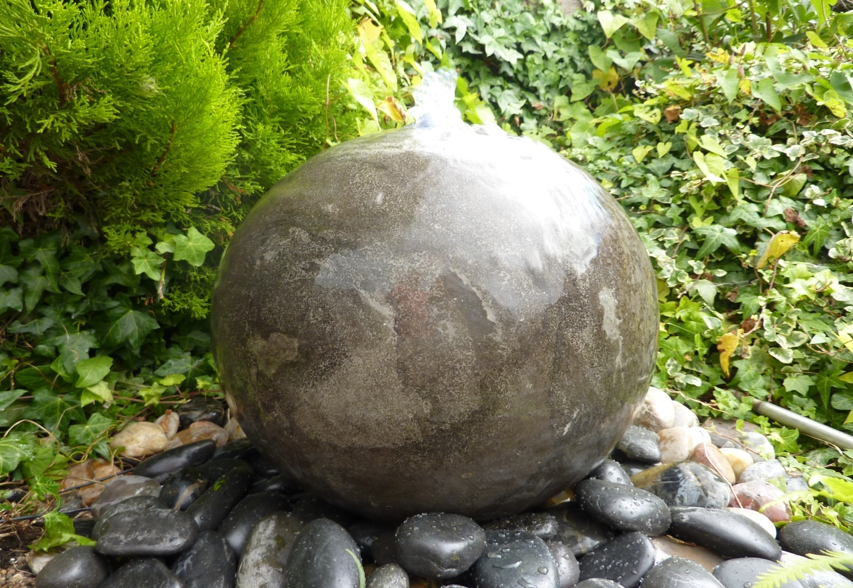
4014BL POLISHED DRILLED BLACK LIMESTONE SPHERE, DIA40CM
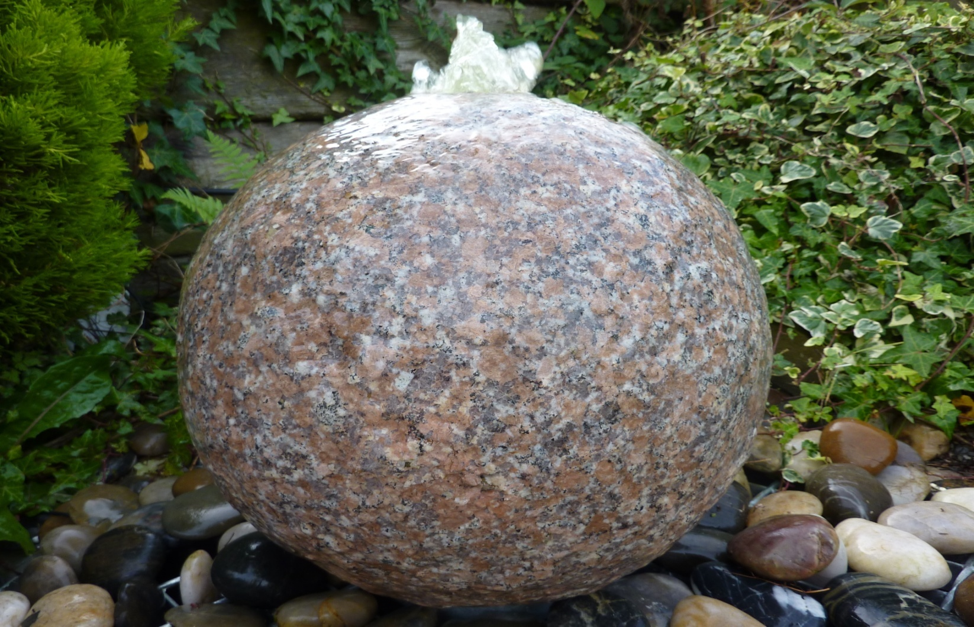
4015P DRILLED GRANITE SPHERE, FLAMED SURFACE, DIAM 35CM, PINKY; 4015G IN GREY GRANITE DIA35CM
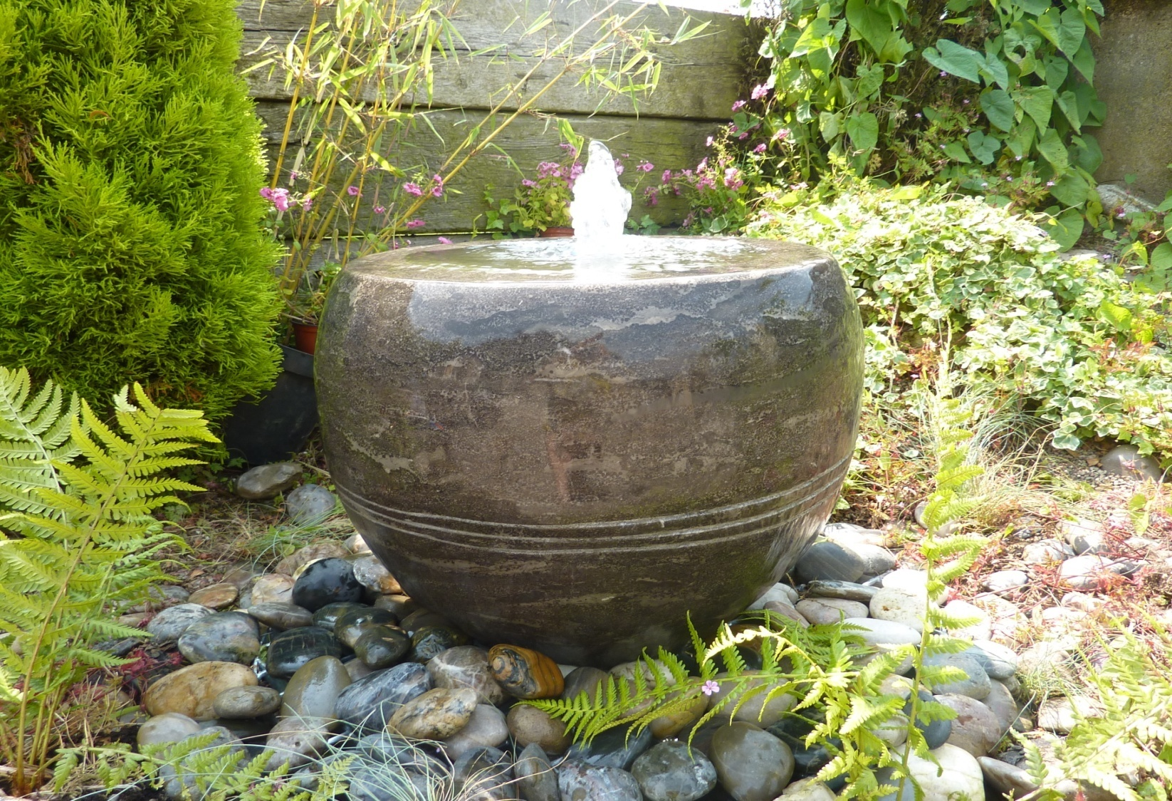
4025S BLACK VASE FOUNTAIN/PLANTER DIA40X32CM H, LIMESTONE

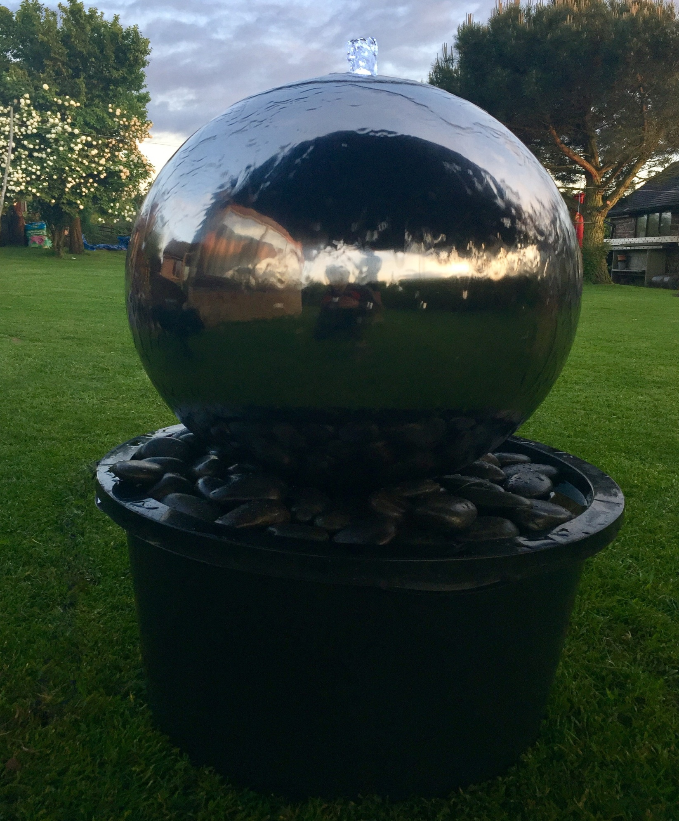
2401-60 BABBLING DIA60CM S.S.SPHERE COMPLETE(+6003+6011F+4007X2BAGS)
2401-40 BABBLING DIA40CM S.S.SPHERE COMPLETE(+6003+6011F+4007X2BAGS)
2401-30 BABBLING DIA30CM S.S.SPHERE COMPLETE(+6003+6011F+4007X2BAGS)

3 - oriental lanterns hand carved

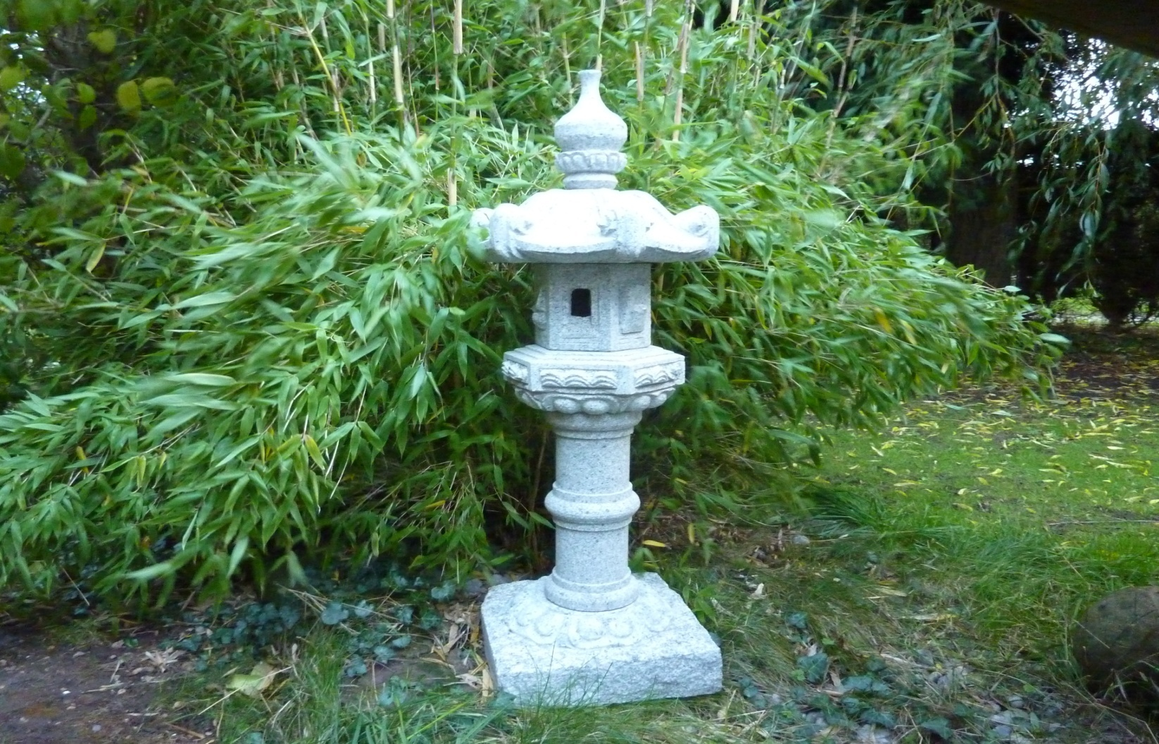
3008 KASUGA LANTERN, 90CM H, grey
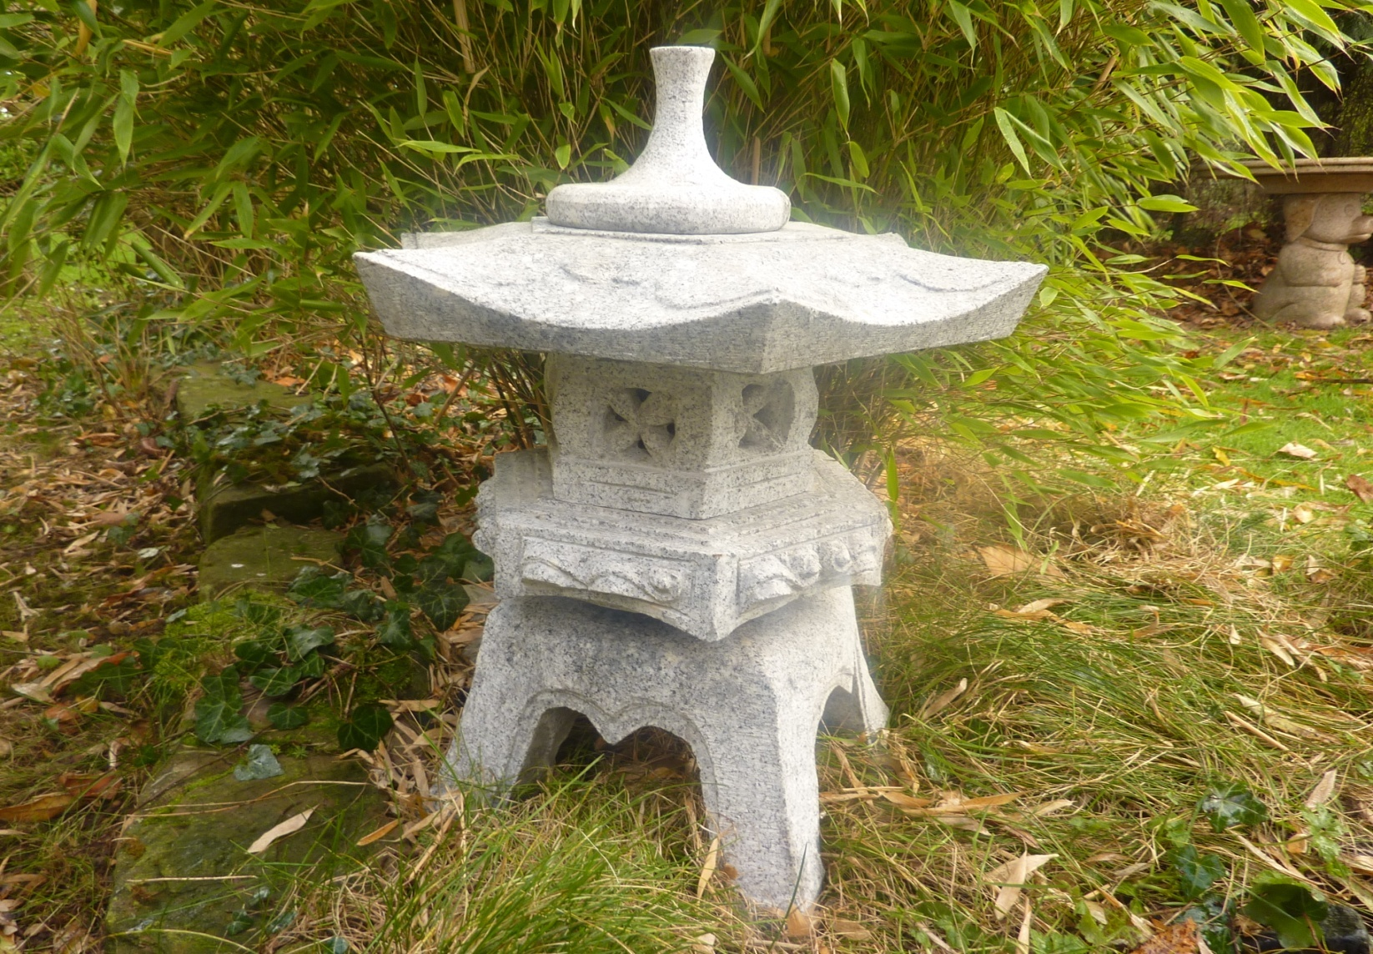
3032 60CM H ROKKAKU-YUKIMI LANTERN, GREY GRANITE
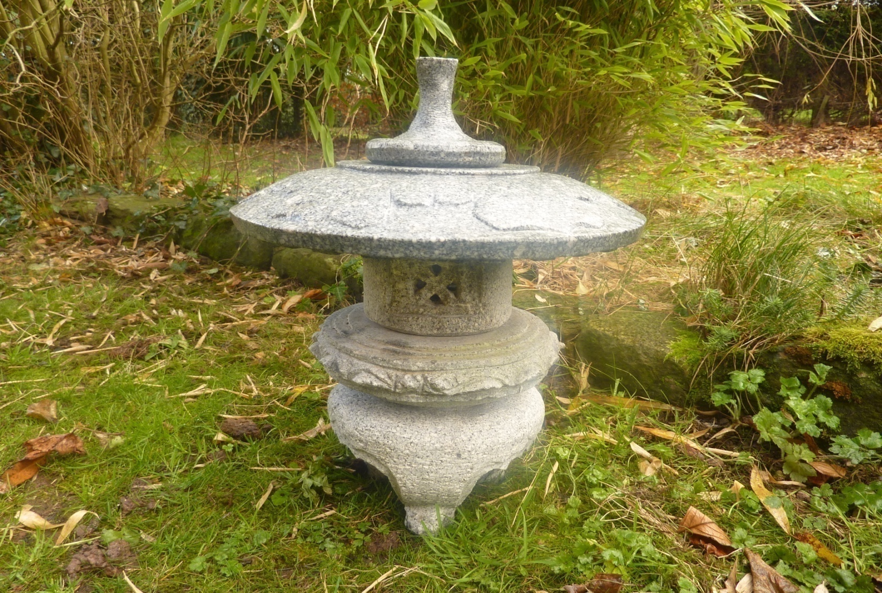
3035 60CM H MARU-YUKIMI LANTERN, GREY GRANITE
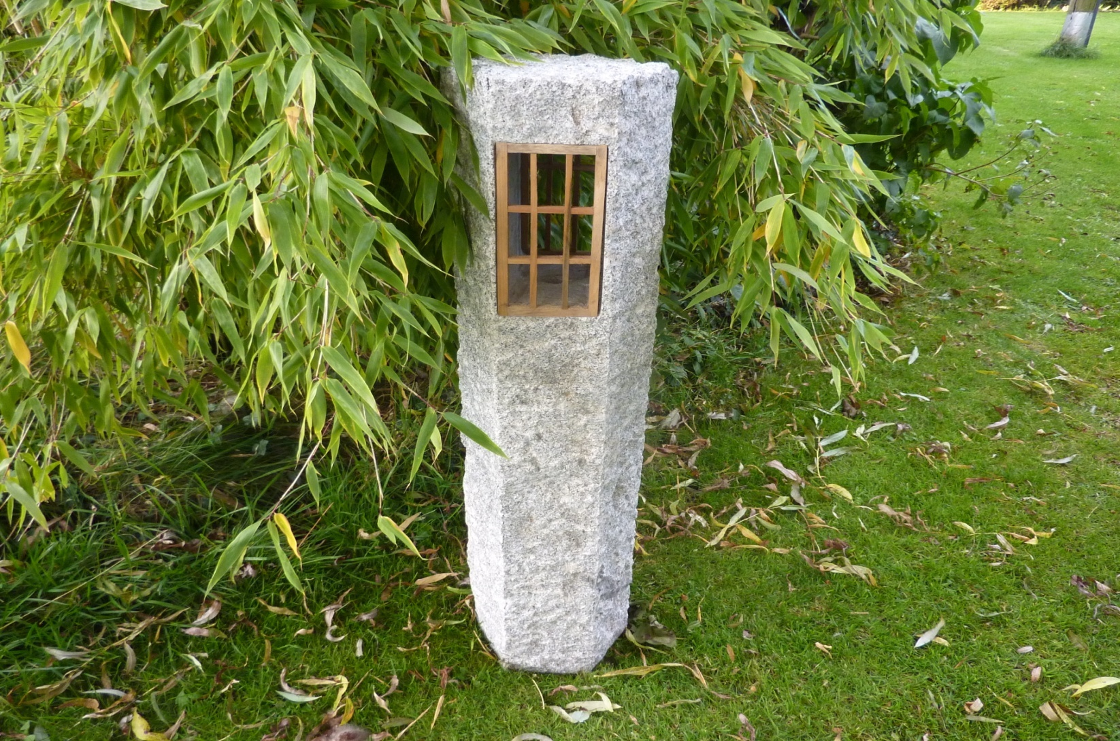
3017 MISHI SHRUBE GUIDE LANTERN, GREY GRANITE, 95CM H
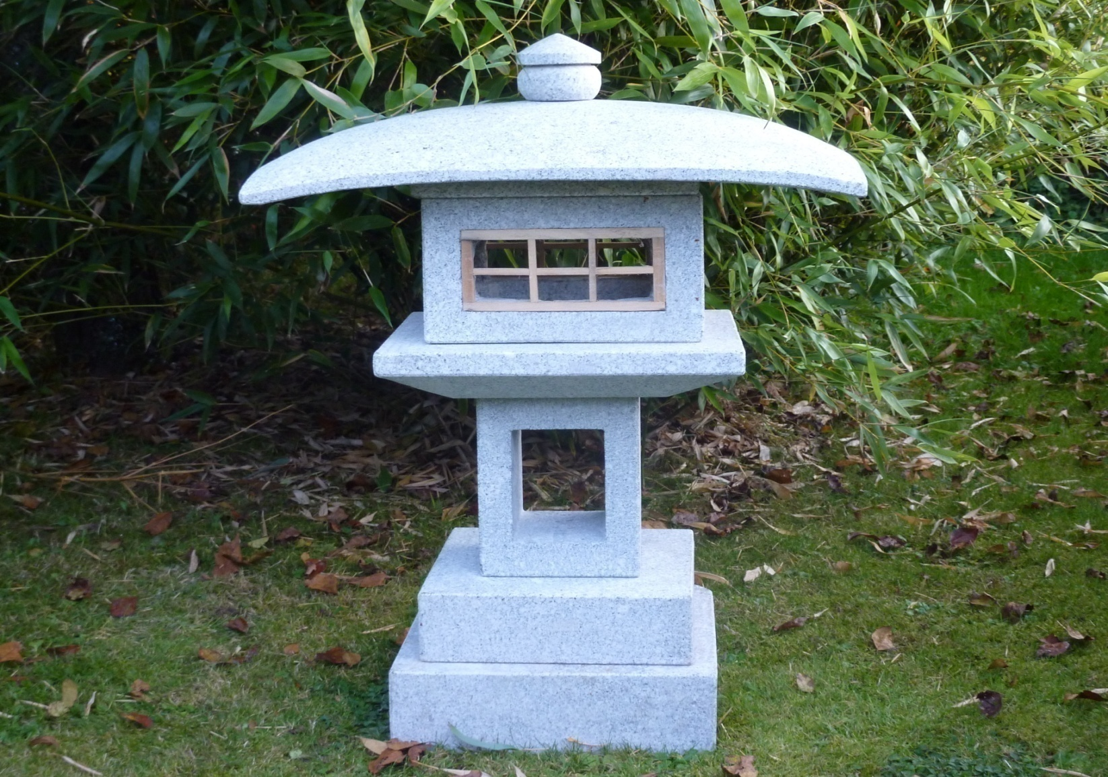
3022 KANSUYUJI LANTERN, 60X35X78CM H, GREY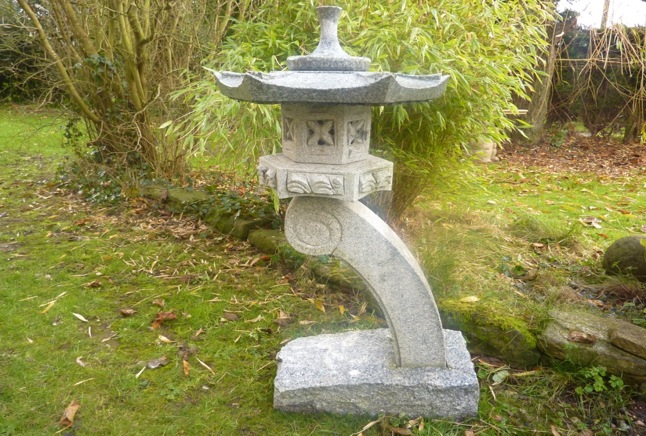 3027 - RANKEI LANTERN, 60CM H IN G383 GREY; 3029 RANKEI LANTERN, 90CM H IN GREY
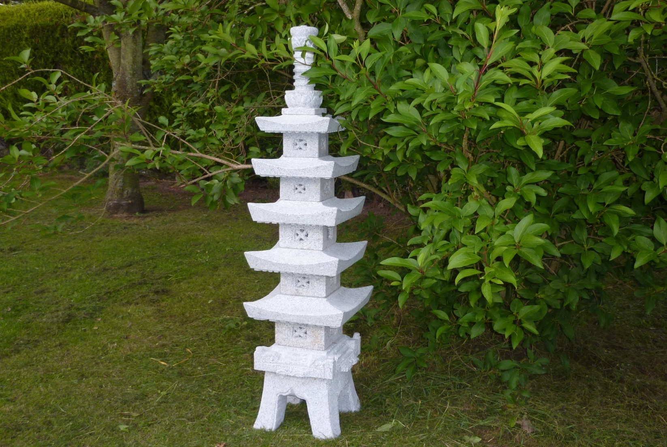
3004 PAGODA with latex window,150CM H, GREY GRANITE
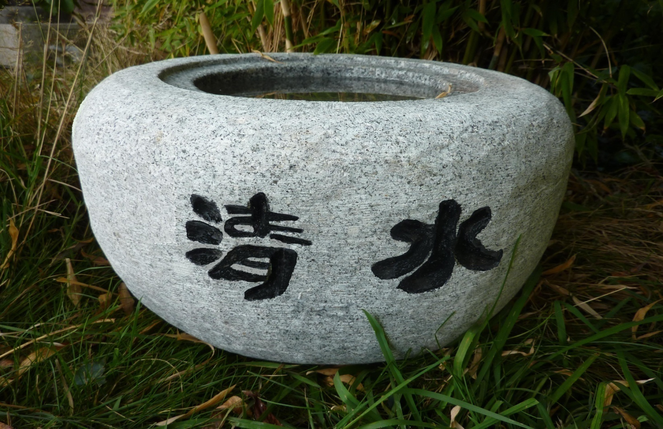
3031 TSUKUBAI BOWL, DIAM 40CMX 26CM H
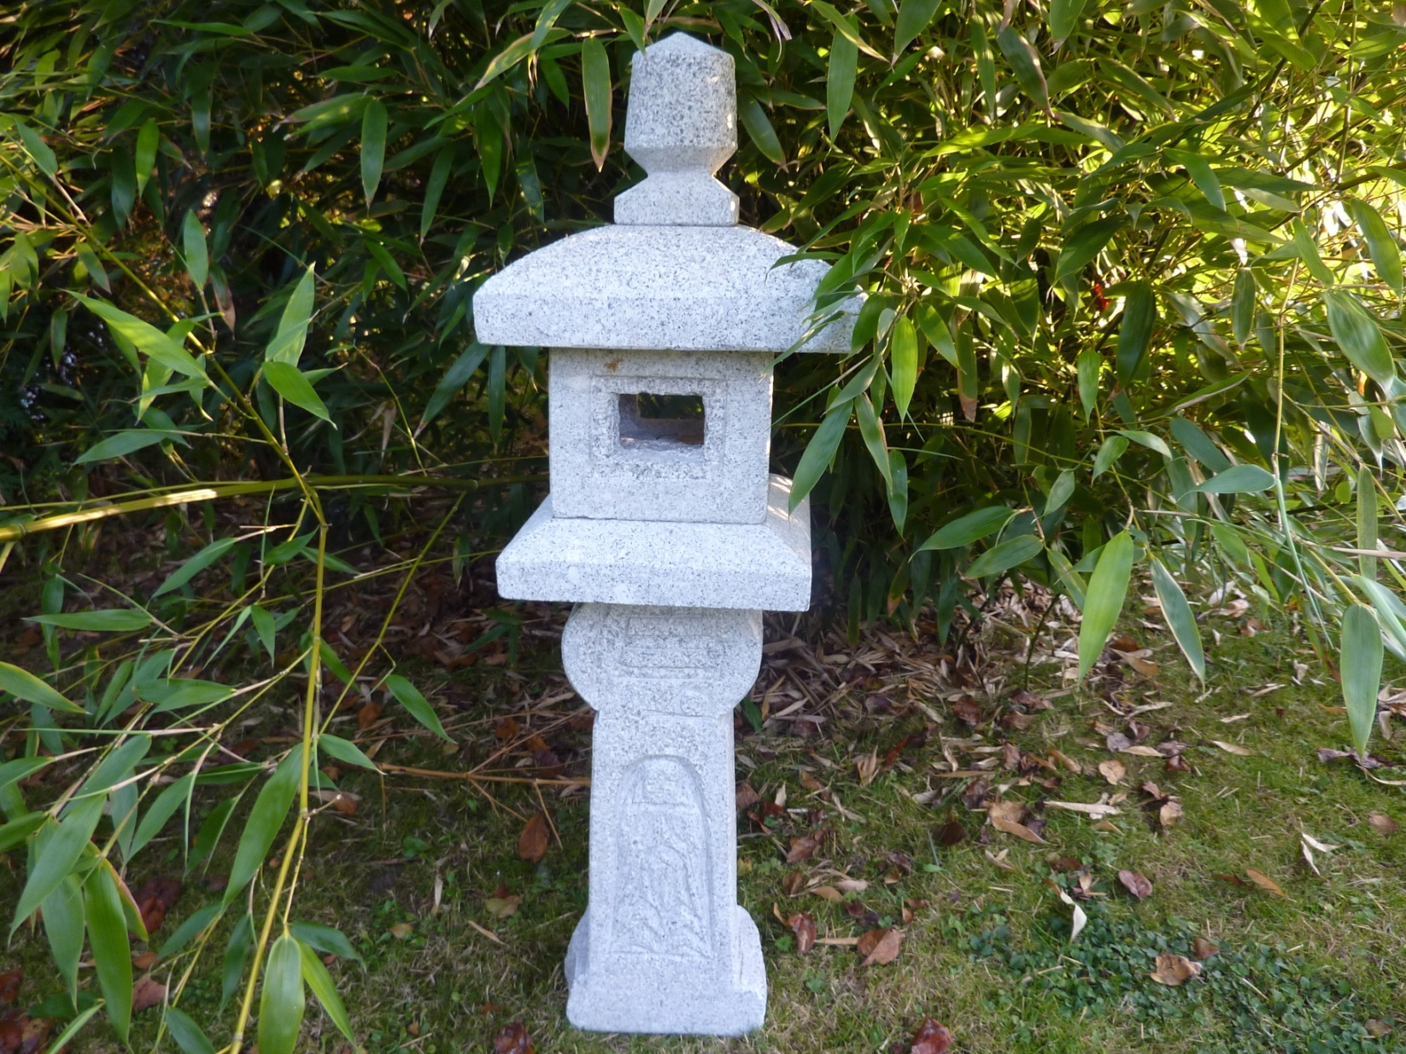
3038 - ORIBE LANTERN, WITH BUDDA CARVING, 90CM H, GREY
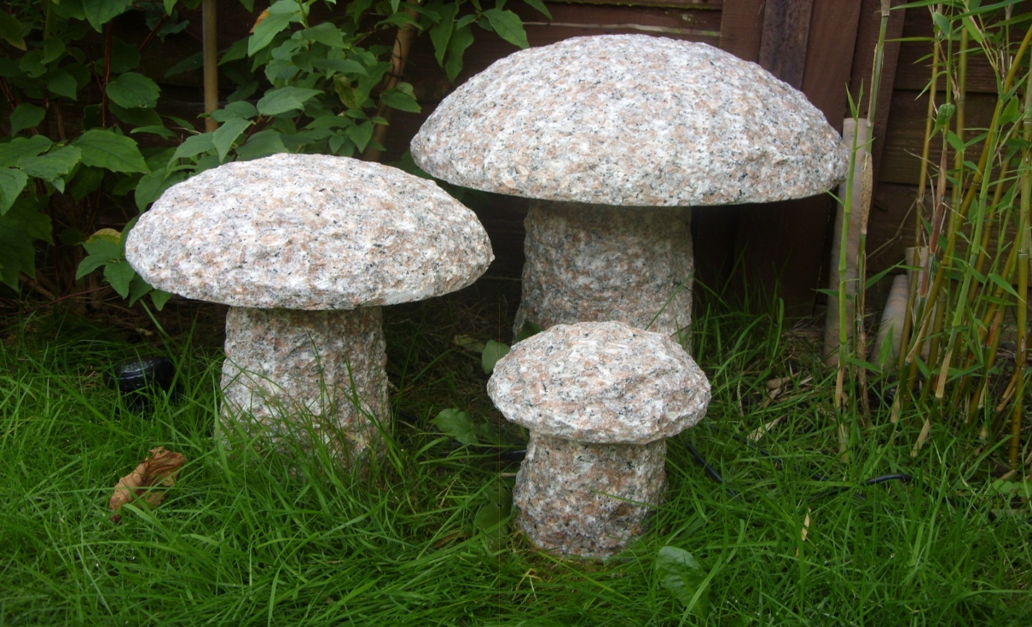
4053 SET OF 3 MUSHROOMS, PINKY, DIA12/22/32 x 17/27/37CM H
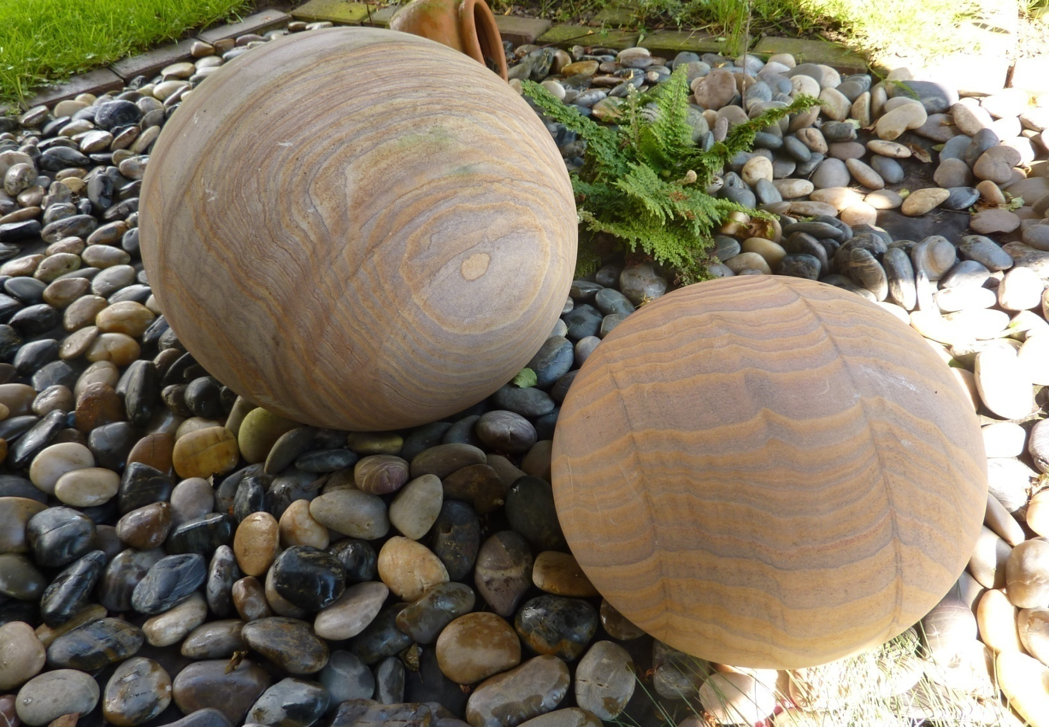
4019 PLAIN RAINBOW SANDSTONE SPHERES UNDRILLED, DIA20CM,30CM, 40CM
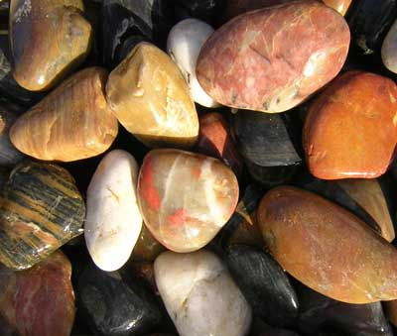
4007M MIXED COLOUR POLISHED RIVER PEBBLES SIZE 5~8CM, 15KG/BAG

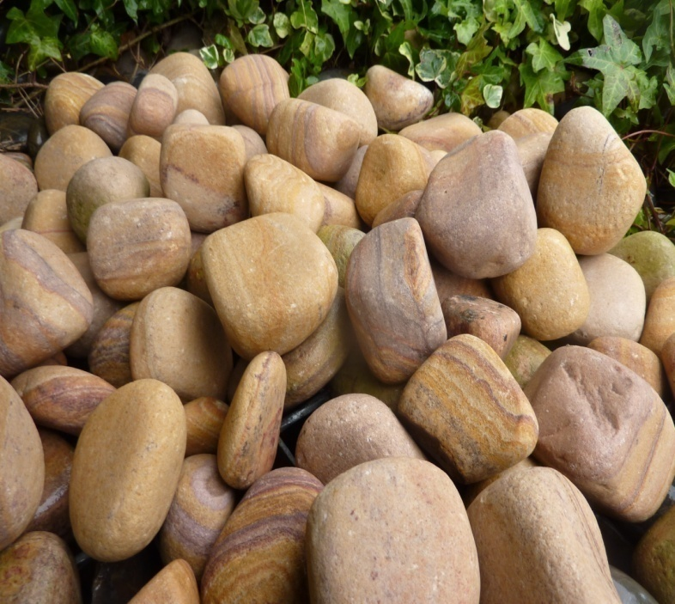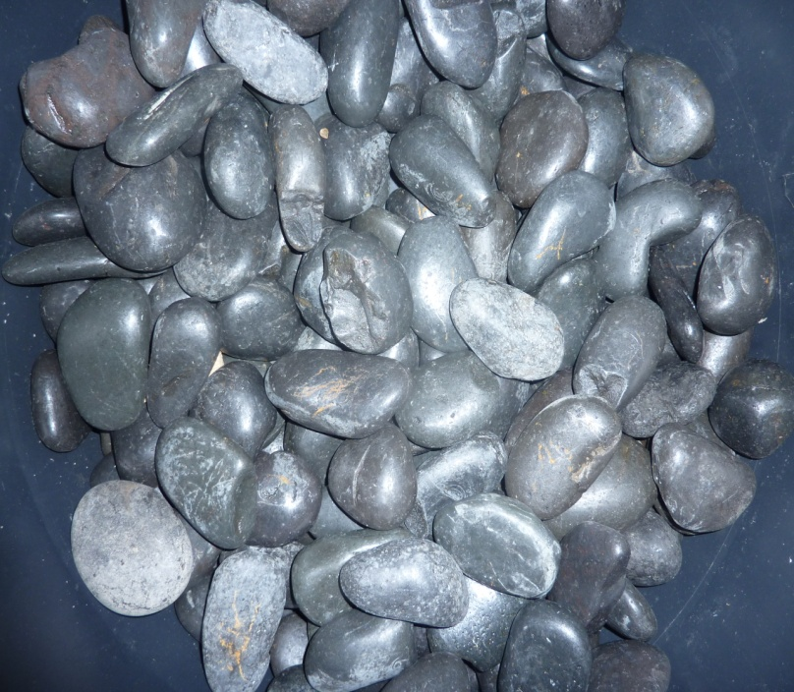

4009 Bag of 20kgs Rainbow sandstone pebbles, 5~8cm 4007 POLISHED RIVER PEBBLES, BLACK, 5~8CM, 15KG/BAG

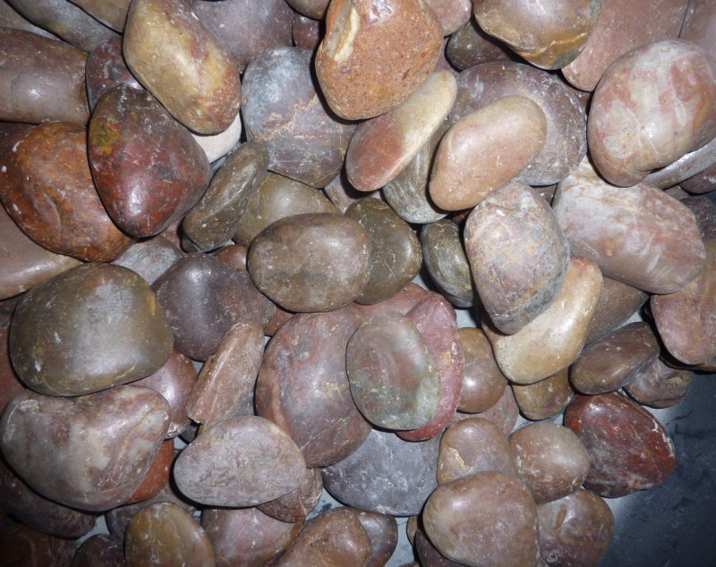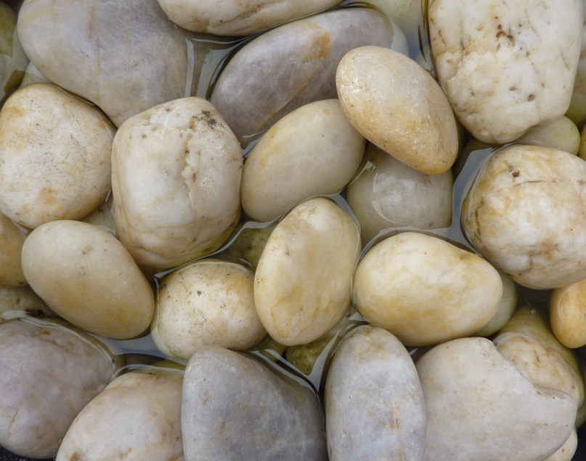
4007-RED POLISHED RIVER PEBBLES, NATURAL RED, 5~8CM, 15KG/BAG ; 4007-WHITE POLISHED 5~8CM, 15KG/BAG

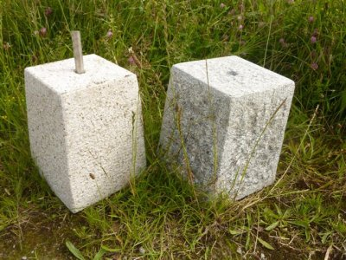 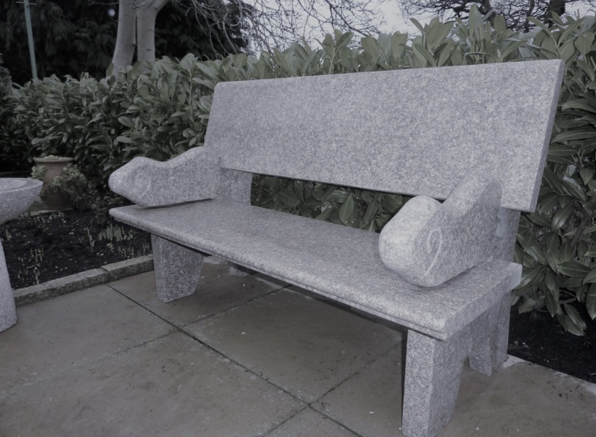4090 STRADDLE STONE 6" top /7" bottom, 9" H, granite 5007 HAYWORTH GARDEN BENCH, GREY, 130X32X43CM H

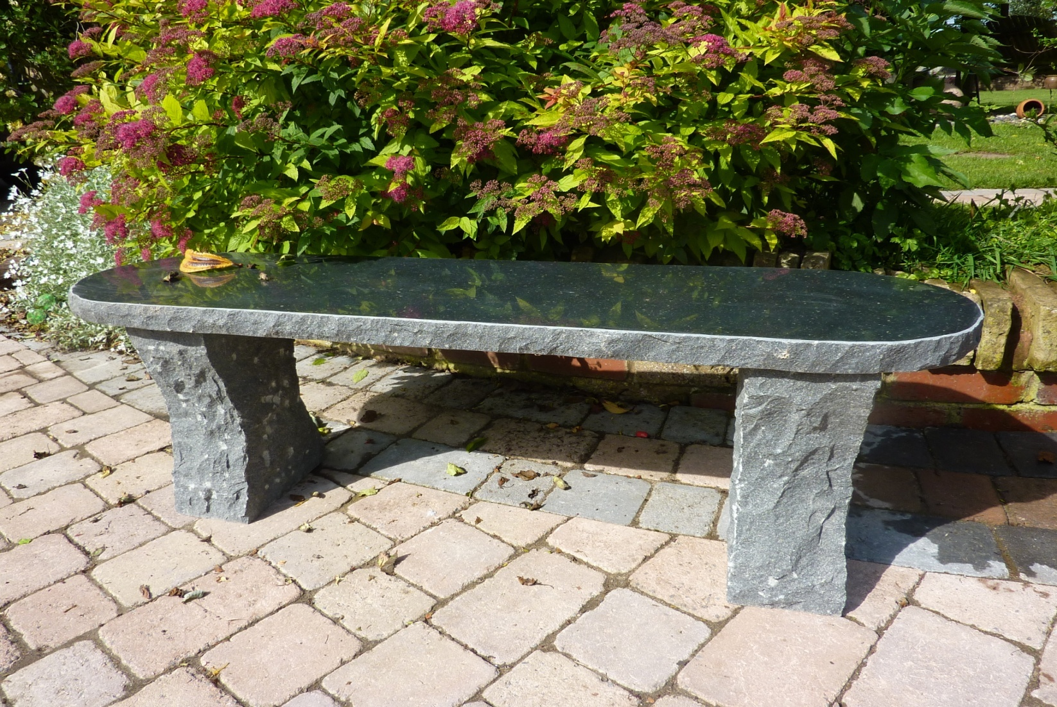
5010D BLACK RUSTIC BENCH, BULL NOSE END, 120 x35 x 42cm H
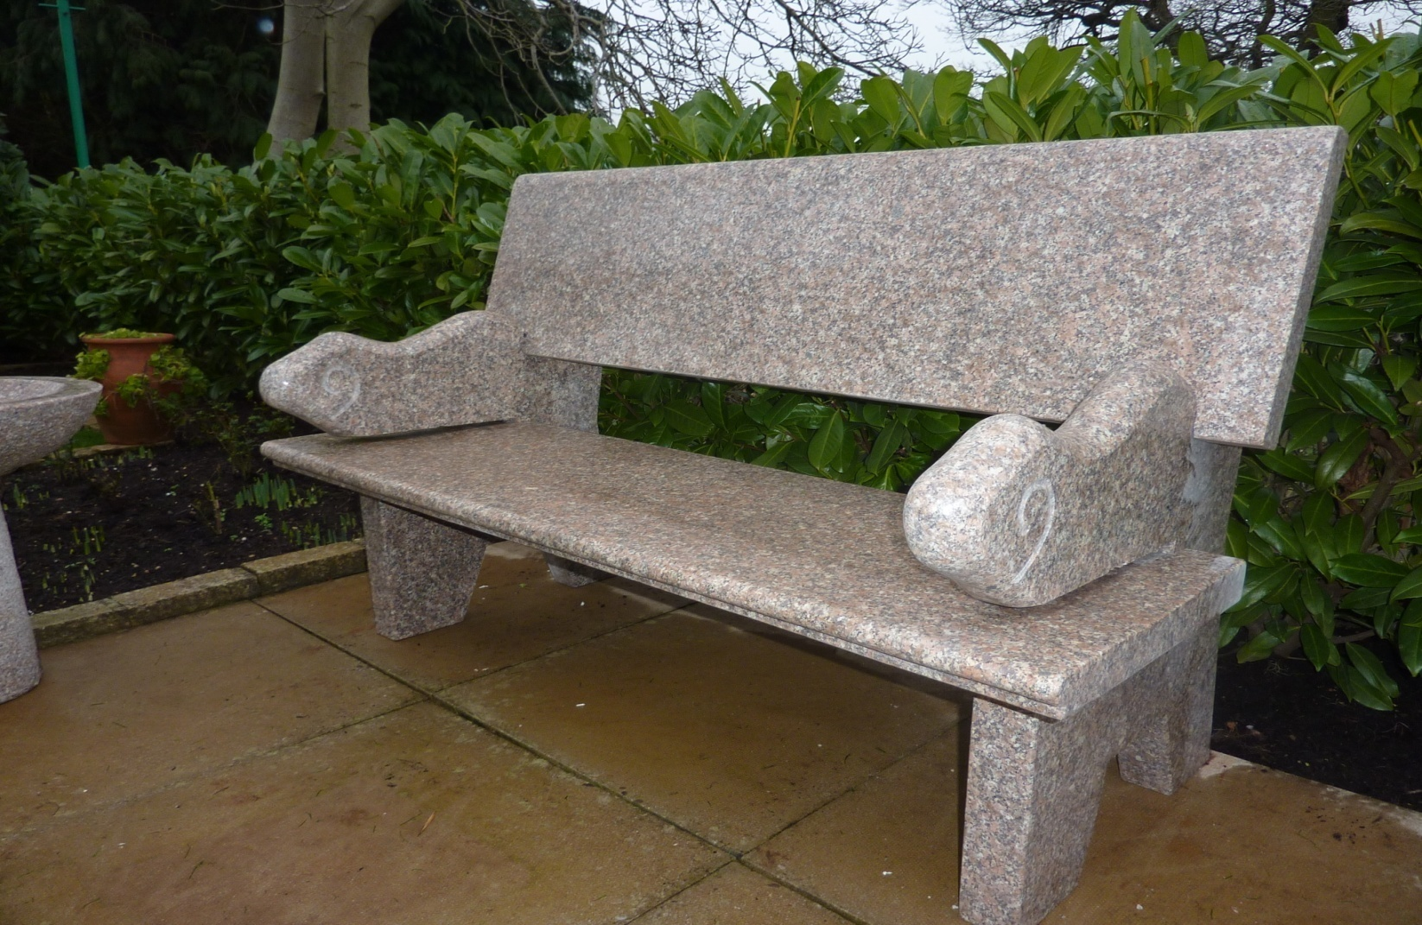
5007P HAYWORTH BENCH, PINKY GRANITE 130CM LONG, POLISHED SURFACE
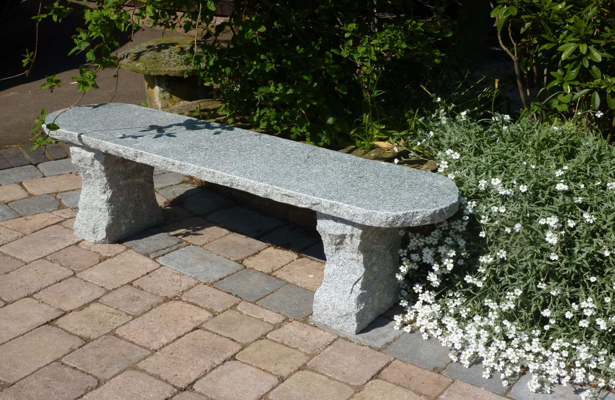
5010G RUSTIC BENCH, 120X35X42CM H,grey granite
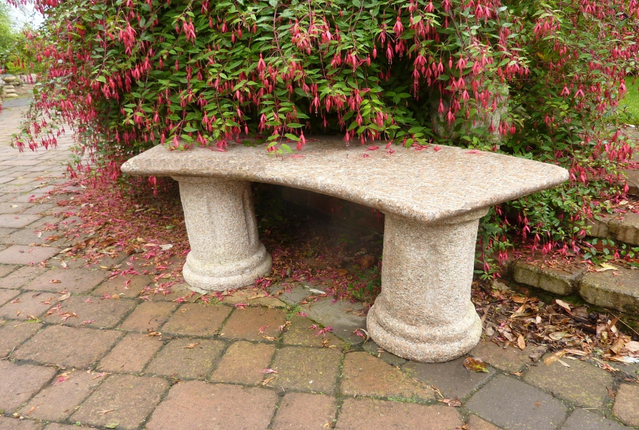
5003P FLORENCE BENCH,PINK GRANITE, 120X32X44CM H
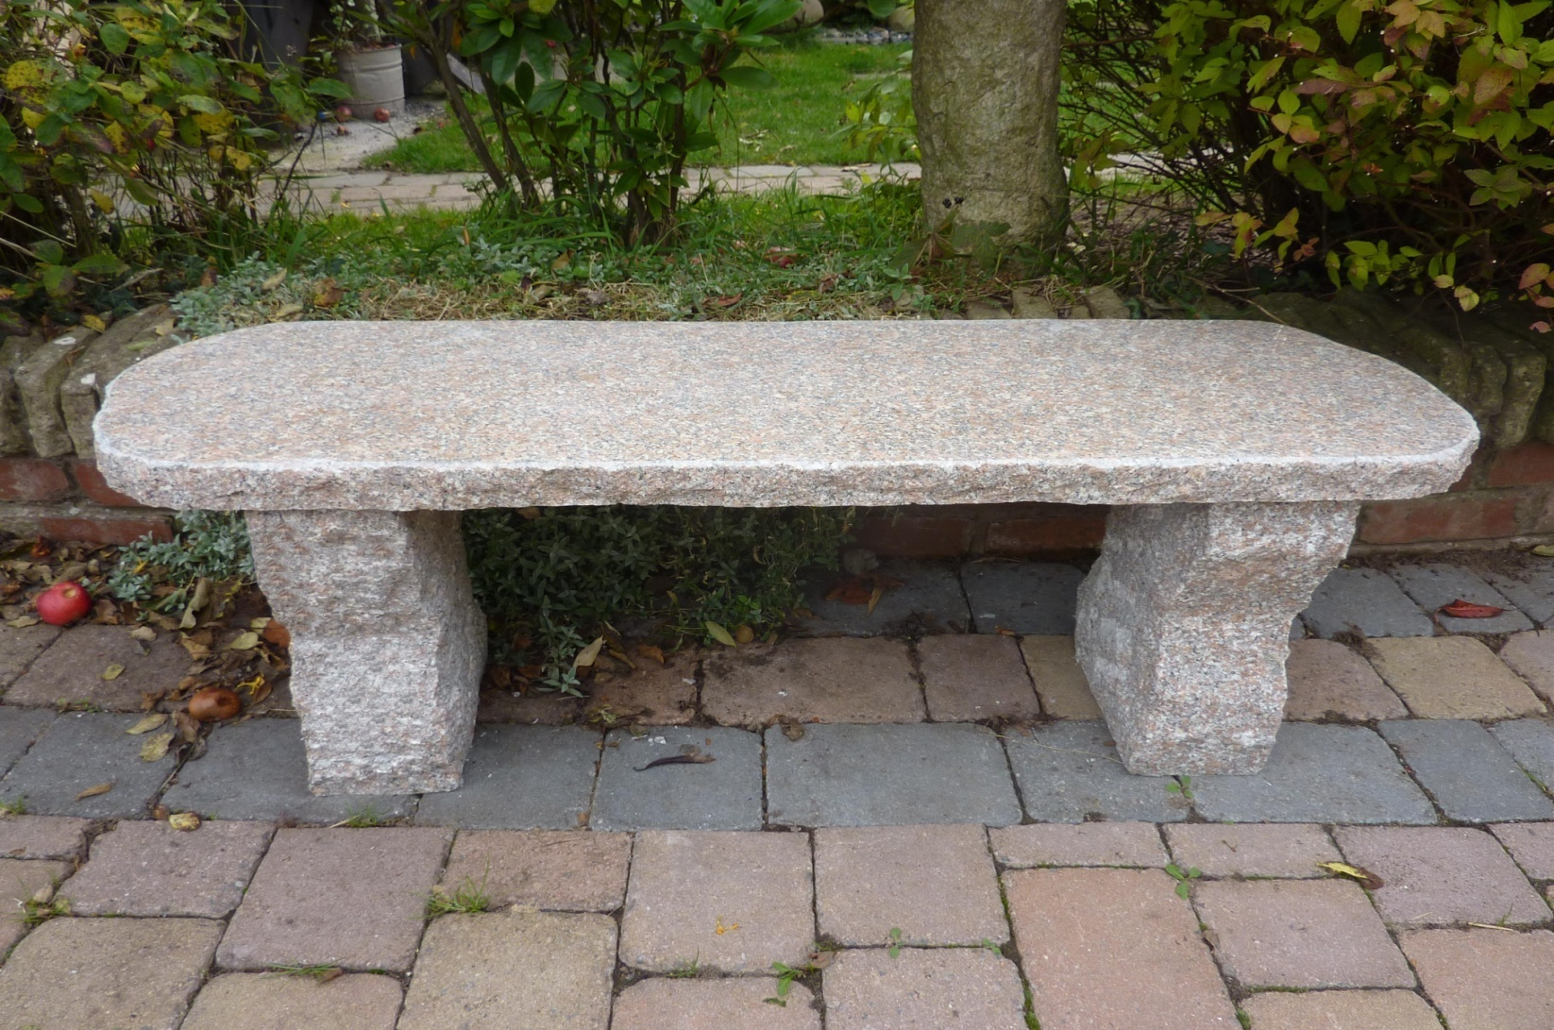
5010P 5010 RUSTIC BENCH, 120X35X42CM H, PINKY GRANITE
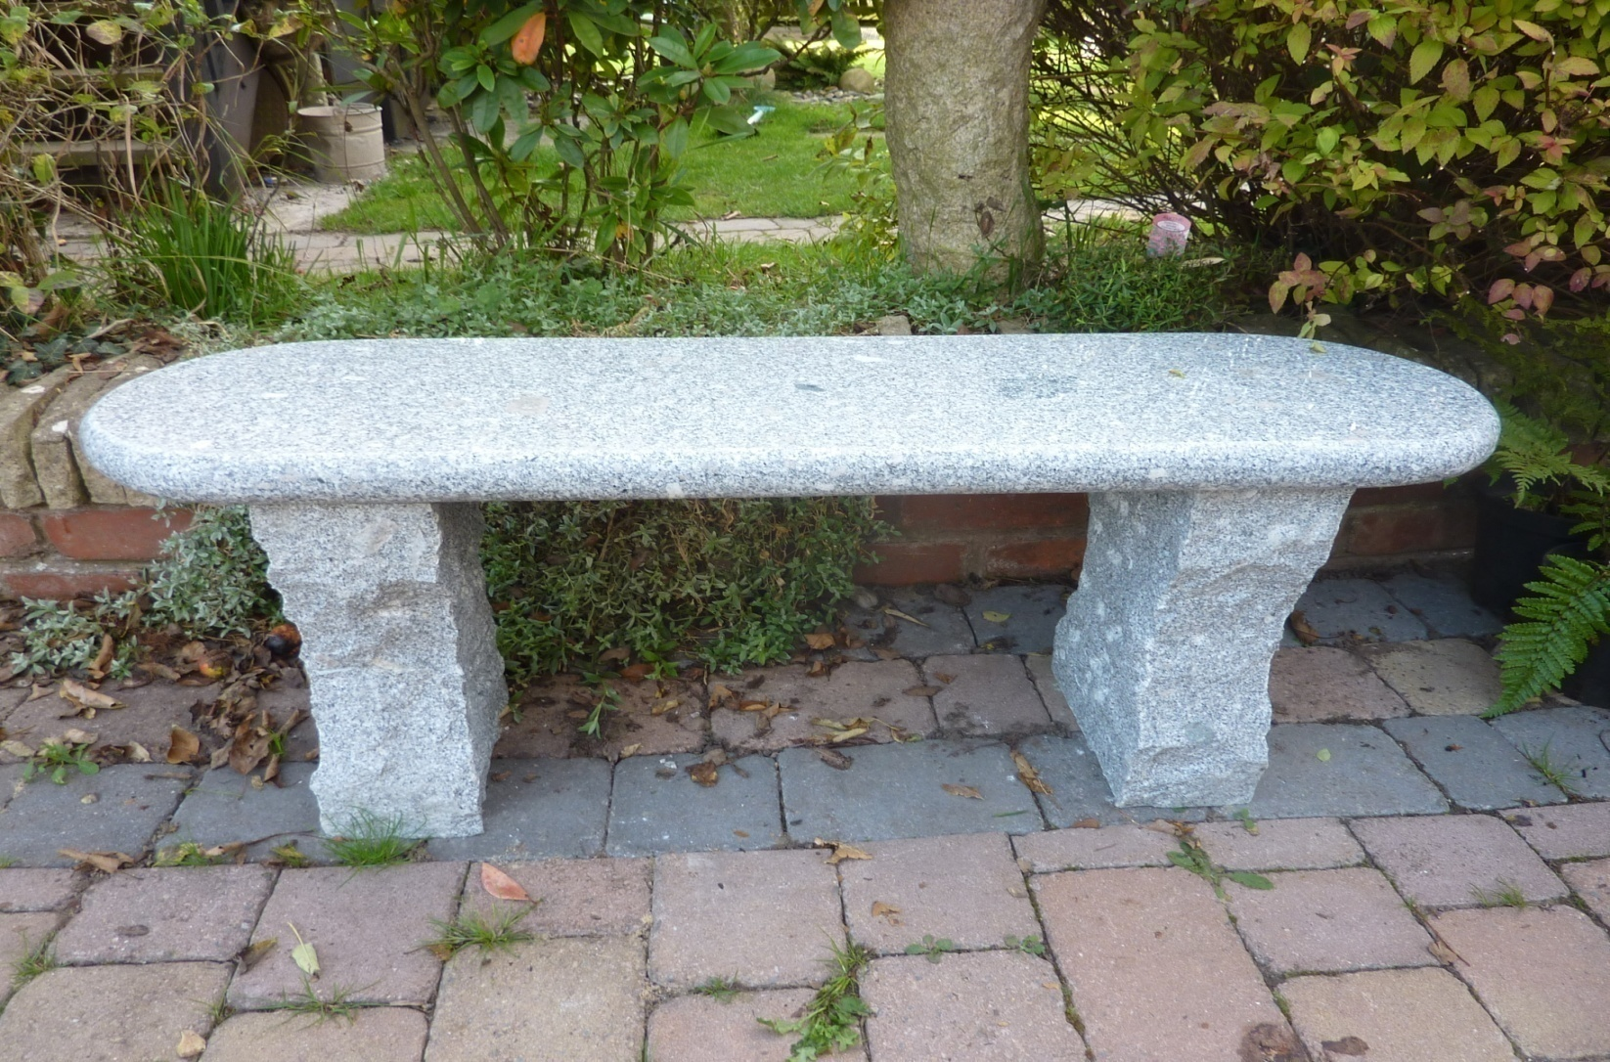
5011 ACTON BENCH, BULL NOSED EDGE, 120X35X42CM H, GREY GRANITE; 5011D DARK GREY GRANITE VERSION
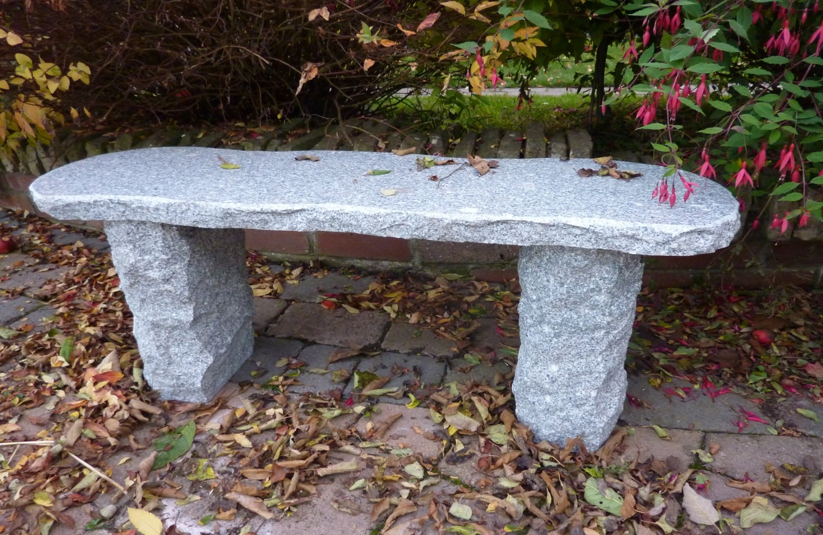
5024G WORCESTER BENCH, 100X30X42CM H, GREY GRANITE
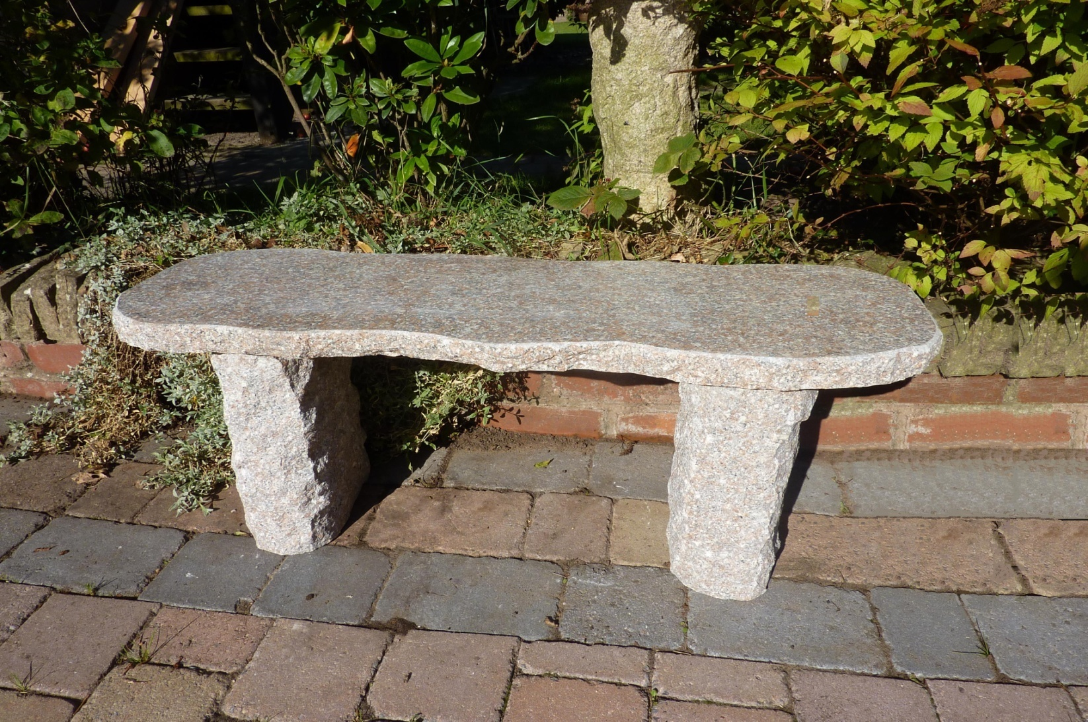
5024P WORCESTER BENCH, 100CM L X30 X42CM H, PINKY GRANITE
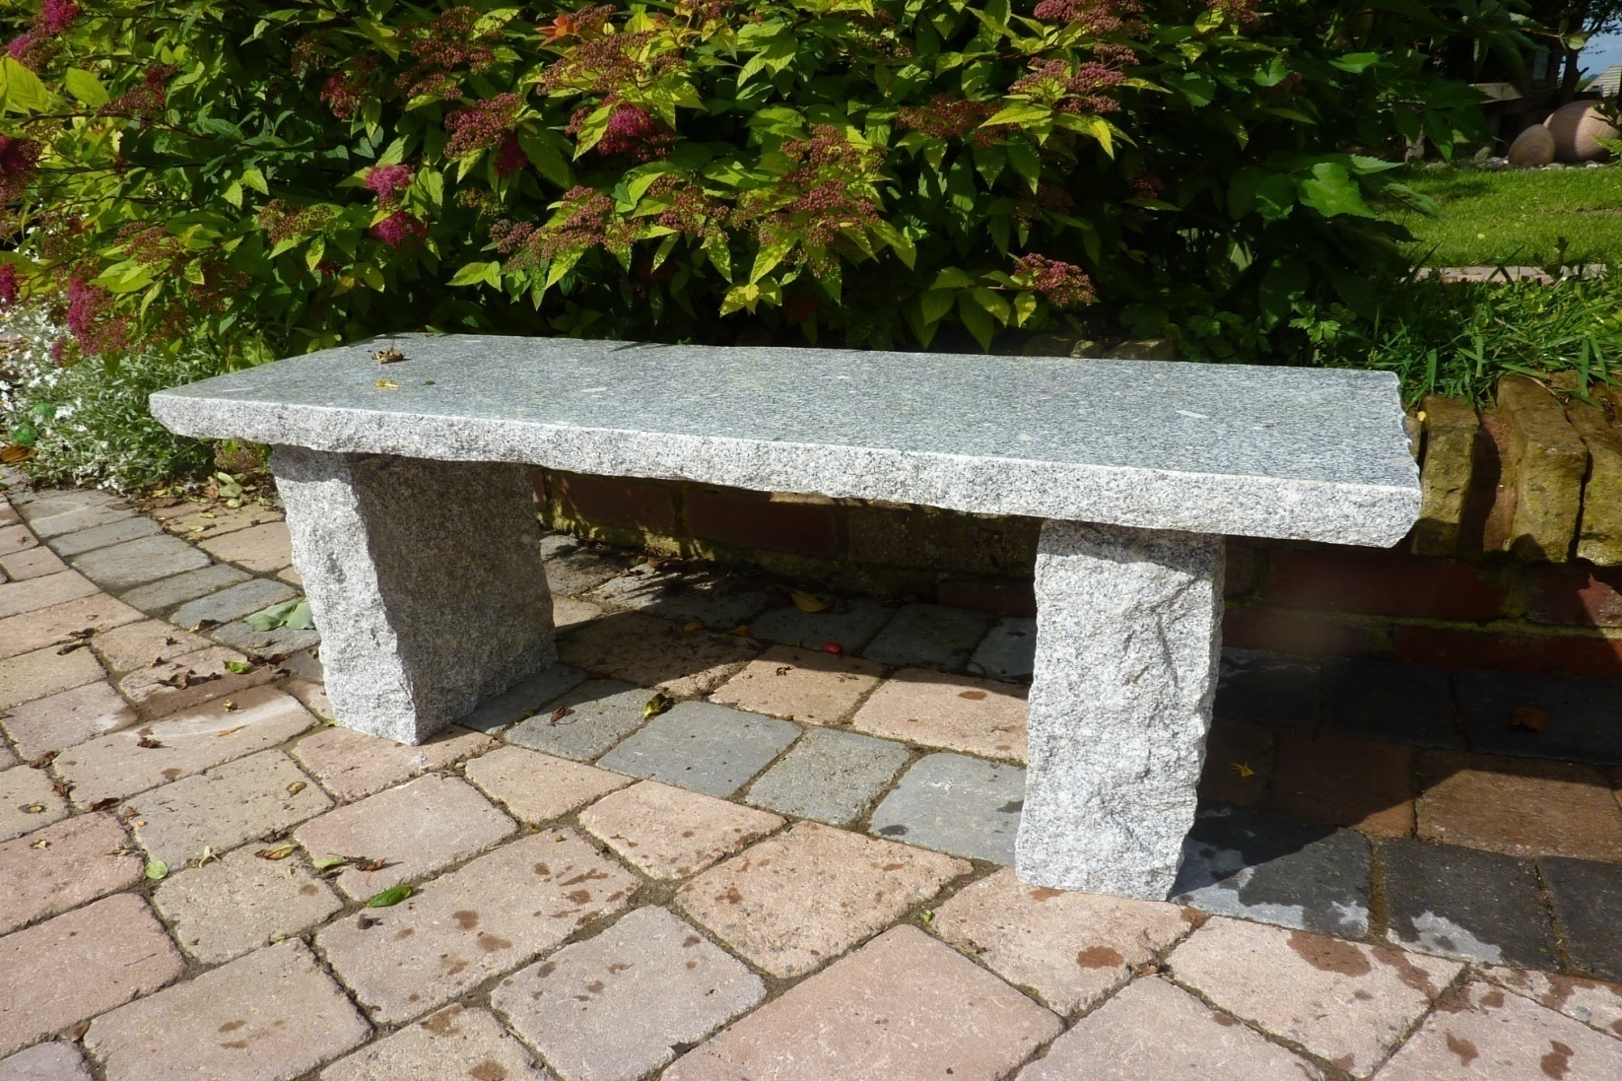
5025 RUSTIC STRAIGHT BENCH 100CM L, GREY GRANITE
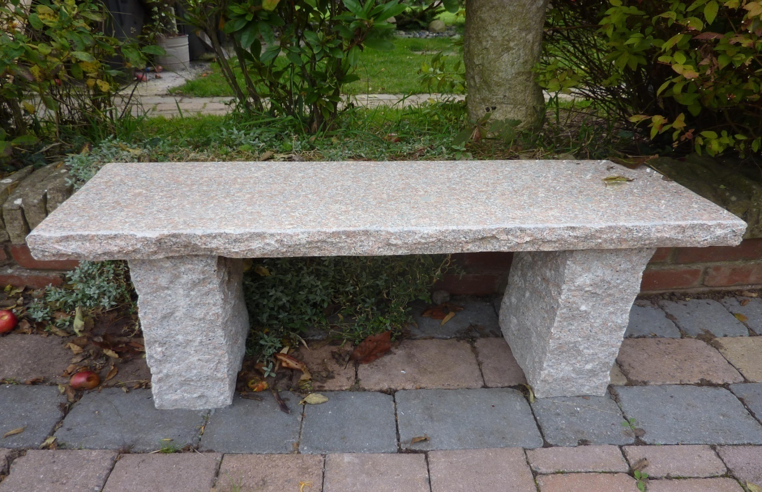
5025P STRAIGHT BENCH, PINKY GRANITE,100cm L, 30CM w
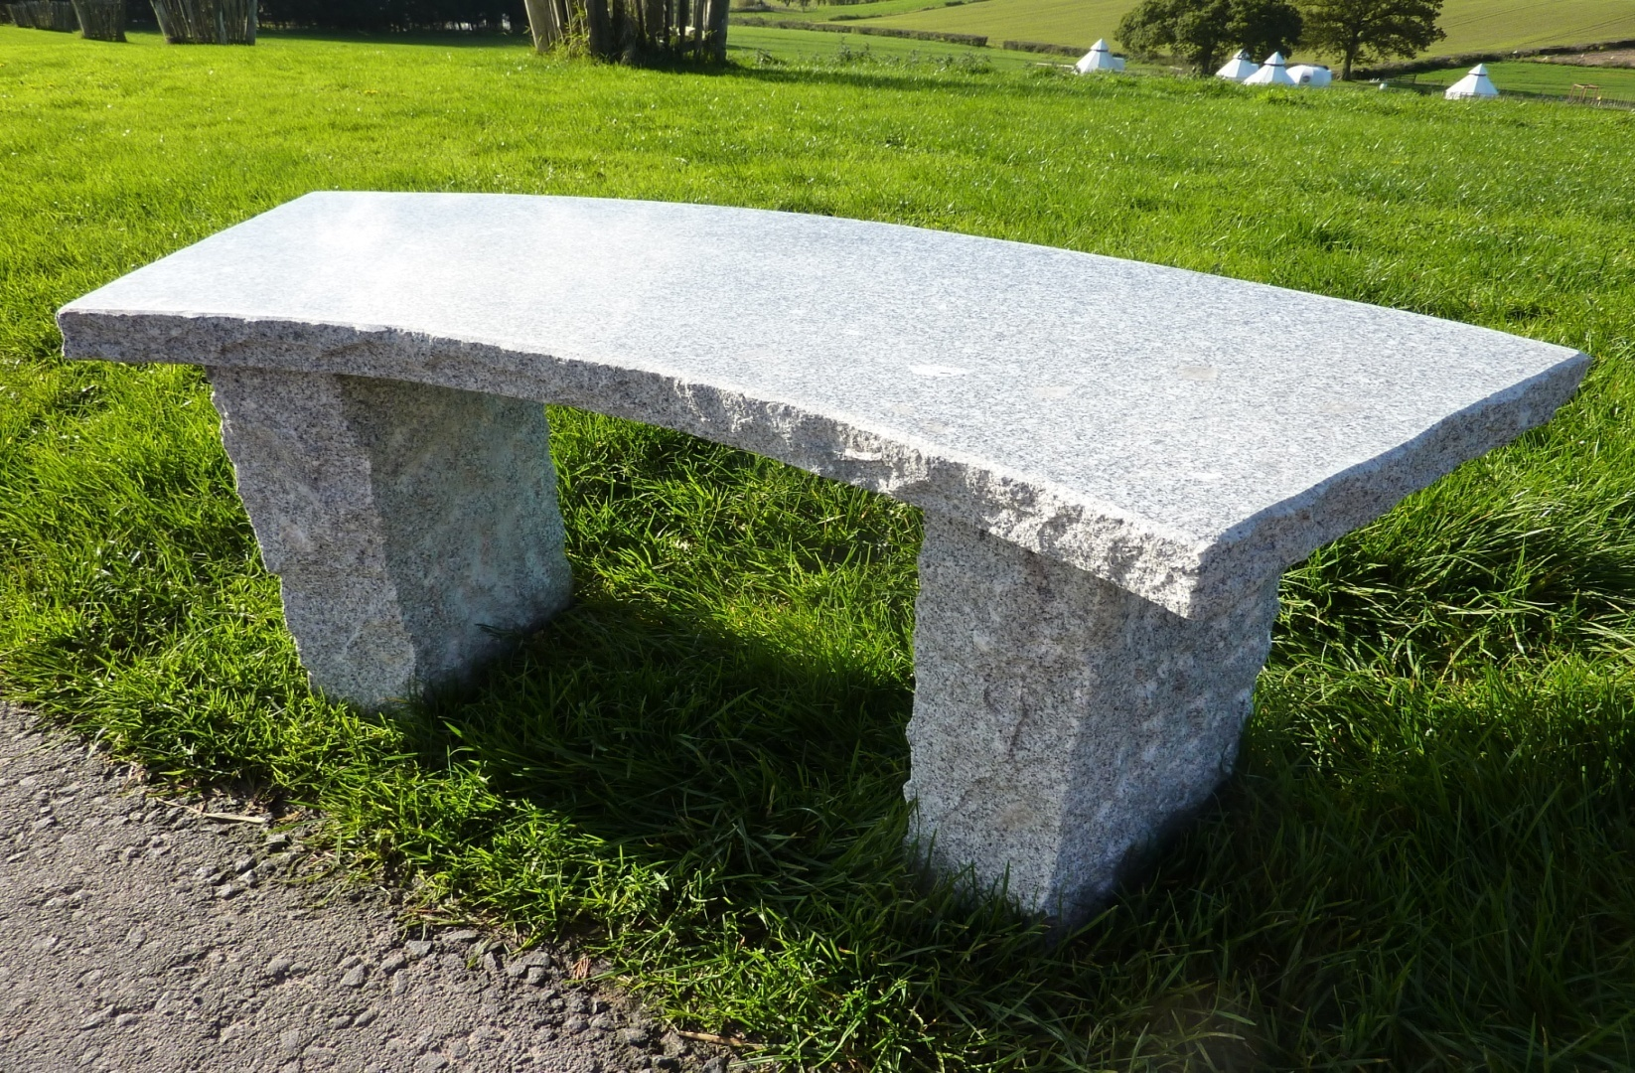
5026G CURVED BENCH IN GREY GRANITE 100X36X42CM H
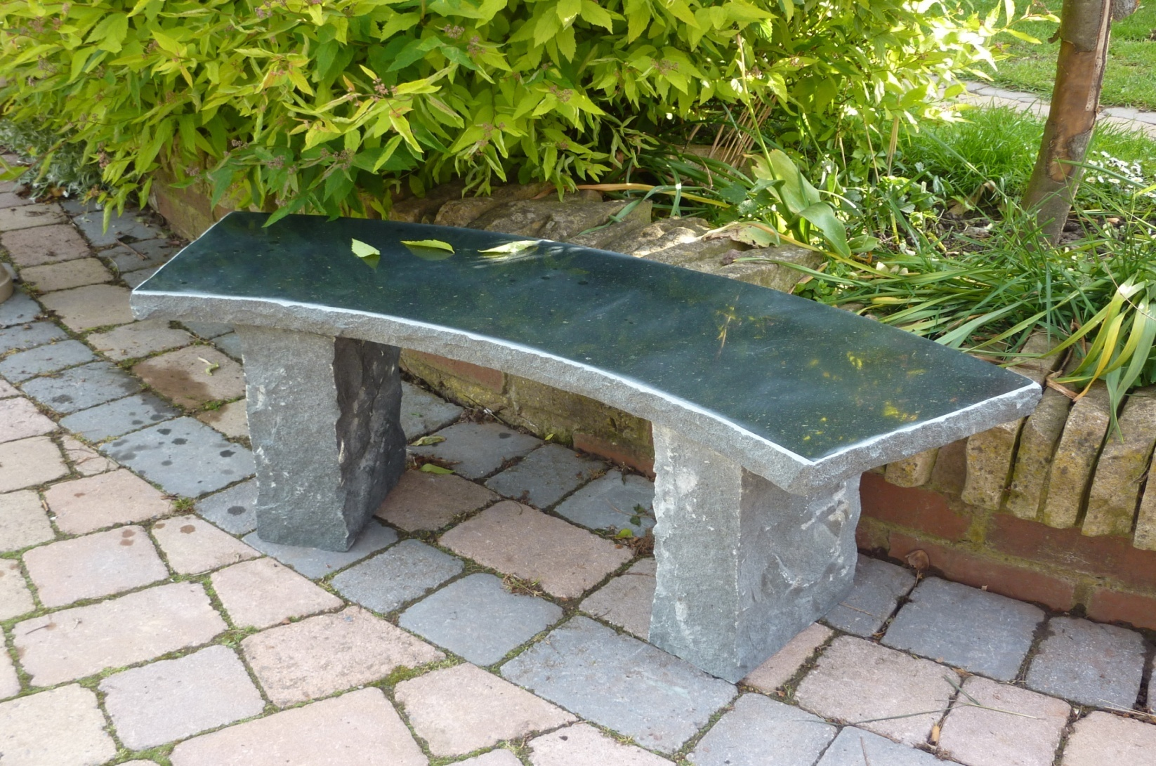
5029 5029 BALMORAL BENCH, BLACK GRANITE, 110 X32X42CM H
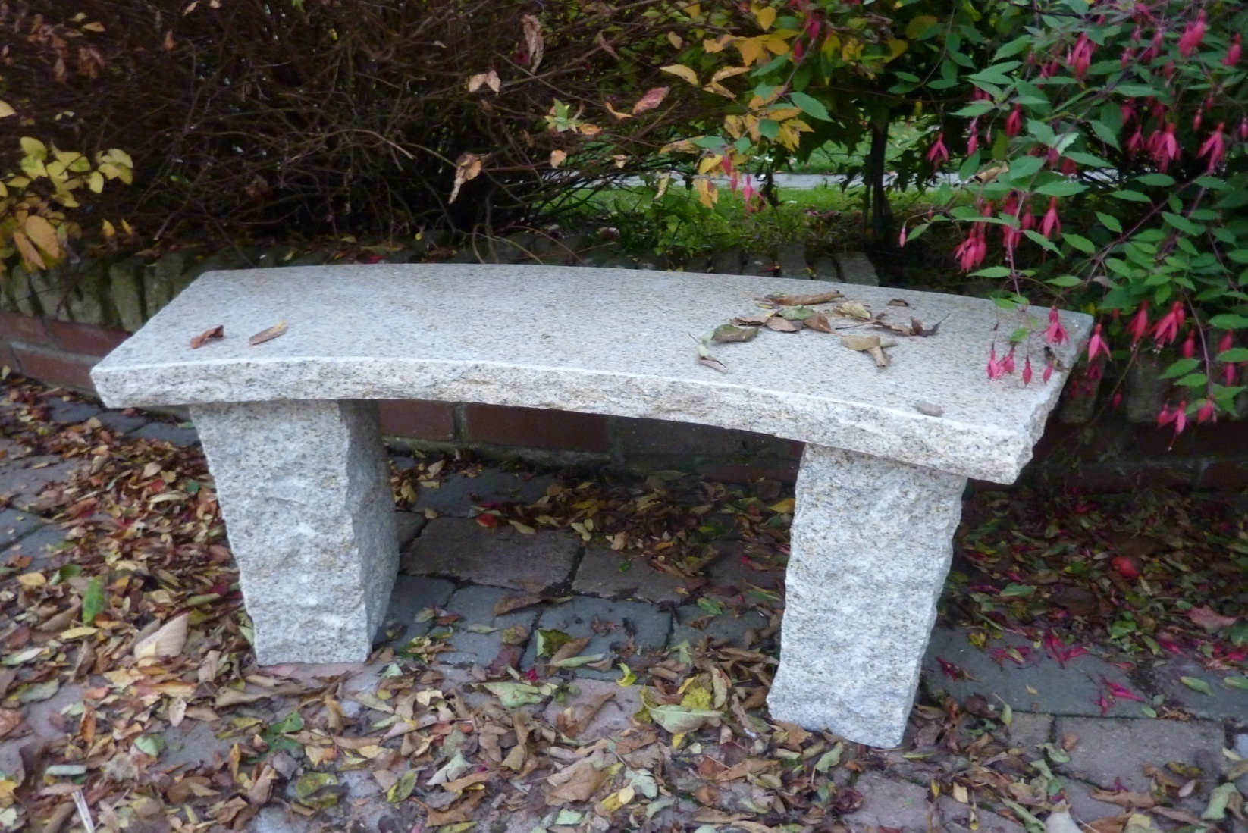
5026B CURVED BENCH IN BEIGE GRANITE 100X36X4CM TOP

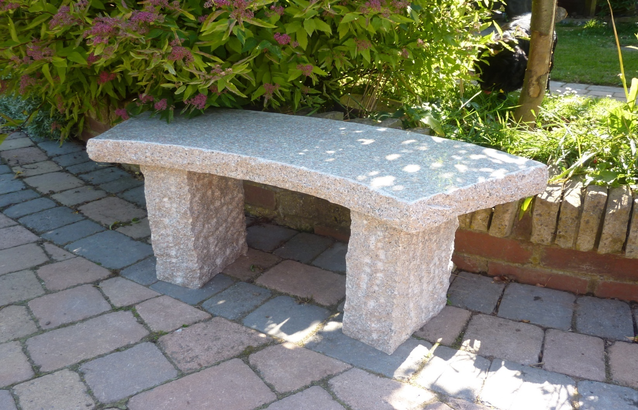
5026P CURVED BENCH IN PINKY GRANITE 100X36X4CM TOP.
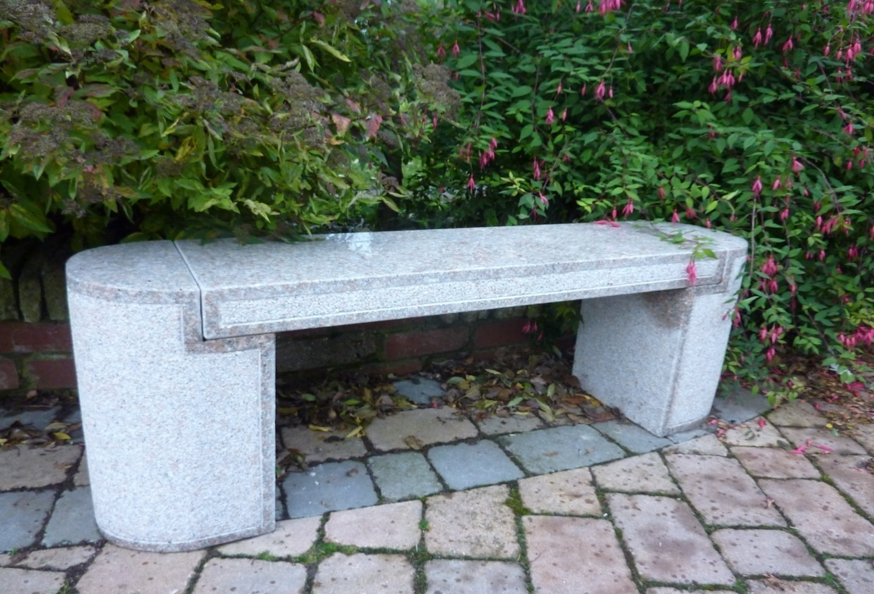
5038 ABERDEEN BENCH, 130X30X45CM H, PINKY GRANITE
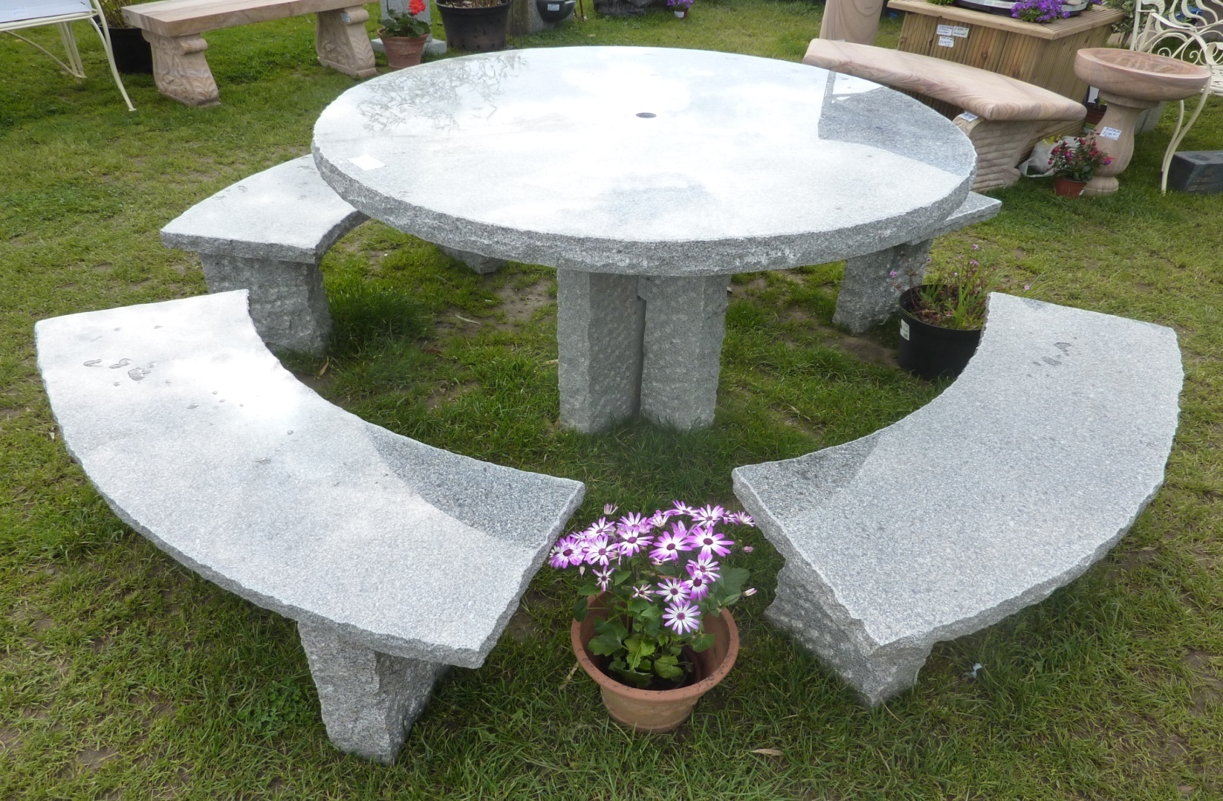
5030SET ENFIELD TABLE & 4 BENCHES SET, TABLE TOP DIA120CM, PINKY or GREY GRANITE
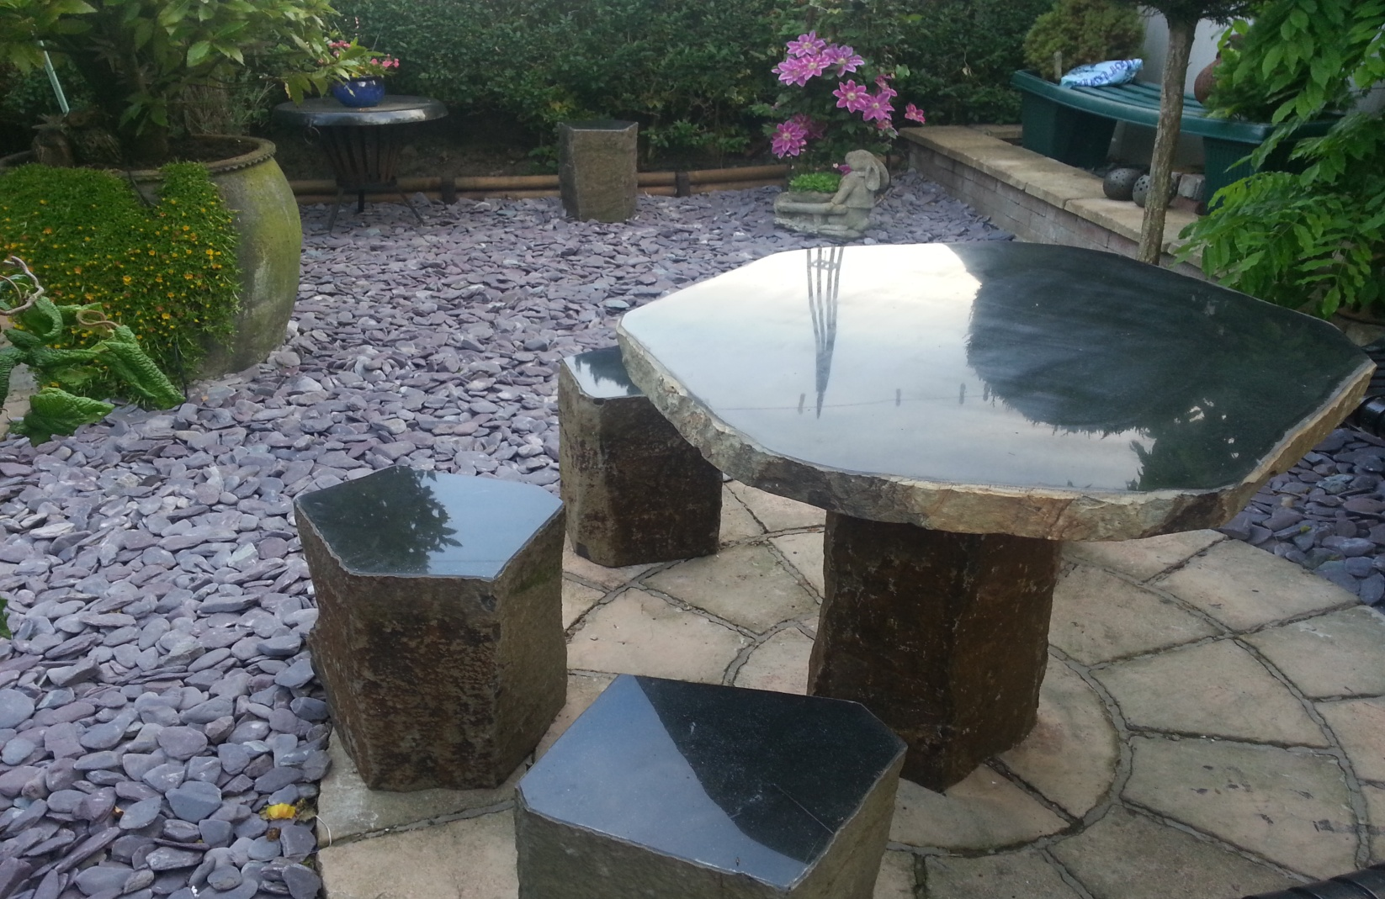
5059SET BASALT TABLE +4STOOLS SET, 100CM X 8CM THICK T/TOP
5059 STOOL ONLY BASALT STOOLS, 25~3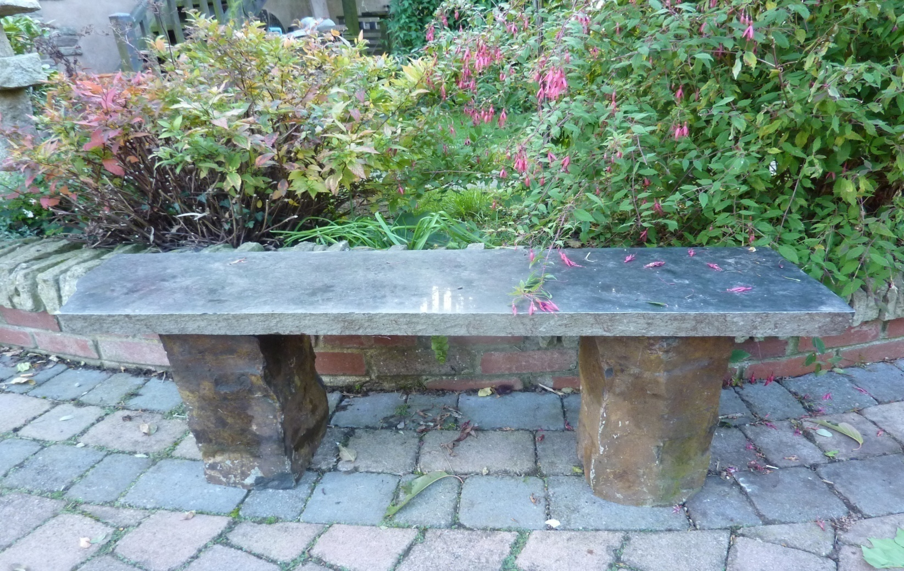
5075 GALWAY BASALT BENCH, 120cm L, bench top 4~6cm thick, natural basalt
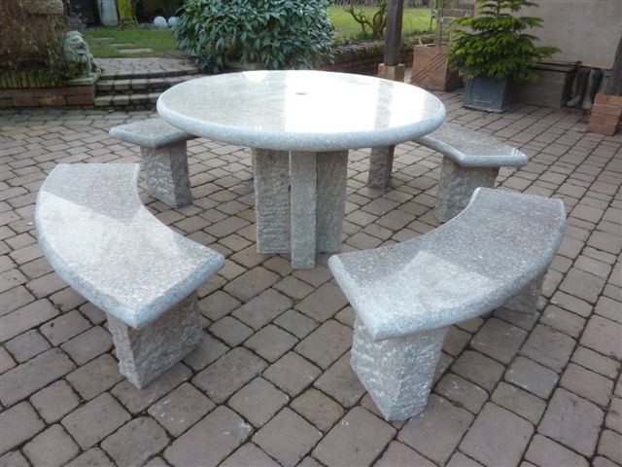
5031SET RICHMOND TABLE & 4 BENCHES SET, TABLE TOP DIA120CM, GREY OR PINKY GRANITE
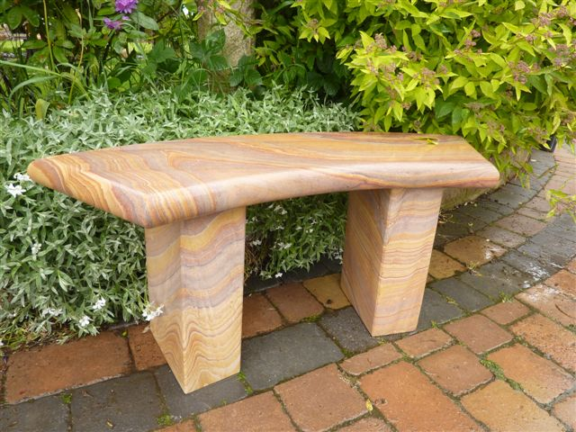
5050L YORK BENCH, CURVED, RAINBOW S. STONE, 120 X30 X44CM H
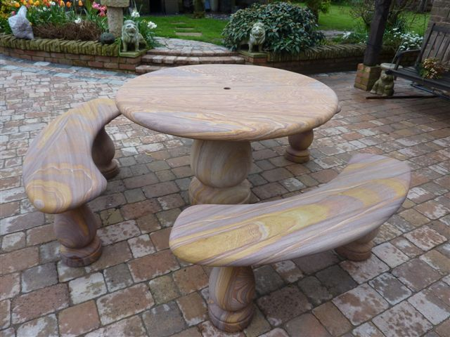
5055SET CHELTENHAM TABLE W/3 BENCHES SET,RAINBOW S. STONE, DIA120CM TOP
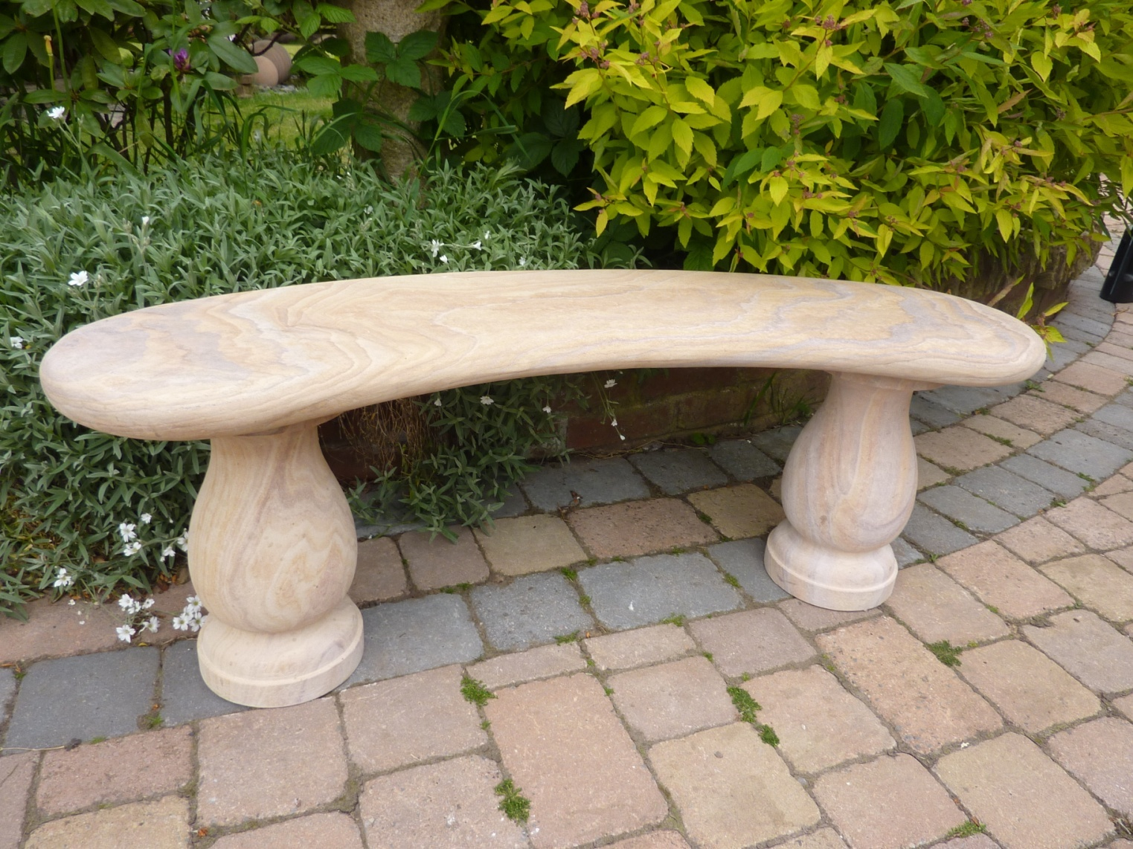
5055BENCH CHELTENHAM BENCH ,CURVED, RAINBOW S. STONE, 120CM L
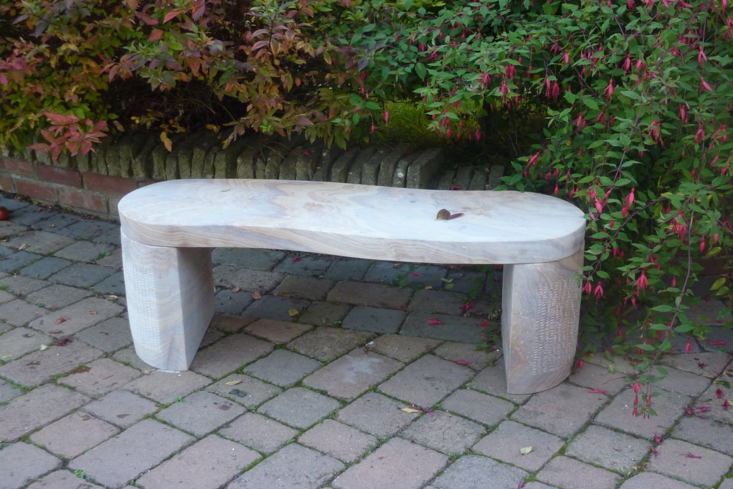
5051 TENBURY BENCH, RAINBOW S.STONE, S SHAPE, 120X30X42CM H
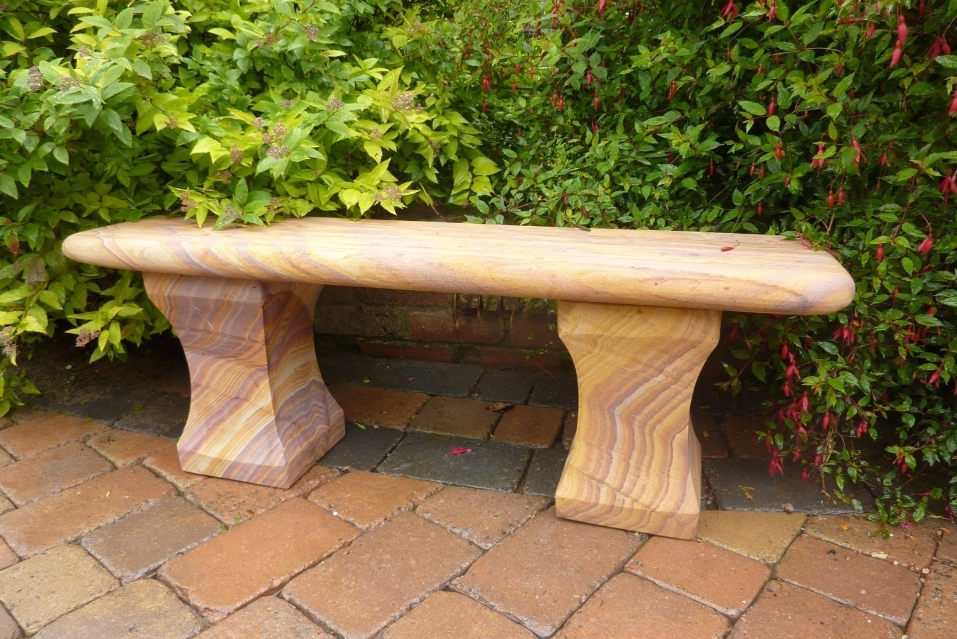
5052 SURREY BENCH,RAINBOW SANDSTONE, 120CM L X30CM W
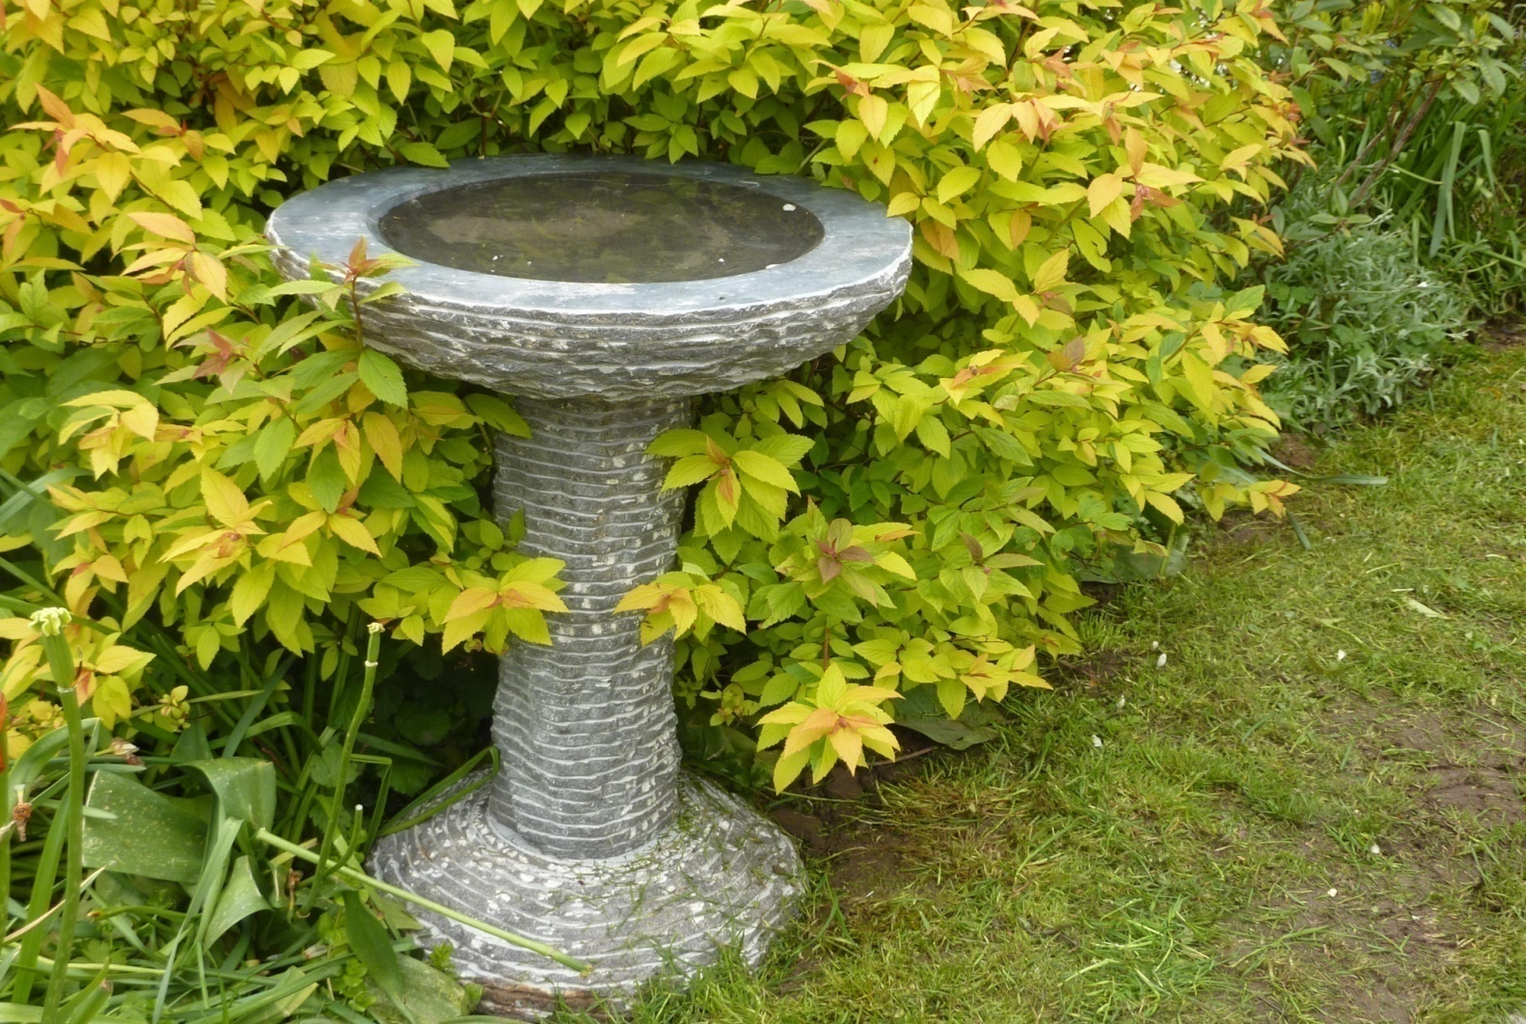
8005 BLACK LIMESTONE BIRD BATH, DIA 50CM X70CM H
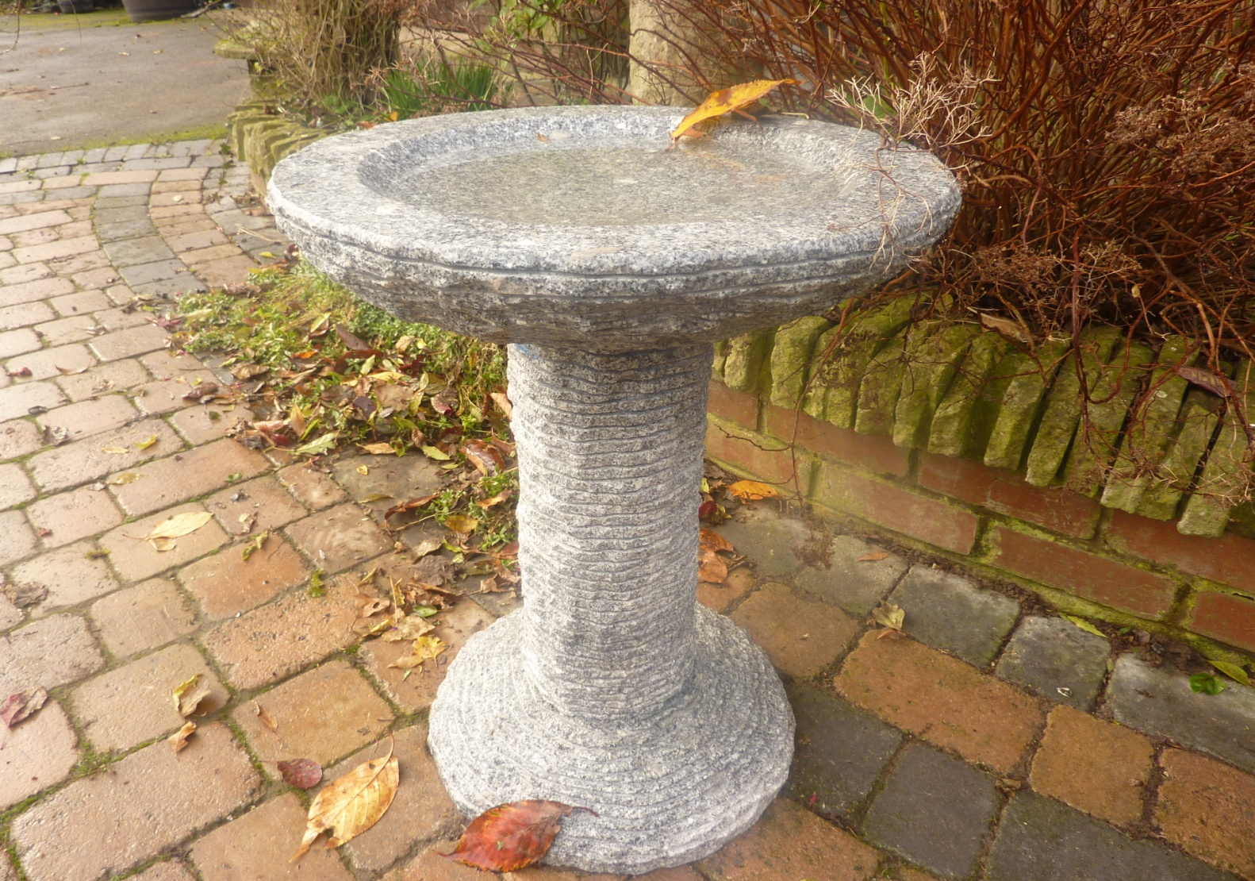
8005G CASCADE BIRD BATH, GREY GRANITE DIA50 X70CM H
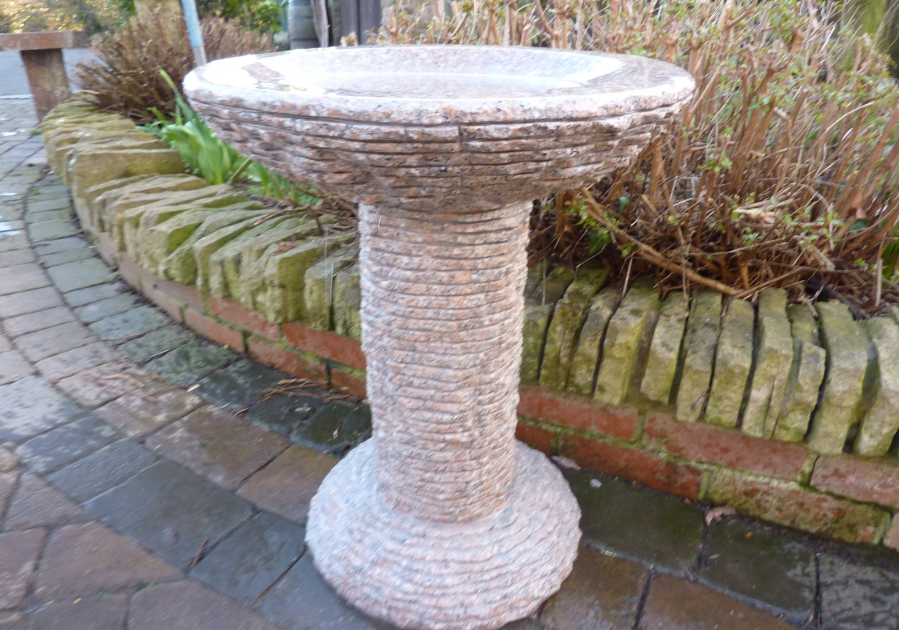
8005P CASCADE BIRD BATH, PINKY GRANITE DIA50 X70CM H
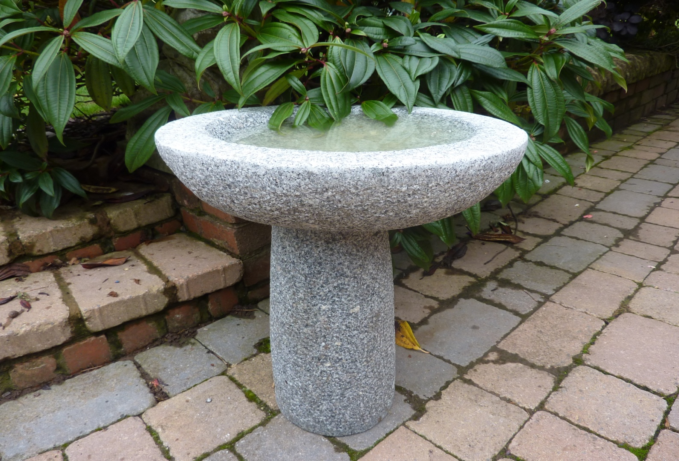
8007MG BASIC ROUND BIRD BATH, DIA45 X50CM H, GREY GRANITE; 8007SG DIA35X40CM H
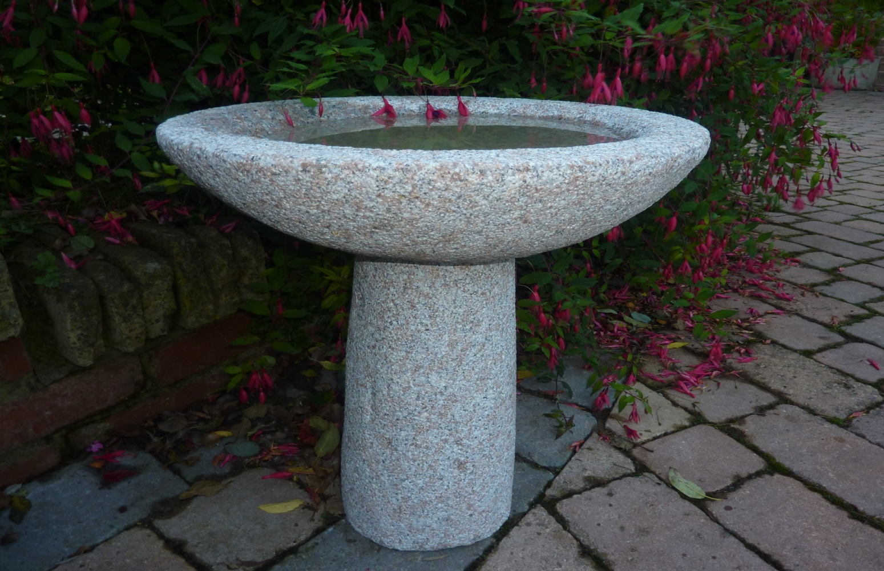
8007M BASIC ROUND BIRD BATH, DIA45 X50CM H, PINKY GRANITE; 8007S DIA35X40CM H PINKY
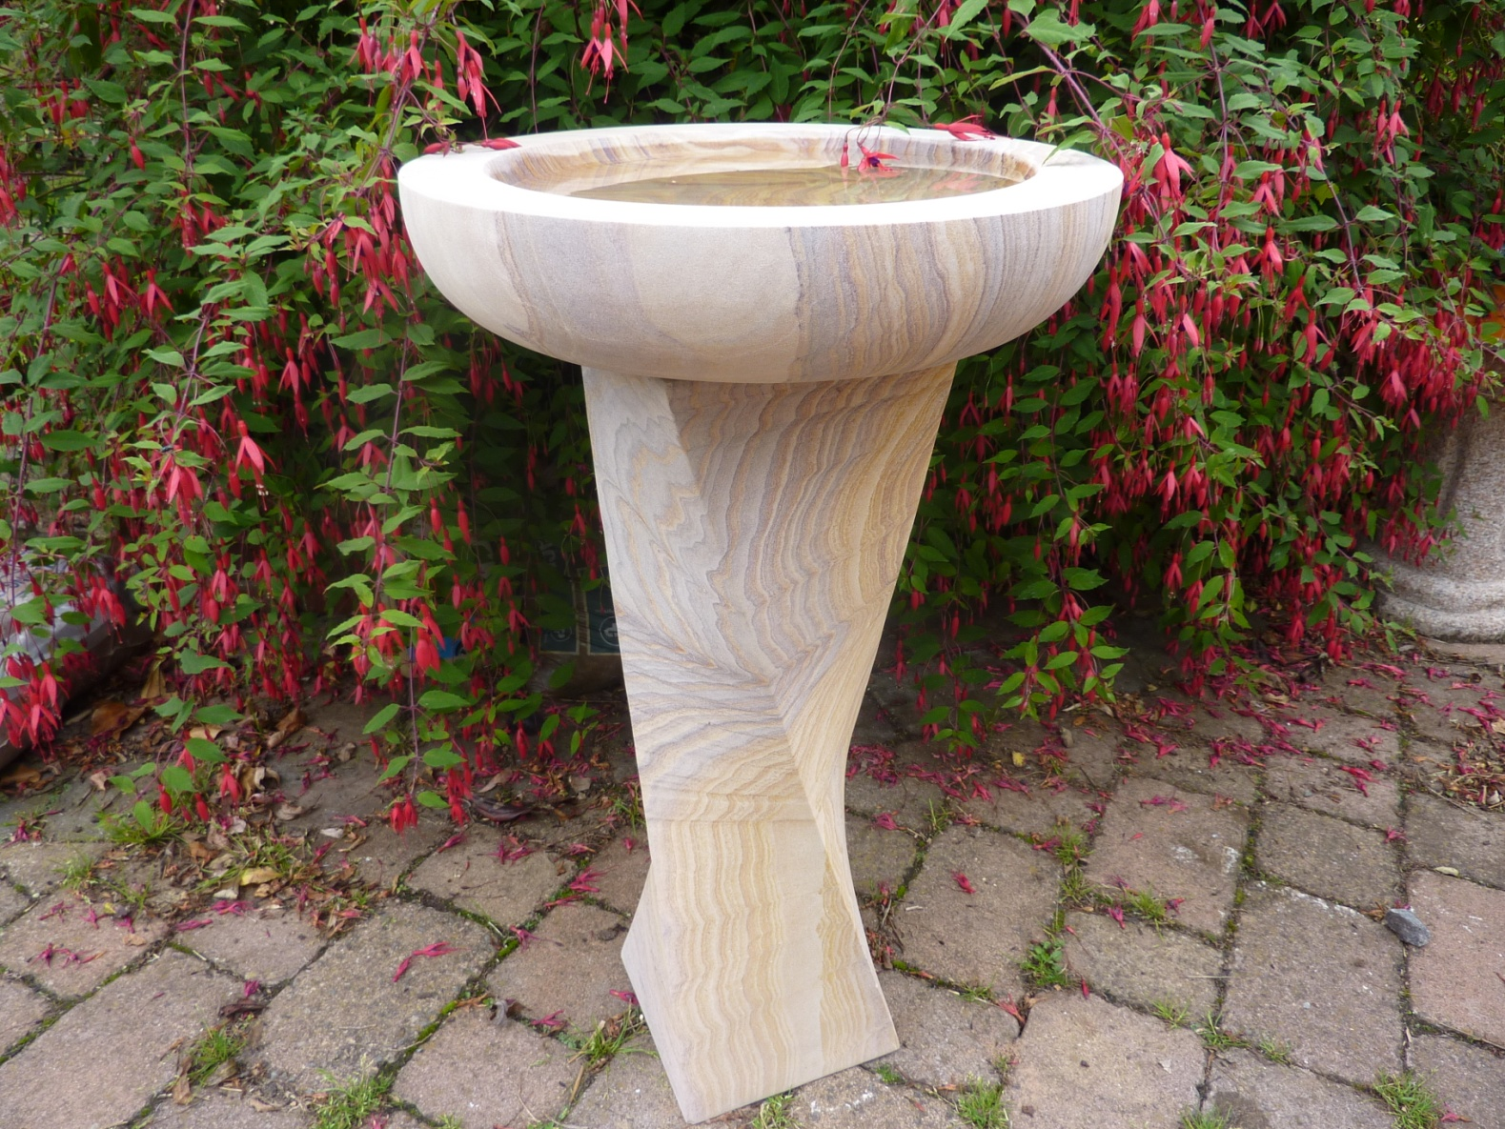
8010 RAINBOW BIRD BATH WITH TWISTED COLUMN, DIA45 X77CM H
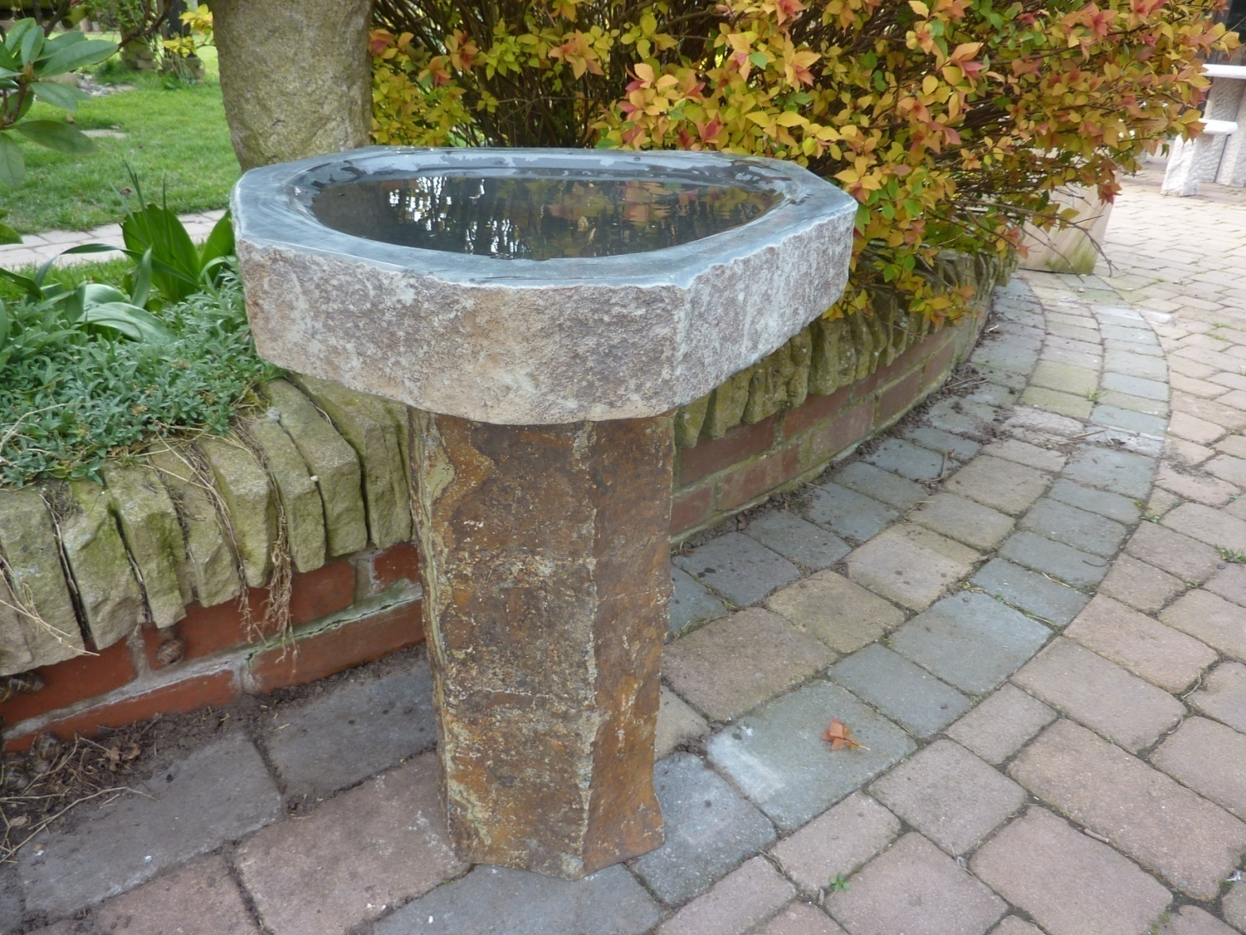
8024 MORAY BASALT BIRD BATH, 40~50CM X 63CM H, polished dished top
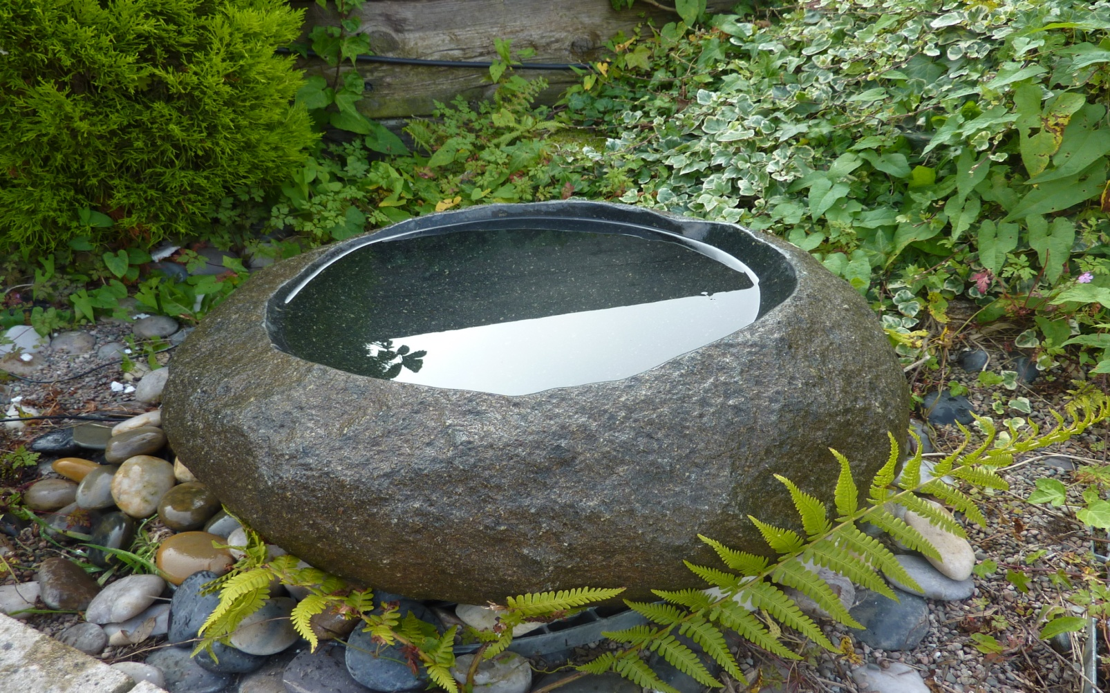
8025S NATURAL BASIN / BIRD BATH, 45CM L APPROXIMATELY
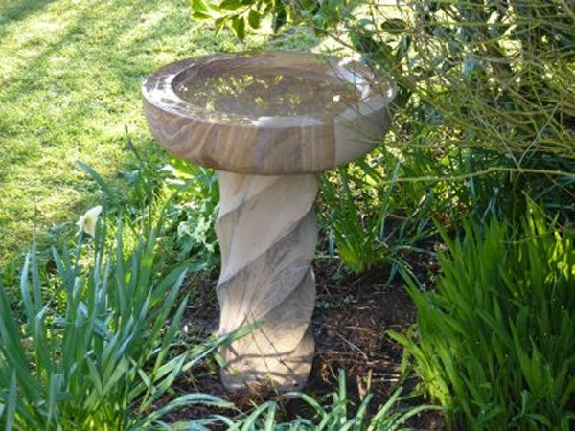
8013 RAINBOW BIRD BATH WITH TWIRLED COLUMN DIA45CM X 64CM H
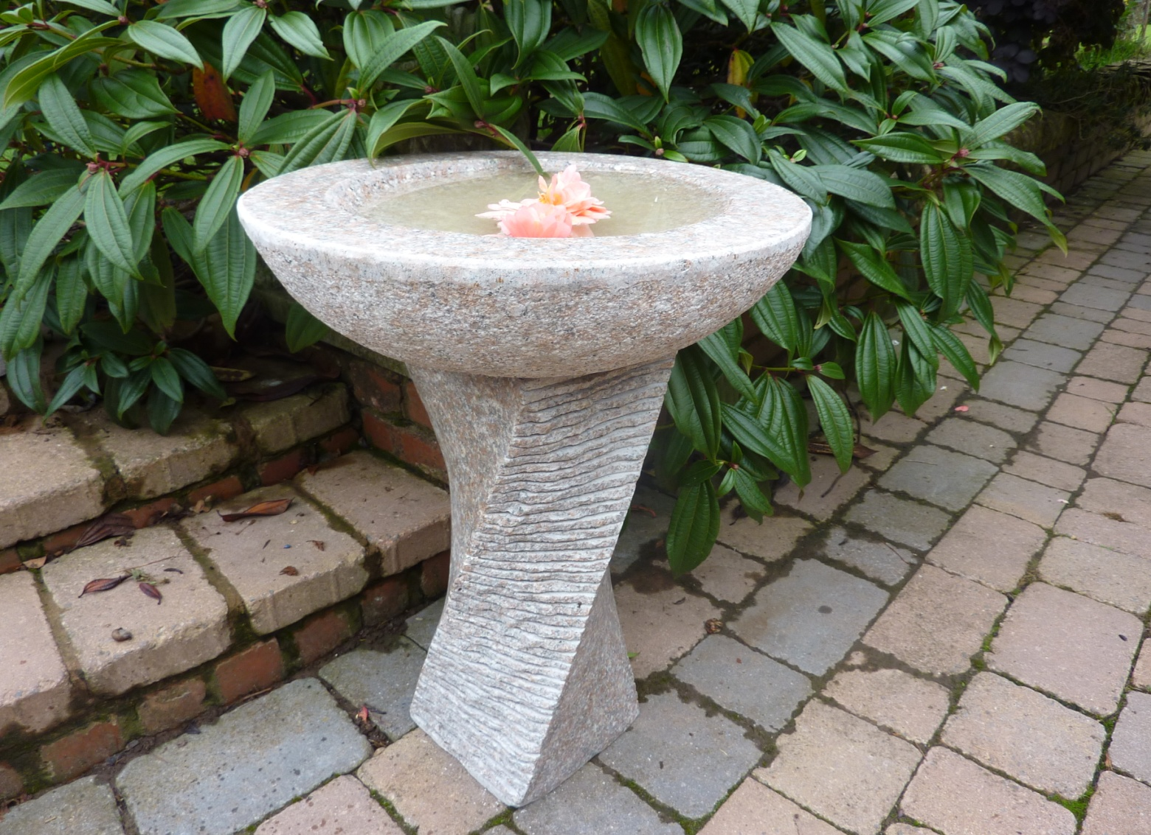
8022MP EDINBURGH BIRD BATH, DIA45 X72CM, PINKY GRANITE
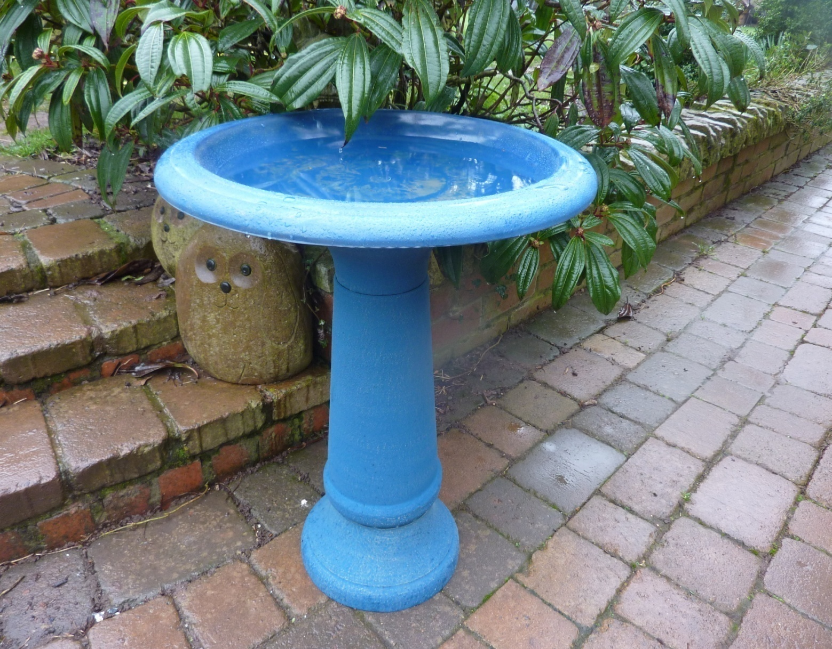
8032MAT FIBER CLAY BLUE MARBLE BIRD BATH, DIA50X70CM H
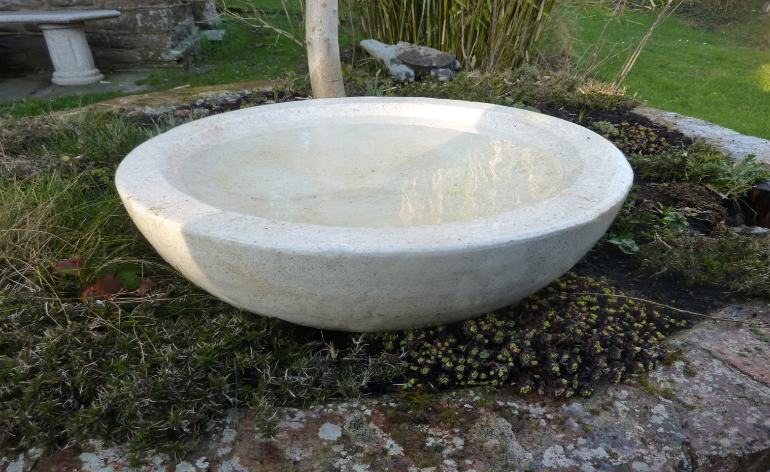
8033 TERRAZZO BIRD BATH WHITE DIA55 X 20CM H
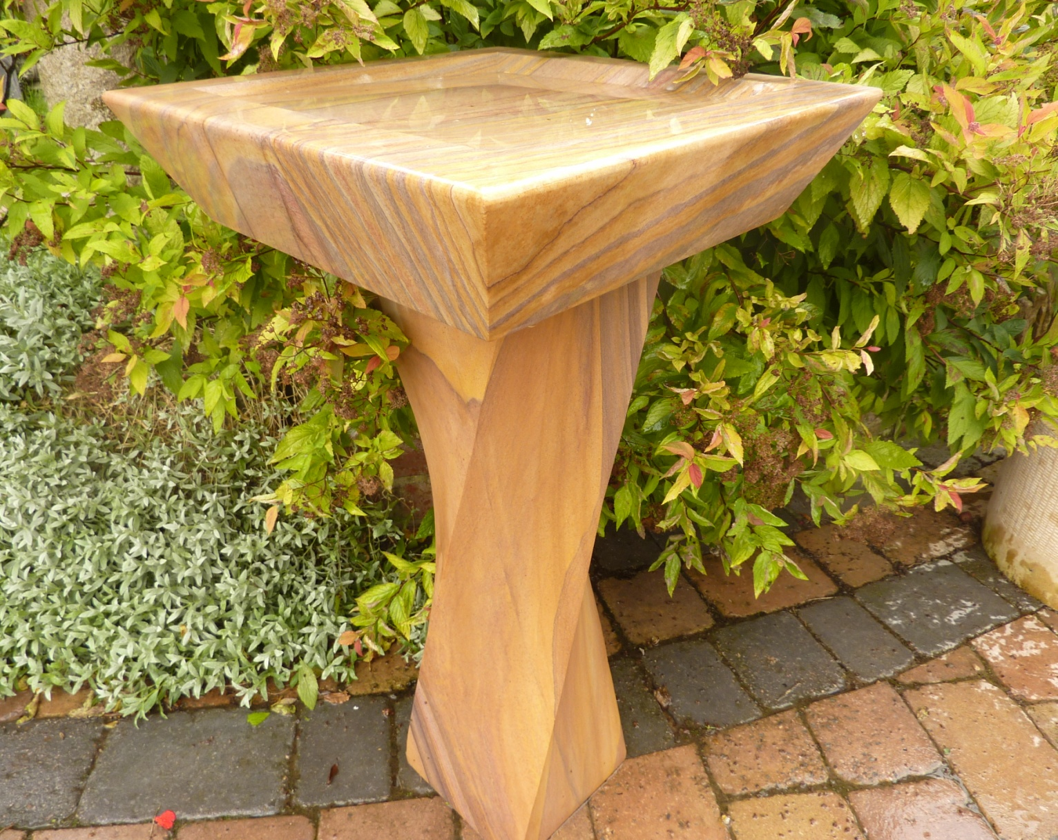
8016 RAINBOW SQUARE TOP with TWISTED COLUMN BIRD BATH 45X45CM SQUARE TOP, TOTAL 77CM H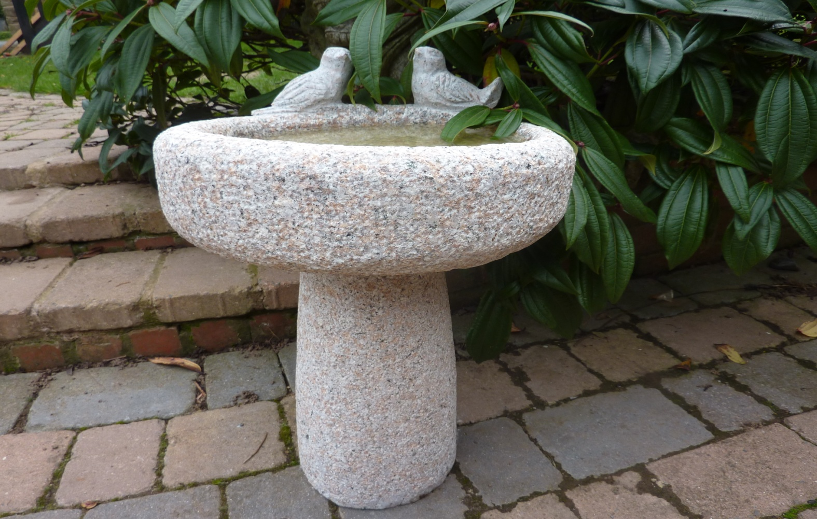
8017 RUSTIC BIRD BATH, DIA40X60CM H, PINKY GRANITE
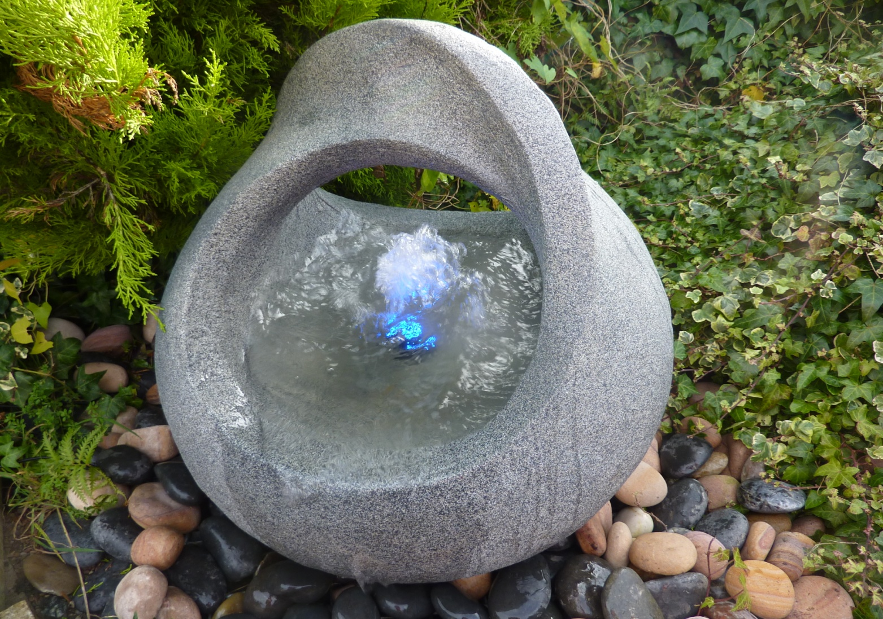
9015 BABBLING BASKET,dia55 x58cm h + 6003 & 6008Eco pump & light kit
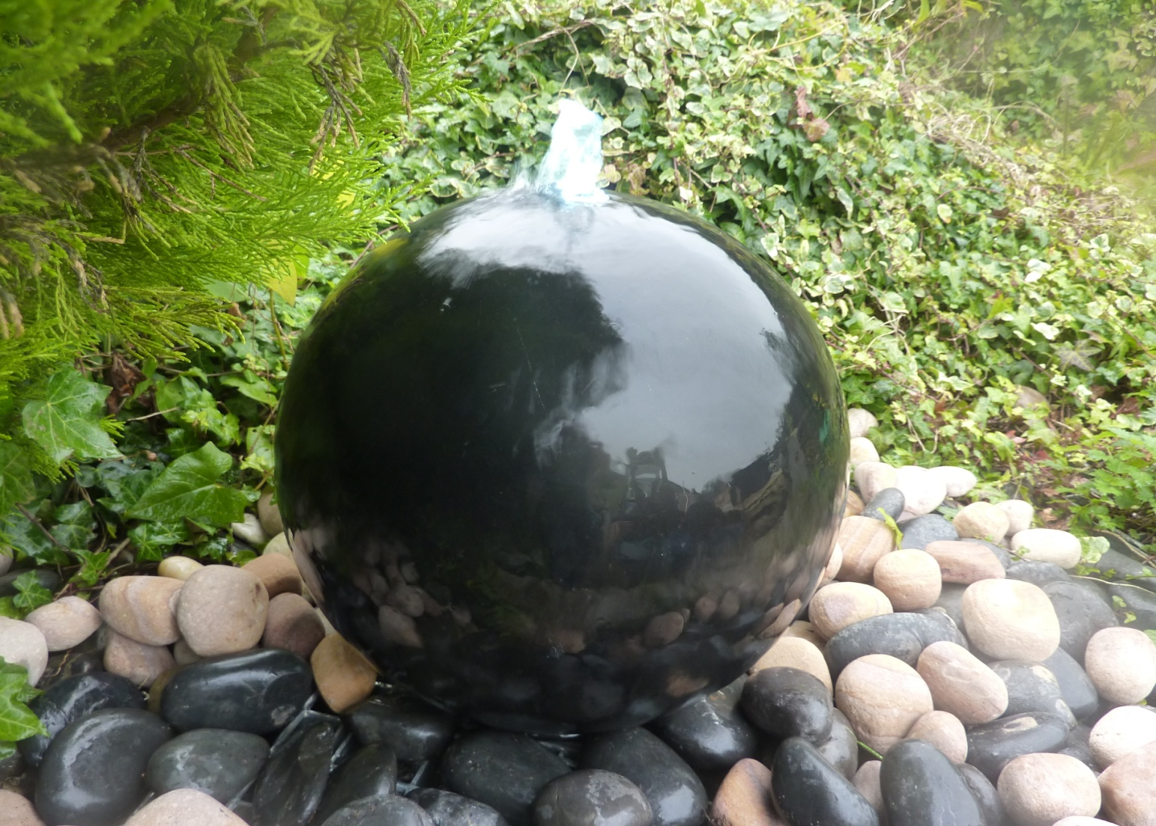
9031/ 9031-50 POLISHED TERAZZO SPHERE FOUNTAIN, DIA40 cm/50CM,W/DIA 54 RESEROIR, GRID, PUMP&LIGHT

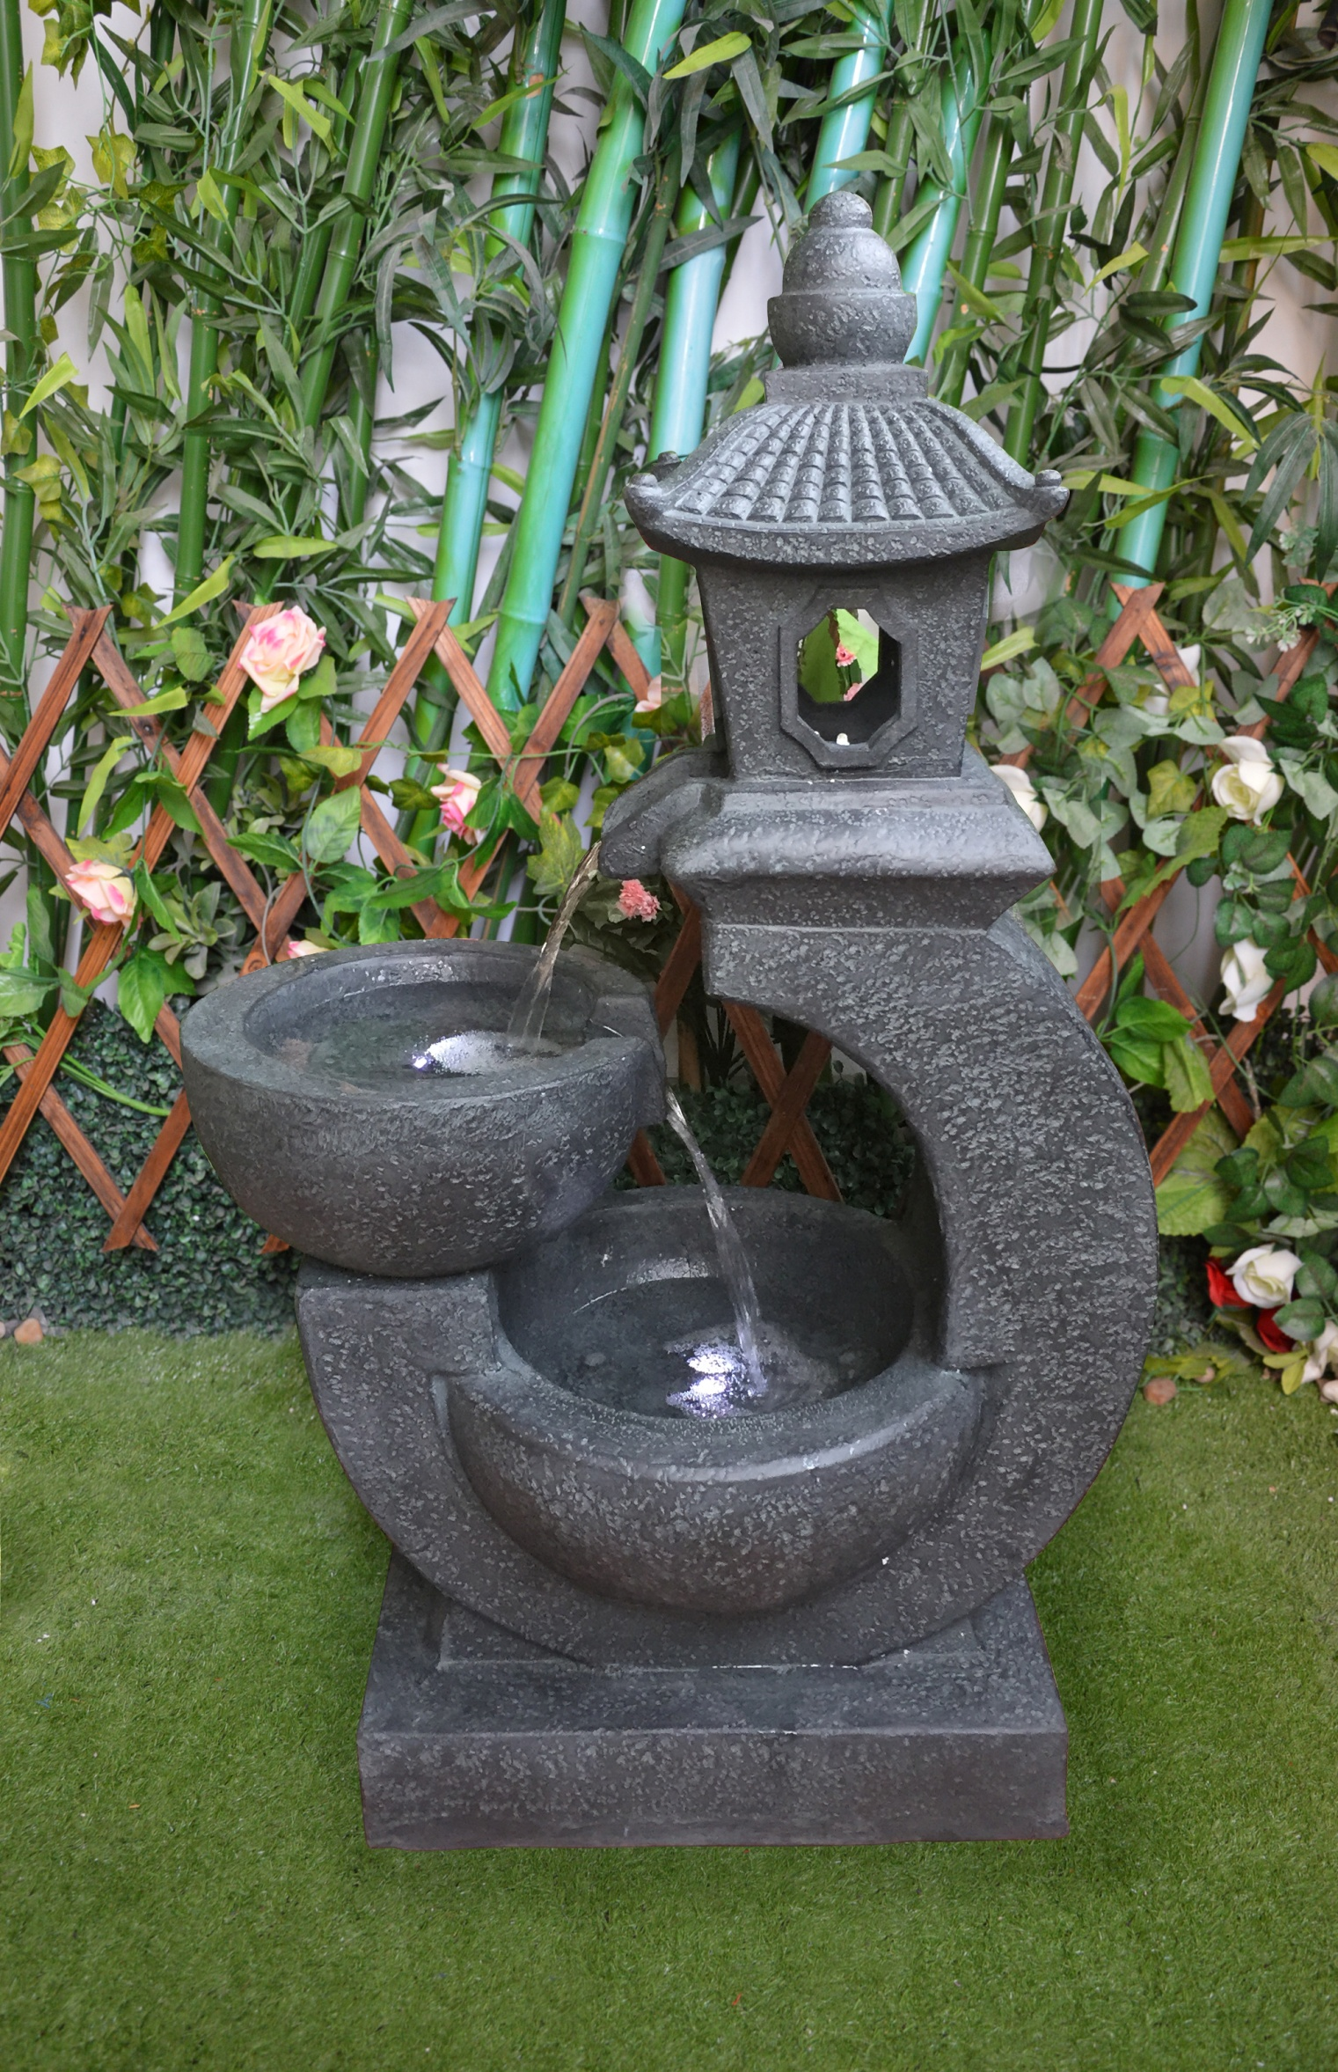
9019 SC RESIN WATER FALL POTS LANTERN,DK GRAY,80CM H
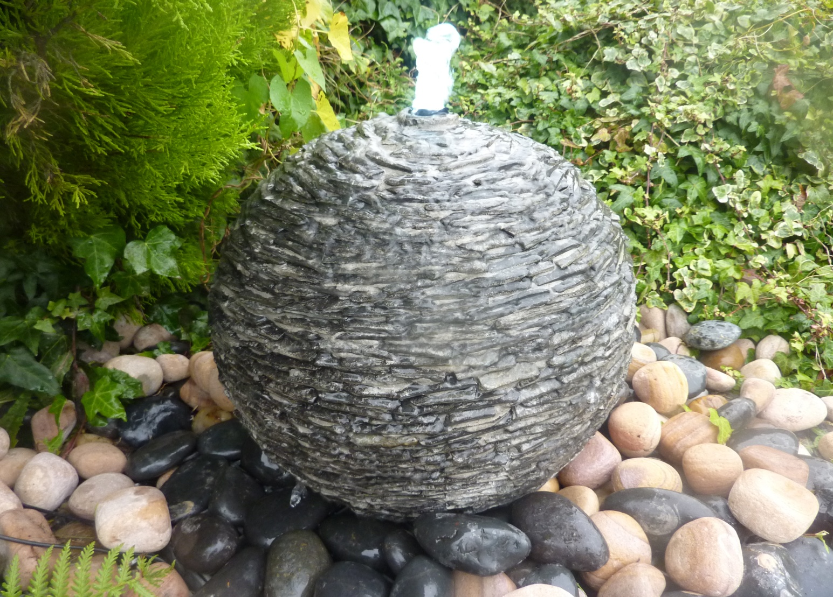
9032 / 9032-50/9032-60 NATURAL SLATE SURFACE SPHERE DIA 40/50/60 cm ,W/D54 RESEROIR, GRID, PUMP&LIGHT
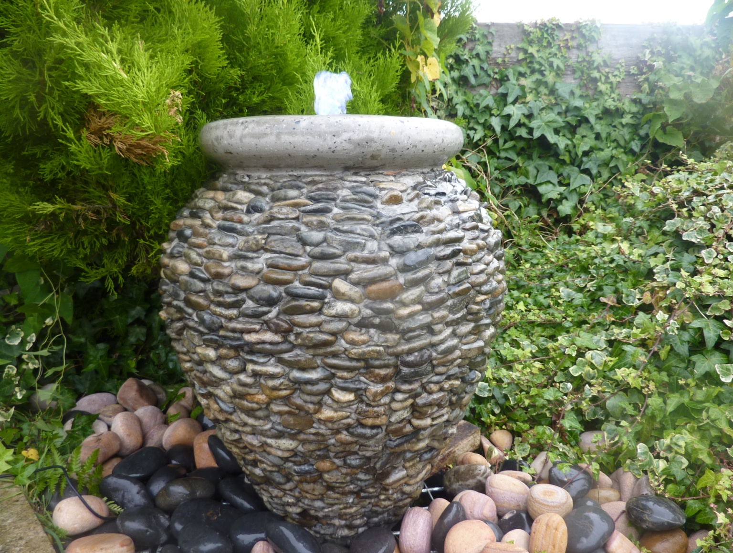
9034 NATURAL PEBBLE URN FOUNTAIN DIA45 X55CM H,W/DIA70 RESEROIR, GRID, PUMP&LIGHT
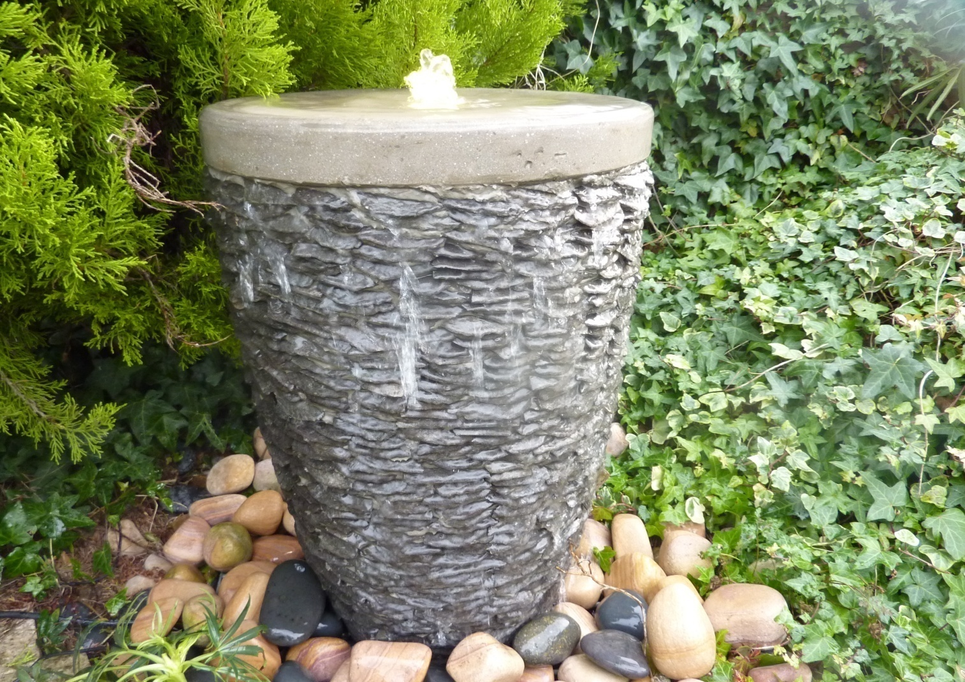
9033-SLATE NATURAL SLATE VASE FOUNTAIN DIA38 X60CM H, W/DIA70 RESEROIR, GRID, PUMP&LIGHT
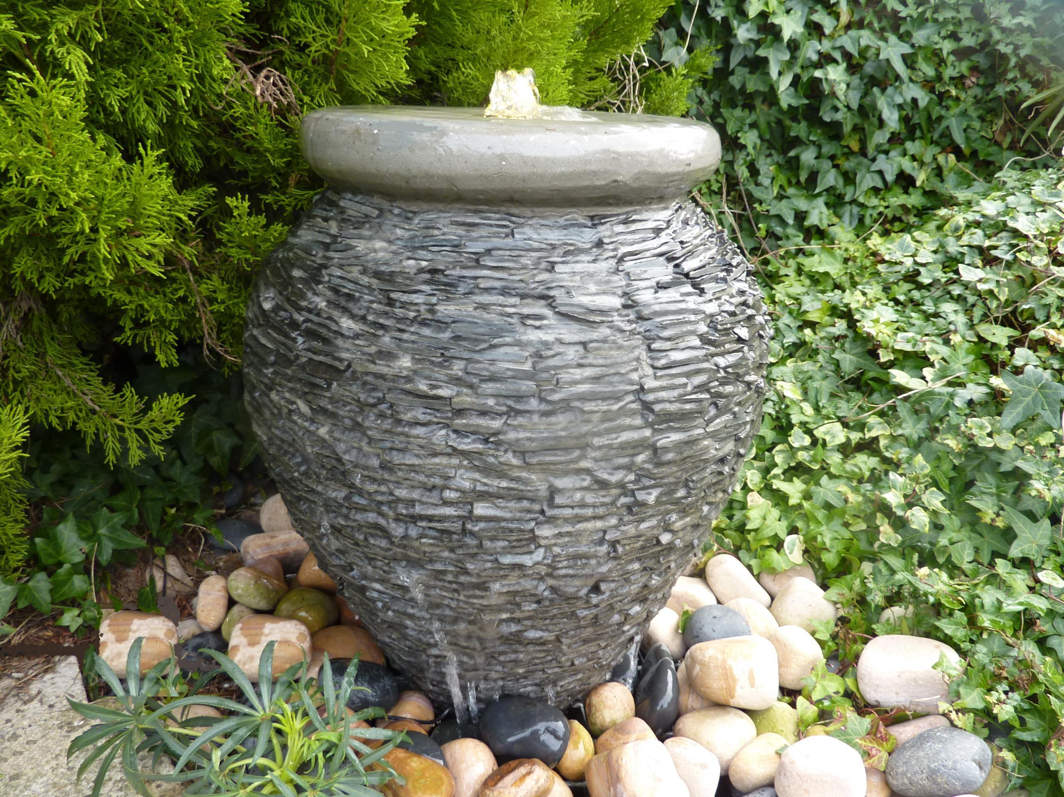
9034-SLATE NATURAL SLATE URN FOUNTAIN DIA45 X55CM H,W/DIA70 RESEROIR, GRID, PUMP&LIGHT
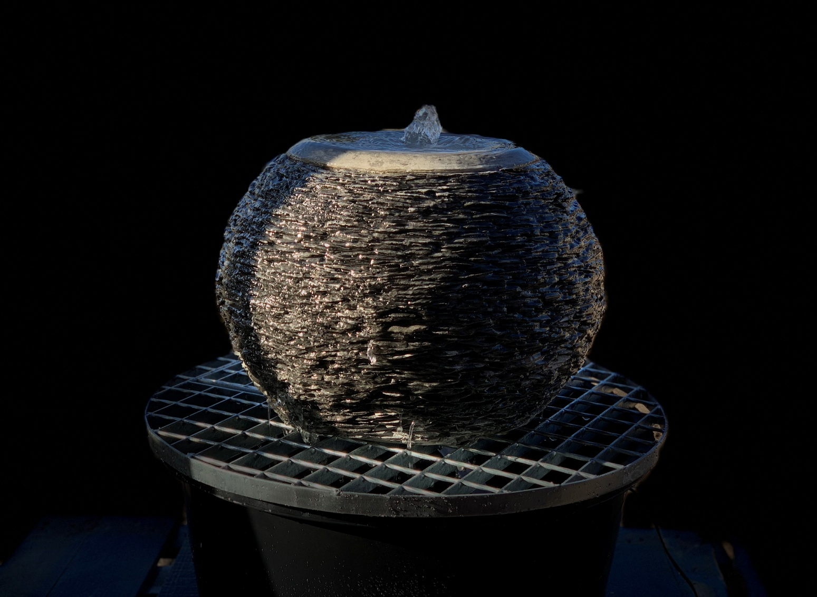
9036 NATURAL SLATE SURFACE BABBLING ARIUS, DIA50X36CM H, W/DIA70 RESEROIR, GRID, PUMP&LIGHT
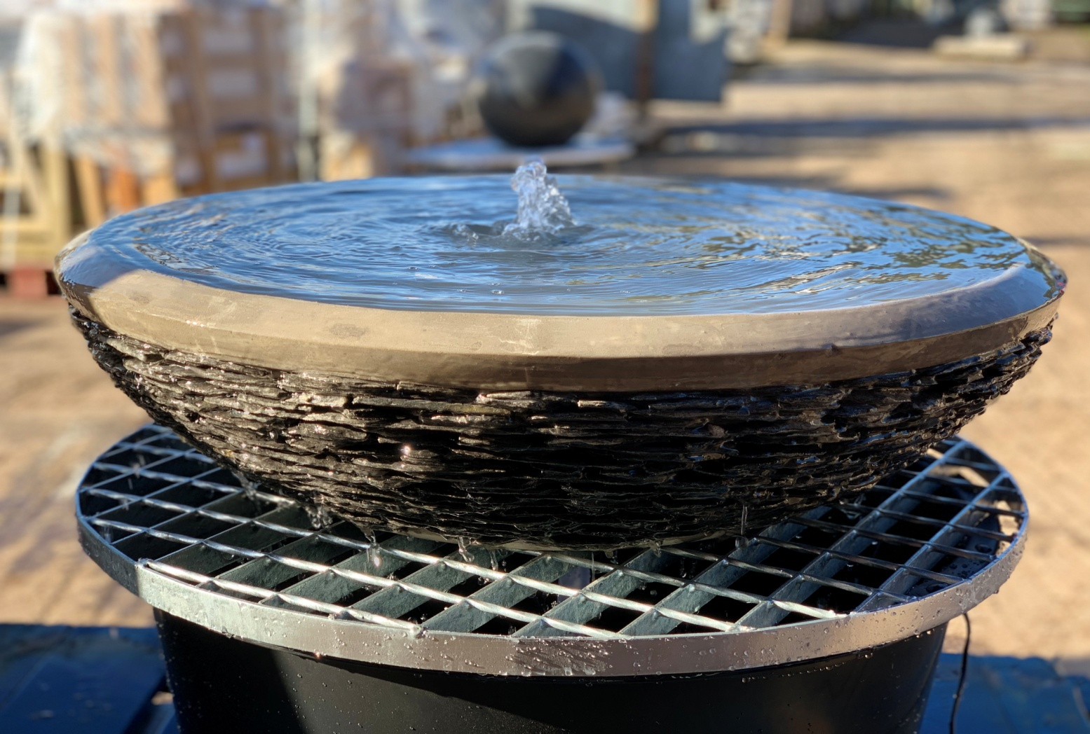
9037 NATURAL SLATE SURFACE BABBLING BOWL, DIA60CM X15CM H, W/DIA70 RESEROIR, GRID, PUMP&LIGHT
9037L NATURAL SLATE SURFACE BABBLING BOWL, DIA70CM X20CM H, W/DIA87 RESEROIR, GRID, PUMP&LIGHT
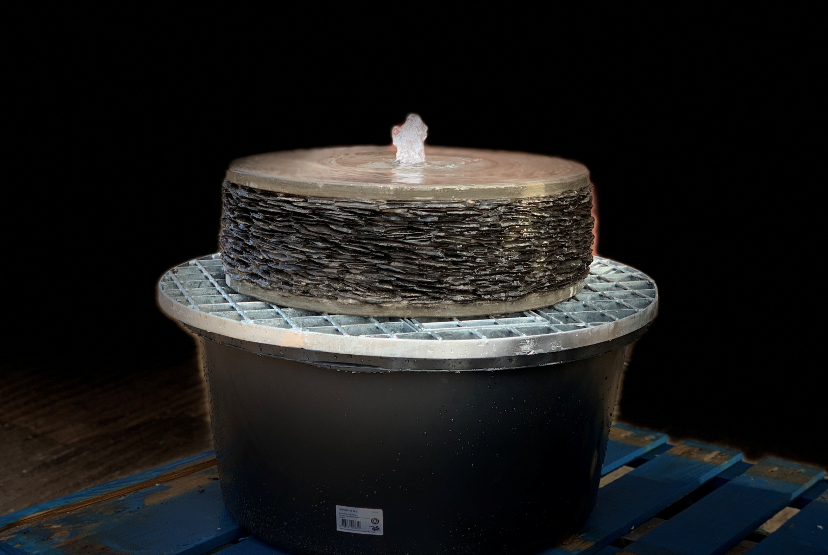
9040 NATURAL SLATE SURFACE MILL STONE, DIA50X18CM H,W/DIA70 RESEROIR, GRID, PUMP&LIGHT
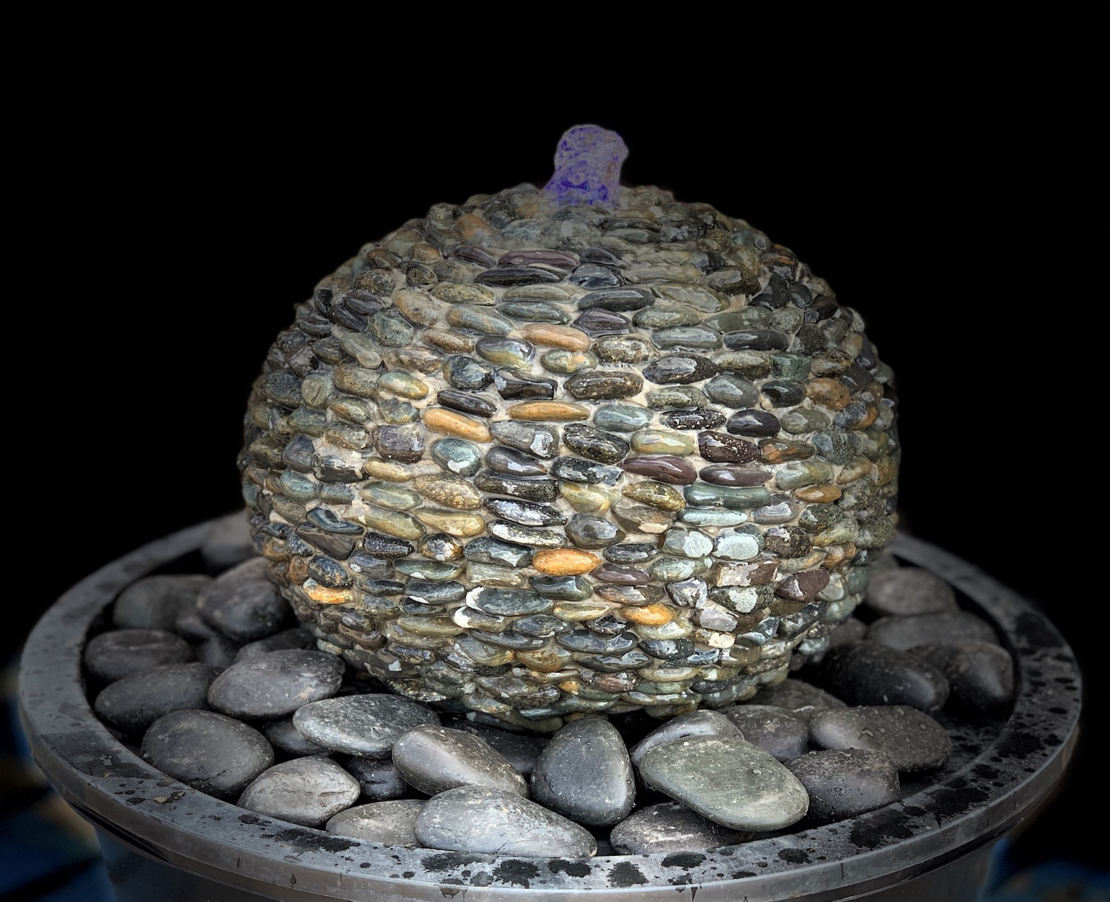
9029 NATURAL PEBBLE SURFACE SPHERE FOUNTAIN DIA 40CM ,W/RESERVIOR, LID, PUMP&LIGHT

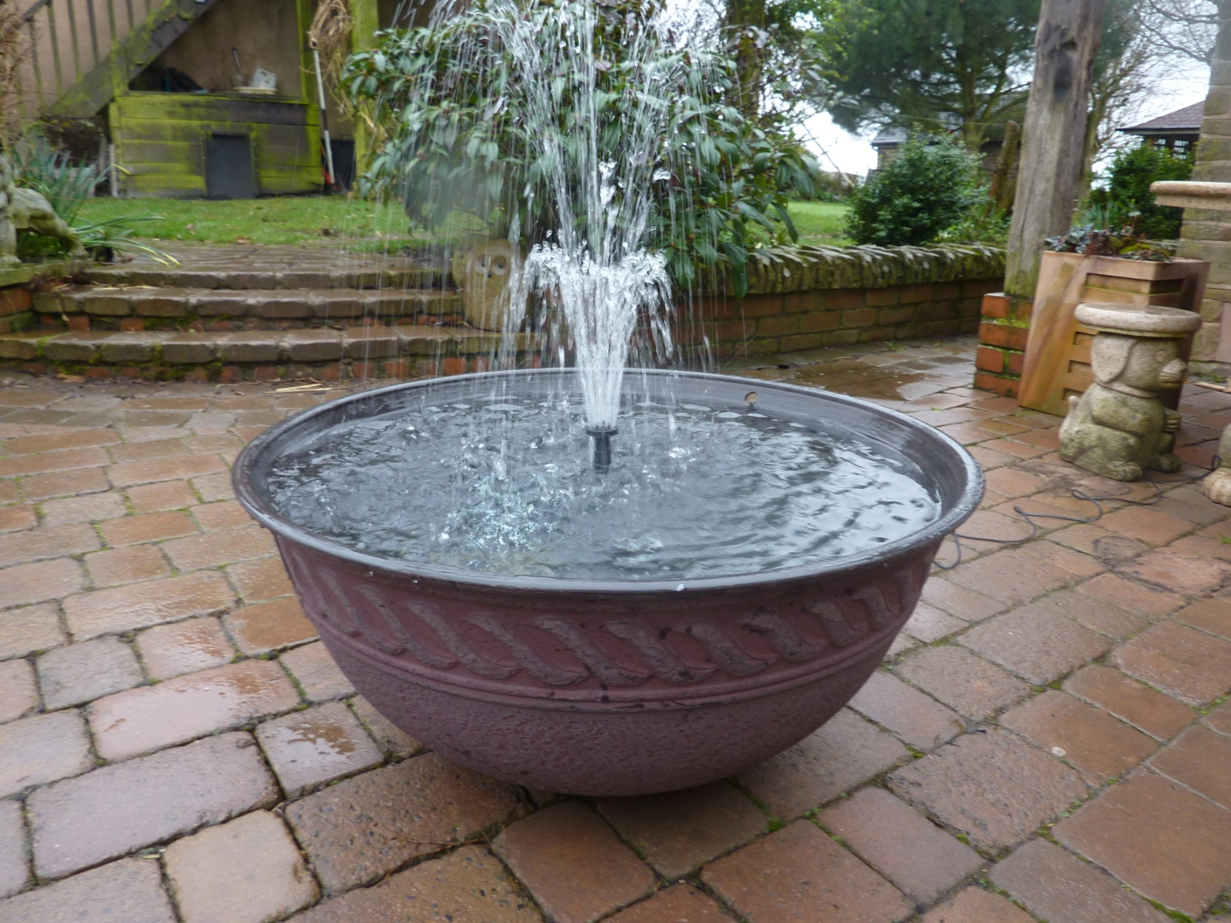
6305F-RED LOTUS BOWL DIA80CM TOP/ 31CM BASE X 37CM H, RED, complete fountain
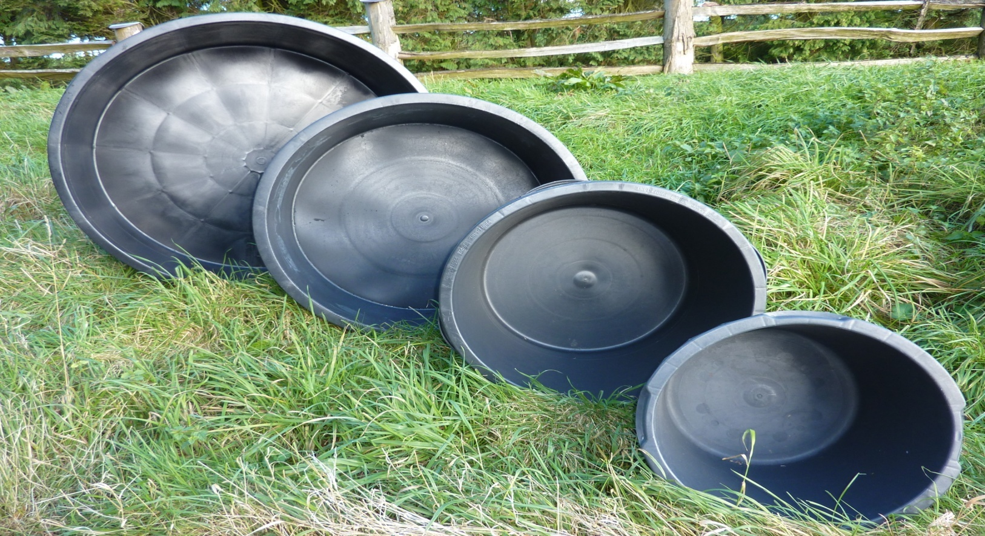
6005 EC PLASTIC BUCKET DIA52/ 60/ 65/ 85 /112 CM

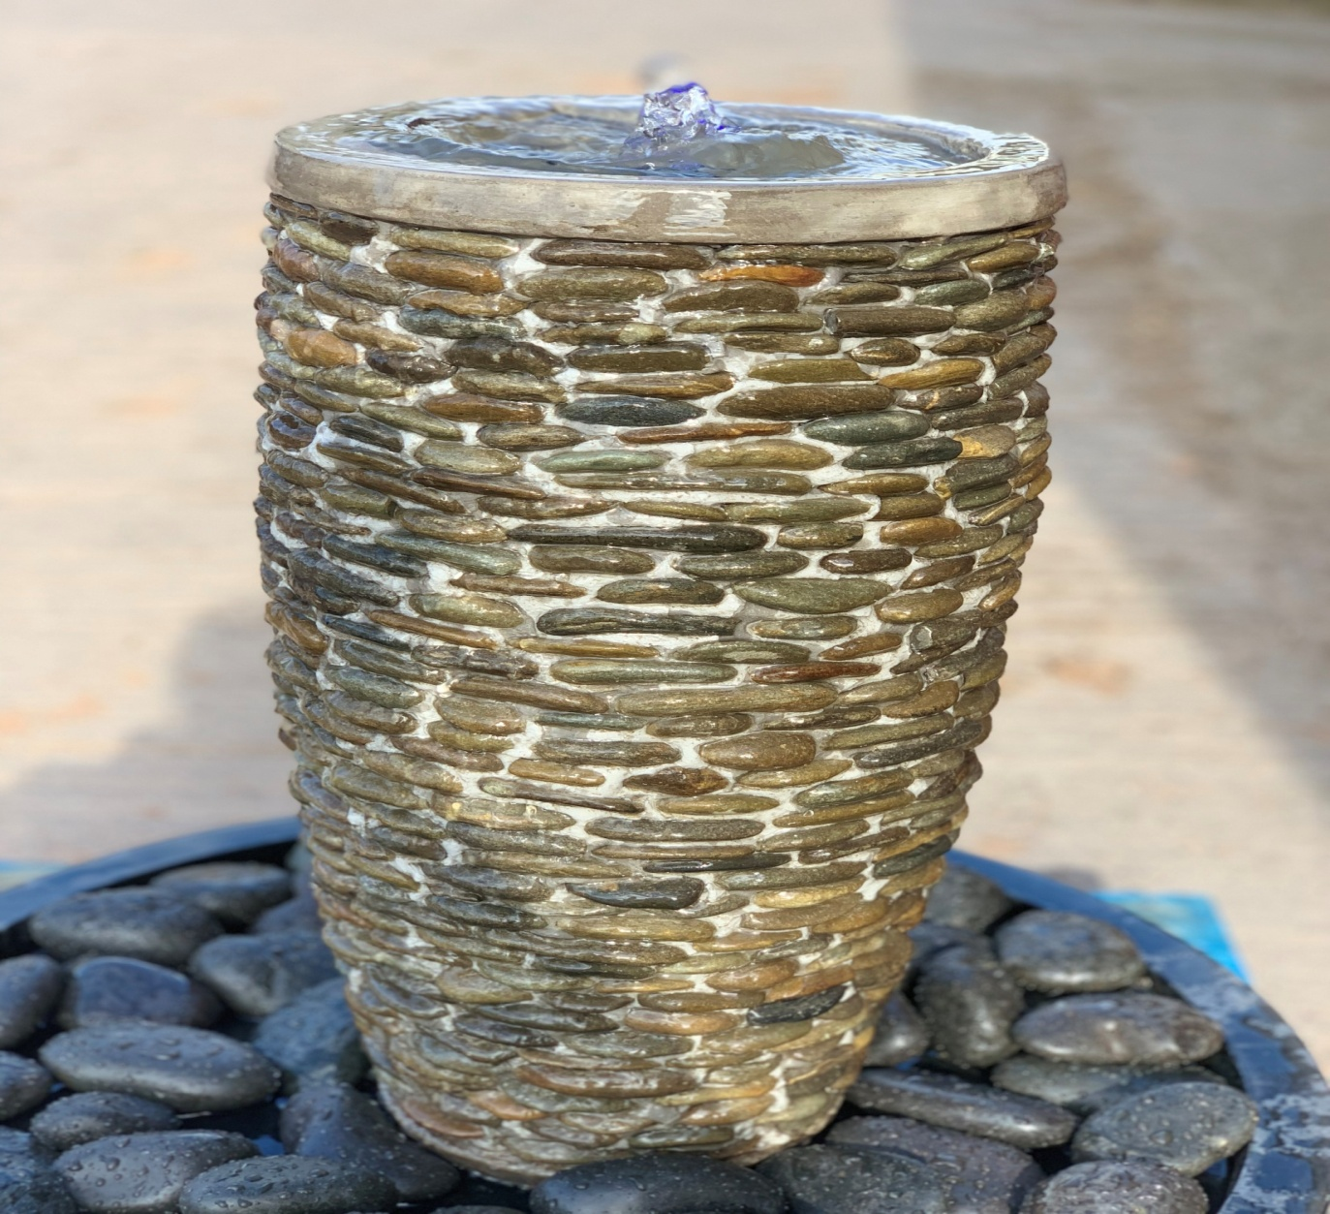
9039M NATURAL PEBBLE SURFACE VASE, DIA30x61CMH, 21KG,W/DIA70 RESEROIR, GRID, PUMP&LIGHT
9039 NATURAL PEBBLE SURFACE VASE, DIA46X76CMH, 42KG,W/DIA70 RESEROIR, GRID, PUMP&LIGHT
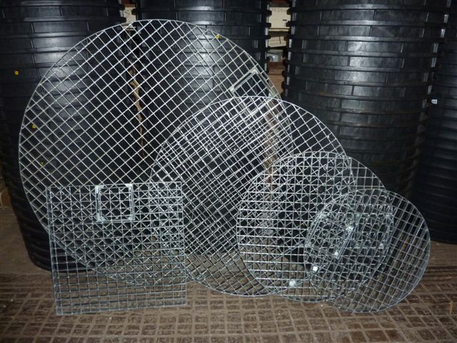
6001 EC ROUND STEEL GRID DIA70CM, WEIGHT IS 6.8KG APPR.

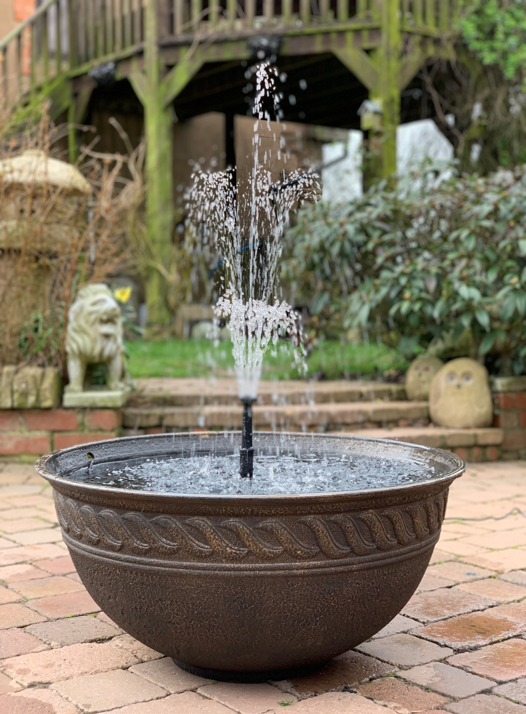
6305F LOTUS BOWL DIA80CM TOP/ 31CM BASE X 37CM H, BONZE FINISH, complete fountain

