Exclusively designed and supplied by Eastern Connections *Copy right reserved.
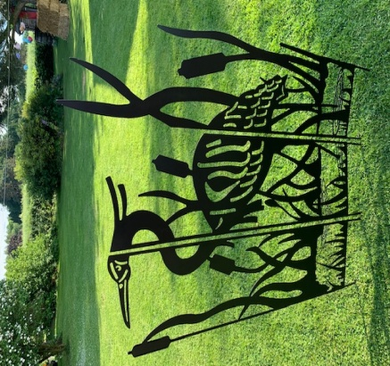
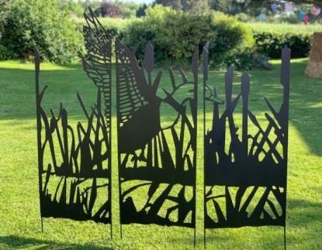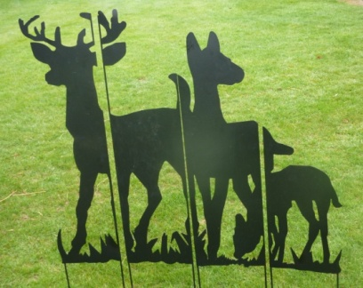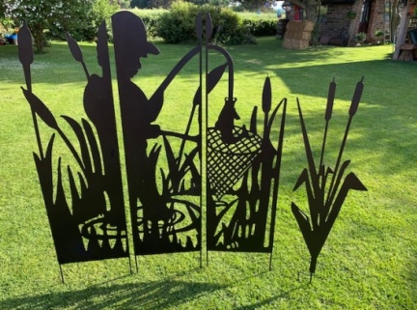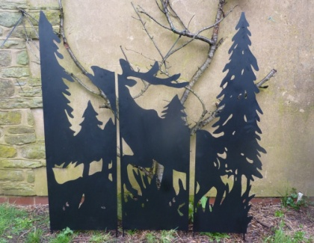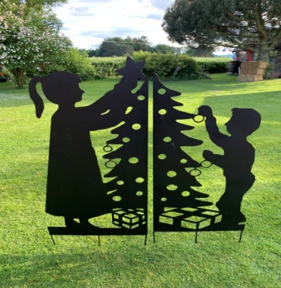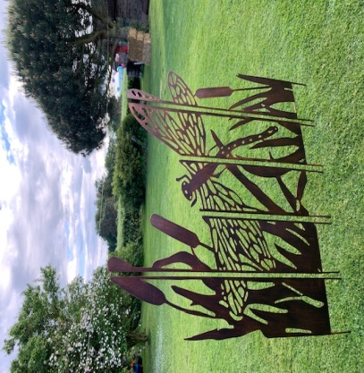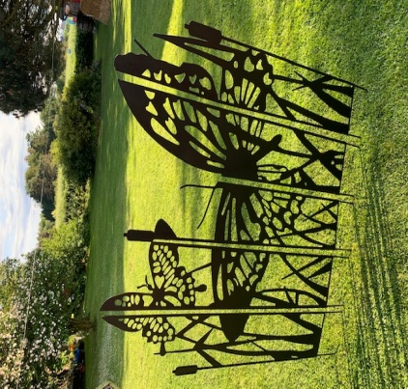
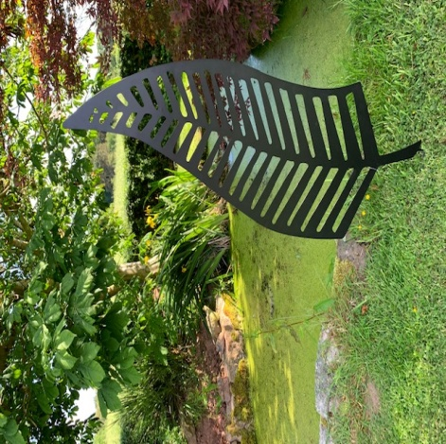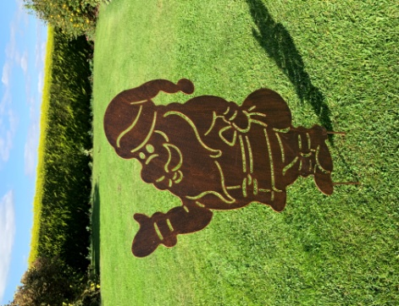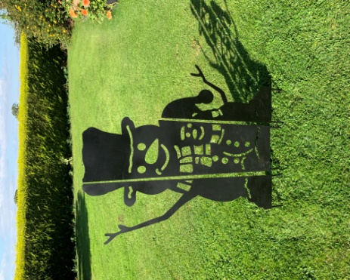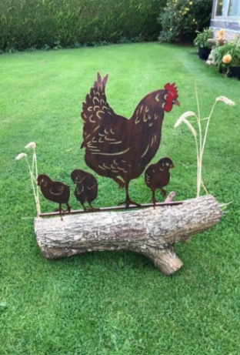
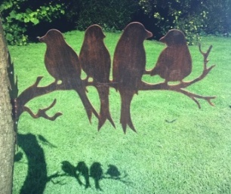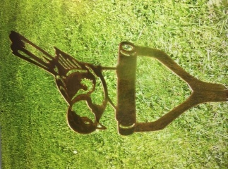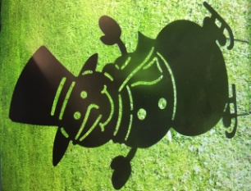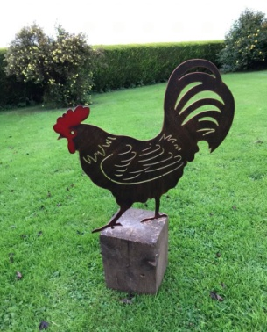
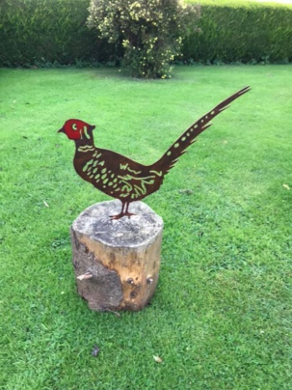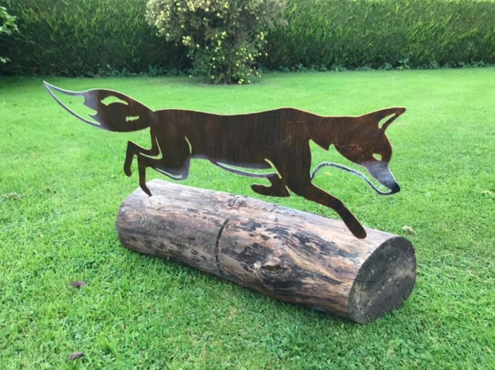
EC garden screen and stake |  |  | MOQ
1030-black | EC GARDEN SCREEN, STAG IN WOODS, 120 X 120CM H +20CM SPIKE | £49.00 | 1
1031-black/brown | EC GARDEN SCREEN, DRAGON FLY, 125 X 135CM H +20CM SPIKE | £65.00 | 1
1032-black/brown | EC GARDEN SCREEN, BUTTERFLY, 125 X 135CM H +20CM SPIKE | £69.00 | 1
1033-black/brown | EC GARDEN SCREEN, FLYING DUCK, 150X 135CM H +20CM SPIKE | £69.00 | 1
1034-black/brown | EC GARDEN SCREEN, HERON,100X 135CM H +20CM SPIKE | £49.00 | 1
1035-black/brown | EC GARDEN SCREEN, FISHING BOY, 135X 135CM H +20CM SPIKE | £65.00 | 1
1036-black/brown | EC GARDEN SCREEN, DEER FAMILY,132X 135CM H +20CM SPIKE | £65.00 | 1
1037 | SNOW MAN SCREEN 3 X30CM W PANELS, 135CM H,20CM SPIKE, BLACK | £39.00 | 1
1038 | BOY&GIRL CHRISTMAS TREE PANEL,2 X60CM W X 135CM H,+SPIKE, Black | £49.00 | 1
1037S | SNOW MAN SCREEN 3 X22CM W PANELS, 90CM H,15CM SPIKE, BLACK | £24.00 | 1
1038S | BOY&GIRL CHRISTMAS TREE PANEL,2 X40CM W X 90CM H,+SPIKE, Black | £29.00 | 1
1039 | SKATING SNOWMAN PANEL, 33.5X0.5X.63CM h, black, 1mm thick steel | £8.50 | 4
1040 | FATHER CHRISTMAS PANEL, 36X0.5X68CM H, COPPER BROWN, 1mm thick steel | £11.00 | 4
1041 | COCKEREL, 49.5X0.5X62CM, COPPER BROWN, RED CROWN, 1mm thick steel | £9.50 | 4
1042 | STEEL HEN&CHICK, 58X1X64CM, COPPER BROWN, 1mm thick steel | £15.00 | 4
1043 | STEEL RUNNING FOX, 95X41CM+SPIKE, COPPER BROWN,1mm thick steel | £15.00 | 4
1045 | STEEL BIRD PANEL WALL ART, mount on panel, 59.5x100cm H | £26.00 | 2
1052 | STEEL PHEASANT STAKE 54X1X38.5CM H, COPPER BROWN,1mm thick steel | £9.50 | 4
1053 | STEEL BIRD GROUP STAKE, 50X10X33CM H, COPPER BROWN,1mm thick steel | £7.95 | 6
1054 | STEEL BIRD STAKE ON GROUND,10X1X35CM H,COPER BROWN,1mm thick steel | £2.45 | 8
1055AB | STEEL set of 2 LEAVE,COPER BROWN,65x122/56.5x106CM 1mm thick | £45.00 | 1
1056 | STEEL SINGLE LEAVE STAKE, 40X1X120CM H, BLACK, 1mm thick steel | £17.00 | 4
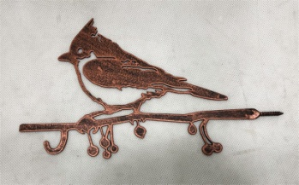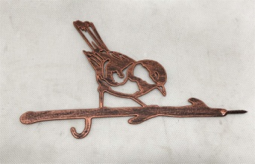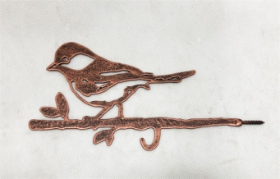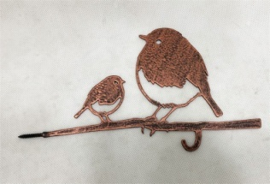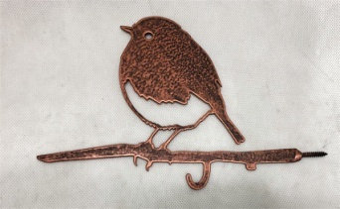
Creasted tit / blue tit/ great tit/ robbin &baby/ single robin / black bird/ wren/ woodpecker/wag tail/ £2.85/pc
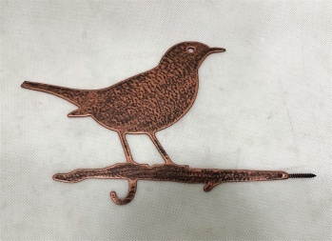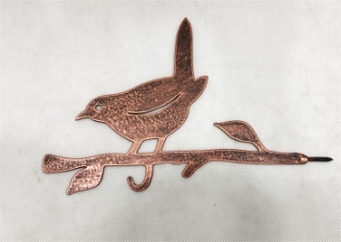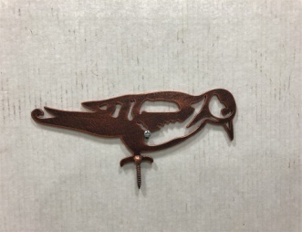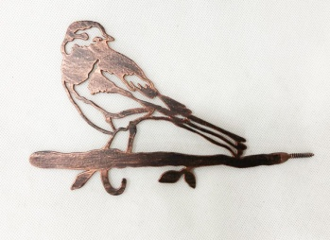2mm thick steel birds
*Our birds have a hook designed for your bird feeder or a garden tree lamp, maybe a wind bell! packed 8pcs/box

